MFL Theme Day: World Cup

Senegal
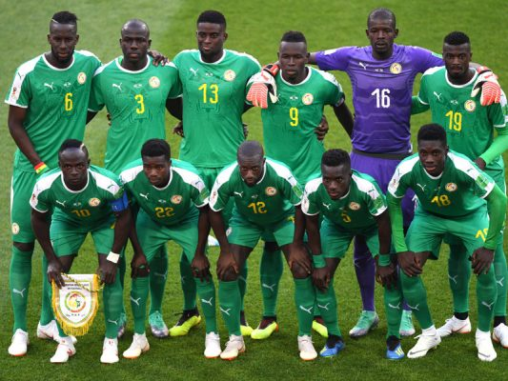
- I can explore the culture, wildlife and traditions of another French speaking country.
- I can research symbolism in the Senegalese culture and create a class collage using traditional patterns to demonstrate my understanding of how diversity and individuality are an integral part of the Senegalese culture.
- I can learn and practice key French phrases to describe the work we are doing today including colours, animals, describing size and talking about where we live.

