Monday
Time and Subject | Learning Objective | Task/Link/Resources
8.45-9.00  Reading | L.O: To practise and consolidate existing reading skills. | Read your individual reading book, either in your head or out loud.
9.00-9.15  Morning Maths | LO: To consolidate recall of number facts.  Revision LO: To add decimals within one. | Complete today’s Beat That. You will find today’s Beat That below today’s timetable. Just scroll down! Remember, it is the same one every day for a week so try and beat your score each time!  We use Morning Maths as a time to revise concepts and keep them at the front of our minds- follow this link to add decimals within one, use the first video on the link, click on Summer Term Week 1:  https://whiterosemaths.com/homelearning/summer-archive/year-5/
9.15-9.45  Spelling | LO: To practice Unit Six RWI Spelling words. | Speed write this week’s words- time yourself a minute for each! Check them and correct any mistakes. Write them in different colours or fancy writing, make yourself a poster of each of the words! Circle the consonants and vowels.  Direction, explanation, cautious, competition, especially, appreciate, ancient, delicious, spacious, subtraction, politician, section.
9.45-10.00  Active break | L.O: To boost my concentration through movement. | https://www.youtube.com/watch?v=FRnEDoVRaa0  Join in with the Go Noodle clip above to get you moving!
10.00-11.00  English | LO: To identify the features of a persuasive letter. | Have a go at today’s lesson by clicking on the link below:  https://classroom.thenational.academy/lessons/to-identify-the-features-of-a-persuasive-letter-61gkec
11.00- 11.15
Break
11.15-12.15  Maths | LO: To understand which operations have equal priority. | Have a go at today’s lesson by clicking on the link below:  https://classroom.thenational.academy/lessons/understanding-which-operations-have-equal-priority-c4t6ce
12.15-1.00
Dinner
1.00-1.15  Storytime | LO: To listen to a story for pleasure. | This week and next we are listening to Diary of a Sixth Grade Ninja by Marcus Emmerson, remember where you get up to:  https://stories.audible.com/pdp/B07XLV7FSM?ref=adbl_ent_anon_ds_pdp_pc_cntr-4-0
1.15-2.30  PE | LO: To learn a dance sequence and develop fitness. | Click on the links below to have a go at today’s lesson:  https://www.youtube.com/watch?v=lc1Ag9m7XQo  https://www.youtube.com/watch?v=GZuEnbSwOto
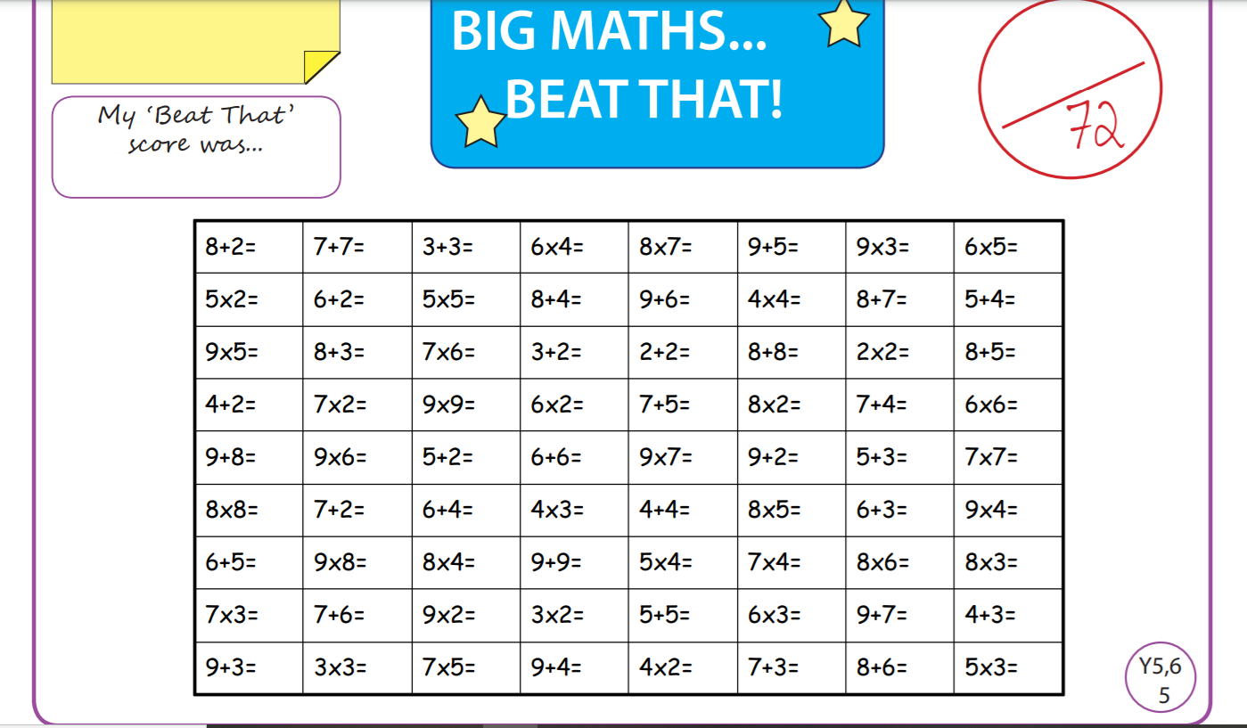
Tuesday
Time and Subject | Learning Objective | Task/Link/Resources
8.45-9.00  Reading | L.O: To practise and consolidate existing reading skills. | Read your individual reading book, either in your head or out loud.
9.00-9.15  Morning Maths | LO: To consolidate recall of number facts.  Revision LO: To subtract decimals within one. | Complete today’s Beat That. You will find today’s Beat That below today’s timetable. Just scroll down! Remember, it is the same one every day for a week so try and beat your score each time!  We use Morning Maths as a time to revise concepts and keep them at the front of our minds- follow this link to subtract decimals within one. Use the second video on the link, click on Summer Term Week 1:  https://whiterosemaths.com/homelearning/summer-archive/year-5/
9.15-9.45  Spelling | LO: To practice Unit Six RWI Spelling words. | Speed write this week’s words- time yourself a minute for each! Check them and correct any mistakes. Write them in different colours or fancy writing, make yourself a poster of each of the words! Circle the consonants and vowels.  Direction, explanation, cautious, competition, especially, appreciate, ancient, delicious, spacious, subtraction, politician, section.
9.45-10.00  Active break | L.O: To boost my concentration through movement. | https://www.youtube.com/watch?v=7Li2qwdUsxU  Join in with the Go Noodle clip above to get you moving!
10.00-11.00  English | LO: To investigate suffixes er and est, comparative and superlative. | Have a go at today’s lesson by clicking on the link below:  https://classroom.thenational.academy/lessons/to-investigate-suffixes-er-and-est-comparative-and-superlative-cmt62r
11.00- 11.15
Break
11.15-12.15  Maths | LO: To understand the order of operations. | Have a go at today’s lesson by clicking on the link below:  https://classroom.thenational.academy/lessons/order-of-operations-ctk3et
12.15-1.00
Dinner
1.00-1.15  Storytime | LO: To listen to a story for pleasure. | This week and next we are listening to Diary of a Sixth Grade Ninja by Marcus Emmerson, remember where you get up to:  https://stories.audible.com/pdp/B07XLV7FSM?ref=adbl_ent_anon_ds_pdp_pc_cntr-4-0
1.15-2.30  Topic  Geography | LO: To evaluate the impact globalisation has had on our lives. | Have a go at today’s Geography lesson by clicking on the link below:  https://classroom.thenational.academy/lessons/what-impact-has-globalisation-had-on-your-life-c8r3gt
2.30-3.00  RHE | LO: To understand the need for rules and law in society. | https://classroom.thenational.academy/lessons/the-mayor-making-ceremony-6wwp4c  Follow the link above to have a go at today’s lesson!
Wednesday
Time and Subject | Learning Objective | Task/Link/Resources
8.45-9.00  Reading | L.O: To practise and consolidate existing reading skills. | Read your individual reading book, either in your head or out loud.
9.00-9.15  Morning Maths | LO: To consolidate recall of number facts.  Revision LO: To work on complements to one. | Complete today’s Beat That. You will find today’s Beat That below today’s timetable. Just scroll down! Remember, it is the same one every day for a week so try and beat your score each time!  We use Morning Maths as a time to revise concepts and keep them at the front of our minds- follow this link to work on complements to one. Use the third video on the link below, click on Summer Term Week 1:  https://whiterosemaths.com/homelearning/summer-archive/year-5/
9.15-9.45  Spelling | LO: To practice Unit Six RWI Spelling words. | Speed write this week’s words- time yourself a minute for each! Check them and correct any mistakes. Write them in different colours or fancy writing, make yourself a poster of each of the words! Circle the consonants and vowels.  Direction, explanation, cautious, competition, especially, appreciate, ancient, delicious, spacious, subtraction, politician, section.
9.45-10.00  Active break | L.O: To boost my concentration through movement. | Get out any jitters by shaking:  Your right hand 10 times.  Your left hand 10 times.  Your right leg 10 times.  Your left leg 10 times.  Now count down and do the same for 9 to 1!
10.00-11.00  English | LO: To develop our understanding of the context for a persuasive letter. | Have a go at today’s lesson by clicking on the link below:  https://classroom.thenational.academy/lessons/to-develop-our-understanding-of-the-context-for-a-persuasive-letter-6mwk0e
11.00- 11.15
Break
11.15-12.15  Maths | LO: To consolidate understanding of operations. | Have a go at today’s lesson by clicking on the link below:  https://classroom.thenational.academy/lessons/consolidating-order-of-operations-68t34d
12.15-1.00
Dinner
1.00-1.15  Storytime | LO: To listen to a story for pleasure. | This week and next we are listening to Diary of a Sixth Grade Ninja by Marcus Emmerson, remember where you get up to:  https://stories.audible.com/pdp/B07XLV7FSM?ref=adbl_ent_anon_ds_pdp_pc_cntr-4-0
1.15-2.30  Topic  RE | RE LO: To explore what a human is. | Have a go at today’s RE lesson by clicking on the link below:  https://classroom.thenational.academy/lessons/what-is-a-human-c9j68d
2.30-3.00  Music | LO: To explore irregular metre. | Have a go at today’s lesson by clicking on the link below:  https://classroom.thenational.academy/lessons/to-explore-irregular-metre-69j3jt
Thursday
Time and Subject | Learning Objective | Task/Link/Resources
8.45-9.00  Reading | L.O: To practise and consolidate existing reading skills. | Read your individual reading b  ook, either in your head or out loud.
9.00-9.15  Morning Maths | LO: To consolidate recall of number facts.  Revision LO: To add decimals across the whole. | Complete today’s Beat That. You will find today’s Beat That below today’s timetable. Just scroll down! Remember, it is the same one every day for a week so try and beat your score each time!  We use Morning Maths as a time to revise concepts and keep them at the front of our minds- follow this link to add decimals crossing the whole. Use the fourth video on the link, click on Summer Term Week 1:  https://whiterosemaths.com/homelearning/summer-archive/year-5/
9.15-9.45  Spelling | LO: To practice Unit Six RWI Spelling words. | Speed write this week’s words- time yourself a minute for each! Check them and correct any mistakes. Write them in different colours or fancy writing, make yourself a poster of each of the words! Circle the consonants and vowels.  Direction, explanation, cautious, competition, especially, appreciate, ancient, delicious, spacious, subtraction, politician, section.
9.45-10.00  Active break | L.O: To boost my concentration through movement. | Join in:  https://www.youtube.com/watch?v=40uEcTuqIvM
10.00-11.00  English | LO: To explore relative clauses. | Have a go at today’s lesson by clicking on the link below:  https://classroom.thenational.academy/lessons/to-explore-relative-clauses-65k30c
11.00- 11.15
Break
11.15-12.15  Maths | LO: To explore linear number sequences. | Have a go at today’s lesson by clicking on the link below:  https://classroom.thenational.academy/lessons/linear-number-sequences-6ct66t
12.15-1.00
Dinner
1.00-1.15  Storytime | LO: To listen to a story for pleasure. | This week and next we are listening to Diary of a Sixth Grade Ninja by Marcus Emmerson, remember where you get up to:  https://stories.audible.com/pdp/B07XLV7FSM?ref=adbl_ent_anon_ds_pdp_pc_cntr-4-0
1.15-2.30  Topic  RE | RE LO: To explore where humanists find their truth. | Have a go at today’s RE lesson by clicking on the link below:  https://classroom.thenational.academy/lessons/where-do-humanists-find-their-truth-6gw66d
2.30-3.00  French | LO: To develop vocabulary. | Follow the link:  https://www.bbc.co.uk/teach/class-clips-video/french-ks2-favourite-hobbies/z4hxpg8
Friday
Time and Subject | Learning Objective | Task/Link/Resources
8.45-9.00  Reading | L.O: To practise and consolidate existing reading skills. | Read your individual reading book, either in your head or out loud.
9.00-9.15  Morning Maths | LO: To consolidate recall of number facts.  Revision LO: To add decimals with the same number of places. | Complete today’s Beat That. You will find today’s Beat That below today’s timetable. Just scroll down! Remember, it is the same one every day for a week so try and beat your score each time!  We use Morning Maths as a time to revise concepts and keep them at the front of our minds- follow this link to add decimals with the same number of places. Use the first video on the link below, click on Summer Term Week 2:  https://whiterosemaths.com/homelearning/summer-archive/year-5/
9.15-9.45  Spelling | LO: To practice Unit Six RWI Spelling words. | Speed write this week’s words- time yourself a minute for each! Check them and correct any mistakes. Write them in different colours or fancy writing, make yourself a poster of each of the words! Circle the consonants and vowels.  Direction, explanation, cautious, competition, especially, appreciate, ancient, delicious, spacious, subtraction, politician, section.  Test yourself using the Look, Cover, Write, Check grid at the very bottom of this week.
9.45-10.00  Active break | L.O: To boost my concentration through movement. | Join in:  https://www.youtube.com/watch?v=OYL20BXslQc
10.00-11.00  English | LO: To develop a rich understanding of words associated with sadness and anger. | Have a go at today’s lesson by clicking on the link below:  https://classroom.thenational.academy/lessons/to-develop-a-rich-understanding-of-words-associated-with-sadness-and-anger-c4u6cc
11.00- 11.15
Break
11.15-12.15  Maths | LO: To express missing numbers algebraically. | Have a go at today’s lesson by clicking on the link below:  https://classroom.thenational.academy/lessons/expressing-missing-numbers-algebraically-ccwpcc
12.15-1.00
Dinner
1.00-1.15  Storytime | LO: To listen to a story for pleasure. | This week and next we are listening to Diary of a Sixth Grade Ninja by Marcus Emmerson, remember where you get up to:  https://stories.audible.com/pdp/B07XLV7FSM?ref=adbl_ent_anon_ds_pdp_pc_cntr-4-0
1.15-3.00  Golden Time Art | LO: To develop my drawing skills. | Enjoy today’s session with the link below:  https://www.youtube.com/watch?v=Wvj3HecVX_s&feature=youtu.be
