Sandal Castle Community Primary School
Behaviour Policy 2019-2020

Policy
This policy is based on advice from the Department for Education (DfE) on:
- Behaviour and discipline in schools
- Searching, screening and confiscation at school
- The Equality Act 2010
- Use of reasonable force in schools
- Supporting pupils with medical conditions at school
It is also based on the special educational needs and disability (SEND) code of practice.
In addition, this policy is based on:
Section 175 of the Education Act 2002, which outlines a school’s duty to safeguard and promote the welfare of its pupils
- Sections 88-94 of the Education and Inspections Act 2006, which require schools to regulate pupils’ behaviour and publish a behaviour policy and written statement of behaviour principles, and give schools the authority to confiscate pupils’ property

In particular Section 91 of the Education and Inspections Act 2006 defines reasonable punishment as: “The penalty must be reasonable in all circumstances and that account must be taken of the pupils age, any Special Educational Needs, disability they may have, any religious requirements affecting them.”

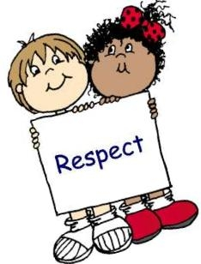
Our Values /Beliefs
We strongly believe that successful learning can only begin to take place when all members of our school community feel safe, valued and respected.
As a caring community we have worked with all stakeholders to ensure that our school can provide a safe and happy learning environment that respects individuality.

Trauma/ACEs

We aim to be a trauma sensitive school, one in which all children feel safe, secure, welcomed, supported and nurtured and where addressing the impact of trauma on learning and on emotional and mental health and well being is at the centre of our educational mission

We understand that many of our children will have had traumatic or adverse childhood experiences and we know that these can impact negatively upon a child’s learning, behaviour and relationships in school and later on in life through risk taking behaviours and poor health outcomes. It is our responsibility to be a trauma sensitive school to mitigate against these experiences.

ACEs

Overview of ACEs
Adverse Childhood Experiences (ACEs) are stressful events occurring in childhood including
- domestic violence
- parental abandonment through separation or divorce
- a parent with a mental health condition
- being the victim of abuse (physical, sexual and/or emotional)
- being the victim of neglect (physical and emotional)
- a member of the household being in prison
- growing up in a household in which there are adults experiencing alcohol and drug use problems.

Rights and Responsibilities
All members of our school community are aware of their rights and agree that with these rights come responsibilities:
Children:
Our Rights | This means we have a responsibility to
Right to feel safe | Behave in such a way that no-one is worried by or frightened of our actions
Right to be treated with respect | Treat ourselves, others and property with respect
Right to learn | Behave in such a way that adults in school can carry out their role effectively
Right to be happy | Be kind and thoughtful
Right to make mistakes | To learn from our mistakes
Adults in school:
Have a right to | This means we have a responsibility to
Be treated with respect | Treat others respectfully
Do our job effectively | Make sure that we deliver activities that are stimulating and take account of individual learners
Be safe | Act in line with school and LA policies
Feel valued | Act in a professional manner at all times

Adults at home:
Have a right to | This means we have a responsibility to
Be kept informed | Communicate with school
Expect the best for our children | Support the school ethos and values
Right to be treated with respect | Behave respectfully in our dealings within the school community

School Rules
We have 5 rules which we have a responsibility to try to adhere to at all times. We feel this is particularly important in school, on school visits, whilst representing the school and on our journey to and from school.

We have five people who help us remember these rules, you will see them around all around school so come on, let’s meet them:

Be helpful

Keep ourselves and others safe

Be kind

Always do our best to learn

Respect ourselves, each other and our environment

Safe Daley Lucy Learn Katie Kind Harry Helpful Ruby Respect

Our rules are based on rights and responsibilities. They aim to help our children develop and grow into young adults who can make appropriate choices about their behaviour, reach their full potential and go on to make a positive contribution to their community. We believe the caring, Christian ethos which underpins all of our work, the regular references to rights and responsibilities, the firm, fair and consistent approach to behaviour management is the best way of promoting this.

How can we help our children keep to the rules?

- Adults working in school are committed to modelling appropriate behaviours. There is an expectation that we will regularly reflect on our practice to ensure the environment we create for our children is conducive to positive behaviour for learning.
- Our children are taught routines, behaviours and expectations that help them keep to the rules.
- As with any learning we reward our children when they achieve and we support them to improve and make better choices when they make mistakes.
- All adults in school are committed to offering a consistent set of expectations around behaviour. We are expected to offer a consistent approach in the delivery of the behaviour policy and its’ appendices.

Consequences of our Actions

We believe very strongly that rewarding the desired behaviour is the most likely way to ensure children repeat the behaviour we want to see.
There are times however when inappropriate behaviours need to be addressed and consequences applied.

Rewards
Examples of positive behaviour
In order to promote the child’s self-esteem we reward as much as possible. We recognise positive behaviour by rewarding:
Attitudes | Work
Care for others | Accuracy
Effort | Achievement
Fairness | Completion of work
Honesty | Consistency of effort
Good manners | Determination
Initiative | Effort
Respectfulness | Independence
Self-discipline | Organisation
Supportiveness towards others | Punctuality/attendance
Thoughtfulness | Perseverance
Reliability | Presentation of work
Responsible behaviour | Motivation
 | Study skills

Example of Rewards
Listed below are some examples of rewards that may be used to reinforce desired behaviour. The list is not definitive as we encourage staff to use their professional experience to develop reward systems that reflect the interests of the children.

Minor | Medium | Major
Verbal praise | Stickers | Taking work to head teacher
Pointing out good behaviour | Character Tokens | Note Home
Non verbal signal, thumbs up, smile etc. | Show work to another adult | Star of the week
Written comments in books etc. | Acknowledgement via class based reward system | Show work in assembly
 | Work displayed on wall | Special mention in assembly
 | Word with parents at end of day | Gold Card Award
 | Special job /role | Trips/Special Event
 |  | Sandal Champagne
 |  | Any of rewards from previous lists

Sanctions
We are aware that behaviour doesn’t occur in a vacuum. So before sanctioning individual children particularly if “clusters “ of behaviour occur, adults are expected to undertake an environmental check list (appendix5). This may highlight where changes in the environment could help reduce inappropriate behaviour.
In accordance with Sect 91 of the Education and Inspection Act 2006, some children with additional needs or who are in circumstances that are known to make them vulnerable may need a significantly differentiated approach to behaviour management, including individual targets and rewards, and an individual Behaviour Management Plan. For these children we adopt “rubber boundaries”, i.e. boundaries that bend and flex but never break.

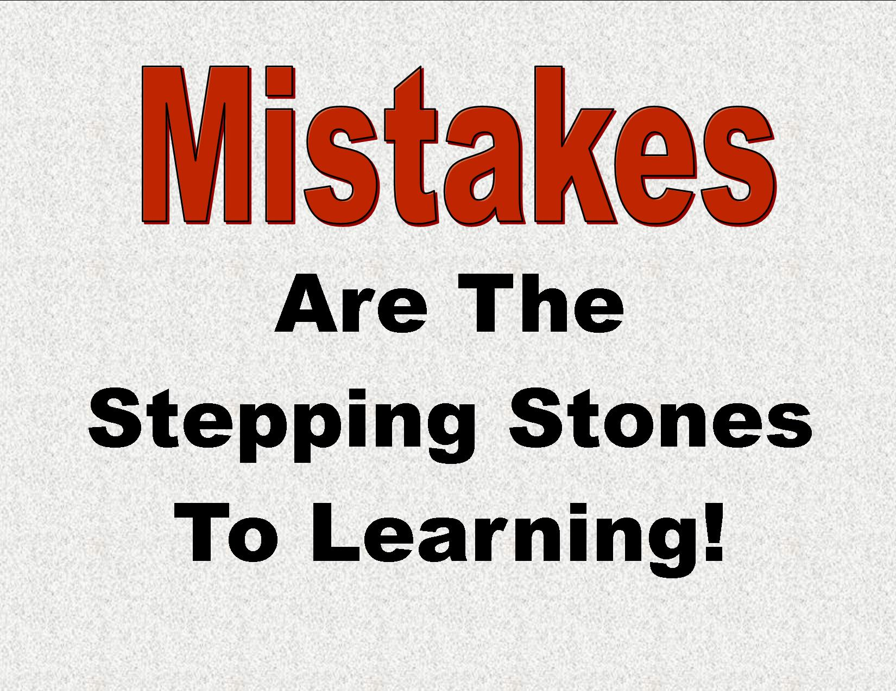
Levels of unacceptable behaviours
We see our children very much as “works in progress” with lots to learn both academically and socially. Therefore we accept that they will make mistakes from time to time. It is only by making mistakes and being taught an alternative that we can learn.
For most children engaging in low level behaviours a low level sanction is often sufficient for them to begin to change their behaviours.
When children don’t respond to the low level sanction it is important that a clear system informs next steps.
To facilitate this we have agreed a hierarchy of behaviours and possible responses.

Minor incidents may include:
Lack of cooperation ( initially)
Not accepting reasonable reminders about, e.g. running on corridor, not lining up appropriately
Low level rudeness to staff
Not attempting work (that the child is able to do)
One off name calling
Low level disruptive behaviour
Swearing or gestures (not intended to hurt)
Poor work solely due to lack of effort. i.e staff are certain the child can do the set task.

Medium level incidents may include:
Failing to respond to sanctions imposed to remedy low level incidents
Being deliberately rude to staff e.g. by swearing, gestures or tone of voice
Being involved in negative incidents with other children which may or may not be physical
Persistent low level disruption

Serious incidents may include:
Refusal to co operate
Persistent swearing or rude gestures intended to hurt
Openly defiant towards staff
Intentional damage to property
Malicious untruths
Stealing
Significant physical, verbal or written abuse of others and property
Significant teasing/ bullying
First offence of racial abuse
Leaving classroom without pass out card/ permission

Very serious incidents may include:
Leaving the school site without permission
Very serious physical or verbal/gestured/ written abuse of staff or children including racially motivated
Deliberately dangerous actions
Deliberately failing to deliver orange/ red card letters to parents

Procedures and Sanctions
The adults working with the children are expected to act in accordance with the advice in this policy and to use their own professional judgement as to the severity and frequency of behaviours.
In all instances minor incidents should be dealt with by the individual who witnessed the incident.
These incidents will usually result in a low level sanction and for most of our children this will be sufficient for them to modify their future behaviour.
Medium incidents may be dealt with by the teacher/ adult in charge and will usually result in the child receiving a low or medium level sanction and/or their first orange warning card. (Appendix 1)
If an orange card is issued by anyone other than the child’s class teacher it is the responsibility of the adult who issued it to notify the class teacher. This enables the management to have an overview of children with orange cards and if necessary initiate next steps. The class teacher will log the incident on CPOMS and in the class Incident Book
When a child gets a second orange card the class teacher must notify a member of the Senior Leadership team on the day of issue, logging the incident in on CPOMS and in the Incident Book. After discussing the incident with the child, the necessary paperwork will be sent home. This should be done on the day of issue wherever possible.

The paperwork comprises a letter outlining the incident and highlighting which rule their child has failed to adhere to. The parent/ carer’s responsibility will be to speak with the child and support school by helping their child to complete a “Next Time I Will ……..“sheet (appendix 3).
Where staff are aware that parents/ carers may find it difficult to support their child with this process, a member of the Inclusion Faculty, ideally who was not involved in the incident, will support the child. However it is important that parents/ carers are still made aware of the incident.
Very serious incidents may need to be dealt with by, Mrs Russell (Headteacher) or a member of the Leadership team. Following such an incident the child will, if appropriate,
be given a red card and a phone call will be made to parents/carers at the earliest opportunity by Mrs Russell.
Following this a letter will be sent to advise parents that it is their responsibility to attend a meeting in school at the earliest opportunity. The purpose of the meeting will be to discuss the incident, plan appropriate sanctions and agree any future actions.
All Red Cards will be logged on CPOMS by a member of the management.
All incidents of behaviour judged to be serious or very serious will be logged in class Incident Books and all orange and red cards logged on CPOMS in order for half termly monitoring and evaluation by specific members of the Inclusion Faculty to take place and reports produced for scrutiny by the GB.

Listed in the table are some possible outcomes of the incidents categorised above:
MINOR | MEDIUM | SERIOUS | VERY SERIOUS
Look | Language of choice | Issue of orange card | Removal from situation
Tactical ignoring | Loss of Golden time | Issue of red card | Letter home
Proximity praise | Reminder of expectations and consequences | Move to work in other class for a period | Loss of privileges possibly including not rep school
Language of choice (appendix 2) | Reminder of previous successes | Loss of privilege/ job | Loss of playtimes for agreed period.
Use of Golden time(appendix 4) | Issue with orange card | Loss of golden time | Isolation for agreed period
Move seat in class | Time working in another class | Reminders of previous success | Parents to bring and collect from school
Redirection | ‘Check – in’ time | Asked to leave room for cool down | Making amends
Adult to sit with group/ individual | Incident logged in class Incident Book | Removal from room using restrictive physical intervention | Possible fixed term exclusion
Refer to environmental checklist (appendix 5) | Incident logged on CPOMS | Loss of part of next play | Possible permanent exclusion
 |  | Completion of missed work in own time | Possible referral to outside agency
 |  | Letter of apology | Individual WRAP/ targets/ risk assessment
 |  | Make amends | Report to Anti-social behaviour team/ police
 |  | Letter home and completion of “Next Time I will….” Sheet (appendix 3)
 |  | Possible referral to outside agency | Incident logged on Integris
 |  | Individual WRAP (Wellness Rehabilitation Action Plan) | Incident logged in class Incident Book
 |  | Incident logged in class Incident Book | Incident logged on CPOMS
 |  | Incident logged on CPOMS

Confiscation and searching both with and without consent
Teachers and any other staff authorised by a member of the senior leadership team can search a pupil with or without their consent where they have reason to suspect the pupils has unauthorised items (stolen goods, weapons, alcohol or illegal drugs. However it may be agreed to be more appropriate to call outside agencies in these circumstances.

Warning Cards appendix 1

It is important that we track the progress children make with their behaviour. To facilitate this we have implemented a simple gold, green, orange and red card system.
Every child starts on green. Loss of Golden minutes for low level behaviours would not usually move the child off green. However if a child persistently repeats a low level behaviour and shows no signs of modifying that behaviour they may move onto their first orange warning card.
When a child gets a second orange card a letter will be sent to parents along with a “Next Time I will Sheet”.
If a child does not modify their behaviour following the orange letter home they will be given a red card and phone call home, followed by a letter , will be made by a member of Senior Management or the class teacher, asking the parents to come into school to discuss the situation and plan ways forward.
A child may be given a red card without going through the stages if their behaviour is very serious.
A child will remain subject of an orange card for a maximum of a week. During this period their behaviour will be monitored and clear expectations of their behaviour should be agreed. If this standard of behaviour is not met a second orange card will be issued. Once the child has been subject to an orange card for a week and it is agreed with those involved in the incident that the child has met their targets the child returns to green.
Gold cards will be issued half termly to a maximum of 2 children per class who have exceled at living the values of the 5 characters. A child receiving a gold card will receive a certificate/postcard home and will be invited to a special celebration with a member of Senior Management.

Language of Choice Script Appendix 2
Golden Time is now the universally agreed behaviour management tool used in school.
As stated in our behaviour policy we want to give our children every opportunity to learn from their mistakes and begin to take make better choices about their behaviour.
We believe using the language of choice model reduces confrontation with pupils and puts the responsibility on the children to make appropriate choices about their behaviour.
Example of the language of choice script:
“Dennis you are climbing on the windowsill”
Turn away and allow take up time.
“Dennis you are climbing on the windowsill, you need to come down and log on to your computer”
Turn away and allow take up time.
“Dennis you are climbing on the windowsill, if you choose to carry on instead of logging on to your computer you are choosing to lose a minute off your golden time. It’s up to you, so make a good choice.”
Turn away, and allow take up time. Either praise the good choice or issue the sanction.

Keeping your tone of voice and body language calm and neutral helps minimise the likelihood of escalation.

Turning away and allowing take up time is very important as it helps prevent the child feeling they have backed down and maybe lost face with their peers ( a particular issue for some of our more challenging children!)

You will be able to use your knowledge of the individual child and the nature of the situation to decide whether or not you speak to them out of earshot of their peers (this is usually the ideal).

Date:

Today has been given a second orange card.

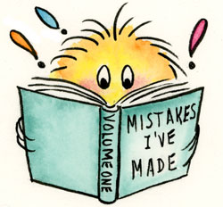
We want to make sure that we give all our children the opportunity to learn from their mistakes and teach them new ways of dealing with difficult situations.

As part of our commitment to working together to help our children learn more appropriate responses we would like you and to spend some time discussing the “Next Time I Will….. “ sheet.
doesn’t have to write his responses but we do ask that they can talk through the sheet, particularly how they will do things differently in the future , with their teacher tomorrow.

If you would like to discuss anything further please contact school.
01924 303525

Who was involved
Next time I will…………..

What happened?

Who was involved? Where did it happen? When did it happen? What were you feeling? What did you hope to gain?

Which characters rule did I break?
Respect ourselves, each other and our environment
Always do our best to learn

Keep ourselves and others safe

Be helpful

Be kind

Safe Daley Lucy Learn Katie Kind Harry Helpful Ruby Respect
What could I have done differently?

What I will do next time. This is the most important section as we can’t change what has happened but by learning from our mistakes we can make sure it doesn’t happen again.

DATE:

Today …………………………….. was given a red card.

I know you will be disappointed by …………………………. behaviour and will want to work with us to support………………………..to learn from this mistake.

Please phone school on 01924 303525 to arrange a time to come into school so that we can plan how best to support………………..

Golden Time Appendix 4

Golden time is the behaviour management tool used in school.
It has been implemented across school, some modification at UFS and in KS1 to ensure the children understand the system and to take into account, particularly in UFS the need for more “instant” rewards.
For most of the children the system is as follows:
They start the week with an “entitlement” to 60 minutes Golden Time between 2pm and 3pm on Friday. If they make bad choices about their behaviour despite warnings from staff they will lose some minutes.
Each class has devised its own Golden Time display, taking into account the children’s age, interests and theme in class.
They sign up for their choice of activity at the start of the half term and in all but very exceptional circumstances they are encouraged to continue with their chosen activity throughout that period.
If a child loses no minutes they will receive a class of juice at the start of Golden Time
If a child has lost some minutes they will sit out their chosen Golden Time activity wuietly until the appropriate time has elapsed when they can go and join in their chosen activity. If the child doesn’t sit quietly after warnings from staff they will be given an individual timer which will be laid on it’s side until the child is behaving appropriately.
In line with our behaviour policy some children access the whole school reward system in a modified format e.g. they may earn minutes for meeting individual targets.

Behavioural Environment Checklist Appendix 5

Notes for guidance:

- This checklist is designed to help you to look at the environment(s) in which the problem is happening (e.g. classroom, playground etc.)
- It is best to complete this checklist with a colleague, for example the school’s behaviour coordinator (or equivalent)
- Do not feel obliged to consider every statement – some may not apply to your situation.
- Once the checklist is completed it will give the basis for a Behavioural Environment Plan.
- Circle 5 if you agree with the statement and zero if you disagree.

1. Equipment is easily accessible | 5 | 4 | 3 | 2 | 1 | 0
2. Furniture arranged to best effect | 5 | 4 | 3 | 2 | 1 | 0
3. Appropriate ambient temperature | 5 | 4 | 3 | 2 | 1 | 0
4. Sufficient ventilation | 5 | 4 | 3 | 2 | 1 | 0
5. Lighting sufficient | 5 | 4 | 3 | 2 | 1 | 0
6. No glare | 5 | 4 | 3 | 2 | 1 | 0
7. Materials well labelled and located | 5 | 4 | 3 | 2 | 1 | 0
8. Ease of movement in room | 5 | 4 | 3 | 2 | 1 | 0
9. Appropriate storage of pupils’ belongings | 5 | 4 | 3 | 2 | 1 | 0
10. Pupils are grouped appropriately | 5 | 4 | 3 | 2 | 1 | 0
11. Pupils are placed reflecting social relationships | 5 | 4 | 3 | 2 | 1 | 0
12. Room organisation meets differing curriculum demands | 5 | 4 | 3 | 2 | 1 | 0
13. White board etc. easily seen | 5 | 4 | 3 | 2 | 1 | 0
14. Furniture suitable | 5 | 4 | 3 | 2 | 1 | 0
15. Classroom looks like a good work environment | 5 | 4 | 3 | 2 | 1 | 0
16. Sufficient space | 5 | 4 | 3 | 2 | 1 | 0
17. Quiet external environment | 5 | 4 | 3 | 2 | 1 | 0
Other specify) ……………….. | 5 | 4 | 3 | 2 | 1 | 0

SECTION B Classroom management

Agree Disagree

18. Adult arrives at lesson/classroom before pupils | 5 | 4 | 3 | 2 | 1 | 0
19. Teacher’s voice is clear | 5 | 4 | 3 | 2 | 1 | 0
20. Instructions are clear | 5 | 4 | 3 | 2 | 1 | 0
21. Good behaviour is noticed and acknowledged | 5 | 4 | 3 | 2 | 1 | 0
22. Small achievements recognised | 5 | 4 | 3 | 2 | 1 | 0
23. A pupil’s good behaviour is ‘named’ and reflected back | 5 | 4 | 3 | 2 | 1 | 0
24. The teacher acts as a role model for desired behaviour | 5 | 4 | 3 | 2 | 1 | 0
25. Materials and equipment are prepared | 5 | 4 | 3 | 2 | 1 | 0
26. Pupils bring correct equipment | 5 | 4 | 3 | 2 | 1 | 0
27. Lessons well prepared | 5 | 4 | 3 | 2 | 1 | 0
28. Curriculum delivery is varied | 5 | 4 | 3 | 2 | 1 | 0
29. Curriculum delivery is differentiated | 5 | 4 | 3 | 2 | 1 | 0
30. Timetable is arranged to best effect | 5 | 4 | 3 | 2 | 1 | 0
31. Peer support is used where appropriate | 5 | 4 | 3 | 2 | 1 | 0
32. Adult support is used where appropriate | 5 | 4 | 3 | 2 | 1 | 0

SECTION C Out of Classroom

33. Routines for movement around school site clear | 5 | 4 | 3 | 2 | 1 | 0
34. Break-time rules understood by pupils | 5 | 4 | 3 | 2 | 1 | 0
35. Break-time systems adopted by all staff | 5 | 4 | 3 | 2 | 1 | 0
36. Break-time rewards/sanctions system clear | 5 | 4 | 3 | 2 | 1 | 0
37. Behaviour policy adopted by ancillary staff | 5 | 4 | 3 | 2 | 1 | 0
38. Problem site areas identified and overcome | 5 | 4 | 3 | 2 | 1 | 0
39. Suitable activities/equipment available for break-times | 5 | 4 | 3 | 2 | 1 | 0
40. There is an effective system for resolution of pupil conflicts | 5 | 4 | 3 | 2 | 1 | 0
Other specify)……………..

SECTION D Classroom rules and routines

Agree Disagree

Rules:
41. Are few in number and clearly phrased | 5 | 4 | 3 | 2 | 1 | 0
42. Are negotiated with, and understood, by pupils | 5 | 4 | 3 | 2 | 1 | 0
43. Are regularly referred to and reinforced | 5 | 4 | 3 | 2 | 1 | 0
44. Are positively framed | 5 | 4 | 3 | 2 | 1 | 0
45. Are clearly displayed in the classroom | 5 | 4 | 3 | 2 | 1 | 0
46. Behaviour to meet rules is taught | 5 | 4 | 3 | 2 | 1 | 0
Rewards:
47. Are valued by pupils | 5 | 4 | 3 | 2 | 1 | 0
48. Area awarded fairly and consistently | 5 | 4 | 3 | 2 | 1 | 0
49. Are clearly related to positive behaviour | 5 | 4 | 3 | 2 | 1 | 0
50. Are small and readily achievable | 5 | 4 | 3 | 2 | 1 | 0
51. Link with school reward system | 5 | 4 | 3 | 2 | 1 | 0
Sanctions:
52. Are related to behaviour | 5 | 4 | 3 | 2 | 1 | 0
53. Are administered fairly and consistently | 5 | 4 | 3 | 2 | 1 | 0
54. Are understood by pupils | 5 | 4 | 3 | 2 | 1 | 0
55. Are understood by parents and carers | 5 | 4 | 3 | 2 | 1 | 0
56. Are within a clear hierarchy of severity | 5 | 4 | 3 | 2 | 1 | 0
Routines are established for:
57. Entering or leaving the room | 5 | 4 | 3 | 2 | 1 | 0
58. Distribution and collection of materials/equipment | 5 | 4 | 3 | 2 | 1 | 0
59. Gaining teacher’s attention and help | 5 | 4 | 3 | 2 | 1 | 0
60. Changing activities | 5 | 4 | 3 | 2 | 1 | 0
61. Gaining quiet/silence/attention | 5 | 4 | 3 | 2 | 1 | 0
62. Clearing up | 5 | 4 | 3 | 2 | 1 | 0
Other specify)………………….

SECTION E Whole school policies

Rules and implications:
63. A behaviour policy exists and is effective | 5 | 4 | 3 | 2 | 1 | 0
64. Staff have clear understanding of the policy | 5 | 4 | 3 | 2 | 1 | 0
65. Rules are communicated frequently and effectively to pupils, staff including non-teaching, parents and governors | 5 | 4 | 3 | 2 | 1 | 0
66. Staff have a clear idea of the range of rewards available to pupils | 5 | 4 | 3 | 2 | 1 | 0
67. Staff have a clear idea of the range of sanctions that can and cannot be used. | 5 | 4 | 3 | 2 | 1 | 0
68. Staff are aware of a good range of techniques that can be used to deal with behaviour problems | 5 | 4 | 3 | 2 | 1 | 0
69. Pupils, as far as they are able, know the reasons behind the rules in the school. | 5 | 4 | 3 | 2 | 1 | 0
70. Behaviour problems are dealt with effectively in the light of equal opportunity issues. | 5 | 4 | 3 | 2 | 1 | 0
Support for staff:
71. There is collective responsibility for behaviour management in the school. | 5 | 4 | 3 | 2 | 1 | 0
72. Staff feel confident to acknowledge difficulties | 5 | 4 | 3 | 2 | 1 | 0
73. Staff have clear means of gaining help | 5 | 4 | 3 | 2 | 1 | 0
74. Staff have effective guidance on dealing with conflict | 5 | 4 | 3 | 2 | 1 | 0
75. Behaviour problems are recorded fairly and efficiently. | 5 | 4 | 3 | 2 | 1 | 0
76. Staff roles are clearly defined | 5 | 4 | 3 | 2 | 1 | 0
77. Support services are used systematically, efficiently. | 5 | 4 | 3 | 2 | 1 | 0

SECTION E Whole school policies (cont.)
Parents and Governors:
78. Parents are involved to best effect in helping with problems | 5 | 4 | 3 | 2 | 1 | 0
79. Parents are routinely told of pupil’s good behaviour | 5 | 4 | 3 | 2 | 1 | 0
80. Governors have agreed written principles | 5 | 4 | 3 | 2 | 1 | 0
81. Governors are appropriately involved in issues relating to behaviour | 5 | 4 | 3 | 2 | 1 | 0
Other (specify) ………………… | 5 | 4 | 3 | 2 | 1 | 0
Further user-devised items
_________________________________ | 5 | 4 | 3 | 2 | 1 | 0
_________________________________ | 5 | 4 | 3 | 2 | 1 | 0
_________________________________ | 5 | 4 | 3 | 2 | 1 | 0
_________________________________ | 5 | 4 | 3 | 2 | 1 | 0
_________________________________ | 5 | 4 | 3 | 2 | 1 | 0
_________________________________ | 5 | 4 | 3 | 2 | 1 | 0
_________________________________ | 5 | 4 | 3 | 2 | 1 | 0
_________________________________ | 5 | 4 | 3 | 2 | 1 | 0

