Monday
Time and Subject | Learning Objective | Task/Link/Resources
8.45-9.00  Reading | L.O: To practise and consolidate existing reading skills. | Read your individual reading book, either in your head or out loud.
9.00-9.15  Morning Maths | LO: To consolidate recall of number facts.  Revision LO: To multiply unit and non- unit fractions by integers. | Complete today’s Beat That. You will find today’s Beat That below today’s timetable. Just scroll down! Remember, it is the same one every day for a week so try and beat your score each time!  We use Morning Maths as a time to revise concepts and keep them at the front of our minds- follow this link to multiply unit and non- unit fractions by integers. Use the first video on the link below, click on Summer Term Week 6:  https://whiterosemaths.com/homelearning/summer-archive/year-5/
9.15-9.45  Spelling | LO: To practice Unit eight RWI Spelling words. | Speed write this week’s words- time yourself a minute for each! Check them and correct any mistakes. Write them in different colours or fancy writing, make yourself a poster of each of the words! Circle the consonants and vowels.  Autumn, climb, climbed, calm, column, crumb, doubt, doubting, gnarled, gnaw, gnawing, gnome, guessed, guessing, guidance, guest, guilt, guitar, half, islander, knee, knight, knocking, know, knowledge.
9.45-10.00  Active break | L.O: To boost my concentration through movement. | Join in:  https://www.youtube.com/watch?v=iuCPKBE_hmY
10.00-11.00  English | LO: To identify the features of a letter. | Have a go at today’s lesson by clicking on the link below:  https://classroom.thenational.academy/lessons/to-identify-the-features-of-a-letter-74rp2e
11.00- 11.15
Break
11.15-12.15  Maths | LO: To represent multiplication with proper fractions. | Have a go at today’s lesson by clicking on the link below:  https://classroom.thenational.academy/lessons/fractions-represent-multiplication-with-proper-fractions-c9h64e
12.15-1.00
Dinner
1.00-1.15  Storytime | LO: To listen to a story for pleasure. | This week we are continuing to listen to Hyperspace High Crash Landing, remember where you get up to each day:  https://stories.audible.com/pdp/B00FL4S5FC?ref=adbl_ent_anon_ds_pdp_pc_cntr-4-4
1.15-3.00  PE | LO: To develop fitness and to learn a dance sequence. | Have a go at today’s lesson by clicking on the links below:  https://www.youtube.com/watch?v=FNFYZ2n90RI  https://www.youtube.com/watch?v=1QRmKit2NXw
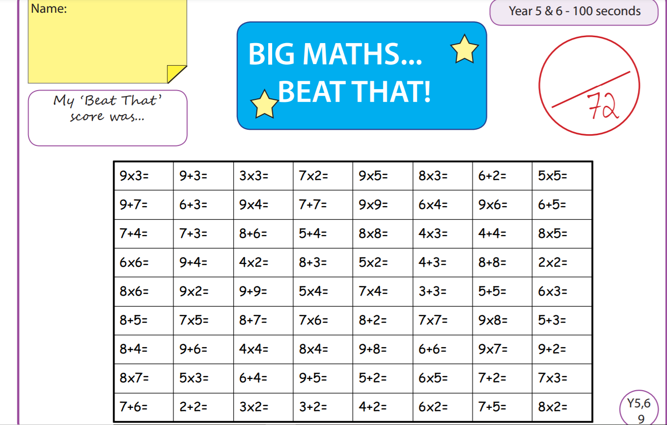
Tuesday
Time and Subject | Learning Objective | Task/Link/Resources
8.45-9.00  Reading | L.O: To practise and consolidate existing reading skills. | Read your individual reading book, either in your head or out loud.
9.00-9.15  Morning Maths | LO: To consolidate recall of number facts.  Revision LO: Multiply mixed numbers by integers. | Complete today’s Beat That. You will find today’s Beat That below today’s timetable. Just scroll down! Remember, it is the same one every day for a week so try and beat your score each time!  We use Morning Maths as a time to revise concepts and keep them at the front of our minds- follow this link to multiply mixed numbers by integers. Use the second video on the link below, click on Summer Term Week 6:  https://whiterosemaths.com/homelearning/summer-archive/year-5/
9.15-9.45  Spelling | LO: To practice Unit Eight RWI Spelling words. | Speed write this week’s words- time yourself a minute for each! Check them and correct any mistakes. Write them in different colours or fancy writing, make yourself a poster of each of the words! Circle the consonants and vowels.  Autumn, climb, climbed, calm, column, crumb, doubt, doubting, gnarled, gnaw, gnawing, gnome, guessed, guessing, guidance, guest, guilt, guitar, half, islander, knee, knight, knocking, know, knowledge.
9.45-10.00  Active break | L.O: To boost my concentration through movement. | Join in:  https://www.youtube.com/watch?v=oaDJWH4OOjQ
10.00-11.00  English | LO: To investigate suffixes le, el, al and il. | Have a go at today’s lesson by clicking on the link below:  https://classroom.thenational.academy/lessons/to-investigate-suffixes-le-el-al-il-cru30r
11.00- 11.15
Break
11.15-12.15  Maths | LO: To multiply pairs of proper fractions. | Have a go at today’s lesson by clicking on the link below:  https://classroom.thenational.academy/lessons/fractions-multiply-pairs-of-proper-fractions-c4rp4r
12.15-1.00
Dinner
1.00-1.15  Storytime | LO: To listen to a story for pleasure. | This week we are continuing to listen to Hyperspace High Crash Landing, remember where you get up to each day:  https://stories.audible.com/pdp/B00FL4S5FC?ref=adbl_ent_anon_ds_pdp_pc_cntr-4-4
1.15-2.30  Topic  History. | LO: To explore how we know about the Shang Dynasty. | Have a go at today’s History lesson by clicking on the link below:  https://classroom.thenational.academy/lessons/how-do-we-know-about-the-shang-dynasty-cdj3gc
2.30-3.00  RHE | LO: To learn how to stay safe on a bike and in a car. | Have a go at today’s lesson by clicking on the link below:  https://classroom.thenational.academy/lessons/king-of-the-road-6mu36t
Wednesday
Time and Subject | Learning Objective | Task/Link/Resources
8.45-9.00  Reading | L.O: To practise and consolidate existing reading skills. | Read your individual reading book, either in your head or out loud.
9.00-9.15  Morning Maths | LO: To consolidate recall of number facts.  Revision LO: To calculate fractions of an amount. | Complete today’s Beat That. You will find today’s Beat That below today’s timetable. Just scroll down! Remember, it is the same one every day for a week so try and beat your score each time!  We use Morning Maths as a time to revise concepts and keep them at the front of our minds- follow this link to calculate fractions of an amount, use the third video on the link below, click on Summer Term Week 6:  https://whiterosemaths.com/homelearning/summer-archive/year-5/
9.15-9.45  Spelling | LO: To practice Unit Eight RWI Spelling words. | Speed write this week’s words- time yourself a minute for each! Check them and correct any mistakes. Write them in different colours or fancy writing, make yourself a poster of each of the words! Circle the consonants and vowels.  Autumn, climb, climbed, calm, column, crumb, doubt, doubting, gnarled, gnaw, gnawing, gnome, guessed, guessing, guidance, guest, guilt, guitar, half, islander, knee, knight, knocking, know, knowledge.
9.45-10.00  Active break | L.O: To boost my concentration through movement. | Join in:  https://www.youtube.com/watch?v=ZQpMUs4EMv8
10.00-11.00  English | LO: To explore non-finite subordinate clauses. | Have a go at today’s lesson by clicking on the link below:  https://classroom.thenational.academy/lessons/to-explore-non-finite-subordinate-clauses-crtkgr
11.00- 11.15
Break
11.15-12.15  Maths | LO: To divide a proper fraction by an integer. | Have a go at today’s lesson by clicking on the link below:  https://classroom.thenational.academy/lessons/fractions-divide-a-proper-fraction-by-an-integer-6tjkgd
12.15-1.00
Dinner
1.00-1.15  Storytime | LO: To listen to a story for pleasure. | This week we are continuing to listen to Hyperspace High Crash Landing, remember where you get up to each day:  https://stories.audible.com/pdp/B00FL4S5FC?ref=adbl_ent_anon_ds_pdp_pc_cntr-4-4
1.15-2.30  Topic  History. | LO: To learn about how the Shang Dynasty began. | Have a go at today’s History lesson by clicking on the link below:  https://classroom.thenational.academy/lessons/how-did-the-shang-dynasty-begin-71j30c
2.30-3.00  Music | LO: To explore bass lines. | Have a go at today’s lesson by clicking on the link below:  https://classroom.thenational.academy/lessons/to-explore-bass-lines-6rwk8c
Thursday
Time and Subject | Learning Objective | Task/Link/Resources
8.45-9.00  Reading | L.O: To practise and consolidate existing reading skills. | Read your individual reading book, either in your head or out loud.
9.00-9.15  Morning Maths | LO: To consolidate recall of number facts.  Revision LO: To use fractions as operators. | Complete today’s Beat That. You will find today’s Beat That below today’s timetable. Just scroll down! Remember, it is the same one every day for a week so try and beat your score each time!  We use Morning Maths as a time to revise concepts and keep them at the front of our minds- follow this link to use fractions as operators. Use the fourth video on the link below, click on Summer Term Week 6:  https://whiterosemaths.com/homelearning/summer-archive/year-5/
9.15-9.45  Spelling | LO: To practice Unit Eight RWI Spelling words. | Speed write this week’s words- time yourself a minute for each! Check them and correct any mistakes. Write them in different colours or fancy writing, make yourself a poster of each of the words! Circle the consonants and vowels.  Autumn, climb, climbed, calm, column, crumb, doubt, doubting, gnarled, gnaw, gnawing, gnome, guessed, guessing, guidance, guest, guilt, guitar, half, islander, knee, knight, knocking, know, knowledge.
9.45-10.00  Active break | L.O: To boost my concentration through movement. | Join in:  https://www.youtube.com/watch?v=15oltV2mPu4
10.00-11.00  English | LO: To further build knowledge of the historical context of the unit. | Have a go at today’s lesson by clicking on the link below:  https://classroom.thenational.academy/lessons/to-further-build-knowledge-of-the-historical-context-of-the-unit-6njp6t
11.00- 11.15
Break
11.15-12.15  Maths | LO: To multiply and divide with improper fractions. | Have a go at today’s lesson by clicking on the link below:  https://classroom.thenational.academy/lessons/fractions-multiply-and-divide-with-improper-fractions-74tk8c
12.15-1.00
Dinner
1.00-1.15  Storytime | LO: To listen to a story for pleasure. | This week we are continuing to listen to Hyperspace High Crash Landing, remember where you get up to each day:  https://stories.audible.com/pdp/B00FL4S5FC?ref=adbl_ent_anon_ds_pdp_pc_cntr-4-4
1.15-2.30  Topic  History. | LO: To explore what life was like for people in the Shang Dynasty. | Have a go at today’s History lesson by clicking on the link below:  https://classroom.thenational.academy/lessons/what-was-life-like-for-people-in-the-shang-dynasty-6grkcc
2.30-3.00  French | LO: To develop vocabulary. | Follow the link:  https://www.bbc.co.uk/teach/class-clips-video/french-ks2-days-of-the-week/zv2jmfr
Friday
Time and Subject | Learning Objective | Task/Link/Resources
8.45-9.00  Reading | L.O: To practise and consolidate existing reading skills. | Read your individual reading book, either in your head or out loud.
9.00-9.15  Morning Maths | LO: To consolidate recall of number facts.  Revision LO: To revise decimals as fractions. | Complete today’s Beat That. You will find today’s Beat That below today’s timetable. Just scroll down! Remember, it is the same one every day for a week so try and beat your score each time!  We use Morning Maths as a time to revise concepts and keep them at the front of our minds- follow this link to revise decimals as fractions, use the first video on the link below, click on Summer Term Week 7:  https://whiterosemaths.com/homelearning/summer-archive/year-5/
9.15-9.45  Spelling | LO: To practice Unit Eight RWI Spelling words. | Speed write this week’s words- time yourself a minute for each! Check them and correct any mistakes. Write them in different colours or fancy writing, make yourself a poster of each of the words! Circle the consonants and vowels.  Autumn, climb, climbed, calm, column, crumb, doubt, doubting, gnarled, gnaw, gnawing, gnome, guessed, guessing, guidance, guest, guilt, guitar, half, islander, knee, knight, knocking, know, knowledge.  Test yourself using the Look, Say, Cover, Write, Check grid at the bottom of the week.
9.45-10.00  Active break | L.O: To boost my concentration through movement. | Join in:  https://www.youtube.com/watch?v=fgQOGORKG5I
10.00-11.00  English | LO: To develop a rich understanding of words associated with feeling hopeful. | Have a go at today’s lesson by clicking on the link below:  https://classroom.thenational.academy/lessons/to-develop-a-rich-understanding-of-words-associated-with-feeling-hopeful-68rk6e
11.00- 11.15
Break
11.15-12.15  Maths | LO: To solve fraction problems with the four operations. | Have a go at today’s lesson by clicking on the link below:  https://classroom.thenational.academy/lessons/fractions-solve-fraction-problems-with-the-four-operations-cgrk0d
12.15-1.00
Dinner
1.00-1.15  Storytime | LO: To listen to a story for pleasure. | This week we are continuing to listen to Hyperspace High Crash Landing, remember where you get up to each day:  https://stories.audible.com/pdp/B00FL4S5FC?ref=adbl_ent_anon_ds_pdp_pc_cntr-4-4
1.15-3.00  Golden Time Art | To: To draw a self- portrait. | Enjoy today’s session by clicking on the link below:  https://www.youtube.com/watch?v=wfosxuah1uk
