Time and Subject | Learning Objective | Task/Link/Resources
8.45-9.00  Reading | L.O: To practise and consolidate existing reading skills. | Read your individual reading book, either in your head or out loud.
9.00-9.15  Morning Maths | LO: To consolidate recall of number facts. | Complete today’s Beat That. You will find today’s Beat That below today’s timetable. Just scroll down! Remember, it is the same one every day for a week so try and beat your score each time!
9.15-9.45  Spelling | LO: To practice Unit Five RWI Spelling words. | Speed write this week’s words- time yourself a minute for each! Check them and correct any mistakes. Write them in different colours or fancy writing, make yourself a poster of each of the words! Circle the consonants and vowels.  Week 9 – adorably comfortably considerably credibly horribly incredibly miserably
9.45-10.00  Active break | L.O: To boost my concentration through movement. | Join in:  https://www.youtube.com/watch?v=iuCPKBE_hmY
10.00-11.00  English | LO: To introduce the context and genre of a text. | Have a go at today’s lesson by clicking on the link below:  https://classroom.thenational.academy/lessons/to-introduce-the-context-and-genre-of-a-text-68uk4e
11.00- 11.15
Break
11.15-12.15  Maths | LO: To convert between proper and improper fractions. | Have a go at today’s lesson by clicking on the link below:  https://classroom.thenational.academy/lessons/converting-between-proper-and-improper-fractions-cmuk6c
12.15-1.00
Dinner
1.00-1.15  Storytime | LO: To listen to a story for pleasure. | Start listening to The Adventures of Alice in Wonderland, remember where you got up to for next time:  https://stories.audible.com/pdp/B015D78L0U?ref=adbl_ent_anon_ds_pdp_pc_cntr-3-2
1.15-2.30  PE | LO: To develop fitness and to learn a dance sequence. | Have a go at today’s lesson by clicking on the links below:  https://www.youtube.com/watch?v=FNFYZ2n90RI  https://www.youtube.com/watch?v=1QRmKit2NXw

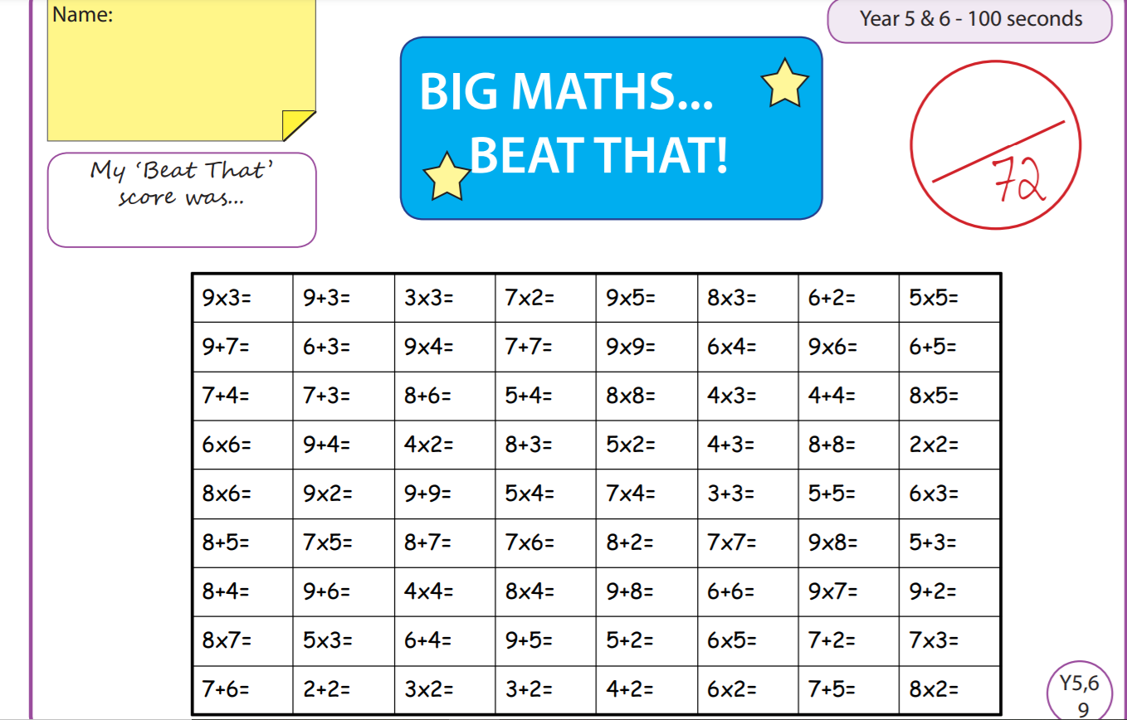

Tuesday
Time and Subject | Learning Objective | Task/Link/Resources
8.45-9.00  Reading | L.O: To practise and consolidate existing reading skills. | Read your individual reading book, either in your head or out loud.
9.00-9.15  Morning Maths | LO: To consolidate recall of number facts. | Complete today’s Beat That. You will find today’s Beat That below today’s timetable. Just scroll down! Remember, it is the same one every day for a week so try and beat your score each time!
9.15-9.45  Spelling | LO: To practice Unit Five RWI Spelling words. | Speed write this week’s words- time yourself a minute for each! Check them and correct any mistakes. Write them in different colours or fancy writing, make yourself a poster of each of the words! Circle the consonants and vowels.  Week 9 – adorably comfortably considerably credibly horribly incredibly miserably
9.45-10.00  Active break | L.O: To boost my concentration through movement. | Join in:  https://www.youtube.com/watch?v=oaDJWH4OOjQ
10.00-11.00  English | LO: To answer retrieval questions. | Have a go at today’s lesson by clicking on the link below:  https://classroom.thenational.academy/lessons/to-answer-retrieval-questions-6gv32c
11.00- 11.15
Break
11.15-12.15  Maths | LO: To understand equivalent fractions. | Have a go at today’s lesson by clicking on the link below:  https://classroom.thenational.academy/lessons/understanding-fractions-equivalent-fractions-chh6cd
12.15-1.00
Dinner
1.00-1.15  Storytime | LO: To listen to a story for pleasure. | Continue listening to The Adventures of Alice in Wonderland, remember where you got up to for next time:  https://stories.audible.com/pdp/B015D78L0U?ref=adbl_ent_anon_ds_pdp_pc_cntr-3-2
1.15-2.30  Topic  RE | LO: To plan and write an essay about Buddhism. | Have a go at today’s lesson by clicking on the link below:  https://classroom.thenational.academy/lessons/to-plan-and-write-an-essay-about-buddhism-part-2-61h62c
2.30-3.00  RHE | LO: To understand how to keep safe on the roads on a bike. | Have a go at today’s lesson by clicking on the link below:  https://classroom.thenational.academy/lessons/king-of-the-road-6mu36t

Wednesday
Time and Subject | Learning Objective | Task/Link/Resources
8.45-9.00  Reading | L.O: To practise and consolidate existing reading skills. | Read your individual reading book, either in your head or out loud.
9.00-9.15  Morning Maths | LO: To consolidate recall of number facts. | Complete today’s Beat That. You will find today’s Beat That below today’s timetable. Just scroll down! Remember, it is the same one every day for a week so try and beat your score each time!
9.15-9.45  Spelling | LO: To practice Unit Five RWI Spelling words. | Speed write this week’s words- time yourself a minute for each! Check them and correct any mistakes. Write them in different colours or fancy writing, make yourself a poster of each of the words! Circle the consonants and vowels.  Week 9 – adorably comfortably considerably credibly horribly incredibly miserably
9.45-10.00  Active break | L.O: To boost my concentration through movement. | Join in:  https://www.youtube.com/watch?v=ZQpMUs4EMv8
10.00-11.00  English | LO: To answer language questions part one. | Have a go at today’s lesson by clicking on the links below:  https://classroom.thenational.academy/lessons/to-answer-language-questions-part-1-6hhkec
11.00- 11.15
Break
11.15-12.15  Maths | LO: To add and subtract fractions with the same denominator. | Have a go at today’s lesson by clicking on the link below:  https://classroom.thenational.academy/lessons/add-and-subtract-fractions-with-the-same-denominator-6nk3jc
12.15-1.00
Dinner
1.00-1.15  Storytime | LO: To listen to a story for pleasure. | Continue listening to The Adventures of Alice in Wonderland, remember where you got up to for next time:  https://stories.audible.com/pdp/B015D78L0U?ref=adbl_ent_anon_ds_pdp_pc_cntr-3-2
1.15-2.30  Topic  RE | LO: To learn how to improve my essay. | Have a go at today’s lesson by clicking on the link below:  https://classroom.thenational.academy/lessons/can-i-improve-my-essay-cmr6ac
2.30-3.00  Music | LO: To enhance a performance using sound sources at home. | Have a go at today’s lesson by clicking on the link below:  https://classroom.thenational.academy/lessons/to-enhance-a-performance-using-sound-sources-at-home-c4tk2r
Thursday
Time and Subject | Learning Objective | Task/Link/Resources
8.45-9.00  Reading | L.O: To practise and consolidate existing reading skills. | Read your individual reading book, either in your head or out loud.
9.00-9.15  Morning Maths | LO: To consolidate recall of number facts. | Complete today’s Beat That. You will find today’s Beat That below today’s timetable. Just scroll down! Remember, it is the same one every day for a week so try and beat your score each time!
9.15-9.45  Spelling | LO: To practice Unit Five RWI Spelling words. | Speed write this week’s words- time yourself a minute for each! Check them and correct any mistakes. Write them in different colours or fancy writing, make yourself a poster of each of the words! Circle the consonants and vowels.  Week 9 – adorably comfortably considerably credibly horribly incredibly miserably
9.45-10.00  Active break | L.O: To boost my concentration through movement. | Join in:  https://www.youtube.com/watch?v=15oltV2mPu4
10.00-11.00  English | LO: To answer language questions part two. | Have a go at today’s lesson by clicking on the link below:  https://classroom.thenational.academy/lessons/to-answer-language-questions-part-2-64wk0c
11.00- 11.15
Break
11.15-12.15  Maths | LO: To add and subtract fractions with a common denominator. | Have a go at today’s lesson by clicking on the link below:  https://classroom.thenational.academy/lessons/add-and-subtract-fractions-with-a-common-denominator-68vpae
12.15-1.00
Dinner
1.00-1.15  Storytime | LO: To listen to a story for pleasure. | Continue listening to The Adventures of Alice in Wonderland, remember where you got up to for next time:  https://stories.audible.com/pdp/B015D78L0U?ref=adbl_ent_anon_ds_pdp_pc_cntr-3-2
1.15-2.30  Topic  Geography | LO: To learn what sustainability is. | Have a go at today’s lesson by clicking on the link below:  https://classroom.thenational.academy/lessons/what-is-sustainability-65gkar
2.30-3.00  French | LO: To develop vocabulary. | Follow the link:  https://www.bbc.co.uk/teach/class-clips-video/french-ks2-days-of-the-week/zv2jmfr
Friday
Time and Subject | Learning Objective | Task/Link/Resources
8.45-9.00  Reading | L.O: To practise and consolidate existing reading skills. | Read your individual reading book, either in your head or out loud.
9.00-9.15  Morning Maths | LO: To consolidate recall of number facts. | Complete today’s Beat That. You will find today’s Beat That below today’s timetable. Just scroll down! Remember, it is the same one every day for a week so try and beat your score each time!
9.15-9.45  Spelling | LO: To practice Unit Five RWI Spelling words. | Speed write this week’s words- time yourself a minute for each! Check them and correct any mistakes. Write them in different colours or fancy writing, make yourself a poster of each of the words! Circle the consonants and vowels.  Week 9 – adorably comfortably considerably credibly horribly incredibly miserably  Test yourself using the Look, Cover, Say, Write and Check grid below!
9.45-10.00  Active break | L.O: To boost my concentration through movement. | Join in:  https://www.youtube.com/watch?v=fgQOGORKG5I
10.00-11.00  English | LO: To make inference based on a text. | Have a go at today’s lesson by clicking on the link below:  https://classroom.thenational.academy/lessons/to-make-inferences-based-on-a-text-70r3ad
11.00- 11.15
Break
11.15-12.15  Maths | LO: To add and subtract improper fractions with a common denominator. | Have a go at today’s lesson by clicking on the link below:  https://classroom.thenational.academy/lessons/add-and-subtract-fractions-with-a-common-denominator-improper-fractions-6cw62d
12.15-1.00
Dinner
1.00-1.15  Storytime | LO: To listen to a story for pleasure. | Continue listening to The Adventures of Alice in Wonderland, remember where you got up to for next time:  https://stories.audible.com/pdp/B015D78L0U?ref=adbl_ent_anon_ds_pdp_pc_cntr-3-2
1.15-3:00  Golden Time Art | LO: To practise drawing skills. | Enjoy today’s session using the link below:  https://www.youtube.com/user/ArtforKidsHub
