Monday
Time and Subject | Learning Objective | Task/Link/Resources
8.45-9.00  Reading | L.O: To practise and consolidate existing reading skills. | Read your individual reading book, either in your head or out loud.
9.00-9.15  Morning Maths | LO: To consolidate recall of number facts.  Revision LO: To compare and order fractions less than one. | Complete today’s Beat That. You will find today’s Beat That below today’s timetable. Just scroll down! Remember, it is the same one every day for a week so try and beat your score each time!  We use Morning Maths as a time to revise concepts and keep them at the front of our minds- follow this link to compare and order fractions less than one. Use the fourth video on the link below, click on Summer Term Week 4:  https://whiterosemaths.com/homelearning/summer-archive/year-5/
9.15-9.45  Spelling | LO: To practice Unit Seven RWI Spelling words. | Speed write this week’s words- time yourself a minute for each! Check them and correct any mistakes. Write them in different colours or fancy writing, make yourself a poster of each of the words! Circle the consonants and vowels.  Impressed, impress, impression, permission, possession, profession, progression, revision, tension, revision.
9.45-10.00  Active break | L.O: To boost my concentration through movement. | Join in:  https://www.youtube.com/watch?v=DS8yeXFeEPA
10.00-11.00  English | LO: To explore fronted adverbials. | Have a go at today’s lesson by clicking on the link below:  https://classroom.thenational.academy/lessons/to-explore-fronted-adverbials-71h64t
11.00- 11.15
Break
11.15-12.15  Maths | LO: To understand decimal and fraction equivalence. | Have a go at today’s lesson by clicking on the link below:  https://classroom.thenational.academy/lessons/decimal-and-fraction-equivalence-cngk8r
12.15-1.00
Dinner
1.00-1.15  Storytime | LO: To listen to a story for pleasure. | For the next four weeks we are listening to Hyperspace High Crash Landing, remember where you get up to each day:  https://stories.audible.com/pdp/B00FL4S5FC?ref=adbl_ent_anon_ds_pdp_pc_cntr-4-4
1.15-3.00  PE | LO: To develop fitness and learn a dance sequence. | Have a go at today’s lesson by clicking on the links below:  https://www.youtube.com/watch?v=lc1Ag9m7XQo  https://www.youtube.com/watch?v=btD_HCO1FT4
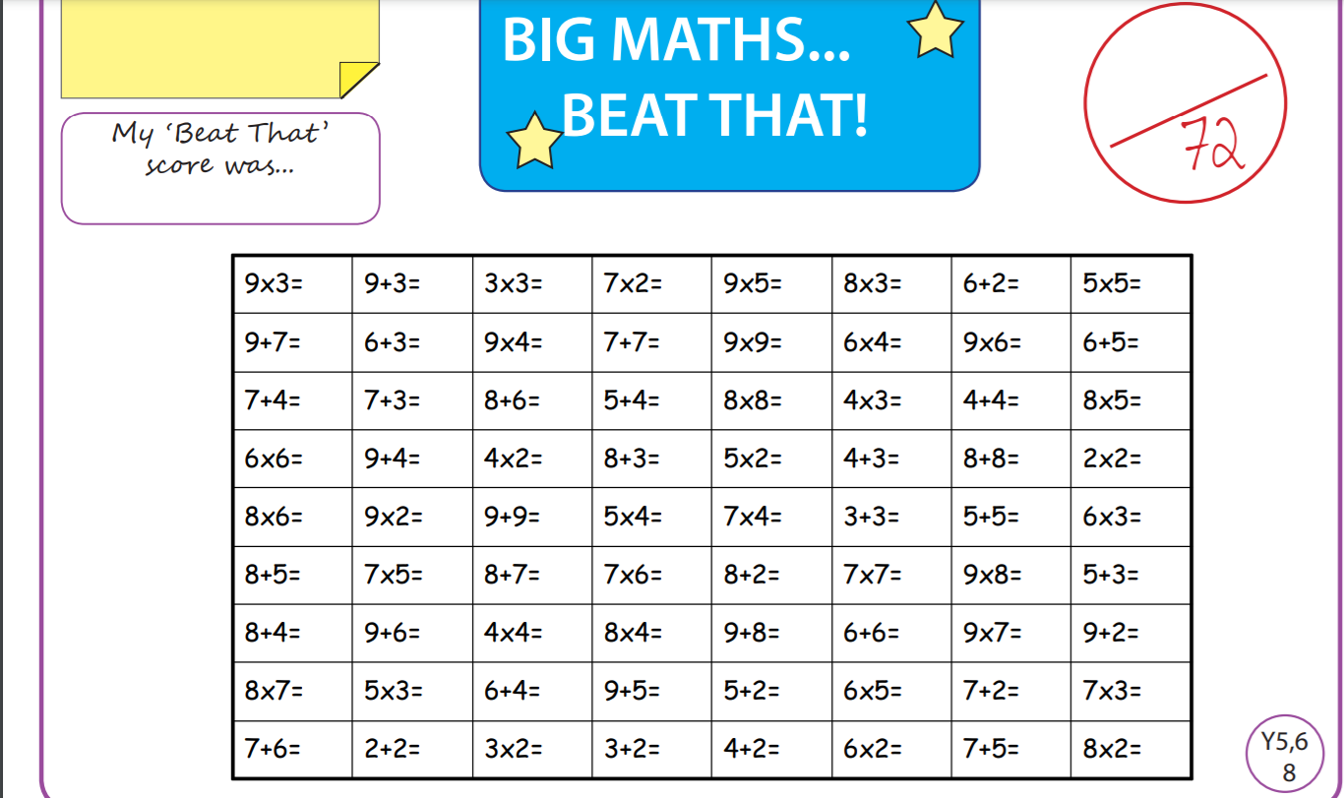
Tuesday
Time and Subject | Learning Objective | Task/Link/Resources
8.45-9.00  Reading | L.O: To practise and consolidate existing reading skills. | Read your individual reading book, either in your head or out loud.
9.00-9.15  Morning Maths | LO: To consolidate recall of number facts.  Revision LO: To add and subtract fractions. | Complete today’s Beat That. You will find today’s Beat That below today’s timetable. Just scroll down! Remember, it is the same one every day for a week so try and beat your score each time!  We use Morning Maths as a time to revise concepts and keep them at the front of our minds- follow this link to add and subtract fractions. Use the first video on the link below, click on Summer Term Week 5:  https://whiterosemaths.com/homelearning/summer-archive/year-5/
9.15-9.45  Spelling | LO: To practice Unit Seven RWI Spelling words. | Speed write this week’s words- time yourself a minute for each! Check them and correct any mistakes. Write them in different colours or fancy writing, make yourself a poster of each of the words! Circle the consonants and vowels.  Impressed, impress, impression, permission, possession, profession, progression, revision, tension, revision.
9.45-10.00  Active break | L.O: To boost my concentration through movement. | Join in:  https://www.youtube.com/watch?v=t8e4Xtr5_W0
10.00-11.00  English | LO: To practise and apply knowledge of suffixes and plurals, including a test. | Have a go at today’s lesson by clicking on the link below:  https://classroom.thenational.academy/lessons/to-practise-and-apply-knowledge-of-suffixes-plurals-including-test-c8u3jd
11.00- 11.15
Break
11.15-12.15  Maths | LO: To understand decimal equivalents of fractions. | Have a go at today’s lesson by clicking on the link below:  https://classroom.thenational.academy/lessons/decimal-equivalents-of-fractions-cnh32r
12.15-1.00
Dinner
1.00-1.15  Storytime | LO: To listen to a story for pleasure. | For the next four weeks we are listening to Hyperspace High Crash Landing, remember where you get up to each day:  https://stories.audible.com/pdp/B00FL4S5FC?ref=adbl_ent_anon_ds_pdp_pc_cntr-4-4
1.15-2.30  Topic  RE | LO: To write an essay about humanism. | Have a go at today’s RE lesson by clicking on the link below:  https://classroom.thenational.academy/lessons/can-i-write-an-essay-about-humanism-69gkad
2.30-3.00  RHE | LO: To learn about hazards in the home. | Have a go at today’s lesson by clicking on the link below:  https://classroom.thenational.academy/lessons/hazards-in-the-home-6mt68c
Wednesday

Time and Subject | Learning Objective | Task/Link/Resources
8.45-9.00  Reading | L.O: To practise and consolidate existing reading skills. | Read your individual reading book, either in your head or out loud.
9.00-9.15  Morning Maths | LO: To consolidate recall of number facts.  Revision LO: To add fractions. | Complete today’s Beat That. You will find today’s Beat That below today’s timetable. Just scroll down! Remember, it is the same one every day for a week so try and beat your score each time!  We use Morning Maths as a time to revise concepts and keep them at the front of our minds- follow this link to add fractions, use the second video on the link below, click on Summer Term Week 5:  https://whiterosemaths.com/homelearning/summer-archive/year-5/
9.15-9.45  Spelling | LO: To practice Unit Seven RWI Spelling words. | Speed write this week’s words- time yourself a minute for each! Check them and correct any mistakes. Write them in different colours or fancy writing, make yourself a poster of each of the words! Circle the consonants and vowels.  Impressed, impress, impression, permission, possession, profession, progression, revision, tension, revision.
9.45-10.00  Active break | L.O: To boost my concentration through movement. | Join in:  https://www.youtube.com/watch?v=KhfkYzUwYFk
10.00-11.00  English | LO: To write the opening of a diary entry. | Have a go at today’s lesson by clicking on the link below:  https://classroom.thenational.academy/lessons/to-write-the-opening-of-a-diary-entry-cmt3er
11.00- 11.15
Break
11.15-12.15  Maths | LO: To add fractions. | Have a go at today’s lesson by clicking on the link below:  https://classroom.thenational.academy/lessons/add-fractions-cnk3ar
12.15-1.00
Dinner
1.00-1.15  Storytime | LO: To listen to a story for pleasure. | For the next four weeks we are listening to Hyperspace High Crash Landing, remember where you get up to each day:  https://stories.audible.com/pdp/B00FL4S5FC?ref=adbl_ent_anon_ds_pdp_pc_cntr-4-4
1.15-2.30  Topic  RE | LO: To finish writing your essay about humanism. | Finish your essay about humanism that we started yesterday.
2.30-3.00  Music | LO: To explore chords. | Have a go at today’s lesson by clicking on the link below:  https://classroom.thenational.academy/lessons/to-explore-chords-75gp6r
Thursday
Time and Subject | Learning Objective | Task/Link/Resources
8.45-9.00  Reading | L.O: To practise and consolidate existing reading skills. | Read your individual reading book, either in your head or out loud.
9.00-9.15  Morning Maths | LO: To consolidate recall of number facts.  Revision LO: To add mixed numbers. | Complete today’s Beat That. You will find today’s Beat That below today’s timetable. Just scroll down! Remember, it is the same one every day for a week so try and beat your score each time!  We use Morning Maths as a time to revise concepts and keep them at the front of our minds- follow this link to add mixed numbers, use the third video on the link below, click on Summer Term Week 5:  https://whiterosemaths.com/homelearning/summer-archive/year-5/
9.15-9.45  Spelling | LO: To practice Unit Seven RWI Spelling words. | Speed write this week’s words- time yourself a minute for each! Check them and correct any mistakes. Write them in different colours or fancy writing, make yourself a poster of each of the words! Circle the consonants and vowels.  Impressed, impress, impression, permission, possession, profession, progression, revision, tension, revision.
9.45-10.00  Active break | L.O: To boost my concentration through movement. | Join in:  https://www.youtube.com/watch?v=mkjvAKPFNJ4
10.00-11.00  English | LO: To plan the main body of my diary entry. | Have a go at today’s lesson by clicking on the link below:  https://classroom.thenational.academy/lessons/to-plan-the-main-body-of-my-diary-entry-74v3jd
11.00- 11.15
Break
11.15-12.15  Maths | LO: To subtract fractions. | Have a go at today’s lesson by clicking on the link below:  https://classroom.thenational.academy/lessons/subtract-fractions-6hh66r
12.15-1.00
Dinner
1.00-1.15  Storytime | LO: To listen to a story for pleasure. | For the next four weeks we are listening to Hyperspace High Crash Landing, remember where you get up to each day:  https://stories.audible.com/pdp/B00FL4S5FC?ref=adbl_ent_anon_ds_pdp_pc_cntr-4-4
1.15-2.30  Topic  RE | LO: To make improvements to my essay about humanism. | Have a go at today’s RE lesson by clicking on the link below:  https://classroom.thenational.academy/lessons/can-i-improve-my-essay-about-humanism-69jk0c
2.30-3.00  French | LO: To develop vocabulary. | Follow the link:  https://www.bbc.co.uk/teach/class-clips-video/french-ks2-clothes-and-colours/zkhxpg8
Friday
Time and Subject | Learning Objective | Task/Link/Resources
8.45-9.00  Reading | L.O: To practise and consolidate existing reading skills. | Read your individual reading book, either in your head or out loud.
9.00-9.15  Morning Maths | LO: To consolidate recall of number facts.  Revision LO: To subtract mixed numbers. | Complete today’s Beat That. You will find today’s Beat That below today’s timetable. Just scroll down! Remember, it is the same one every day for a week so try and beat your score each time!  We use Morning Maths as a time to revise concepts and keep them at the front of our minds- follow this link to subtract mixed numbers, use the fourth video on the link below, click on Summer Term Week 5:  https://whiterosemaths.com/homelearning/summer-archive/year-5/
9.15-9.45  Spelling | LO: To practice Unit Seven RWI Spelling words. | Speed write this week’s words- time yourself a minute for each! Check them and correct any mistakes. Write them in different colours or fancy writing, make yourself a poster of each of the words! Circle the consonants and vowels.  Impressed, impress, impression, permission, possession, profession, progression, revision, tension, revision.  Test yourself using the Look, Say, Cover, Write, Check grid at the very bottom of the week.
9.45-10.00  Active break | L.O: To boost my concentration through movement. | Join in:  https://www.youtube.com/watch?v=jBidsDA410s
10.00-11.00  English | LO: To write the main body of the diary entry. | Have a go at today’s lesson by clicking on the link below:  https://classroom.thenational.academy/lessons/to-write-the-main-body-of-a-diary-entry-69h64r
11.00- 11.15
Break
11.15-12.15  Maths | LO: To problem solve using fractions. | Have a go at today’s lesson by clicking on the link below:  https://classroom.thenational.academy/lessons/fractions-problem-solving-c9k38d
12.15-1.00
Dinner
1.00-1.15  Storytime | LO: To listen to a story for pleasure. | For the next four weeks we are listening to Hyperspace High Crash Landing, remember where you get up to each day:  https://stories.audible.com/pdp/B00FL4S5FC?ref=adbl_ent_anon_ds_pdp_pc_cntr-4-4
1.15-3.00  Golden Time Art | LO: To learn how to draw an animal. | Enjoy today’s session using the link below:  https://youtu.be/IWs9lo1piOY
