Time and Subject | Learning Objective | Task/Link/Resources
8.45-9.00  Reading | L.O: To practise and consolidate existing reading skills. | Read your individual reading book, either in your head or out loud.
9.00-9.15  Morning Maths | LO: To consolidate recall of number facts. | Complete today’s Beat That. You will find today’s Beat That below today’s timetable. Just scroll down! Remember, it is the same one every day for a week so try and beat your score each time!
9.15-9.45  Spelling | LO: To practice Unit Four RWI Spelling words. | Speed write this week’s words- time yourself a minute for each! Check them and correct any mistakes. Write them in different colours or fancy writing, make yourself a poster of each of the words! Circle the consonants and vowels.  Week 8 – thistle castle glisten jostle hustle fasten bustle
9.45-10.00  Active break | L.O: To boost my concentration through movement. | Join in:  https://www.youtube.com/watch?v=DS8yeXFeEPA
10.00-11.00  English | LO: To plan a biography. | Have a go at today’s lesson by clicking on the link below:  https://classroom.thenational.academy/lessons/to-plan-a-biography-c8wp6d
11.00- 11.15
Break
11.15-12.15  Maths | LO: To order and compare decimals up to 3 decimal places. | Have a go at today’s lesson by clicking on the link below:  https://classroom.thenational.academy/lessons/comparing-and-ordering-ccwk0r
12.15-1.00
Dinner
1.00-1.15  Storytime | LO: To listen to a story for pleasure. | Continue listening to Anne of Green Gables, remember where you get up to for next time:  https://stories.audible.com/pdp/B01KGL13FI?ref=adbl_ent_anon_ds_pdp_pc_cntr-3-3
1.15-2.30  PE | LO: To develop fitness and learn a dance sequence. | Have a go at today’s lesson by clicking on the links below:  https://www.youtube.com/watch?v=lc1Ag9m7XQo  https://www.youtube.com/watch?v=btD_HCO1FT4
Monday
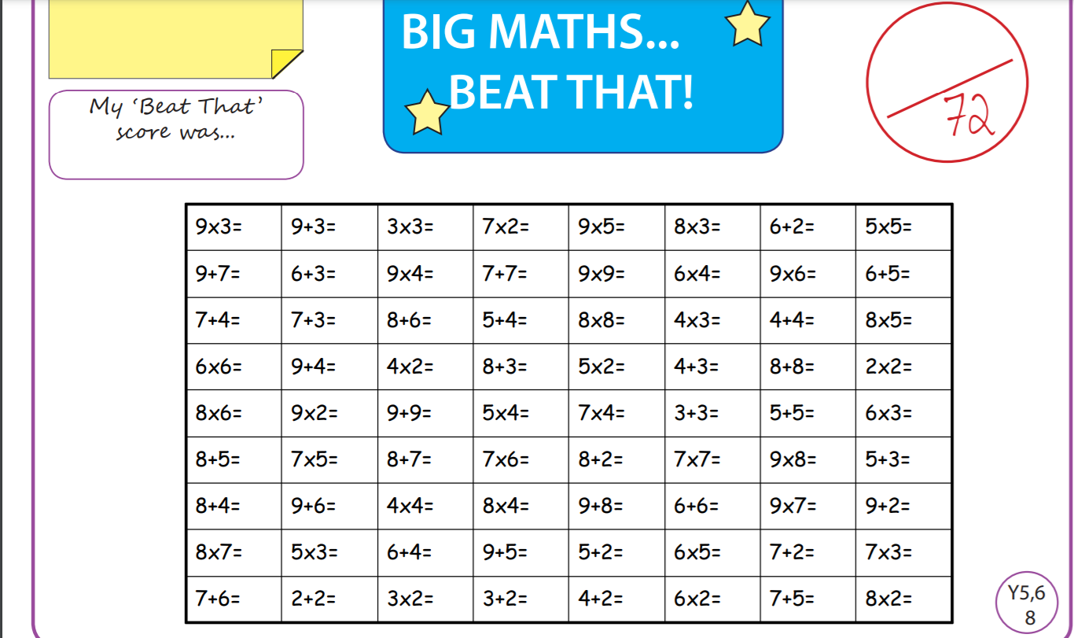

Tuesday
Time and Subject | Learning Objective | Task/Link/Resources
8.45-9.00  Reading | L.O: To practise and consolidate existing reading skills. | Read your individual reading book, either in your head or out loud.
9.00-9.15  Morning Maths | LO: To consolidate recall of number facts. | Complete today’s Beat That. You will find today’s Beat That below today’s timetable. Just scroll down! Remember, it is the same one every day for a week so try and beat your score each time!
9.15-9.45  Spelling | LO: To practice Unit Four RWI Spelling words. | Speed write this week’s words- time yourself a minute for each! Check them and correct any mistakes. Write them in different colours or fancy writing, make yourself a poster of each of the words! Circle the consonants and vowels.  Week 8 – thistle castle glisten jostle hustle fasten bustle
9.45-10.00  Active break | L.O: To boost my concentration through movement. | Join in:  https://www.youtube.com/watch?v=t8e4Xtr5_W0
10.00-11.00  English | LO: To practise and apply knowledge of unstressed vowels in polysyllabic words including test. | Have a go at today’s lesson by clicking on the link below:  https://classroom.thenational.academy/lessons/to-practise-and-apply-knowledge-of-unstressed-vowels-in-polysyllabic-words-including-test-6gvk6c
11.00- 11.15
Break
11.15-12.15  Maths | LO: To round decimals with two decimal places to the nearest whole number. | Have a go at today’s lesson by clicking on the link below:  https://classroom.thenational.academy/lessons/rounding-decimals-part-1-70r6at
12.15-1.00
Dinner
1.00-1.15  Storytime | LO: To listen to a story for pleasure. | Continue listening to Anne of Green Gables, remember where you get up to for next time:  https://stories.audible.com/pdp/B01KGL13FI?ref=adbl_ent_anon_ds_pdp_pc_cntr-3-3
1.15-2.30  Topic  RE | LO: To learn about Buddhist monks and nuns. | Have a go at today’s lesson by clicking on the lesson below:  https://classroom.thenational.academy/lessons/what-is-life-like-inside-a-buddhist-monastery-75hket
2.30-3.00  RHE | LO: To identify hazards in the home to keep us safe. | Have a go at today’s lesson by clicking on the link below:  https://classroom.thenational.academy/lessons/hazards-in-the-home-6mt68c
Wednesday
Time and Subject | Learning Objective | Task/Link/Resources
8.45-9.00  Reading | L.O: To practise and consolidate existing reading skills. | Read your individual reading book, either in your head or out loud.
9.00-9.15  Morning Maths | LO: To consolidate recall of number facts. | Complete today’s Beat That. You will find today’s Beat That below today’s timetable. Just scroll down! Remember, it is the same one every day for a week so try and beat your score each time!
9.15-9.45  Spelling | LO: To practice Unit Four RWI Spelling words. | Speed write this week’s words- time yourself a minute for each! Check them and correct any mistakes. Write them in different colours or fancy writing, make yourself a poster of each of the words! Circle the consonants and vowels.  Week 8 – thistle castle glisten jostle hustle fasten bustle
9.45-10.00  Active break | L.O: To boost my concentration through movement. | Join in:  https://www.youtube.com/watch?v=KhfkYzUwYFk
10.00-11.00  English | LO: To write a biography part one. | Have a go at today’s lesson by clicking on the link below:  https://classroom.thenational.academy/lessons/to-write-a-biography-part-1-cmwkgr
11.00- 11.15
Break
11.15-12.15  Maths | LO: To round decimals to one decimal place. | Have a go at today’s lesson by clicking on the link below:  https://classroom.thenational.academy/lessons/rounding-decimals-part-2-74rkgc
12.15-1.00
Dinner
1.00-1.15  Storytime | LO: To listen to a story for pleasure. | Continue listening to Anne of Green Gables, remember where you get up to for next time:  https://stories.audible.com/pdp/B01KGL13FI?ref=adbl_ent_anon_ds_pdp_pc_cntr-3-3
1.15-2.30  Topic  RE | LO: To learn who the Dalai Lama is. | Have a go at today’s lesson by clicking on the link below:  https://classroom.thenational.academy/lessons/who-is-the-dalai-lama-74vkar
2.30-3.00  Music | LO: To imitate world percussion using sound sources found in the home. | Have a go at today’s lesson by clicking on the link below:  https://classroom.thenational.academy/lessons/to-imitate-world-percussion-using-sound-sources-found-in-the-home-c5gk4c
Thursday
Time and Subject | Learning Objective | Task/Link/Resources
8.45-9.00  Reading | L.O: To practise and consolidate existing reading skills. | Read your individual reading book, either in your head or out loud.
9.00-9.15  Morning Maths | LO: To consolidate recall of number facts. | Complete today’s Beat That. You will find today’s Beat That below today’s timetable. Just scroll down! Remember, it is the same one every day for a week so try and beat your score each time!
9.15-9.45  Spelling | LO: To practice Unit Four RWI Spelling words. | Speed write this week’s words- time yourself a minute for each! Check them and correct any mistakes. Write them in different colours or fancy writing, make yourself a poster of each of the words! Circle the consonants and vowels.  Week 8 – thistle castle glisten jostle hustle fasten bustle
9.45-10.00  Active break | L.O: To boost my concentration through movement. | Join in:  https://www.youtube.com/watch?v=mkjvAKPFNJ4
10.00-11.00  English | LO: To write a biography part two. | Have a go at today’s lesson by clicking on the link below:  https://classroom.thenational.academy/lessons/to-write-a-biography-part-2-6njpad
11.00- 11.15
Break
11.15-12.15  Maths | LO: To understand the link between fractions and division. | Have a go at today’s lesson by clicking on the link below:  https://classroom.thenational.academy/lessons/fractions-and-division-part-1-64u32d
12.15-1.00
Dinner
1.00-1.15  Storytime | LO: To listen to a story for pleasure. | Continue listening to Anne of Green Gables, remember where you get up to for next time:  https://stories.audible.com/pdp/B01KGL13FI?ref=adbl_ent_anon_ds_pdp_pc_cntr-3-3
1.15-2.30  Topic  RE | LO: To plan and write an essay about Buddhism. | Have a go at today’s lesson by clicking on the link below:  https://classroom.thenational.academy/lessons/to-plan-and-write-an-essay-about-buddhism-part-1-74rk6t
2.30-3.00  French | LO: To develop vocabulary. | Follow the link:  https://www.bbc.co.uk/teach/class-clips-video/french-ks2-clothes-and-colours/zkhxpg8
Friday
Time and Subject | Learning Objective | Task/Link/Resources
8.45-9.00  Reading | L.O: To practise and consolidate existing reading skills. | Read your individual reading book, either in your head or out loud.
9.00-9.15  Morning Maths | LO: To consolidate recall of number facts. | Complete today’s Beat That. You will find today’s Beat That below today’s timetable. Just scroll down! Remember, it is the same one every day for a week so try and beat your score each time!
9.15-9.45  Spelling | LO: To practice Unit Four RWI Spelling words. | Speed write this week’s words- time yourself a minute for each! Check them and correct any mistakes. Write them in different colours or fancy writing, make yourself a poster of each of the words! Circle the consonants and vowels.  Week 8 – thistle castle glisten jostle hustle fasten bustle  Test yourself using the Look, Cover, Say, Write and Check grid below.
9.45-10.00  Active break | L.O: To boost my concentration through movement. | Join in:  https://www.youtube.com/watch?v=jBidsDA410s
10.00-11.00  English | LO: | Have a go at today’s lesson by clicking on the link below:  https://classroom.thenational.academy/lessons/to-edit-a-biography-ctj32c
11.00- 11.15
Break
11.15-12.15  Maths | LO: To use short division to understand the link between fractions and division. | Have a go at today’s lesson by clicking on the link below:  https://classroom.thenational.academy/lessons/fractions-and-division-part-2-6dgk4e
12.15-1.00
Dinner
1.00-1.15  Storytime | LO: To listen to a story for pleasure. | Finish listening to Anne of Green Gables, remember where you get up to for next time:  https://stories.audible.com/pdp/B01KGL13FI?ref=adbl_ent_anon_ds_pdp_pc_cntr-3-3
1.15-3:00  Golden Time Art | LO: To draw an animal. | Enjoy today’s session using the link below:  https://youtu.be/IWs9lo1piOY
