Time and Subject  Monday | Learning Objective | Task/Link/Resources
8.45-9.00  Reading | LO: To practise and consolidate existing reading skills. | Read your individual reading book, either in your head or out loud.
9.00-9.15  Morning Maths | LO: To consolidate recall of number facts.  Revision LO: To add fractions. | Complete today’s Beat That- scroll down below today’s timetable to find the questions. Remember, it is the same one every day for a week. Can you beat your own score?  Morning Maths: In Morning Maths today, you are going to revise your knowledge of fractions. Click the link below and select the video Add fractions.  https://whiterosemaths.com/homelearning/year-4/spring-week-7-number-fractions/
9.15-9.45  Spelling | LO: To revise important spelling rules. | This week, we are going to practise spelling words ending in ‘ture’. Watch this video to find out more about our spelling rule:  https://www.bbc.co.uk/bitesize/topics/zt62mnb/articles/z3jpk2p  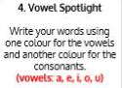  Use Vowel Spotlight to practise spelling this week’s words:  creature, nature, fixture, mixture, adventure, temperature, feature, departure, sculpture
9.45-10.00  Active break | LO: To boost my concentration through movement. | Join in with the Go Noodle clip below to get you moving!  Moose Tube Mash-Up - GoNoodle
10.00-11.00  English | SPaG Revision LO: To use apostrophes to contract and combine words.  LO: To plan a narrative climax. | For today’s SPaG Daily Practice, revise your knowledge of apostrophes. Watch the videos and complete activity 2.  Using apostrophes to contract and combine words - Year 4 and P5 - English - Catch Up Lesson - Home Learning with BBC Bitesize - BBC Bitesize  Follow the link below to have a go at today’s English lesson:  To plan a narrative climax (thenational.academy)
11.00- 11.15
Break
11.15-12.15  Maths | LO: To practise my recall of the 2 times table.  LO: To use and apply knowledge of the properties of 3D shapes. | Follow the link below to practise the 2 times table and get moving!  2 TIMES TABLE SONG - 2x TABLE ADVENTURE - YouTube  Follow the link below to have a go at today’s maths lesson:  Using and applying knowledge of the properties of 3D shapes (thenational.academy)
12.15-1.00
Dinner
1.00-1.15  Storytime | LO: To listen to a story for pleasure. | Listen to Chapter 13 of Mark Anchovy: Pizza Detective:  Mark Anchovy: Pizza Detective - World Book Day
1.15-3.00  Topic-Geography | LO: To identify the physical features of Europe. | Follow the link below to have a go at today’s lesson:  What are the physical features of Europe? (thenational.academy)

Beat That!
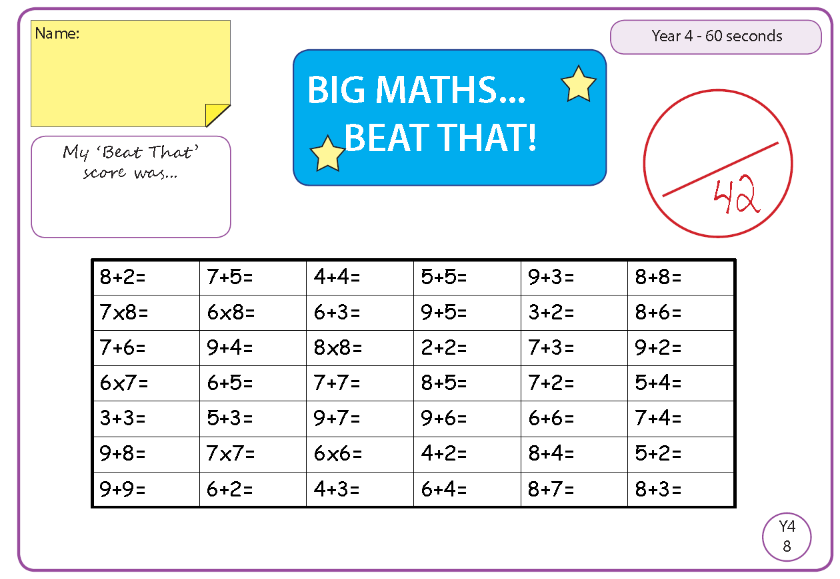

Time and Subject  Tuesday | Learning Objective | Task/Link/Resources
8.45-9.00  Reading | L.O: To practise and consolidate existing reading skills. | Read your individual reading book, either in your head or out loud.
9.00-9.15  Morning Maths | LO: To consolidate recall of number facts.  Revision LO: To add 2 or more fractions. | Complete today’s Beat That- scroll down below today’s timetable to find the questions. Remember, it is the same one every day for a week. Can you beat your own score?  Morning Maths: In Morning Maths today, you are going to revise your knowledge of fractions. Click the link below and select the video Add 2 or more fractions.  https://whiterosemaths.com/homelearning/year-4/spring-week-7-number-fractions/
9.15-9.45  Spelling | LO: To revise important spelling rules. | This week, we are going to practise words ending in ‘ture’.  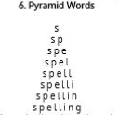  Use Pyramid Words to practise spelling this week’s words:  creature, nature, fixture, mixture, adventure, temperature, feature, departure, sculpture
9.45-10.00  Active break | L.O: To boost my concentration through movement. | Join in with the Go Noodle clip below to get you moving!  Get Energized - GoNoodle
10.00-11.00  English | SPaG Revision LO: To use apostrophes to contract and combine words.  LO: To write a narrative climax. | For today’s SPaG Daily Practice, revise your knowledge of apostrophes. Watch the videos and complete activity 3.  Using apostrophes to contract and combine words - Year 4 and P5 - English - Catch Up Lesson - Home Learning with BBC Bitesize - BBC Bitesize  Follow the link below to have a go at today’s English lesson:  To write a narrative climax (thenational.academy)
11.00- 11.15
Break
11.15-12.15  Maths | LO: To practise my recall of the 3 times table.  LO: To identify the properties of 3D shapes. | Follow the link below to practise the 3 times table and get moving!  3 TIMES TABLE SONG - 3x TABLE ADVENTURE - YouTube  Follow the link below to have a go at today’s maths lesson:  Identifying the properties of 3D shapes (thenational.academy)
12.15-1.00
Dinner
1.00-1.15  Storytime | LO: To listen to a story for pleasure. | Listen to Chapter 14 of Mark Anchovy: Pizza Detective:  Mark Anchovy: Pizza Detective - World Book Day
1.15-2.30  Topic- Geography | LO: To explore some of Europe’s most important human characteristics. | Follow the link below to have a go at today’s lesson:  What are some of Europe's most important human characteristics? (thenational.academy)
2.30-3.00  French | LO: To revise basic conversation in French. | Follow the link below to have a go at today’s lesson:  Learn French with Twinkl - YouTube

Beat That!
Time and Subject  Wednesday | Learning Objective | Task/Link/Resources
8.45-9.00  Reading | L.O: To practise and consolidate existing reading skills. | Read your individual reading book, either in your head or out loud.
9.00-9.15  Morning Maths | LO: To consolidate recall of number facts.  Revision LO: To subtract fractions. | Complete today’s Beat That- scroll down below today’s timetable to find the questions. Remember, it is the same one every day for a week. Can you beat your own score?  Morning Maths: In Morning Maths today, you are going to revise your knowledge of fractions. Click the link below and select the video To subtract fractions.  https://whiterosemaths.com/homelearning/year-4/spring-week-7-number-fractions/
9.15-9.45  Spelling | LO: To revise important spelling rules. | This week, we are going to practise words ending in ‘ture’.  Use Rainbow Words to practise spelling this week’s words:  creature, nature, fixture, mixture, adventure, temperature, feature, departure, sculpture
9.45-10.00  Active break | LO: To boost my concentration through movement. | Join in with the Go Noodle clip below to get you moving!  Take On The Day - GoNoodle
10.00-11.00  English | SPaG Revision LO: To use brackets.  LO: To plan a narrative resolution. | For today’s SPaG Daily Practice, revise your knowledge of brackets. Watch the videos and complete activity 1.  Using brackets - Year 4 - P5 - English - Catch Up Lessons - Home Learning with BBC Bitesize - BBC Bitesize  Follow the link below to have a go at today’s English lesson:  To plan a narrative resolution (thenational.academy)
11.00- 11.15
Break
11.15-12.15  Maths | LO: To practise my recall of the 4 times table.  LO: To identify the properties of constructed 3D shapes. | Follow the link below to practise the 4 times table and get moving!  4 TIMES TABLE SONG - 4x TABLE ADVENTURE - YouTube  Follow the link below to have a go at today’s maths lesson:  Identifying the properties of constructed 3-D shapes (thenational.academy)
12.15-1.00
Dinner
1.00-1.15  Storytime | LO: To listen to a story for pleasure. | Listen to Chapter 15 of Mark Anchovy: Pizza Detective:  Mark Anchovy: Pizza Detective - World Book Day
1.15-3.00  Topic- | LO: To understand what bullying is. | Follow the link below to have a go at today’s lesson:  Bullying (thenational.academy)

Beat That!
Time and Subject  Thursday | Learning Objective | Task/Link/Resources
8.45-9.00  Reading | L.O: To practise and consolidate existing reading skills. | Read your individual reading book, either in your head or out loud.
9.00-9.15  Morning Maths | LO: To consolidate recall of number facts.  Revision LO: To subtract 2 fractions. | Complete today’s Beat That- scroll down below today’s timetable to find the questions. Remember, it is the same one every day for a week. Can you beat your own score?  Morning Maths: In Morning Maths today, you are going to revise your knowledge of fractions. Click the link below and select the video Subtract 2 fractions.  https://whiterosemaths.com/homelearning/year-4/spring-week-7-number-fractions/
9.15-9.45  Spelling | LO: To revise important spelling rules. | This week, we are going to practise words ending in ‘ture’.  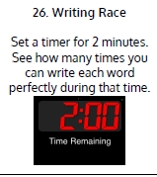  Use Writing Race to practise spelling this week’s words:  creature, nature, fixture, mixture, adventure, temperature, feature, departure, sculpture
9.45-10.00  Active break | LO: To boost my concentration through movement. | Join in with the Go Noodle clip below to get you moving!  Wake Up - Fresh Start Fitness | GoNoodle - YouTube
10.00-11.00  English | SPaG Revision LO: To use brackets.  LO: To write a narrative resolution. | For today’s SPaG Daily Practice, revise your knowledge of brackets. Watch the videos and complete activity 2.  Using brackets - Year 4 - P5 - English - Catch Up Lessons - Home Learning with BBC Bitesize - BBC Bitesize  Follow the link below to have a go at today’s English lesson:  To write a narrative resolution (thenational.academy)
11.00- 11.15
Break
11.15-12.15  Maths | LO: To practise my recall of the 5 times table.  LO: To problem solve using 2D representation of 3D shapes. | Follow the link below to practise the 5 times table and get moving!  5 TIMES TABLE SONG - 5x TABLE ADVENTURE - YouTube  Follow the link below to have a go at today’s lesson:  Problem solving using 2-D representations of 3-D shapes (thenational.academy)
12.15-1.00
Dinner
1.00-1.15  Storytime | LO: To listen to a story for pleasure. | Listen to Chapter 16 of Mark Anchovy: Pizza Detective:  Mark Anchovy: Pizza Detective - World Book Day
1.15-3.00  PE | LO: To practise and perform a dance. | Follow the link to have a go at today’s PE activity:  Masterclass on Bhangra and street fusion | Physical Education - Street Dance Masterclass - YouTube

Beat That!
Time and Subject  Friday | Learning Objective | Task/Link/Resources
8.45-9.00  Reading | L.O: To practise and consolidate existing reading skills. | Read your individual reading book, either in your head or out loud.
9.00-9.15  Morning Maths | LO: To consolidate recall of number facts.  Revision LO: To subtract from whole amounts. | Complete today’s Beat That- scroll down below today’s timetable to find the questions. Remember, it is the same one every day for a week. Can you beat your own score?  Morning Maths: In Morning Maths today, you are going to revise your knowledge of fractions. Click the link below and select the video Subtract from whole amounts.  https://whiterosemaths.com/homelearning/year-4/spring-week-7-number-fractions/
9.15-9.45  Spelling | LO: To revise important spelling rules. | This week, we are going to practise words ending in ‘ture’.  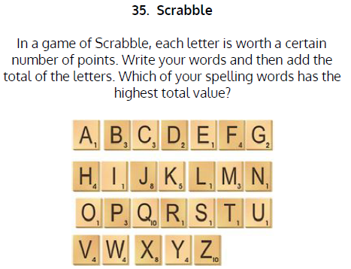  Use Scrabble to practise spelling this week’s words:  creature, nature, fixture, mixture, adventure, temperature, feature, departure, sculpture  Spelling Test:  Scroll down below today’s timetable to use the look, cover, write, check sheet to help you to test yourself on this week’s words.
9.45-10.00  Active break | L.O: To boost my concentration through movement. | Join in with the Go Noodle clip to get you moving!  Celebrate The New Day - GoNoodle
10.00-11.00  English | SPaG Revision LO: To use brackets.  LO: To develop reading for pleasure through book recommendations. | For today’s SPaG Daily Practice, revise your knowledge of brackets. Watch the videos and complete activity 3.  Using brackets - Year 4 - P5 - English - Catch Up Lessons - Home Learning with BBC Bitesize - BBC Bitesize  Follow the link below to have a go at today’s lesson:  To develop reading for pleasure through book recommendations (thenational.academy)
11.00- 11.15
Break
11.15-12.15  Maths | LO: To practise my recall of the 8 times table.  LO: To consolidate 3D shape learning. | Follow the link below to practise the 8 times table and get moving!  8 TIMES TABLE SONG - 8x TABLE ADVENTURE - YouTube  Follow the link below to have a go at today’s lesson:  Consolidating 3D shape learning (thenational.academy)
12.15-1.00
Dinner
1.00-1.15  Storytime | LO: To listen to a story for pleasure. | Listen to Chapter 17 of Mark Anchovy: Pizza Detective:  Mark Anchovy: Pizza Detective - World Book Day
1.15-3:00  Golden Time | LO: To practise mindfulness. | Have a go at this meditation:  Bring It Down - Flow | GoNoodle - YouTube  Have a go at this fun Yoga session:  Movie Night Kids Yoga! 🍿🎬 Yoga Club (Week 14) | Cosmic Kids - YouTube  You could also choose to complete the art activity below this week’s timetable.

Beat That!
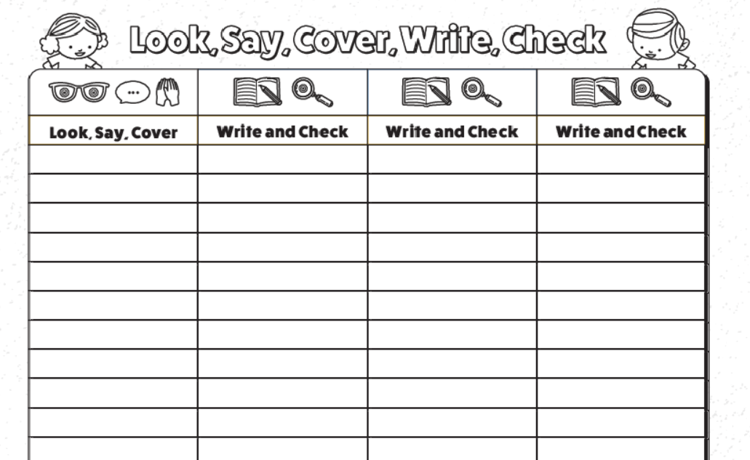
Spelling Test

I can reflect upon music from a different culture.
Today, we will be listening to Spanish because much of Gaudi’s work is situated in Barcelona. Barcelona is Spain. You can visit Gaudi’s work as it is still there.
A culture is a way of life and it shares basic behaviours. Cultures are usually things that have happened for many years in that country. Take a look at the video below and see if you can identify the activity that is part of Spanish culture.
https://www.youtube.com/watch?v=XNhfV_53W7A
Did you guess it? Flamenco
Now watch this second video. What are the similarities from the Spanish culture? Which music do you prefer?
https://www.youtube.com/watch?v=XNhfV_53W7A
