Time and Subject  Monday | Learning Objective | Task/Link/Resources
8.45-9.00  Reading | LO: To practise and consolidate existing reading skills. | Read your individual reading book, either in your head or out loud.
9.00-9.15  Morning Maths | LO: To consolidate recall of number facts.  Revision LO: To divide 2-digits by 1-digit. | Complete today’s Beat That- scroll down below today’s timetable to find the questions. Remember, it is the same one every day for a week. Can you beat your own score?  Morning Maths: In Morning Maths today, you are going to revise your knowledge of division. Click the link below and select the video Divide 2-digits by 1-digit (1).  Spring Week 2 - Number: Multiplication & Division | White Rose Maths
9.15-9.45  Spelling | LO: To revise important spelling rules. | This week, we are going to practise adding the suffix -es.  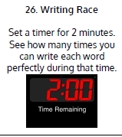  Use Writing Race to practise spelling this week’s words:  babies, carries, copies, families, cries, bodies, flies, fries, hobbies, ladies, multiplies, replies.
9.45-10.00  Active break | LO: To boost my concentration through movement. | Join in with the Go Noodle clip below to get you moving!  Moose Tube Mash-Up - GoNoodle
10.00-11.00  English | SPaG Revision LO: To use apostrophes for possession.  LO: To understand how to retrieve information from a text. | For today’s SPaG Daily Practice, revise your knowledge of using apostrophes to show ownership. Watch the video and complete activity 3.  Using apostrophes to show ownership - Year 3 - P4 - English - Catch Up Lessons - Home Learning with BBC Bitesize - BBC Bitesize  Follow the link below to have a go at today’s English lesson:  Reading skills: finding information - Year 3 - P4 - English - Catch Up Lesson - Home Learning with BBC Bitesize - BBC Bitesize
11.00- 11.15
Break
11.15-12.15  Maths | LO: To practise my recall of the 2 times table.  LO: To identify perpendicular lines. | Follow the link below to practise the 2 times table and get moving!  2 TIMES TABLE SONG - 2x TABLE ADVENTURE - YouTube  Follow the link below to have a go at today’s maths lesson:  To identify perpendicular lines (thenational.academy)
12.15-1.00
Dinner
1.00-1.15  Storytime | LO: To listen to a story for pleasure. | Listen to Chapter 13 of Mark Anchovy: Pizza Detective:  Mark Anchovy: Pizza Detective - World Book Day
1.15-3.00  Topic- Science | LO: To explore the difference between night and day. | Follow the link below to have a go at today’s lesson:  What is the difference between night and day? (thenational.academy)

Beat That!
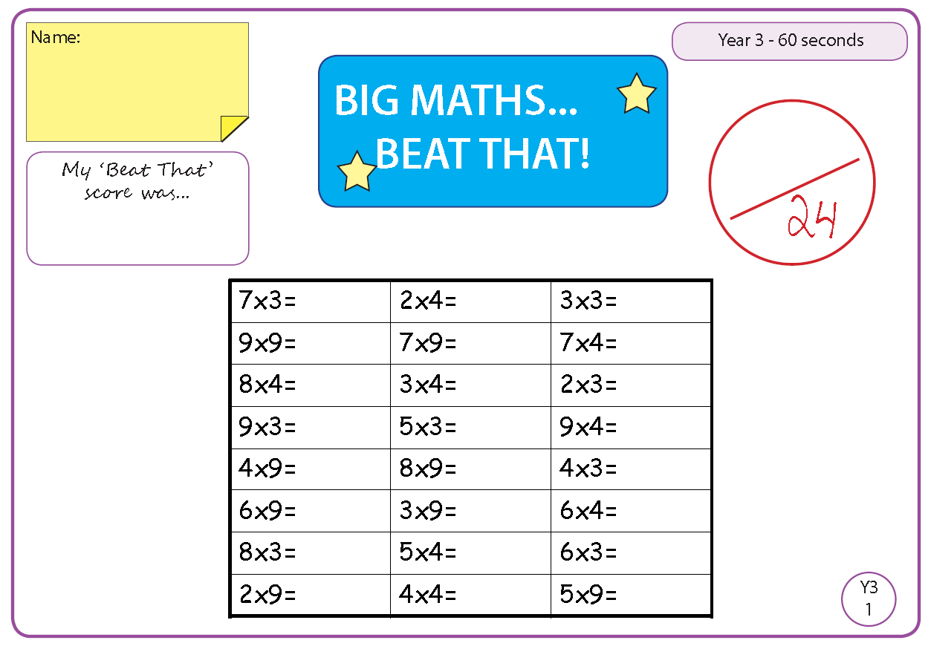

Time and Subject  Tuesday | Learning Objective | Task/Link/Resources
8.45-9.00  Reading | L.O: To practise and consolidate existing reading skills. | Read your individual reading book, either in your head or out loud.
9.00-9.15  Morning Maths | LO: To consolidate recall of number facts.  Revision LO: To divide 2-digits by 1-digit. | Complete today’s Beat That- scroll down below today’s timetable to find the questions. Remember, it is the same one every day for a week. Can you beat your own score?  Morning Maths: In Morning Maths today, you are going to revise your knowledge of division. Click the link below and select the video Divide 2-digits by 1-digit (2).  Spring Week 2 - Number: Multiplication & Division | White Rose Maths
9.15-9.45  Spelling | LO: To revise important spelling rules. | This week, we are going to practise adding the suffix -es.  Use Rainbow Words to practise spelling this week’s words:  babies, carries, copies, families, cries, bodies, flies, fries, hobbies, ladies, multiplies, replies.
9.45-10.00  Active break | L.O: To boost my concentration through movement. | Join in with the Go Noodle clip below to get you moving!  Get Energized - GoNoodle
10.00-11.00  English | SPaG Revision LO: To use apostrophes for contraction.  LO: To use inference. | For today’s SPaG Daily Practice, revise your knowledge of using apostrophes for contraction. Watch the video and complete activity 1.  Using apostrophes to contract and combine words - Year 3 - P4 - English - Catch Up Lessons - Home Learning with BBC Bitesize - BBC Bitesize  Follow the link below to have a go at today’s English lesson:  Using inference - Year 3 - P4 - English - Catch Up Lesson - Home Learning with BBC Bitesize - BBC Bitesize
11.00- 11.15
Break
11.15-12.15  Maths | LO: To practise my recall of the 3 times table.  LO: To draw perpendicular lines. | Follow the link below to practise the 3 times table and get moving!  3 TIMES TABLE SONG - 3x TABLE ADVENTURE - YouTube  Follow the link below to have a go at today’s maths lesson:  To draw perpendicular lines (thenational.academy)
12.15-1.00
Dinner
1.00-1.15  Storytime | LO: To listen to a story for pleasure. | Listen to Chapter 14 of Mark Anchovy: Pizza Detective:  Mark Anchovy: Pizza Detective - World Book Day
1.15-2.30  Topic- Science | LO: To investigate reflective and non-reflective materials. | Follow the link below to have a go at today’s lesson:  Which materials are reflective? (thenational.academy)
2.30-3.00  French | LO: To revise basic conversation in French. | Follow the link below to have a go at today’s lesson:  Learn French with Twinkl - YouTube

Beat That!

Time and Subject  Wednesday | Learning Objective | Task/Link/Resources
8.45-9.00  Reading | L.O: To practise and consolidate existing reading skills. | Read your individual reading book, either in your head or out loud.
9.00-9.15  Morning Maths | LO: To consolidate recall of number facts.  Revision LO: To divide 100 into 2, 4, 5 and 10 equal parts. | Complete today’s Beat That- scroll down below today’s timetable to find the questions. Remember, it is the same one every day for a week. Can you beat your own score?  Morning Maths: In Morning Maths today, you are going to revise your knowledge of division. Click the link below and select the video Divide 100 into 2, 4, 5 and 10 equal parts.  Spring Week 2 - Number: Multiplication & Division | White Rose Maths
9.15-9.45  Spelling | LO: To revise important spelling rules. | This week, we are going to practise adding the suffix -es.  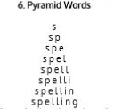  Use Pyramid Words to practise spelling this week’s words:  babies, carries, copies, families, cries, bodies, flies, fries, hobbies, ladies, multiplies, replies.
9.45-10.00  Active break | LO: To boost my concentration through movement. | Join in with the Go Noodle clip below to get you moving!  Take On The Day - GoNoodle
10.00-11.00  English | SPaG Revision LO: To use apostrophes for contraction.  LO: To practise prediction. | For today’s SPaG Daily Practice, revise your knowledge of using apostrophes for contraction. Watch the video and complete activity 2.  Using apostrophes to contract and combine words - Year 3 - P4 - English - Catch Up Lessons - Home Learning with BBC Bitesize - BBC Bitesize  Follow the link below to have a go at today’s English lesson:  Reading skills: Prediction - Year 3 - P4 - English - Catch Up Lessons - Home Learning with BBC Bitesize - BBC Bitesize
11.00- 11.15
Break
11.15-12.15  Maths | LO: To practise my recall of the 4 times table.  LO: To identify and explain parallel lines. | Follow the link below to practise the 4 times table and get moving!  4 TIMES TABLE SONG - 4x TABLE ADVENTURE - YouTube  Follow the link below to have a go at today’s maths lesson:  To identify and explain parallel lines (thenational.academy)
12.15-1.00
Dinner
1.00-1.15  Storytime | LO: To listen to a story for pleasure. | Listen to Chapter 15 of Mark Anchovy: Pizza Detective:  Mark Anchovy: Pizza Detective - World Book Day
1.15-3.00  Topic- Science | LO: To understand how shadows are formed. | Follow the link below to have a go at today’s lesson:  How are shadows formed? (thenational.academy)

Beat That!
Time and Subject  Thursday | Learning Objective | Task/Link/Resources
8.45-9.00  Reading | L.O: To practise and consolidate existing reading skills. | Read your individual reading book, either in your head or out loud.
9.00-9.15  Morning Maths | LO: To consolidate recall of number facts.  Revision LO: To divide with remainders. | Complete today’s Beat That- scroll down below today’s timetable to find the questions. Remember, it is the same one every day for a week. Can you beat your own score?  Morning Maths: In Morning Maths today, you are going to revise your knowledge of division. Click the link below and select the video Divide with remainders activity.  Spring Week 3 – Number: Multiplication & Division | White Rose Maths
9.15-9.45  Spelling | LO: To revise important spelling rules. | This week, we are going to practise adding the suffix -es.  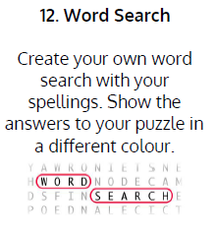  Use Word Search to practise spelling this week’s words:  babies, carries, copies, families, cries, bodies, flies, fries, hobbies, ladies, multiplies, replies.
9.45-10.00  Active break | LO: To boost my concentration through movement. | Join in with the Go Noodle clip below to get you moving!  Wake Up - Fresh Start Fitness | GoNoodle - YouTube
10.00-11.00  English | SPaG Revision LO: To use apostrophes for contraction.  LO: To answer questions about a text. | For today’s SPaG Daily Practice, revise your knowledge of using apostrophes for contraction. Watch the video and complete activity 3.  Using apostrophes to contract and combine words - Year 3 - P4 - English - Catch Up Lessons - Home Learning with BBC Bitesize - BBC Bitesize  Follow the link below to have a go at today’s English lesson:  Home Learning with BBC Bitesize - KS3 Primary English for Year 3 - BBC Bitesize
11.00- 11.15
Break
11.15-12.15  Maths | LO: To practise my recall of the 5 times table.  LO: To revise parallel and perpendicular lines. | Follow the link below to practise the 5 times table and get moving!  5 TIMES TABLE SONG - 5x TABLE ADVENTURE - YouTube  Follow the link below to have a go at today’s lesson:  To revise parallel and perpendicular lines (thenational.academy)
12.15-1.00
Dinner
1.00-1.15  Storytime | LO: To listen to a story for pleasure. | Listen to Chapter 16 of Mark Anchovy: Pizza Detective:  Mark Anchovy: Pizza Detective - World Book Day
1.15-3.00  PE | LO: To practise and perform a dance. | Follow the link to have a go at today’s PE activity:  Masterclass on Bhangra and street fusion | Physical Education - Street Dance Masterclass - YouTube

Beat That!
Time and Subject  Friday | Learning Objective | Task/Link/Resources
8.45-9.00  Reading | L.O: To practise and consolidate existing reading skills. | Read your individual reading book, either in your head or out loud.
9.00-9.15  Morning Maths | LO: To consolidate recall of number facts.  Revision LO: To divide 2-digits by 1-digit. | Complete today’s Beat That- scroll down below today’s timetable to find the questions. Remember, it is the same one every day for a week. Can you beat your own score?  Morning Maths: In Morning Maths today, you are going to revise your knowledge of division. Click the link below and select the video Divide 2-digits by 1-digit (3).  Spring Week 3 – Number: Multiplication & Division | White Rose Maths
9.15-9.45  Spelling | LO: To revise important spelling rules. | This week, we are going to practise adding the suffix -es.  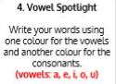  Use Vowel Spotlight to practise spelling this week’s words:  babies, carries, copies, families, cries, bodies, flies, fries, hobbies, ladies, multiplies, replies.  Spelling Test:  Scroll down below today’s timetable to use the look, cover, write, check sheet to help you to test yourself on this week’s words.
9.45-10.00  Active break | L.O: To boost my concentration through movement. | Join in with the Go Noodle clip to get you moving!  Celebrate The New Day - GoNoodle
10.00-11.00  English | SPaG Revision LO: To use punctuation marks.  LO: To answer questions about a text. | For today’s SPaG Daily Practice, revise your knowledge of using punctuation marks. Watch the videos and complete activity 1.  Punctuation marks - Year 3 - P4 - English - Catch Up Lessons - Home Learning with BBC Bitesize - BBC Bitesize  Follow the link below to have a go at today’s lesson:  Home Learning with BBC Bitesize - KS3 Primary English for Year 3 - BBC Bitesize
11.00- 11.15
Break
11.15-12.15  Maths | LO: To practise my recall of the 8 times table.  LO: To identify rectangles including squares. | Follow the link below to practise the 8 times table and get moving!  8 TIMES TABLE SONG - 8x TABLE ADVENTURE - YouTube  Follow the link below to have a go at today’s lesson:  To identify rectangles including squares (thenational.academy)
12.15-1.00
Dinner
1.00-1.15  Storytime | LO: To listen to a story for pleasure. | Listen to Chapter 17 of Mark Anchovy: Pizza Detective:  Mark Anchovy: Pizza Detective - World Book Day
1.15-3:00  Golden Time | LO: To practise mindfulness. | Have a go at this meditation:  Bring It Down - Flow | GoNoodle - YouTube  Have a go at this fun Yoga session:  Movie Night Kids Yoga! 🍿🎬 Yoga Club (Week 14) | Cosmic Kids - YouTube

Beat That!
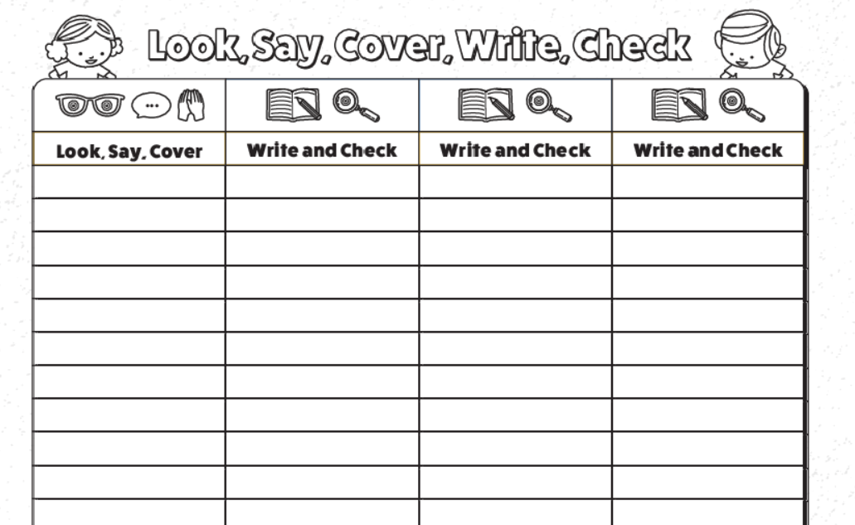
Spelling Test

