Monday
Time and Subject | Learning Objective | Task/Link/Resources
8.45-9.00  Reading | L.O: To practise and consolidate existing reading skills. | Read your individual reading book, either in your head or out loud.
9.00-9.15  Morning Maths | LO: To consolidate recall of number facts.  Revision LO: To divide with remainders. | Complete today’s Beat That. You will find today’s Beat That below today’s timetable. Just scroll down! Remember, it is the same one every day for a week so try and beat your score each time!  We use Morning Maths as a time to revise concepts and keep them at the front of our minds- follow this link to divide with remainders. Use the third video on the link below, click on Summer Term Week 3:  https://whiterosemaths.com/homelearning/summer-archive/year-5/
9.15-9.45  Spelling | LO: To practice Unit Seven RWI Spelling words. | Speed write this week’s words- time yourself a minute for each! Check them and correct any mistakes. Write them in different colours or fancy writing, make yourself a poster of each of the words! Circle the consonants and vowels.  Admission, Asia, collision, comprehension, confession, decision, decide, decision, discussion, expanded, expansion, explosion.
9.45-10.00  Active break | L.O: To boost my concentration through movement. | https://www.youtube.com/watch?v=Y9LLfv7yauM  Join in with the Go Noodle clip above to get you moving!
10.00-11.00  English | LO: To build knowledge of the historical context of the unit. | Have a go at today’s lesson by clicking on the link below:  https://classroom.thenational.academy/lessons/to-build-knowledge-of-the-historical-context-of-the-unit-6nk32d
11.00- 11.15
Break
11.15-12.15  Maths | LO: To identify, describe and represent fractions. | Have a go at today’s lesson by clicking on the link below:  https://classroom.thenational.academy/lessons/to-identify-describe-and-represent-fractions-ccw3ee
12.15-1.00
Dinner
1.00-1.15  Storytime | LO: To listen to a story for pleasure. | This week we are listening to the Reluctant Dragon, remember where you get up to each day!  https://stories.audible.com/pdp/B002V080R2?ref=adbl_ent_anon_ds_pdp_pc_cntr-4-5
1.15-3.00  PE | LO: To develop fitness and learn a dance sequence. | Have a go at today’s lesson by clicking on the links below:  https://www.youtube.com/watch?v=FrRDG4krjv8  https://www.youtube.com/watch?v=MCeo6Q3p7Mc
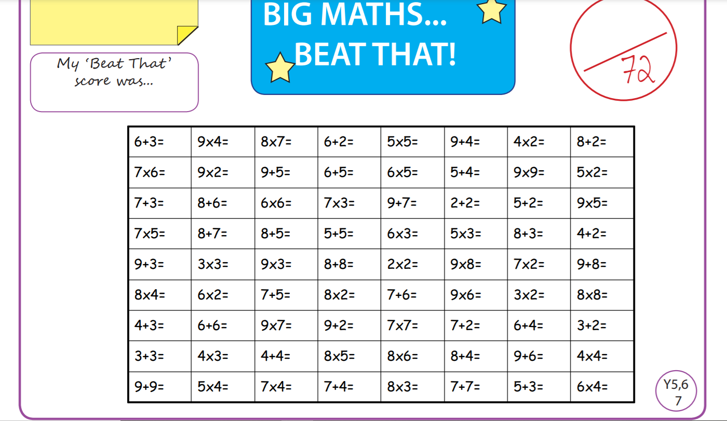
Tuesday
Time and Subject | Learning Objective | Task/Link/Resources
8.45-9.00  Reading | L.O: To practise and consolidate existing reading skills. | Read your individual reading book, either in your head or out loud.
9.00-9.15  Morning Maths | LO: To consolidate recall of number facts.  Revision LO: To calculate perimeter. | Complete today’s Beat That. You will find today’s Beat That below today’s timetable. Just scroll down! Remember, it is the same one every day for a week so try and beat your score each time!  We use Morning Maths as a time to revise concepts and keep them at the front of our minds- follow this link to calculate perimeter. Use the fourth video on the link below, click on Summer Term Week 3:  https://whiterosemaths.com/homelearning/summer-archive/year-5/
9.15-9.45  Spelling | LO: To practice Unit Seven RWI Spelling words. | Speed write this week’s words- time yourself a minute for each! Check them and correct any mistakes. Write them in different colours or fancy writing, make yourself a poster of each of the words! Circle the consonants and vowels.  Admission, Asia, collision, comprehension, confession, decision, decide, decision, discussion, expanded, expansion, explosion.
9.45-10.00  Active break | L.O: To boost my concentration through movement. | https://www.youtube.com/watch?v=OPLWyZMRNn0  Join in with the Go Noodle clip above to get you moving!
10.00-11.00  English | LO: To investigate suffixes and plurals. | Have a go at today’s lesson by clicking on the link below:  https://classroom.thenational.academy/lessons/to-investigate-suffixes-plurals-chh3jc
11.00- 11.15
Break
11.15-12.15  Maths | LO: To understand equivalence. | Have a go at today’s lesson by clicking on the link below:  https://classroom.thenational.academy/lessons/understanding-equivalence-75hkge
12.15-1.00
Dinner
1.00-1.15  Storytime | LO: To listen to a story for pleasure. | This week we are listening to the Reluctant Dragon, remember where you get up to each day!  https://stories.audible.com/pdp/B002V080R2?ref=adbl_ent_anon_ds_pdp_pc_cntr-4-5
1.15-2.30  Topic  RE | LO: To explore what humanists’ goals are for society. | Have a go at today’s RE lesson by clicking on the link below:  https://classroom.thenational.academy/lessons/what-are-humanists-goals-for-society-6mtkjd
2.30-3.00  RHE | LO: To identify the basic human rights and those of children. | Follow the link below to have a go at today’s lesson:  https://classroom.thenational.academy/lessons/i-have-rights-64v3et
Wednesday
Time and Subject | Learning Objective | Task/Link/Resources
8.45-9.00  Reading | L.O: To practise and consolidate existing reading skills. | Read your individual reading book, either in your head or out loud.
9.00-9.15  Morning Maths | LO: To consolidate recall of number facts.  Revision LO: To calculate the area of rectangles. | Complete today’s Beat That. You will find today’s Beat That below today’s timetable. Just scroll down! Remember, it is the same one every day for a week so try and beat your score each time!  We use Morning Maths as a time to revise concepts and keep them at the front of our minds- follow this link to calculate the area of rectangles, use the first video on the link below, click on Summer Term Week 4:  https://whiterosemaths.com/homelearning/summer-archive/year-5/
9.15-9.45  Spelling | LO: To practice Unit Seven RWI Spelling words. | Speed write this week’s words- time yourself a minute for each! Check them and correct any mistakes. Write them in different colours or fancy writing, make yourself a poster of each of the words! Circle the consonants and vowels.  Admission, Asia, collision, comprehension, confession, decision, decide, decision, discussion, expanded, expansion, explosion.
9.45-10.00  Active break | L.O: To boost my concentration through movement. | https://www.youtube.com/watch?v=7pUAdYWud10  Join in with the Go Noodle clip above to get you moving!
10.00-11.00  English | LO: To identify the features of a diary entry. | Have a go at today’s lesson by clicking on the link below:  https://classroom.thenational.academy/lessons/to-identify-the-features-of-a-diary-entry-cngp6d
11.00- 11.15
Break
11.15-12.15  Maths | LO: To find equivalent fractions. | Have a go at today’s lesson by clicking on the link below:  https://classroom.thenational.academy/lessons/finding-equivalent-fractions-ctgp4r
12.15-1.00
Dinner
1.00-1.15  Storytime | LO: To listen to a story for pleasure. | This week we are listening to the Reluctant Dragon, remember where you get up to each day!  https://stories.audible.com/pdp/B002V080R2?ref=adbl_ent_anon_ds_pdp_pc_cntr-4-5
1.15-2.30  Topic  RE | LO: To investigate famous humanists we can learn from. | Have a go at today’s RE lesson by clicking on the link below:  https://classroom.thenational.academy/lessons/what-famous-humanists-can-we-learn-from-6th3gr
2.30-3.00  Music | LO: To sing in canon. | Have a go at today’s lesson by clicking on the link below:  https://classroom.thenational.academy/lessons/to-sing-in-canon-71j3gr
Thursday
Time and Subject | Learning Objective | Task/Link/Resources
8.45-9.00  Reading | L.O: To practise and consolidate existing reading skills. | Read your individual reading book, either in your head or out loud.
9.00-9.15  Morning Maths | LO: To consolidate recall of number facts.  Revision LO: To revise equivalent fractions. | Complete today’s Beat That. You will find today’s Beat That below today’s timetable. Just scroll down! Remember, it is the same one every day for a week so try and beat your score each time!  We use Morning Maths as a time to revise concepts and keep them at the front of our minds- follow this link to revise equivalent fractions. Use the second video on the link below, click on Summer Term Week 4:  https://whiterosemaths.com/homelearning/summer-archive/year-5/
9.15-9.45  Spelling | LO: To practice Unit Seven RWI Spelling words. | Speed write this week’s words- time yourself a minute for each! Check them and correct any mistakes. Write them in different colours or fancy writing, make yourself a poster of each of the words! Circle the consonants and vowels.  Admission, Asia, collision, comprehension, confession, decision, decide, decision, discussion, expanded, expansion, explosion.
9.45-10.00  Active break | L.O: To boost my concentration through movement. | https://www.youtube.com/watch?v=Hl5dRW4E9hc  Join in with the Go Noodle clip above to get you moving!
10.00-11.00  English | LO: To generate vocabulary linked to emotions. | Have a go at today’s lesson by clicking on the link below:  https://classroom.thenational.academy/lessons/to-generate-vocabulary-emotions-6ww6cd
11.00- 11.15
Break
11.15-12.15  Maths | LO: To compare fractions less than one. | Have a go at today’s lesson by clicking on the link below:  https://classroom.thenational.academy/lessons/compare-fractions-less-than-one-c4ukcc
12.15-1.00
Dinner
1.00-1.15  Storytime | LO: To listen to a story for pleasure. | This week we are listening to the Reluctant Dragon, remember where you get up to each day!  https://stories.audible.com/pdp/B002V080R2?ref=adbl_ent_anon_ds_pdp_pc_cntr-4-5
1.15-2.30  Topic  RE | LO: To plan an essay about humanism. | Have a go at today’s RE lesson by clicking on the link below:  https://classroom.thenational.academy/lessons/can-i-plan-an-essay-about-humanism-6mw3er
2.30-3.00  French | LO: To develop vocabulary. | Follow the link:  https://www.bbc.co.uk/teach/class-clips-video/french-ks2-masculine-and-feminine-body-parts/zn84d6f
Friday
Time and Subject | Learning Objective | Task/Link/Resources
8.45-9.00  Reading | L.O: To practise and consolidate existing reading skills. | Read your individual reading book, either in your head or out loud.
9.00-9.15  Morning Maths | LO: To consolidate recall of number facts.  Revision LO: To convert improper fractions to mixed numbers and vice versa. | Complete today’s Beat That. You will find today’s Beat That below today’s timetable. Just scroll down! Remember, it is the same one every day for a week so try and beat your score each time!  We use Morning Maths as a time to revise concepts and keep them at the front of our minds- follow this link to convert improper fractions to mixed numbers and vice versa. Use the third video on the link below, click on Summer Term Week 4:  https://whiterosemaths.com/homelearning/summer-archive/year-5/
9.15-9.45  Spelling | LO: To practice Unit Seven RWI Spelling words. | Speed write this week’s words- time yourself a minute for each! Check them and correct any mistakes. Write them in different colours or fancy writing, make yourself a poster of each of the words! Circle the consonants and vowels.  Admission, Asia, collision, comprehension, confession, decision, decide, decision, discussion, expanded, expansion, explosion.  Test yourself using the Look, Say, Cover, Write, Check grid at the very bottom of this week.
9.45-10.00  Active break | L.O: To boost my concentration through movement. | https://www.youtube.com/watch?v=aEIpC4e2aBY  Join in with the Go Noodle clip above to get you moving!
10.00-11.00  English | LO: To develop a rich understanding of words associated with feeling stressed or scared. | Have a go at today’s lesson by clicking on the link below:  https://classroom.thenational.academy/lessons/to-develop-a-rich-understanding-of-words-associated-with-feeling-stressed-or-scared-6gv3gd
11.00- 11.15
Break
11.15-12.15  Maths | LO: To compare fractions greater than one. | Have a go at today’s lesson by clicking on the link below:  https://classroom.thenational.academy/lessons/compare-fractions-greater-than-one-c8vkgr
12.15-1.00
Dinner
1.00-1.15  Storytime | LO: To listen to a story for pleasure. | This week we are listening to the Reluctant Dragon, remember where you get up to each day!  https://stories.audible.com/pdp/B002V080R2?ref=adbl_ent_anon_ds_pdp_pc_cntr-4-5
1.15-3.00  Golden Time Art | LO: To create your own land art. | Enjoy today’s session by clicking on the link below:  https://youtu.be/JTnHiOA6a0E  Can you create your own? Here are some examples:  