Time and Subject | Learning Objective | Task/Link/Resources
8.45-9.00  Reading | L.O: To practise and consolidate existing reading skills. | Read your individual reading book, either in your head or out loud.
9.00-9.15  Morning Maths | LO: To consolidate recall of number facts. | Complete today’s Beat That. You will find today’s Beat That below today’s timetable. Just scroll down! Remember, it is the same one every day for a week so try and beat your score each time!
9.15-9.45  Spelling | LO: To practice Unit Four RWI Spelling words. | Speed write this week’s words- time yourself a minute for each! Check them and correct any mistakes. Write them in different colours or fancy writing, make yourself a poster of each of the words! Circle the consonants and vowels.  Week 7 – wrestle whistle soften nestle listen rustle
9.45-10.00  Active break | L.O: To boost my concentration through movement. | https://www.youtube.com/watch?v=Y9LLfv7yauM  Join in with the Go Noodle clip above to get you moving!
10.00-11.00  English | LO: To identify features of a biography. | Have a go at today’s lesson by clicking on the link below:  https://classroom.thenational.academy/lessons/to-identify-features-of-a-biography-c4w3jt
11.00- 11.15
Break
11.15-12.15  Maths | LO: To convert between fractions and decimals. | Have a go at today’s lesson by clicking on the link below:  https://classroom.thenational.academy/lessons/fractions-and-decimals-70tp4c
12.15-1.00
Dinner
1.00-1.15  Storytime | LO: To listen to a story for pleasure. | Continue listening to Anne of Green Gables, remember where you get up to for next time:  https://stories.audible.com/pdp/B01KGL13FI?ref=adbl_ent_anon_ds_pdp_pc_cntr-3-3
1.15-2.30  PE | LO: To develop fitness and learn a dance sequence. | Have a go at today’s lesson by clicking on the links below:  https://www.youtube.com/watch?v=FrRDG4krjv8  https://www.youtube.com/watch?v=MCeo6Q3p7Mc
Monday
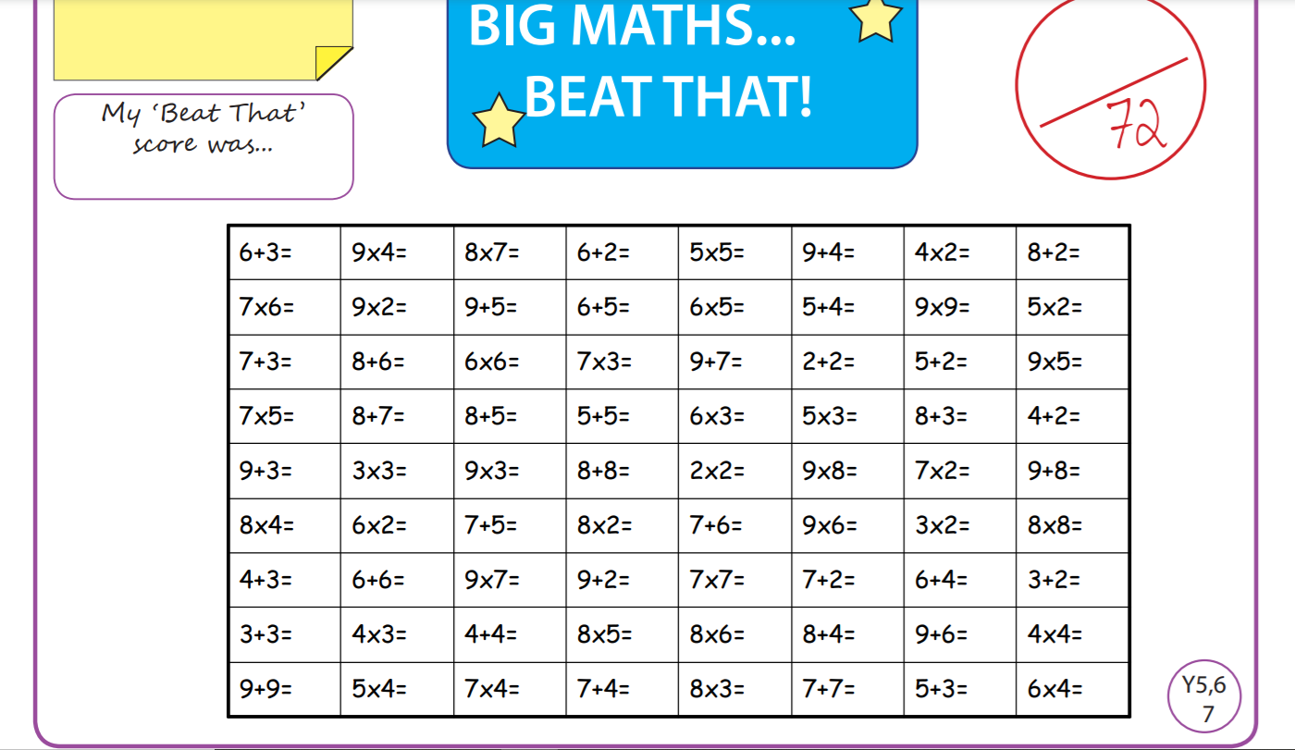

Tuesday
Time and Subject | Learning Objective | Task/Link/Resources
8.45-9.00  Reading | L.O: To practise and consolidate existing reading skills. | Read your individual reading book, either in your head or out loud.
9.00-9.15  Morning Maths | LO: To consolidate recall of number facts. | Complete today’s Beat That. You will find today’s Beat That below today’s timetable. Just scroll down! Remember, it is the same one every day for a week so try and beat your score each time!
9.15-9.45  Spelling | LO: To practice Unit Four RWI Spelling words. | Speed write this week’s words- time yourself a minute for each! Check them and correct any mistakes. Write them in different colours or fancy writing, make yourself a poster of each of the words! Circle the consonants and vowels.  Week 7 – wrestle whistle soften nestle listen rustle
9.45-10.00  Active break | L.O: To boost my concentration through movement. | https://www.youtube.com/watch?v=OPLWyZMRNn0  Join in with the Go Noodle clip above to get you moving!
10.00-11.00  English | LO: To investigate unstressed vowels in polysyllabic words. | Have a go at today’s lesson by clicking on the link below:  https://classroom.thenational.academy/lessons/to-investigate-unstressed-vowels-in-polysyllabic-words-69gkcr
11.00- 11.15
Break
11.15-12.15  Maths | LO: To recognise and use thousandths. | Have a go at today’s lesson by clicking on the link below:  https://classroom.thenational.academy/lessons/thousandths-6wup6t
12.15-1.00
Dinner
1.00-1.15  Storytime | LO: To listen to a story for pleasure. | Continue listening to Anne of Green Gables, remember where you get up to for next time:  https://stories.audible.com/pdp/B01KGL13FI?ref=adbl_ent_anon_ds_pdp_pc_cntr-3-3
1.15-2.30  Topic  RE | LO: To learn about the eightfold path. | Have a go at today’s lesson by clicking on the link below:  https://classroom.thenational.academy/lessons/what-is-the-eightfold-path-6mw3ed
2.30-3.00  RHE | LO: To identify basic human rights, including those of children. | Have a go at today’s lesson by clicking on the link below:  https://classroom.thenational.academy/lessons/i-have-rights-64v3et

Wednesday
Time and Subject | Learning Objective | Task/Link/Resources
8.45-9.00  Reading | L.O: To practise and consolidate existing reading skills. | Read your individual reading book, either in your head or out loud.
9.00-9.15  Morning Maths | LO: To consolidate recall of number facts. | Complete today’s Beat That. You will find today’s Beat That below today’s timetable. Just scroll down! Remember, it is the same one every day for a week so try and beat your score each time!
9.15-9.45  Spelling | LO: To practice Unit Four RWI Spelling words. | Speed write this week’s words- time yourself a minute for each! Check them and correct any mistakes. Write them in different colours or fancy writing, make yourself a poster of each of the words! Circle the consonants and vowels.  Week 7 – wrestle whistle soften nestle listen rustle
9.45-10.00  Active break | L.O: To boost my concentration through movement. | https://www.youtube.com/watch?v=7pUAdYWud10  Join in with the Go Noodle clip above to get you moving!
10.00-11.00  English | LO: To revise the past, present and future progressive. | Have a go at today’s lesson by clicking on the link below:  https://classroom.thenational.academy/lessons/to-revise-the-past-present-and-future-progressive-tense-6rukjd
11.00- 11.15
Break
11.15-12.15  Maths | LO: To compare fractions and decimals. | Have a go at today’s lesson by clicking on the link below:  https://classroom.thenational.academy/lessons/comparing-fractions-and-decimals-c5jp8r
12.15-1.00
Dinner
1.00-1.15  Storytime | LO: To listen to a story for pleasure. | Continue listening to Anne of Green Gables, remember where you get up to for next time:  https://stories.audible.com/pdp/B01KGL13FI?ref=adbl_ent_anon_ds_pdp_pc_cntr-3-3
1.15-2.30  Topic  RE | LO: To learn about Buddhist festivals. | Have a go at today’s lesson by clicking on the link below:  https://classroom.thenational.academy/lessons/which-festivals-do-buddhists-celebrate-cdhk0d
2.30-3.00  Music | LO: To classify instruments. | Have a go at today’s lesson by clicking on the link below:  https://classroom.thenational.academy/lessons/to-classify-instruments-6wtkat
Thursday
Time and Subject | Learning Objective | Task/Link/Resources
8.45-9.00  Reading | L.O: To practise and consolidate existing reading skills. | Read your individual reading book, either in your head or out loud.
9.00-9.15  Morning Maths | LO: To consolidate recall of number facts. | Complete today’s Beat That. You will find today’s Beat That below today’s timetable. Just scroll down! Remember, it is the same one every day for a week so try and beat your score each time!
9.15-9.45  Spelling | LO: To practice Unit Four RWI Spelling words. | Speed write this week’s words- time yourself a minute for each! Check them and correct any mistakes. Write them in different colours or fancy writing, make yourself a poster of each of the words! Circle the consonants and vowels.  Week 7 – wrestle whistle soften nestle listen rustle
9.45-10.00  Active break | L.O: To boost my concentration through movement. | https://www.youtube.com/watch?v=Hl5dRW4E9hc  Join in with the Go Noodle clip above to get you moving!
10.00-11.00  English | LO: To gather information on an inspirational figure. | Have a go at today’s lesson by clicking on the link below:  https://classroom.thenational.academy/lessons/to-gather-information-on-an-inspirational-figure-74u68d
11.00- 11.15
Break
11.15-12.15  Maths | LO: To recognise and name improper fractions. | Have a go at today’s lesson by clicking on the link below:  https://classroom.thenational.academy/lessons/improper-fractions-part-1-c4tkac
12.15-1.00
Dinner
1.00-1.15  Storytime | LO: To listen to a story for pleasure. | Continue listening to Anne of Green Gables, remember where you get up to for next time:  https://stories.audible.com/pdp/B01KGL13FI?ref=adbl_ent_anon_ds_pdp_pc_cntr-3-3
1.15-2.30  Topic  RE | LO: To learn why Buddhists meditate. | Have a go at today’s lesson by clicking on the link below:  https://classroom.thenational.academy/lessons/why-do-buddhists-meditate-cthp2d
2.30-3.00  French | LO: To develop vocabulary. | Follow the link:  https://www.bbc.co.uk/teach/class-clips-video/french-ks2-masculine-and-feminine-body-parts/zn84d6f
Friday
Time and Subject | Learning Objective | Task/Link/Resources
8.45-9.00  Reading | L.O: To practise and consolidate existing reading skills. | Read your individual reading book, either in your head or out loud.
9.00-9.15  Morning Maths | LO: To consolidate recall of number facts. | Complete today’s Beat That. You will find today’s Beat That below today’s timetable. Just scroll down! Remember, it is the same one every day for a week so try and beat your score each time!
9.15-9.45  Spelling | LO: To practice Unit Four RWI Spelling words. | Speed write this week’s words- time yourself a minute for each! Check them and correct any mistakes. Write them in different colours or fancy writing, make yourself a poster of each of the words! Circle the consonants and vowels.  Week 7 – wrestle whistle soften nestle listen rustle  Test yourself using the Look, Cover, Say, Write and Check grid below.
9.45-10.00  Active break | L.O: To boost my concentration through movement. | https://www.youtube.com/watch?v=aEIpC4e2aBY  Join in with the Go Noodle clip above to get you moving!
10.00-11.00  English | LO: To develop a rich understanding of words associated with being hard working. | Have a go at today’s lesson by clicking on the link below:  https://classroom.thenational.academy/lessons/to-develop-a-rich-understanding-of-words-associated-with-with-being-hard-working-65gkcc
11.00- 11.15
Break
11.15-12.15  Maths | LO: To convert between improper and mixed fractions. | Have a go at today’s lesson by clicking on the link below:  https://classroom.thenational.academy/lessons/improper-fractions-part-2-64upad
12.15-1.00
Dinner
1.00-1.15  Storytime | LO: To listen to a story for pleasure. | Continue listening to Anne of Green Gables, remember where you get up to for next time:  https://stories.audible.com/pdp/B01KGL13FI?ref=adbl_ent_anon_ds_pdp_pc_cntr-3-3
1.15-3:00  Golden Time Art | LO: To create my own land art. | Enjoy today’s session by clicking on the link below:  https://youtu.be/JTnHiOA6a0E  Here are some examples:
