Time and Subject  Monday | Learning Objective | Task/Link/Resources
8.45-9.00  Reading | LO: To practise and consolidate existing reading skills. | Read your individual reading book, either in your head or out loud.
9.00-9.15  Morning Maths | LO: To consolidate recall of number facts.  Revision LO: To count in tenths. | Complete today’s Beat That- scroll down below today’s timetable to find the questions. Remember, it is the same one every day for a week. Can you beat your own score?  Morning Maths: In Morning Maths today, you are going to revise your knowledge of fractions. Click the link below and select the video Count in tenths.  https://whiterosemaths.com/homelearning/year-4/spring-week-5-number-fractions/
9.15-9.45  Spelling | LO: To revise important spelling rules. | This week, we are going to practise adding the suffix -ous to root words. Watch this video to learn how adding -ous changes the meaning of the root word: https://www.bbc.co.uk/bitesize/topics/zqqsw6f/articles/zqcpv9q  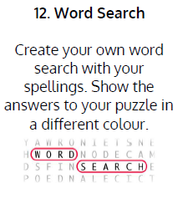  Use Word Search to practise spelling this week’s words:  famous, enormous, hazardous, jealous, tremendous, dangerous, mountainous, venomous, poisonous, perilous, pompous, nervous, fabulous, generous
9.45-10.00  Active break | LO: To boost my concentration through movement. | Join in with the Go Noodle clip below to get you moving!  Roy G Biv - GoNoodle
10.00-11.00  English | SPaG Revision LO: To use inverted commas.  LO: To plan a narrative build-up. | For today’s SPaG Daily Practice, revise your knowledge of inverted commas. Watch the videos and complete activity 4.  Using inverted commas - Year 4 - P5 - English - Catch Up Lessons - Home Learning with BBC Bitesize - BBC Bitesize  Follow the link below to have a go at today’s English lesson:  To plan a narrative build-up (thenational.academy)
11.00- 11.15
Break
11.15-12.15  Maths | LO: To practise my recall of the 8 times table.  LO: To identify lines of symmetry in 2D shapes. | Follow the link below to practise the 8 times table and get moving!  KS2 Maths: The 8 Times Table with Filbert Fox - BBC Teach  Follow the link below to have a go at today’s maths lesson:  To identify lines of symmetry in 2-D shapes (thenational.academy)
12.15-1.00
Dinner
1.00-1.15  Storytime | LO: To listen to a story for pleasure. | Listen to Chapter 8 of Mark Anchovy: Pizza Detective:  Mark Anchovy: Pizza Detective - World Book Day
1.15-3.00  Topic-DT | LO: To make a healthy dip for vegetables. | Follow the link below to have a go at today’s lesson:  Delicious dips (thenational.academy)

Beat That!
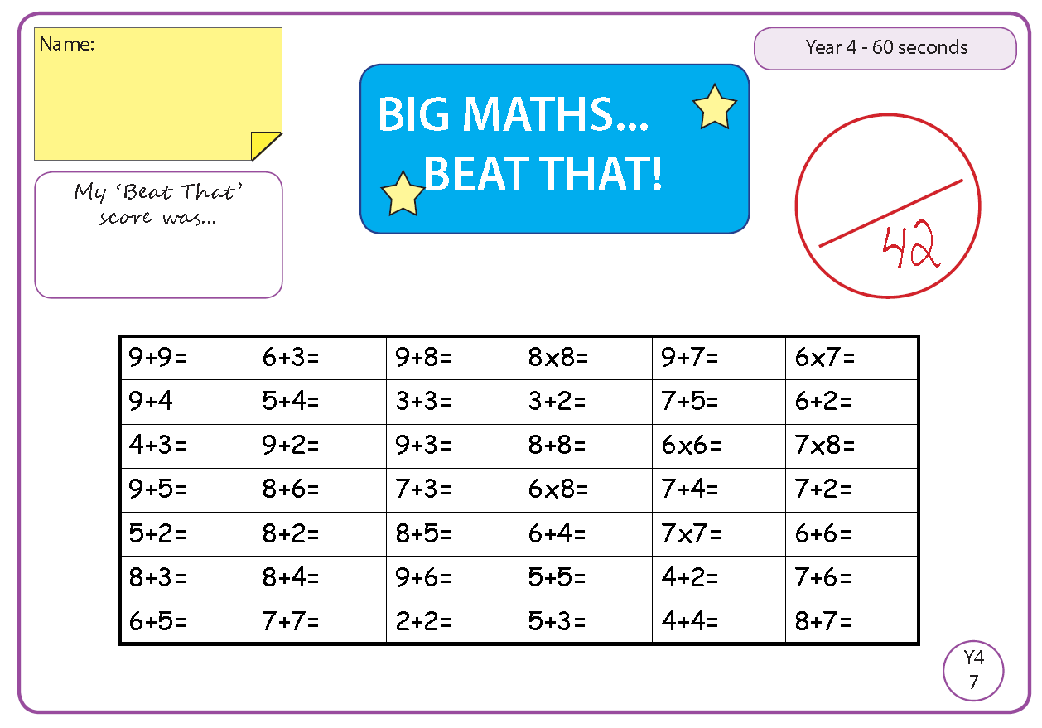

Time and Subject  Tuesday | Learning Objective | Task/Link/Resources
8.45-9.00  Reading | L.O: To practise and consolidate existing reading skills. | Read your individual reading book, either in your head or out loud.
9.00-9.15  Morning Maths | LO: To consolidate recall of number facts.  Revision LO: To explore equivalent fractions. | Complete today’s Beat That- scroll down below today’s timetable to find the questions. Remember, it is the same one every day for a week. Can you beat your own score?  Morning Maths: In Morning Maths today, you are going to revise your knowledge of fractions. Click the link below and select the video Equivalent fractions (1).  https://whiterosemaths.com/homelearning/year-4/spring-week-5-number-fractions/
9.15-9.45  Spelling | LO: To revise important spelling rules. | This week, we are going to practise adding the suffix -ous to root words.  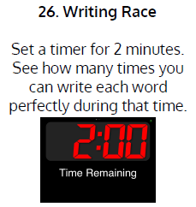  Use Writing Race to practise spelling this week’s words:  famous, enormous, hazardous, jealous, tremendous, dangerous, mountainous, venomous, poisonous, perilous, pompous, nervous, fabulous, generous
9.45-10.00  Active break | L.O: To boost my concentration through movement. | Join in with the Go Noodle clip below to get you moving!  Power Up! - YouTube
10.00-11.00  English | SPaG Revision LO: To use apostrophes for possession.  LO: To practise and apply knowledge of suffixes. | For today’s SPaG Daily Practice, revise your knowledge of apostrophes. Watch the video and complete activity 1.  Using apostrophes to show possession - Year 4 - P5 - English - Catch Up Lessons - Home Learning with BBC Bitesize - BBC Bitesize  Follow the link below to have a go at today’s English lesson:  To practise and apply knowledge of suffixes (-ify -ise) (thenational.academy)
11.00- 11.15
Break
11.15-12.15  Maths | LO: To practise my recall of the 8 times table.  LO: To identify lines of symmetry in a pattern. | Follow the link below to practise the 8 times table:  Coconut Multiples - Reinforce Times Tables (topmarks.co.uk)  Follow the link below to have a go at today’s maths lesson:  To identify lines of symmetry in a pattern (thenational.academy)
12.15-1.00
Dinner
1.00-1.15  Storytime | LO: To listen to a story for pleasure. | Listen to Chapter 9 of Mark Anchovy: Pizza Detective:  Mark Anchovy: Pizza Detective - World Book Day
1.15-2.30  Topic- DT | LO: To make a healthy oat bar. | Follow the link below to have a go at today’s lesson:  Marvellous oat bars (thenational.academy)
2.30-3.00  French | LO: To be able to give and follow instructions in French. | Follow the link below to have a go at today’s lesson:  Learn French with Twinkl - Giving Instructions - YouTube

Beat That!

Time and Subject  Wednesday | Learning Objective | Task/Link/Resources
8.45-9.00  Reading | L.O: To practise and consolidate existing reading skills. | Read your individual reading book, either in your head or out loud.
9.00-9.15  Morning Maths | LO: To consolidate recall of number facts.  Revision LO: To explore equivalent fractions. | Complete today’s Beat That- scroll down below today’s timetable to find the questions. Remember, it is the same one every day for a week. Can you beat your own score?  Morning Maths: In Morning Maths today, you are going to revise your knowledge of fractions. Click the link below and select the video Equivalent fractions (2).  https://whiterosemaths.com/homelearning/year-4/spring-week-6-number-fractions/
9.15-9.45  Spelling | LO: To revise important spelling rules. | This week, we are going to practise adding the suffix -ous to root words.  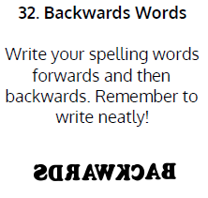  Use Writing Race to practise spelling this week’s words:  famous, enormous, hazardous, jealous, tremendous, dangerous, mountainous, venomous, poisonous, perilous, pompous, nervous, fabulous, generous
9.45-10.00  Active break | LO: To boost my concentration through movement. | Join in with the Go Noodle clip below to get you moving!  Chillax to the Max - YouTube
10.00-11.00  English | SPaG Revision LO: To use apostrophes for possession.  LO: To practise punctuating speech. | For today’s SPaG Daily Practice, revise your knowledge of apostrophes. Watch the video and complete activity 2.  Using apostrophes to show possession - Year 4 - P5 - English - Catch Up Lessons - Home Learning with BBC Bitesize - BBC Bitesize  Follow the link below to have a go at today’s English lesson:  To practise punctuating speech (thenational.academy)
11.00- 11.15
Break
11.15-12.15  Maths | LO: To practise my recall of the 8 times table.  LO: To complete a simple symmetrical figure. | Follow the link below to practise the 8 times table:  8x Table Practice (snappymaths.com)  Follow the link below to have a go at today’s maths lesson:  To complete a simple symmetrical figure (thenational.academy)
12.15-1.00
Dinner
1.00-1.15  Storytime | LO: To listen to a story for pleasure. | Listen to Chapter 10 of Mark Anchovy: Pizza Detective:  Mark Anchovy: Pizza Detective - World Book Day
1.15-3.00  Topic-Geography | LO: To identify the countries of Europe. | Follow the link below to have a go at today’s lesson:  What are the countries of Europe? (thenational.academy)

Beat That!

Time and Subject  Thursday | Learning Objective | Task/Link/Resources
8.45-9.00  Reading | L.O: To practise and consolidate existing reading skills. | Read your individual reading book, either in your head or out loud.
9.00-9.15  Morning Maths | LO: To consolidate recall of number facts.  Revision LO: To understand fractions greater than 1. | Complete today’s Beat That- scroll down below today’s timetable to find the questions. Remember, it is the same one every day for a week. Can you beat your own score?  Morning Maths: In Morning Maths today, you are going to revise your knowledge of fractions. Click the link below and select the video Fractions greater than 1.  https://whiterosemaths.com/homelearning/year-4/spring-week-6-number-fractions/
9.15-9.45  Spelling | LO: To revise important spelling rules. | This week, we are going to practise adding the suffix -ous to root words.  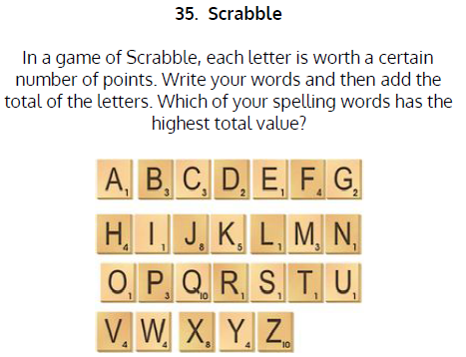  Use Scrabble to practise spelling this week’s words:  famous, enormous, hazardous, jealous, tremendous, dangerous, mountainous, venomous, poisonous, perilous, pompous, nervous, fabulous, generous
9.45-10.00  Active break | LO: To boost my concentration through movement. | Join in with the Go Noodle clip below to get you moving!  Cookie Boogie - Awesome Sauce | GoNoodle - YouTube
10.00-11.00  English | SPaG Revision LO: To use apostrophes to show possession.  LO: To write a narrative build-up. | For today’s SPaG Daily Practice, revise your knowledge of apostrophes. Watch the video and complete activity 3.  Using apostrophes to show possession - Year 4 - P5 - English - Catch Up Lessons - Home Learning with BBC Bitesize - BBC Bitesize  Follow the link below to have a go at today’s English lesson:  To write a narrative build-up (thenational.academy)
11.00- 11.15
Break
11.15-12.15  Maths | LO: To practise my recall of the 8 times table.  LO: To investigate a problem using symmetry. | Follow the link below to practise the 8 times table:  8x Table Beat the Clock (snappymaths.com)  Follow the link below to have a go at today’s lesson:  To investigate a problem using symmetry (Part 1) (thenational.academy)
12.15-1.00
Dinner
1.00-1.15  Storytime | LO: To listen to a story for pleasure. | Listen to Chapter 11 of Mark Anchovy: Pizza Detective:  Mark Anchovy: Pizza Detective - World Book Day
1.15-3.00  PE | LO: To develop strength and stamina. | Follow the link to have a go at today’s PE activity:  Online Primary PE Lessons by Positive Impact - Interval Training - YouTube

Beat That!

Time and Subject  Friday | Learning Objective | Task/Link/Resources
8.45-9.00  Reading | L.O: To practise and consolidate existing reading skills. | Read your individual reading book, either in your head or out loud.
9.00-9.15  Morning Maths | LO: To consolidate recall of number facts.  Revision LO: To count in fractions. | Complete today’s Beat That- scroll down below today’s timetable to find the questions. Remember, it is the same one every day for a week. Can you beat your own score?  Morning Maths: In Morning Maths today, you are going to revise your knowledge of fractions. Click the link below and select the video Count in fractions.  https://whiterosemaths.com/homelearning/year-4/spring-week-6-number-fractions/
9.15-9.45  Spelling | LO: To revise important spelling rules. | This week, we are going to practise adding the suffix -ous- to root words.  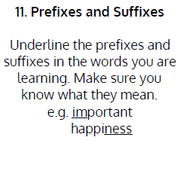  Use Scrabble to practise spelling this week’s words:  famous, enormous, hazardous, jealous, tremendous, dangerous, mountainous, venomous, poisonous, perilous, pompous, nervous, fabulous, generous  Spelling Test:  Scroll down below today’s timetable to use the look, cover, write, check sheet to help you to test yourself on this week’s words.
9.45-10.00  Active break | L.O: To boost my concentration through movement. | Join in with the Go Noodle clip to get you moving!  GoNoodle Hand Jive - GoNoodle
10.00-11.00  English | SPaG Revision LO: To use apostrophes to contract and combine words.  LO: To analyse a visual film clip. | For today’s SPaG Daily Practice, revise your knowledge of apostrophes. Watch the videos and complete activity 1.  Using apostrophes to contract and combine words - Year 4 and P5 - English - Catch Up Lesson - Home Learning with BBC Bitesize - BBC Bitesize  Follow the link below to have a go at today’s lesson:  To analyse a visual film clip (thenational.academy)
11.00- 11.15
Break
11.15-12.15  Maths | LO: To practise my recall of the 8 times table.  LO: To investigate a problem using symmetry. | Follow the link below to practise the 8 times table:  8x Table (Missing Value) Practice (snappymaths.com)  Follow the link below to have a go at today’s lesson:  To investigate a problem using symmetry (Part 2) (thenational.academy)
12.15-1.00
Dinner
1.00-1.15  Storytime | LO: To listen to a story for pleasure. | Listen to Chapter 12 of Mark Anchovy: Pizza Detective:  Mark Anchovy: Pizza Detective - World Book Day
1.15-3:00  Golden Time | LO: To practise mindfulness. | Have a go at this meditation:  On & Off - Flow | GoNoodle - YouTube  Have a go at this fun Yoga session:  Kids Yoga based on Brilliant Books 📚🤓 - YouTube  You could also choose to complete the art activity included below this week’s timetable.

Beat That!

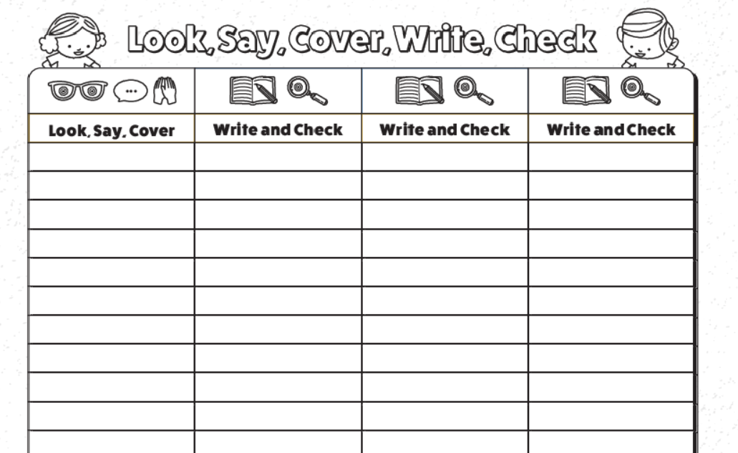
Spelling Test

I can create a sculpture.
Today, we will focus on our final strand of art called “sculpture”. Take a look at the Tate definition of sculpture.
https://www.tate.org.uk/art/art-terms/s/sculpture#:~:text=Three%2Ddimensional%20art%20made%20by,Tate
I would like to construct a building made from cardboard. You could use cereal boxes, toilet roll tubes, kitchen roll tubes, packaging from food. I would like you to include detail such as windows. You might want to stick pieces of rice or pasta to create fine detail. Maybe you have beads or feathers to add texture to your sculpture.
I have included some examples of buildings below.
