Time and Subject  Monday | Learning Objective | Task/Link/Resources
8.45-9.00  Reading | LO: To practise and consolidate existing reading skills. | Read your individual reading book, either in your head or out loud.
9.00-9.15  Morning Maths | LO: To consolidate recall of number facts.  Revision LO: To understand related calculations. | Complete today’s Beat That- scroll down below today’s timetable to find the questions. Remember, it is the same one every day for a week. Can you beat your own score?  Morning Maths: In Morning Maths today, you are going to revise your knowledge of multiplication. Click the link below and select the video Related calculations.  Spring Week 1 - Number: Multiplication & Division | White Rose Maths
9.15-9.45  Spelling | LO: To revise important spelling rules. | This week, we are going to practise adding the suffixes -er or -est.  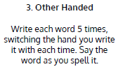  Use Other Handed to practise spelling this week’s words:  braver, bravest, cuter, cutest, closer, closest, faster, fastest, finer, finest, harder, hardest.
9.45-10.00  Active break | LO: To boost my concentration through movement. | Join in with the Go Noodle clip below to get you moving!  Roy G Biv - GoNoodle
10.00-11.00  English | SPaG Revision LO: To explore ‘their’, ‘there’ and ‘they’re’.  LO: To plan the climax. | For today’s SPaG Daily Practice, revise your knowledge of ‘their’, ‘there’ and ‘they’re’. Watch the videos and complete activity 1.  Homeschool lessons in Primary English Year 3 - BBC Bitesize  Follow the link below to have a go at today’s English lesson:  To plan the climax (thenational.academy)
11.00- 11.15
Break
11.15-12.15  Maths | LO: To practise my recall of the 8 times table.  LO: To identify and recognise angles. | Follow the link below to practise the 8 times table and get moving!  KS2 Maths: The 8 Times Table with Filbert Fox - BBC Teach  Follow the link below to have a go at today’s maths lesson:  To identify and recognise angles (thenational.academy)
12.15-1.00
Dinner
1.00-1.15  Storytime | LO: To listen to a story for pleasure. | Listen to Chapter 8 of Mark Anchovy: Pizza Detective:  Mark Anchovy: Pizza Detective - World Book Day
1.15-3.00  Topic- Art | LO: To evaluate our craft work. | Follow the link below to have a go at today’s lesson:  Finishing touches and evaluation of craft work (thenational.academy)
Beat That!
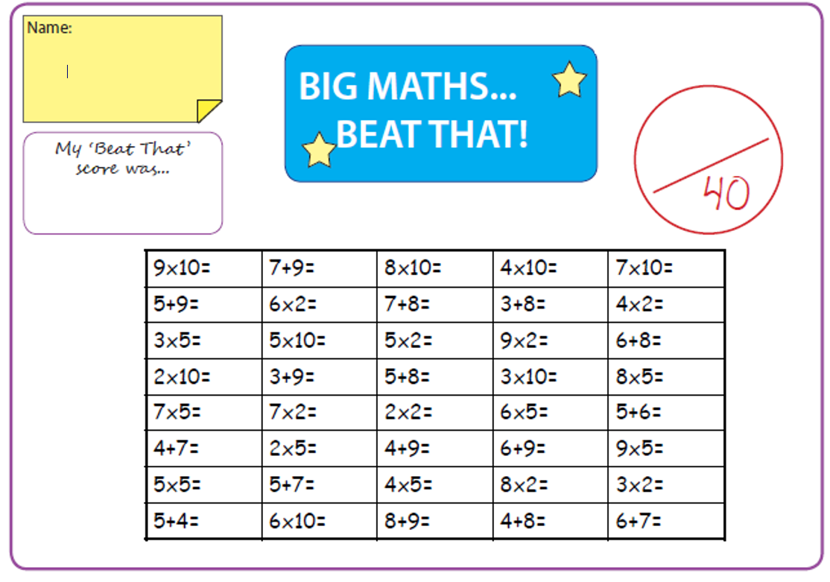
Time and Subject  Tuesday | Learning Objective | Task/Link/Resources
8.45-9.00  Reading | L.O: To practise and consolidate existing reading skills. | Read your individual reading book, either in your head or out loud.
9.00-9.15  Morning Maths | LO: To consolidate recall of number facts.  Revision LO: To multiply 2-digits by 1-digit. | Complete today’s Beat That- scroll down below today’s timetable to find the questions. Remember, it is the same one every day for a week. Can you beat your own score?  Morning Maths: In Morning Maths today, you are going to revise your knowledge of multiplication. Click the link below and select the video Multiply 2-digits by 1-digit (no exchange) activity.  Spring Week 1 - Number: Multiplication & Division | White Rose Maths
9.15-9.45  Spelling | LO: To revise important spelling rules. | This week, we are going to practise adding the suffixes -er or -est.  Use Rainbow Words to practise spelling this week’s words:  braver, bravest, cuter, cutest, closer, closest, faster, fastest, finer, finest, harder, hardest.
9.45-10.00  Active break | L.O: To boost my concentration through movement. | Join in with the Go Noodle clip below to get you moving!  Power Up! - YouTube
10.00-11.00  English | SPaG Revision LO: To explore ‘their’, ‘there’ and ‘they’re’.  LO: To practise and apply knowledge of more prefixes. | For today’s SPaG Daily Practice, revise your knowledge of ‘their’, ‘there’ and ‘they’re’. Watch the videos and complete activity 2.  Homeschool lessons in Primary English Year 3 - BBC Bitesize  Follow the link below to have a go at today’s English lesson:  To practise and apply knowledge of more prefixes, including test (thenational.academy)
11.00- 11.15
Break
11.15-12.15  Maths | LO: To practise my recall of the 8 times table.  LO: To identify angles inside 2D shapes. | Follow the link below to practise the 8 times table:  Coconut Multiples - Reinforce Times Tables (topmarks.co.uk)  Follow the link below to have a go at today’s maths lesson:  To identify angles inside 2D shapes (thenational.academy)
12.15-1.00
Dinner
1.00-1.15  Storytime | LO: To listen to a story for pleasure. | Listen to Chapter 9 of Mark Anchovy: Pizza Detective:  Mark Anchovy: Pizza Detective - World Book Day
1.15-2.30  Topic- Science | LO: To explore where light comes from and how we can see it. | Follow the link below to have a go at today’s lesson:  What is light? (thenational.academy)
2.30-3.00  French | LO: To be able to give and follow instructions in French. | Follow the link below to have a go at today’s lesson:  Learn French with Twinkl - Giving Instructions - YouTube

Beat That!

Time and Subject  Wednesday | Learning Objective | Task/Link/Resources
8.45-9.00  Reading | L.O: To practise and consolidate existing reading skills. | Read your individual reading book, either in your head or out loud.
9.00-9.15  Morning Maths | LO: To consolidate recall of number facts.  Revision LO: To multiply 2-digits by 1-digit. | Complete today’s Beat That- scroll down below today’s timetable to find the questions. Remember, it is the same one every day for a week. Can you beat your own score?  Morning Maths: In Morning Maths today, you are going to revise your knowledge of multiplication. Click the link below and select the video Multiply 2-digits by 1-digit.  Spring Week 1 - Number: Multiplication & Division | White Rose Maths
9.15-9.45  Spelling | LO: To revise important spelling rules. | This week, we are going to practise adding the suffixes -er or -est.  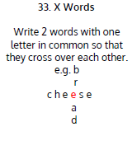  Use X Words to practise spelling this week’s words:  braver, bravest, cuter, cutest, closer, closest, faster, fastest, finer, finest, harder, hardest.
9.45-10.00  Active break | LO: To boost my concentration through movement. | Join in with the Go Noodle clip below to get you moving!  Chillax to the Max - YouTube
10.00-11.00  English | SPaG Revision LO: To explore ‘their’, ‘there’ and ‘they’re’.  LO: To write the climax. | For today’s SPaG Daily Practice, revise your knowledge of ‘their’, ‘there’ and ‘they’re’. Watch the videos and complete activity 3.  Homeschool lessons in Primary English Year 3 - BBC Bitesize  Follow the link below to have a go at today’s English lesson:  To write the climax (thenational.academy)
11.00- 11.15
Break
11.15-12.15  Maths | LO: To practise my recall of the 8 times table.  LO: To recognise right angles. | Follow the link below to practise the 8 times table:  8x Table Practice (snappymaths.com)  Follow the link below to have a go at today’s maths lesson:  To recognise right angles (thenational.academy)
12.15-1.00
Dinner
1.00-1.15  Storytime | LO: To listen to a story for pleasure. | Listen to Chapter 10 of Mark Anchovy: Pizza Detective:  Mark Anchovy: Pizza Detective - World Book Day
1.15-3.00  Topic- Science | LO: To understand how we see objects. | Follow the link below to have a go at today’s lesson:  How can we see objects? (thenational.academy)

Beat That!

Time and Subject  Thursday | Learning Objective | Task/Link/Resources
8.45-9.00  Reading | L.O: To practise and consolidate existing reading skills. | Read your individual reading book, either in your head or out loud.
9.00-9.15  Morning Maths | LO: To consolidate recall of number facts.  Revision LO: To multiply 2-digits by 1-digit (with exchange) | Complete today’s Beat That- scroll down below today’s timetable to find the questions. Remember, it is the same one every day for a week. Can you beat your own score?  Morning Maths: In Morning Maths today, you are going to revise your knowledge of multiplication. Click the link below and select the video Multiply 2-digits by 1-digit- exchange.  Spring Week 2 - Number: Multiplication & Division | White Rose Maths
9.15-9.45  Spelling | LO: To revise important spelling rules. | This week, we are going to practise adding the suffixes -er or -est.  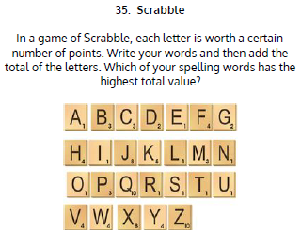  Use Scrabble to practise spelling this week’s words:  braver, bravest, cuter, cutest, closer, closest, faster, fastest, finer, finest, harder, hardest.
9.45-10.00  Active break | LO: To boost my concentration through movement. | Join in with the Go Noodle clip below to get you moving!  Cookie Boogie - Awesome Sauce | GoNoodle - YouTube
10.00-11.00  English | SPaG Revision LO: To use apostrophes for possession.  LO: To edit our work. | For today’s SPaG Daily Practice, revise your knowledge of using apostrophes to show ownership. Watch the video and complete activity 1.  Using apostrophes to show ownership - Year 3 - P4 - English - Catch Up Lessons - Home Learning with BBC Bitesize - BBC Bitesize  Follow the link below to have a go at today’s English lesson:  To edit our work (thenational.academy)
11.00- 11.15
Break
11.15-12.15  Maths | LO: To practise my recall of the 8 times table.  LO: To recognise obtuse and acute angles. | Follow the link below to practise the 8 times table:  8x Table Beat the Clock (snappymaths.com)  Follow the link below to have a go at today’s lesson:  To recognise obtuse and acute angles (thenational.academy)
12.15-1.00
Dinner
1.00-1.15  Storytime | LO: To listen to a story for pleasure. | Listen to Chapter 11 of Mark Anchovy: Pizza Detective:  Mark Anchovy: Pizza Detective - World Book Day
1.15-3.00  PE | LO: To develop strength and stamina. | Follow the link to have a go at today’s PE activity:  Online Primary PE Lessons by Positive Impact - Interval Training - YouTube

Beat That!

Time and Subject  Friday | Learning Objective | Task/Link/Resources
8.45-9.00  Reading | L.O: To practise and consolidate existing reading skills. | Read your individual reading book, either in your head or out loud.
9.00-9.15  Morning Maths | LO: To consolidate recall of number facts.  Revision LO: To multiply 2-digits by 1-digit. | Complete today’s Beat That- scroll down below today’s timetable to find the questions. Remember, it is the same one every day for a week. Can you beat your own score?  Morning Maths: In Morning Maths today, you are going to revise your knowledge of multiplication. Click the link below and select the video Multiply 2-digits by 1-digit (2).  Spring Week 2 - Number: Multiplication & Division | White Rose Maths
9.15-9.45  Spelling | LO: To revise important spelling rules. | This week, we are going to practise adding the suffixes -er or -est.  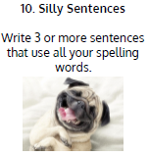  Use Silly Sentences to practise spelling this week’s words:  braver, bravest, cuter, cutest, closer, closest, faster, fastest, finer, finest, harder, hardest.  Spelling Test:  Scroll down below today’s timetable to use the look, cover, write, check sheet to help you to test yourself on this week’s words.
9.45-10.00  Active break | L.O: To boost my concentration through movement. | Join in with the Go Noodle clip to get you moving!  GoNoodle Hand Jive - GoNoodle
10.00-11.00  English | SPaG Revision LO: To use apostrophes for possession.  LO: To read and understand texts. | For today’s SPaG Daily Practice, revise your knowledge of using apostrophes to show ownership. Watch the video and complete activity 2.  Using apostrophes to show ownership - Year 3 - P4 - English - Catch Up Lessons - Home Learning with BBC Bitesize - BBC Bitesize  Follow the link below to have a go at today’s lesson:  Reading and understanding texts - Year 3 - P4 - English - Catch Up Lesson - Home Learning with BBC Bitesize - BBC Bitesize
11.00- 11.15
Break
11.15-12.15  Maths | LO: To practise my recall of the 8 times table.  LO: To revise angles. | Follow the link below to practise the 8 times table:  8x Table (Missing Value) Practice (snappymaths.com)  Follow the link below to have a go at today’s lesson:  To revise angles (thenational.academy)
12.15-1.00
Dinner
1.00-1.15  Storytime | LO: To listen to a story for pleasure. | Listen to Chapter 12 of Mark Anchovy: Pizza Detective:  Mark Anchovy: Pizza Detective - World Book Day
1.15-3:00  Golden Time | LO: To practise mindfulness. | Have a go at this meditation:  On & Off - Flow | GoNoodle - YouTube  Have a go at this fun Yoga session:  Kids Yoga based on Brilliant Books 📚🤓 - YouTube  You could also choose to complete the art activity included below this week’s timetable.

Beat That!

Spelling Test
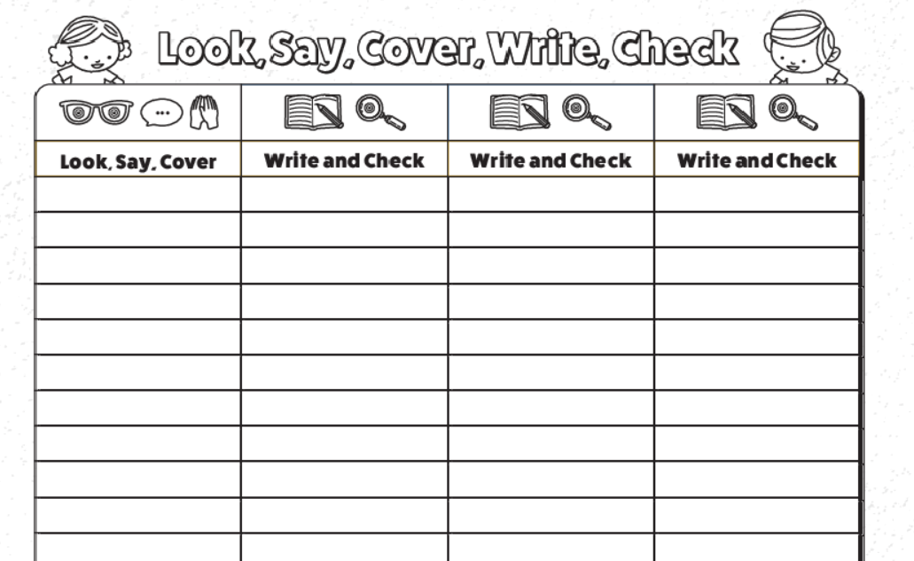

I can create a print.
Today, we will focus on our final type of Art, this is printing. Printing is an impression made by any method involving transfer from one to surface to another.
Printing could be as simple as dipping a sponge in paint and printing it onto paper or it could be dipping your hand into paint and printing it onto paper. There are many examples of printing, can you think of any others?
Watch the video below to see different examples of printing:
https://www.bbc.co.uk/teach/class-clips-video/art-and-design-printmaking-different-materials/zhytscw

For today’s lesson, we will need some string, paint and an A4 piece of paper. I would like you to fold your paper in half. Dip your string into paint. Place it in an eye shape on the paper. Then fold the other half of the paper over and press down. The image will be printed onto the other side. It is quite a tricky skill to do. Remember that you might need a couple of practises. It might look something like this when you are finished.

