Time and Subject  Monday | Learning Objective | Task/Link/Resources
8.45-9.00  Reading | LO: To practise and consolidate existing reading skills. | Read your individual reading book, either in your head or out loud.
9.00-9.15  Morning Maths | LO: To consolidate recall of number facts.  Revision LO: To count in tenths. | Complete today’s Beat That- scroll down below today’s timetable to find the questions. Remember, it is the same one every day for a week. Can you beat your own score?  Morning Maths: In Morning Maths today, you are going to revise your knowledge of counting in tenths. Click the link below, choose Week 1 and select the video Lesson 4 Count in tenths:  https://whiterosemaths.com/homelearning/summer-archive/year-3/
9.15-9.45  Spelling | LO: To practise Year 3/4 Common Exception words. | This week, we are going to practise spelling some of our tricky orange words!  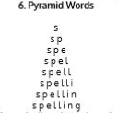  Use Pyramid Words to practise spelling this week’s orange words:  caught, centre, century, certain, circle, complete, consider, continue
9.45-10.00  Active break | LO: To boost my concentration through movement. | Join in with the Go Noodle clip below to get you moving!  https://www.youtube.com/watch?v=aZru-M3TUlI
10.00-11.00  English | SPaG Revision LO: To explore prepositions.  LO: To analyse and interpret a setting description from an extract. | For today’s SPaG Daily Practice, revise your knowledge of prepositions:  https://classroom.thenational.academy/lessons/to-explore-prepositions-74t66r  Follow the link below to have a go at today’s English lesson:  https://classroom.thenational.academy/lessons/to-analyse-and-interpret-a-setting-description-from-an-extract-c9k3jr
11.00- 11.15
Break
11.15-12.15  Maths | LO: To practise my recall of the 10 times table.  LO: To calculate multiplication facts using the distributive law. | Follow the link below to practise the 10 times table and get moving!  https://www.bbc.co.uk/teach/supermovers/ks1-maths-the-10-times-table-with-webster-the-spider/zm32cqt  Follow the link below to have a go at today’s maths lesson:  https://classroom.thenational.academy/lessons/to-calculate-multiplication-facts-using-the-distributive-law-cmvkad
12.15-1.00
Dinner
1.00-1.15  Storytime | LO: To listen to a story for pleasure. | Listen to Chapter 15 of The Green Ember.  https://stories.audible.com/pdp/B00T50R42I?ref=adbl_ent_anon_ds_pdp_plc
1.15-2.30  Topic | LO: To explore how much we rely on electricity. | Follow the link to have a go at today’s lesson:  https://classroom.thenational.academy/lessons/how-much-do-we-rely-on-electricity-cnhkct
2.30-3.00  Music | LO: To recognise time signatures. | Follow the link below to have a go at today’s lesson:  https://classroom.thenational.academy/lessons/recognising-time-signatures-6rv36d

Beat That!
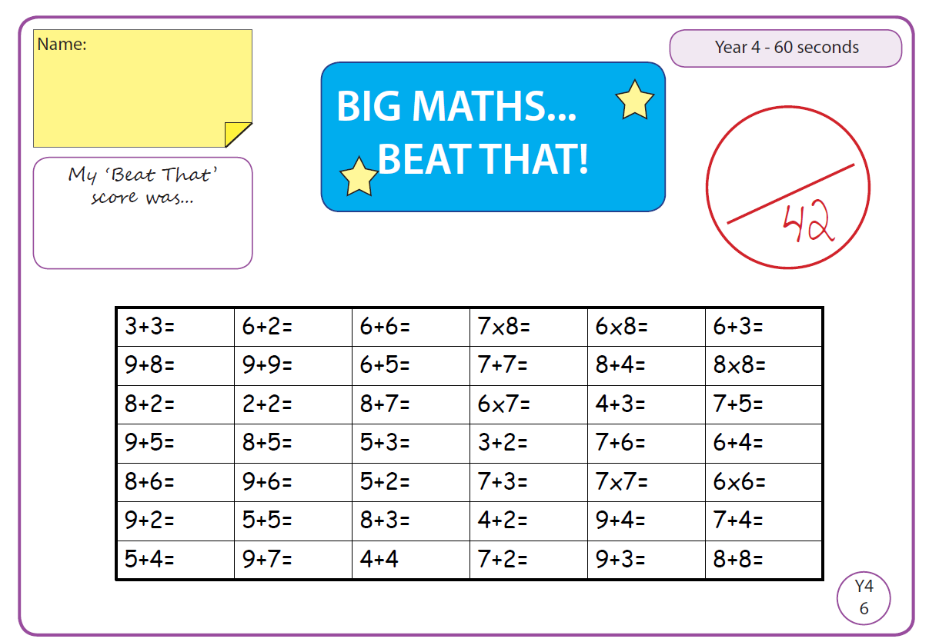

Time and Subject  Tuesday | Learning Objective | Task/Link/Resources
8.45-9.00  Reading | L.O: To practise and consolidate existing reading skills. | Read your individual reading book, either in your head or out loud.
9.00-9.15  Morning Maths | LO: To consolidate recall of number facts.  Revision LO: To explore tenths as decimals. | Complete today’s Beat That- scroll down below today’s timetable to find the questions. Remember, it is the same one every day for a week. Can you beat your own score?  Morning Maths: In Morning Maths today, you are going to revise your knowledge of tenths as decimals. Click the link below, choose Week 1 and select the video Lesson 5 Tenths as decimals:  https://whiterosemaths.com/homelearning/summer-archive/year-3/
9.15-9.45  Spelling | LO: To practise Year 3/4 Common Exception words. | This week, we are going to practise spelling some of our tricky orange words!  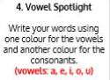  Use Vowel Spotlight to practise spelling this week’s words:  caught, centre, century, certain, circle, complete, consider, continue
9.45-10.00  Active break | L.O: To boost my concentration through movement. | Join in with the Go Noodle clip below to get you moving!  https://www.youtube.com/watch?v=wIYys4iDtHo
10.00-11.00  English | SPaG Revision LO: To explore conjunctions.  LO: To practise and apply our knowledge of the suffixes -ary and -ery. | For today’s SPaG Daily Practice, click the link below to revise your knowledge of conjunctions:  https://classroom.thenational.academy/lessons/to-explore-conjunctions-c4wkee  Follow the link below to have a go at today’s English lesson:  https://classroom.thenational.academy/lessons/to-practise-and-apply-knowledge-of-suffixes-ary-ery-c4r3ce
11.00- 11.15
Break
11.15-12.15  Maths | LO: To practise my recall of the 10 times table.  LO: To solve two-step multiplication problems using the distributive law. | Follow the link below to practise the 10 times table:  https://www.timestables.co.uk/10-times-table.html  Follow the link below to have a go at today’s maths lesson:  https://classroom.thenational.academy/lessons/solving-2-digit-multiplication-calculations-using-the-distributive-law-6rr30d
12.15-1.00
Dinner
1.00-1.15  Storytime | LO: To listen to a story for pleasure. | Listen to Chapter 16 of The Green Ember.  https://stories.audible.com/pdp/B00T50R42I?ref=adbl_ent_anon_ds_pdp_plc
1.15-2.30  Topic-R.E | LO: To explore how the religion of Islam began. | Follow the link below to have a go at today’s lesson:  https://classroom.thenational.academy/lessons/how-did-the-religion-of-islam-begin-74vk2r
2.30-3.00  French | LO: To learn the months of the year in French. | Follow the link below to have a go at today’s lesson:  https://www.youtube.com/watch?v=Jzbs17EVKlw  Join in with this song:  https://www.youtube.com/watch?v=7_u2SigckNQ

Beat That!

Time and Subject  Wednesday | Learning Objective | Task/Link/Resources
8.45-9.00  Reading | L.O: To practise and consolidate existing reading skills. | Read your individual reading book, either in your head or out loud.
9.00-9.15  Morning Maths | LO: To consolidate recall of number facts.  Revision LO: To explore fractions on a number line. | Complete today’s Beat That- scroll down below today’s timetable to find the questions. Remember, it is the same one every day for a week. Can you beat your own score?  Morning Maths: In Morning Maths today, you are going to revise your knowledge of fractions. Click the link below, choose Week 2 and select the video Lesson 1 Fractions on a number line:  https://whiterosemaths.com/homelearning/summer-archive/year-3/
9.15-9.45  Spelling | LO: To practise Year 3/4 Common Exception words. | This week, we are going to practise spelling some of our tricky orange words.  Use Rainbow Words to practise spelling this week’s words:  caught, centre, century, certain, circle, complete, consider, continue
9.45-10.00  Active break | LO: To boost my concentration through movement. | Join in with the Go Noodle clip below to get you moving!  https://www.youtube.com/watch?v=sWH4fJ0pt-I
10.00-11.00  English | SPaG Revision LO: To explore complex sentences.  LO: To plan the opening. | For today’s SPaG Daily Practice, revise your knowledge of complex sentences. Click the link below for today’s lesson:  https://classroom.thenational.academy/lessons/to-explore-complex-sentences-60t66c  Follow the link below to have a go at today’s English lesson:  https://classroom.thenational.academy/lessons/to-plan-the-opening-6rrk0e
11.00- 11.15
Break
11.15-12.15  Maths | LO: To practise my recall of the 10 times table.  LO: To solve three one-digit multiplication calculations. | Follow the link below to practise the 10 times table and get moving!  https://www.youtube.com/watch?v=8yxMJUHBslY  Follow the link below to have a go at today’s maths lesson:  https://classroom.thenational.academy/lessons/solving-three-1-digit-multiplication-equations-60rkat
12.15-1.00
Dinner
1.00-1.15  Storytime | LO: To listen to a story for pleasure. | Listen to Chapter 17 of The Green Ember.  https://stories.audible.com/pdp/B00T50R42I?ref=adbl_ent_anon_ds_pdp_plc
1.15-2.30  Topic-R.E | LO: To understand what Muslims believe. | Follow the link to have a go at today’s lesson:  https://classroom.thenational.academy/lessons/what-do-muslims-believe-cnk3je
2.30-3.00  RHE | LO: To identify human rights and how they protect people. | Follow the link to have a go at today’s lesson:  https://classroom.thenational.academy/lessons/i-have-a-dream-crtkjd

Beat That!

Time and Subject  Thursday | Learning Objective | Task/Link/Resources
8.45-9.00  Reading | L.O: To practise and consolidate existing reading skills. | Read your individual reading book, either in your head or out loud.
9.00-9.15  Morning Maths | LO: To consolidate recall of number facts.  Revision LO: To find fractions of a set of objects. | Complete today’s Beat That- scroll down below today’s timetable to find the questions. Remember, it is the same one every day for a week. Can you beat your own score?  Morning Maths: In Morning Maths today, you are going to revise finding fractions of a set of objects. Click the link below, choose Week 2 and select the video Lesson 2 Fractions of a set of objects (1):  https://whiterosemaths.com/homelearning/summer-archive/year-3/
9.15-9.45  Spelling | LO: To practise Year 3/4 Common Exception words. | This week, we are going to practise spelling some of our tricky orange words.  Use Bubble Letters to practise spelling this week’s words:  caught, centre, century, certain, circle, complete, consider, continue
9.45-10.00  Active break | LO: To boost my concentration through movement. | Join in with the Go Noodle clip below to get you moving!  https://www.youtube.com/watch?v=1b6axyuaKcY
10.00-11.00  English | SPaG Revision LO: To revise our understanding of simple compound and complex sentences.  LO: To write the opening. | For today’s SPaG Daily Practice, we are going to revise our knowledge of simple and complex sentences and how to write them. Click the link to have a go at today’s lesson:  https://classroom.thenational.academy/lessons/to-revise-our-understanding-of-simple-compound-and-complex-sentences-74t64d  Follow the link below to have a go at today’s English lesson:  https://classroom.thenational.academy/lessons/to-write-the-opening-6xk38d
11.00- 11.15
Break
11.15-12.15  Maths | LO: To practise my recall of the 10 times table.  LO: To multiply 3-digit numbers by 1-digit numbers. | Follow the link below to practise the 10 times table:  http://www.snappymaths.com/multdiv/10xtable/interactive/newlook/10xtablebtcd.htm  Follow the link below to have a go at today’s lesson:  https://classroom.thenational.academy/lessons/multiplying-3-digit-numbers-by-1-digit-numbers-60t6ae
12.15-1.00
Dinner
1.00-1.15  Storytime | LO: To listen to a story for pleasure. | Listen to Chapter 18 of The Green Ember.  https://stories.audible.com/pdp/B00T50R42I?ref=adbl_ent_anon_ds_pdp_plc
1.15-3.00  PE | LO: To learn and perform a dance routine. | Follow the link below to learn a dance routine inspired by Trolls!  https://www.youtube.com/watch?v=MCeo6Q3p7Mc

Beat That!

Time and Subject  Friday | Learning Objective | Task/Link/Resources
8.45-9.00  Reading | L.O: To practise and consolidate existing reading skills. | Read your individual reading book, either in your head or out loud.
9.00-9.15  Morning Maths | LO: To consolidate recall of number facts.  Revision LO:  To find fractions of a set of objects. | Complete today’s Beat That- scroll down below today’s timetable to find the questions. Remember, it is the same one every day for a week. Can you beat your own score?  Morning Maths: In Morning Maths today, you are going to revise finding fractions of a set of objects. Click the link below, choose Week 2 and select the video Lesson 3 Fractions of a set of objects (2):  https://whiterosemaths.com/homelearning/summer-archive/year-3/
9.15-9.45  Spelling | LO: To practise Year 3/4 Common Exception words. | This week, we are going to practise spelling some of our tricky orange words.  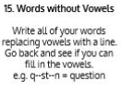  Use Words without Vowels to practise spelling this week’s words:  caught, centre, century, certain, circle, complete, consider, continue  Spelling Test:  Scroll down below today’s timetable to use the look, cover, write, check sheet to help you to test yourself on this week’s words.
9.45-10.00  Active break | L.O: To boost my concentration through movement. | Join in with the Go Noodle clip to get you moving!  https://www.youtube.com/watch?v=psUPYR235O8
10.00-11.00  English | SPaG Revision LO: To understand the two functions of apostrophes.  LO: To practise speech with punctuation. | For today’s SPaG Daily Practice, revise your knowledge of apostrophes. Click the link below to have a go at today’s lesson:  https://classroom.thenational.academy/lessons/to-understand-the-two-functions-of-apostrophes-68vk6t  Follow the link below to have a go at today’s lesson:  https://classroom.thenational.academy/lessons/to-practise-speech-with-punctuation-68rp8e
11.00- 11.15
Break
11.15-12.15  Maths | LO: To practise my recall of the 10 times table.  LO: To multiply 3-digit numbers by 1-digit numbers. | Follow the link below to practise the 10 times table:  http://www.snappymaths.com/multdiv/10xtable/interactive/newlook/10xmissintd.htm  Follow the link below to have a go at today’s lesson:  https://classroom.thenational.academy/lessons/multiplying-3-digit-numbers-by-1-digit-numbers-6ctkjd
12.15-1.00
Dinner
1.00-1.15  Storytime | LO: To listen to a story for pleasure. | Listen to Chapter 19 of The Green Ember.  https://stories.audible.com/pdp/B00T50R42I?ref=adbl_ent_anon_ds_pdp_plc
1.15-3:00  Mindfulness | Golden Time  LO: To practise mindfulness. | Have a go at creating some mindfulness art:  https://www.youtube.com/watch?v=xWhXbBaCfxw  Have a go at mindfulness meditation:  https://www.youtube.com/watch?v=Bk_qU7l-fcU

Beat That!

Spelling Test
