Monday
Time and Subject | Learning Objective | Task/Link/Resources
8.45-9.00  Reading | L.O: To practise and consolidate existing reading skills. | Read your individual reading book, either in your head or out loud.
9.00-9.15  Morning Maths | LO: To consolidate recall of number facts.  Revision LO: To subtract decimals with the same number of decimal places. | Complete today’s Beat That. You will find today’s Beat That below today’s timetable. Just scroll down! Remember, it is the same one every day for a week so try and beat your score each time!  We use Morning Maths as a time to revise concepts and keep them at the front of our minds- follow this link to subtract decimals with the same number of decimals places, use the second link on the video below, click on Summer Term Week 2:  https://whiterosemaths.com/homelearning/summer-archive/year-5/
9.15-9.45  Spelling | LO: To practice Unit Six RWI Spelling words. | Speed write this week’s words- time yourself a minute for each! Check them and correct any mistakes. Write them in different colours or fancy writing, make yourself a poster of each of the words! Circle the consonants and vowels.  infection, international, rejuvenation, antisocial, misrepresentation, calculation, official, conscience, conscious, compete.
9.45-10.00  Active break | L.O: To boost my concentration through movement. | Stand up and off we go:  High knees.  Jumping Jacks.  Hop on one foot, now on the other!  Jump!
10.00-11.00  English | LO: To practise persuasive techniques. | Have a go at today’s lesson by clicking on the link below:  https://classroom.thenational.academy/lessons/to-practise-persuasive-techniques-65hk4t
11.00- 11.15
Break
11.15-12.15  Maths | LO: To express missing number problems algebraically. | Have a go at today’s lesson by clicking on the link below:  https://classroom.thenational.academy/lessons/expressing-missing-number-problems-algebraically-c8v64r
12.15-1.00
Dinner
1.00-1.15  Storytime | LO: To listen to a story for pleasure. | This week we are still listening to Diary of a Sixth Grade Ninja by Marcus Emmerson, remember where you get up to:  https://stories.audible.com/pdp/B07XLV7FSM?ref=adbl_ent_anon_ds_pdp_pc_cntr-4-0
1.15-3.00  PE | LO: To develop fitness and learn a dance sequence. | Have a go at today’s lesson by clicking on the link below:  https://www.youtube.com/watch?v=aNI_WlGS3Cg  https://www.youtube.com/watch?v=EJmpCH9p2X8
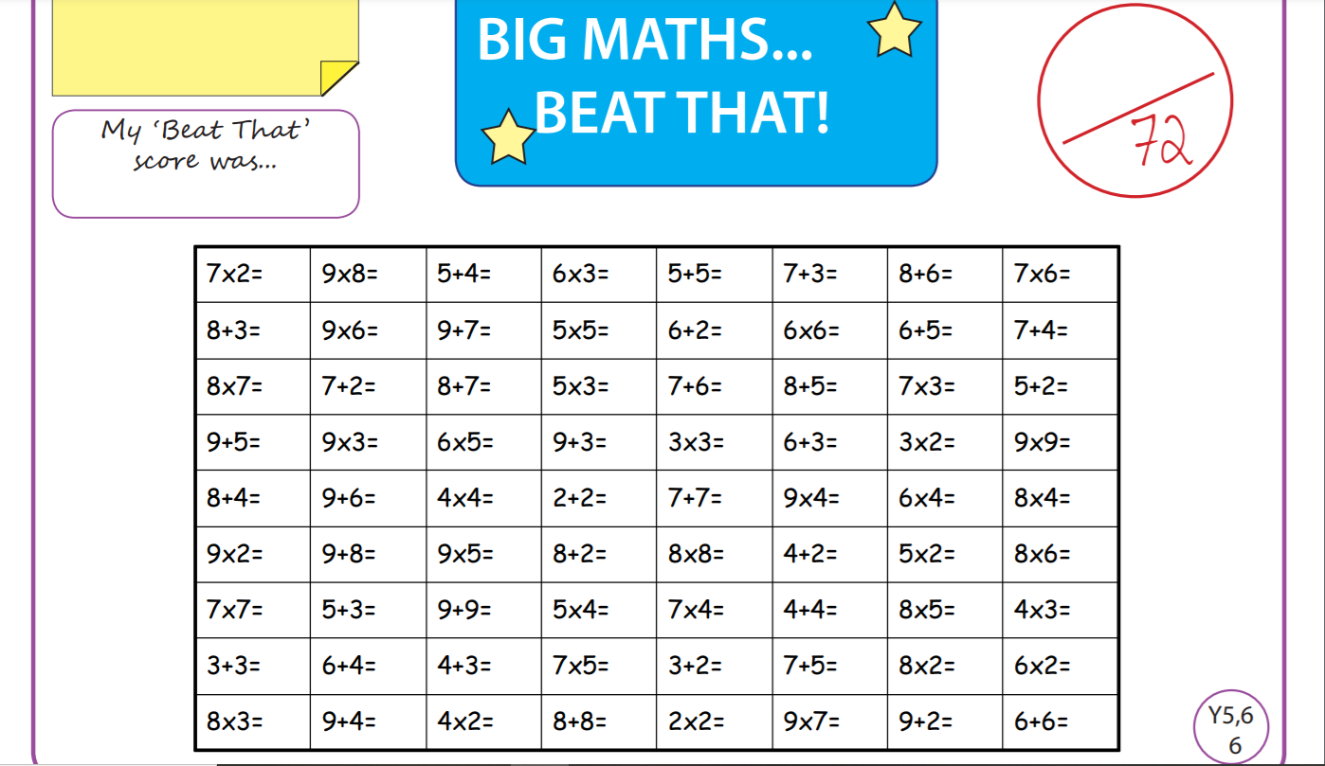
Tuesday
Time and Subject | Learning Objective | Task/Link/Resources
8.45-9.00  Reading | L.O: To practise and consolidate existing reading skills. | Read your individual reading book, either in your head or out loud.
9.00-9.15  Morning Maths | LO: To consolidate recall of number facts.  Revision LO: To add numbers with a different number of decimal places. | Complete today’s Beat That. You will find today’s Beat That below today’s timetable. Just scroll down! Remember, it is the same one every day for a week so try and beat your score each time!  We use Morning Maths as a time to revise concepts and keep them at the front of our minds- follow this link to add numbers with a different number of decimal places. Use the third link on the video below, click on Summer Term Week 2:  https://whiterosemaths.com/homelearning/summer-archive/year-5/
9.15-9.45  Spelling | LO: To practice Unit Six RWI Spelling words. | Speed write this week’s words- time yourself a minute for each! Check them and correct any mistakes. Write them in different colours or fancy writing, make yourself a poster of each of the words! Circle the consonants and vowels.  infection, international, rejuvenation, antisocial, misrepresentation, calculation, official, conscience, conscious, compete.
9.45-10.00  Active break | L.O: To boost my concentration through movement. | Stand up and off we go:  Jump and twist, put your favourite song on and dance!
10.00-11.00  English | LO: To practise and apply knowledge of suffixes er and est comparatives and superlative, including a test. | Have a go at today’s lesson by clicking on the link below:  https://classroom.thenational.academy/lessons/to-practise-and-apply-knowledge-of-suffixes-er-and-est-comparative-and-superlative-including-test-6tjp4c
11.00- 11.15
Break
11.15-12.15  Maths | LO: To find solutions to problems with two variables. | Have a go at today’s lesson by clicking on the link below:  https://classroom.thenational.academy/lessons/finding-solutions-to-problems-with-two-variables-cmt30r
12.15-1.00
Dinner
1.00-1.15  Storytime | LO: To listen to a story for pleasure. | This week we are still listening to Diary of a Sixth Grade Ninja by Marcus Emmerson, remember where you get up to:  https://stories.audible.com/pdp/B07XLV7FSM?ref=adbl_ent_anon_ds_pdp_pc_cntr-4-0
1.15-2.30  Topic  RE | RE LO: To explore how humanists work out what is right or wrong. | Have a go at today’s RE lesson by clicking on the link below:  https://classroom.thenational.academy/lessons/how-do-humanists-work-out-what-is-right-or-wrong-65gk2d
2.30-3.00  RHE | LO: To identify what human rights are and how they protect people. | Follow the link below to have a go at today’s lesson:  https://classroom.thenational.academy/lessons/i-have-a-dream-crtkjd
Wednesday
Time and Subject | Learning Objective | Task/Link/Resources
8.45-9.00  Reading | L.O: To practise and consolidate existing reading skills. | Read your individual reading book, either in your head or out loud.
9.00-9.15  Morning Maths | LO: To consolidate recall of number facts.  Revision LO: To subtract numbers with a different number of decimals places. | Complete today’s Beat That. You will find today’s Beat That below today’s timetable. Just scroll down! Remember, it is the same one every day for a week so try and beat your score each time!  We use Morning Maths as a time to revise concepts and keep them at the front of our minds- follow this link to subtract numbers with a different number of decimals places. Use the fourth video on the link below, click on Summer Term Week 2:  https://whiterosemaths.com/homelearning/summer-archive/year-5/
9.15-9.45  Spelling | LO: To practice Unit Six RWI Spelling words. | Speed write this week’s words- time yourself a minute for each! Check them and correct any mistakes. Write them in different colours or fancy writing, make yourself a poster of each of the words! Circle the consonants and vowels.  infection, international, rejuvenation, antisocial, misrepresentation, calculation, official, conscience, conscious, compete.
9.45-10.00  Active break | L.O: To boost my concentration through movement. | Stand up and off we go:  Jump up into the air three times and then turn to the left and turn to the right!  REPEAT!
10.00-11.00  English | LO: To write the opening of a persuasive letter. | Have a go at today’s lesson by clicking on the link below:  https://classroom.thenational.academy/lessons/to-write-the-opening-of-a-persuasive-letter-ccw66d
11.00- 11.15
Break
11.15-12.15  Maths | LO: To consolidate linear sequences and representing problems with algebra. | Have a go at today’s lesson by clicking on the link below:  https://classroom.thenational.academy/lessons/consolidating-linear-sequences-and-representing-problems-with-algebra-71j3gr
12.15-1.00
Dinner
1.00-1.15  Storytime | LO: To listen to a story for pleasure. | This week we are still listening to Diary of a Sixth Grade Ninja by Marcus Emmerson, remember where you get up to:  https://stories.audible.com/pdp/B07XLV7FSM?ref=adbl_ent_anon_ds_pdp_pc_cntr-4-0
1.15-2.30  Topic  RE | LO: To explore what humanists believe about life and death. | Have a go at today’s RE lesson by clicking on the link below:  https://classroom.thenational.academy/lessons/what-do-humanists-believe-about-life-and-death-6cvkjc
2.30-3.00  Music | LO: To develop our understanding of irregular metre. | Have a go at today’s lesson by clicking on the link below:  https://classroom.thenational.academy/lessons/to-develop-our-understanding-of-irregular-metre-cmr68e
Thursday
Time and Subject | Learning Objective | Task/Link/Resources
8.45-9.00  Reading | L.O: To practise and consolidate existing reading skills. | Read your individual reading book, either in your head or out loud.
9.00-9.15  Morning Maths | LO: To consolidate recall of number facts.  Revision LO: To multiply two digit numbers using an area model. | Complete today’s Beat That. You will find today’s Beat That below today’s timetable. Just scroll down! Remember, it is the same one every day for a week so try and beat your score each time!  We use Morning Maths as a time to revise concepts and keep them at the front of our minds- follow this link to multiply two digit numbers using an area model, use the first video in the link below, click on Summer Term Week 3:  https://whiterosemaths.com/homelearning/summer-archive/year-5/
9.15-9.45  Spelling | LO: To practice Unit Six RWI Spelling words. | Speed write this week’s words- time yourself a minute for each! Check them and correct any mistakes. Write them in different colours or fancy writing, make yourself a poster of each of the words! Circle the consonants and vowels.  infection, international, rejuvenation, antisocial, misrepresentation, calculation, official, conscience, conscious, compete.
9.45-10.00  Active break | L.O: To boost my concentration through movement. | Skip for one minute.  Bounce up and down for one minute.  Walk sideways for one minute.  Jog on the spot for one minute! Repeat!
10.00-11.00  English | LO: To plan the main body of a persuasive letter. | Have a go at today’s lesson by clicking on the link below:  https://classroom.thenational.academy/lessons/to-plan-the-main-body-of-a-persuasive-letter-cgw32d
11.00- 11.15
Break
11.15-12.15  Maths | LO: To reason and problem solve. | Have a go at today’s lesson by clicking on the link below:  https://classroom.thenational.academy/lessons/reasoning-and-problem-solving-6mwkct
12.15-1.00
Dinner
1.00-1.15  Storytime | LO: To listen to a story for pleasure. | This week we are still listening to Diary of a Sixth Grade Ninja by Marcus Emmerson, remember where you get up to:  https://stories.audible.com/pdp/B07XLV7FSM?ref=adbl_ent_anon_ds_pdp_pc_cntr-4-0
1.15-2.30  Topic  RE | LO: To explore how humanists celebrate different life events. | Have a go at today’s RE lesson by clicking on the link below:  https://classroom.thenational.academy/lessons/how-do-humanists-celebrate-different-life-events-69j3ec
2.30-3.00  French | LO: To develop vocabulary. | Follow the link:  https://www.bbc.co.uk/teach/class-clips-video/french-ks2-shopping-for-food/z7ynvk7
Friday
Time and Subject | Learning Objective | Task/Link/Resources
8.45-9.00  Reading | L.O: To practise and consolidate existing reading skills. | Read your individual reading book, either in your head or out loud.
9.00-9.15  Morning Maths | LO: To consolidate recall of number facts.  Revision LO: To multiply 4 digits by 2 digits. | Complete today’s Beat That. You will find today’s Beat That below today’s timetable. Just scroll down! Remember, it is the same one every day for a week so try and beat your score each time!  We use Morning Maths as a time to revise concepts and keep them at the front of our minds- follow this link to multiply 4 digits by 2 digits, use the second video on the link below, click on Summer Term Week 3:  https://whiterosemaths.com/homelearning/summer-archive/year-5/
9.15-9.45  Spelling | LO: To practice Unit Six RWI Spelling words. | Speed write this week’s words- time yourself a minute for each! Check them and correct any mistakes. Write them in different colours or fancy writing, make yourself a poster of each of the words! Circle the consonants and vowels.  infection, international, rejuvenation, antisocial, misrepresentation, calculation, official, conscience, conscious, compete.
9.45-10.00  Active break | L.O: To boost my concentration through movement. | https://www.youtube.com/watch?v=aEIpC4e2aBY  Join in with the Go Noodle clip above to get you moving!
10.00-11.00  English | LO: To write the main body of a persuasive letter. | Have a go at today’s lesson by clicking on the link below:  https://classroom.thenational.academy/lessons/to-write-the-main-body-of-a-persuasive-letter-c4v3jd
11.00- 11.15
Break
11.15-12.15  Maths | LO: To reason and problem solve. | Have a go at today’s lesson by clicking on the link below:  https://classroom.thenational.academy/lessons/reasoning-and-problem-solving-part-2-6cvp4c
12.15-1.00
Dinner
1.00-1.15  Storytime | LO: To listen to a story for pleasure. | This week we are still listening to Diary of a Sixth Grade Ninja by Marcus Emmerson, remember where you get up to:  https://stories.audible.com/pdp/B07XLV7FSM?ref=adbl_ent_anon_ds_pdp_pc_cntr-4-0
1.15-3.00  Golden Time Art | LO: To use resources at home to create art. | Enjoy today’s session by clicking on the link below:  https://youtu.be/0lAYPF9h8G8
