Time and Subject  Monday | Learning Objective | Task/Link/Resources
8.45-9.00  Reading | LO: To practise and consolidate existing reading skills. | Read your individual reading book, either in your head or out loud.
9.00-9.15  Morning Maths | LO: To consolidate recall of number facts.  Revision LO: To multiply by 8. | Complete today’s Beat That- scroll down below today’s timetable to find the questions. Remember, it is the same one every day for a week. Can you beat your own score?  Morning Maths: In Morning Maths today, you are going to revise your knowledge of multiplication. Click the link below and select the video Multiply by 8.  Autumn Week 12 - Number: Multiplication & Division | White Rose Maths
9.15-9.45  Spelling | LO: To revise important spelling rules. | This week, we are going to practise spelling words with the soft ‘c’.  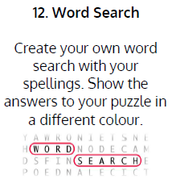  Use Word Search to practise spelling this week’s words:  cell, certain, concentrate, circus, city, concert, cycle, excellent, exercise, except, face, fancy.
9.45-10.00  Active break | LO: To boost my concentration through movement. | Join in with the Go Noodle clip below to get you moving!  Lunch - Blazer Fresh | GoNoodle - YouTube
10.00-11.00  English | SPaG Revision LO: To explore coordinating conjunctions.  LO: To plan a build-up | For today’s SPaG Daily Practice, revise your knowledge of coordinating conjunctions. Watch the videos and complete activity 1.  Coordinating conjunctions - Homeschool lessons in Primary English Year 3 - BBC Bitesize  Follow the link below to have a go at today’s English lesson:  To plan a build-up (thenational.academy)
11.00- 11.15
Break
11.15-12.15  Maths | LO: To practise my recall of the 4 times table.  LO: To use bar models to represent multiplication and division word problems. | Follow the link below to practise the 4 times table and get moving!  KS1 Maths: The 4 Times Table with Cyril the Swan - BBC Teach  Follow the link below to have a go at today’s maths lesson:  Using bar modelling to represent multiplication and division word problems (thenational.academy)
12.15-1.00
Dinner
1.00-1.15  Storytime | LO: To listen to a story for pleasure. | Listen to Chapter 3 of Mark Anchovy: Pizza Detective:  Mark Anchovy: Pizza Detective - World Book Day
1.15-3.00  Topic- Art | LO: To explore different types of paper crafts. | Follow the link below to have a go at today’s lesson:  Exploring paper crafts (thenational.academy)

Beat That!
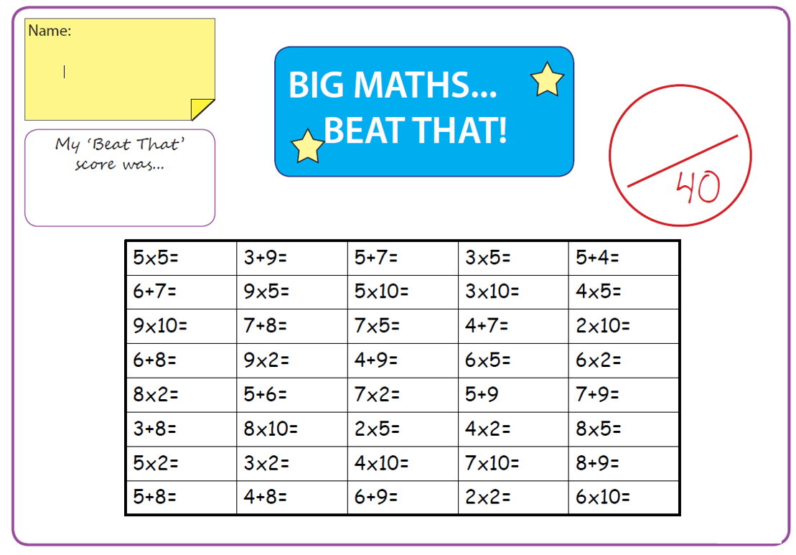
Time and Subject  Tuesday | Learning Objective | Task/Link/Resources
8.45-9.00  Reading | L.O: To practise and consolidate existing reading skills. | Read your individual reading book, either in your head or out loud.
9.00-9.15  Morning Maths | LO: To consolidate recall of number facts.  Revision LO: To divide by 8. | Complete today’s Beat That- scroll down below today’s timetable to find the questions. Remember, it is the same one every day for a week. Can you beat your own score?  Morning Maths: In Morning Maths today, you are going to revise your knowledge of division. Click the link below and select the video Divide by 8.  Autumn Week 12 - Number: Multiplication & Division | White Rose Maths
9.15-9.45  Spelling | LO: To revise important spelling rules. | This week, we are going to practise spelling words with the soft ‘c’.  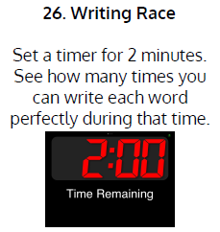  Use Writing Race to practise spelling this week’s words:  cell, certain, concentrate, circus, city, concert, cycle, excellent, exercise, except, face, fancy.
9.45-10.00  Active break | L.O: To boost my concentration through movement. | Join in with the Go Noodle clip below to get you moving!  Line Up - Moose Tube | GoNoodle - YouTube
10.00-11.00  English | SPaG Revision LO: To explore coordinating conjunctions.  LO: To investigate more prefixes. | For today’s SPaG Daily Practice, revise your knowledge of coordinating conjunctions. Watch the videos and complete activity 2.  Coordinating conjunctions - Homeschool lessons in Primary English Year 3 - BBC Bitesize  Follow the link below to have a go at today’s English lesson:  To investigate more prefixes (thenational.academy)
11.00- 11.15
Break
11.15-12.15  Maths | LO: To practise my recall of the 4 times table.  LO: To draw bar models to represent multiplication and division word problems. | Follow the link below to practise the 4 times table:  Coconut Multiples - Reinforce Times Tables (topmarks.co.uk)  Follow the link below to have a go at today’s maths lesson:  Drawing bar models to represent multiplication and division word problems (thenational.academy)
12.15-1.00
Dinner
1.00-1.15  Storytime | LO: To listen to a story for pleasure. | Listen to Chapter 4 of Mark Anchovy: Pizza Detective:  Mark Anchovy: Pizza Detective - World Book Day
1.15-2.30  Topic- Art | LO: To evaluate the work of artists and craftspeople. | Follow the link below to have a go at today’s lesson:  Taking inspiration from artists and craftspeople (thenational.academy)
2.30-3.00  French | LO: To revise introducing yourself in French. | Follow the link below to have a go at today’s lesson:  French Language Live Lesson | Learn French with Twinkl - YouTube

Beat That!

Time and Subject  Wednesday | Learning Objective | Task/Link/Resources
8.45-9.00  Reading | L.O: To practise and consolidate existing reading skills. | Read your individual reading book, either in your head or out loud.
9.00-9.15  Morning Maths | LO: To consolidate recall of number facts.  Revision LO: To practise the 8 times table. | Complete today’s Beat That- scroll down below today’s timetable to find the questions. Remember, it is the same one every day for a week. Can you beat your own score?  Morning Maths: In Morning Maths today, you are going to revise your knowledge of multiplication. Click the link below and select the video The 8 times table.  Autumn Week 12 - Number: Multiplication & Division | White Rose Maths
9.15-9.45  Spelling | LO: To revise important spelling rules. | This week, we are going to practise spelling words with the soft ‘c’.  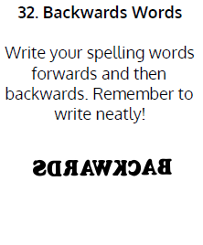  Use Backwards Words to practise spelling this week’s words:  cell, certain, concentrate, circus, city, concert, cycle, excellent, exercise, except, face, fancy.
9.45-10.00  Active break | LO: To boost my concentration through movement. | Join in with the Go Noodle clip below to get you moving!  Tune In To Your World - GoNoodle
10.00-11.00  English | SPaG Revision LO: To explore synonyms and antonyms.  LO: To understand the two functions of apostrophes. | For today’s SPaG Daily Practice, revise your knowledge of synonyms and antonyms. Watch the video and complete activity 1.  Exploring synonyms and antonyms - Year 3 - P4 - English - Catch Up Lessons - Home Learning with BBC Bitesize - BBC Bitesize  Follow the link below to have a go at today’s English lesson:  To understand the two functions of apostrophes (thenational.academy)
11.00- 11.15
Break
11.15-12.15  Maths | LO: To practise my recall of the 4 times table.  LO: To use bar models to represent measurement problems. | Follow the link below to practise the 4 times table:  4x Table (Four Times Table) Practice (snappymaths.com)  Follow the link below to have a go at today’s maths lesson:  Using bar models to represent measurement problems (thenational.academy)
12.15-1.00
Dinner
1.00-1.15  Storytime | LO: To listen to a story for pleasure. | Listen to Chapter 5 of Mark Anchovy: Pizza Detective:  Mark Anchovy: Pizza Detective - World Book Day
1.15-3.00  Topic- Art | LO: To select and use materials and techniques for crafting. | Follow the link below to have a go at today’s lesson:  Selecting and using materials and techniques for craft making (thenational.academy)

Beat That!
Time and Subject  Thursday | Learning Objective | Task/Link/Resources
8.45-9.00  Reading | L.O: To practise and consolidate existing reading skills. | Read your individual reading book, either in your head or out loud.
9.00-9.15  Morning Maths | LO: To consolidate recall of number facts.  Revision LO: To consolidate the 2, 4 and 8 times table. | Complete today’s Beat That- scroll down below today’s timetable to find the questions. Remember, it is the same one every day for a week. Can you beat your own score?  Morning Maths: In Morning Maths today, you are going to revise your knowledge of multiplication. Click the link below and select the video To consolidate 2, 4 and 8 times table.  Spring Week 1 - Number: Multiplication & Division | White Rose Maths
9.15-9.45  Spelling | LO: To revise important spelling rules. | This week, we are going to practise spelling words with the soft ‘c’.  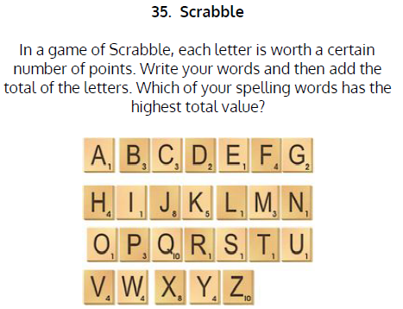  Use Scrabble to practise spelling this week’s words:  cell, certain, concentrate, circus, city, concert, cycle, excellent, exercise, except, face, fancy.
9.45-10.00  Active break | LO: To boost my concentration through movement. | Join in with the Go Noodle clip below to get you moving!  Strengthen Your Focus - Empower Tools | GoNoodle - YouTube
10.00-11.00  English | SPaG Revision LO: To explore synonyms and antonyms.  LO: To write the build-up | For today’s SPaG Daily Practice, revise your knowledge of synonyms and antonyms. Watch the video and complete activity 2.  Exploring synonyms and antonyms - Year 3 - P4 - English - Catch Up Lessons - Home Learning with BBC Bitesize - BBC Bitesize  Follow the link below to have a go at today’s English lesson:  To write the build-up (thenational.academy)
11.00- 11.15
Break
11.15-12.15  Maths | LO: To practise my recall of the 4 times table.  LO: To draw bar models to help us with measuring word problems. | Follow the link below to practise the 4 times table:  4x Table Beat the Clock (snappymaths.com)  Follow the link below to have a go at today’s lesson:  Drawing bar models to help us with measuring word problems (thenational.academy)
12.15-1.00
Dinner
1.00-1.15  Storytime | LO: To listen to a story for pleasure. | Listen to Chapter 6 of Mark Anchovy: Pizza Detective:  Mark Anchovy: Pizza Detective - World Book Day
1.15-3.00  PE | LO: To learn and practise a street dance routine. | Follow the link to have a go at today’s PE activity:  Street dance house masterclass | Physical Education - Street Dance Masterclass - YouTube

Beat That!
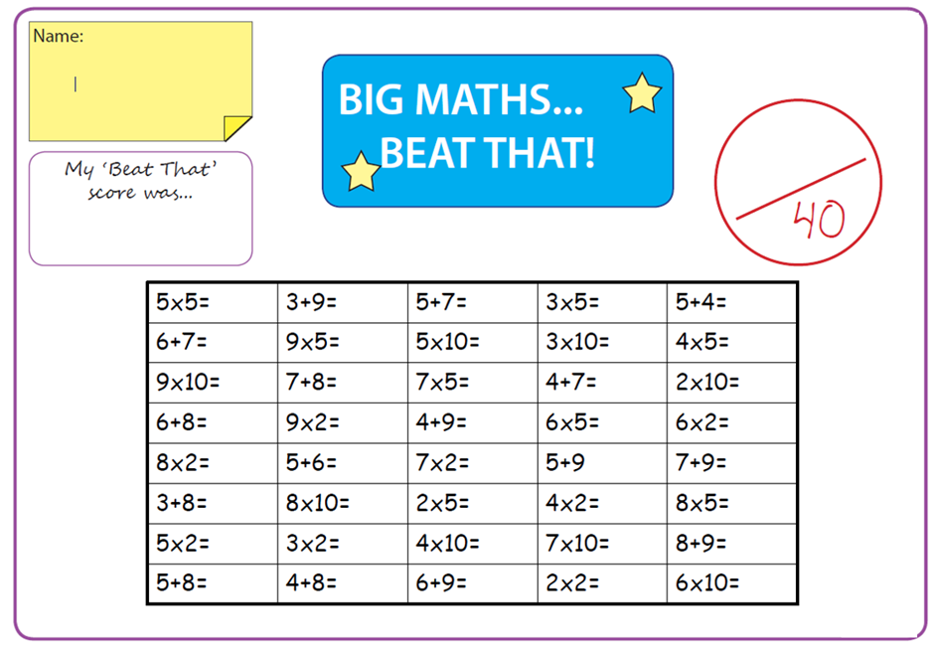

Time and Subject  Friday | Learning Objective | Task/Link/Resources
8.45-9.00  Reading | L.O: To practise and consolidate existing reading skills. | Read your individual reading book, either in your head or out loud.
9.00-9.15  Morning Maths | LO: To consolidate recall of number facts.  Revision LO:  To compare statements. | Complete today’s Beat That- scroll down below today’s timetable to find the questions. Remember, it is the same one every day for a week. Can you beat your own score?  Morning Maths: In Morning Maths today, you are going to revise your knowledge of multiplication. Click the link below and select the video Comparing statements.  Spring Week 1 - Number: Multiplication & Division | White Rose Maths
9.15-9.45  Spelling | LO: To revise important spelling rules. | This week, we are going to practise spelling words with the soft ‘c’.  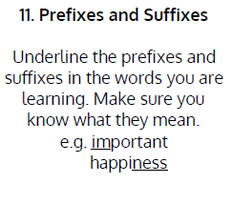  Use Prefixes and Suffixes to practise spelling this week’s words:  cell, certain, concentrate, circus, city, concert, cycle, excellent, exercise, except, face, fancy.  Spelling Test:  Scroll down below today’s timetable to use the look, cover, write, check sheet to help you to test yourself on this week’s words.
9.45-10.00  Active break | L.O: To boost my concentration through movement. | Join in with the Go Noodle clip to get you moving!  Rock Your Body - GoNoodle
10.00-11.00  English | SPaG Revision LO: To explore antonyms and synonyms.  LO: To develop a rich understanding of words associated with clever or sly traits. | For today’s SPaG Daily Practice, revise your knowledge of synonyms and antonyms. Watch the video and complete activity 3.  Exploring synonyms and antonyms - Year 3 - P4 - English - Catch Up Lessons - Home Learning with BBC Bitesize - BBC Bitesize  Follow the link below to have a go at today’s lesson:  To develop a rich understanding of words associated with clever or sly traits (Part 2) (thenational.academy)
11.00- 11.15
Break
11.15-12.15  Maths | LO: To practise my recall of the 4 times table.  LO: To solve problems using measures. | Follow the link below to practise the 4 times table:  4x Table (Missing Value) Practice (snappymaths.com)  Follow the link below to have a go at today’s lesson:  Solving problems using measures (thenational.academy)
12.15-1.00
Dinner
1.00-1.15  Storytime | LO: To listen to a story for pleasure. | Listen to Chapter 7 of Mark Anchovy: Pizza Detective:  Mark Anchovy: Pizza Detective - World Book Day
1.15-3:00  Golden Time | LO: To practise mindfulness. | Have a go at this meditation:  Be Kind To Yourself - Empower Tools | GoNoodle - YouTube  Have a go at this fun Yoga session:  Kids Yoga and Mindfulness all about DOGS! 🐕🐩🐶 - YouTube  You could also choose to complete the art activity included below this week’s timetable.

Beat That!

Spelling Test
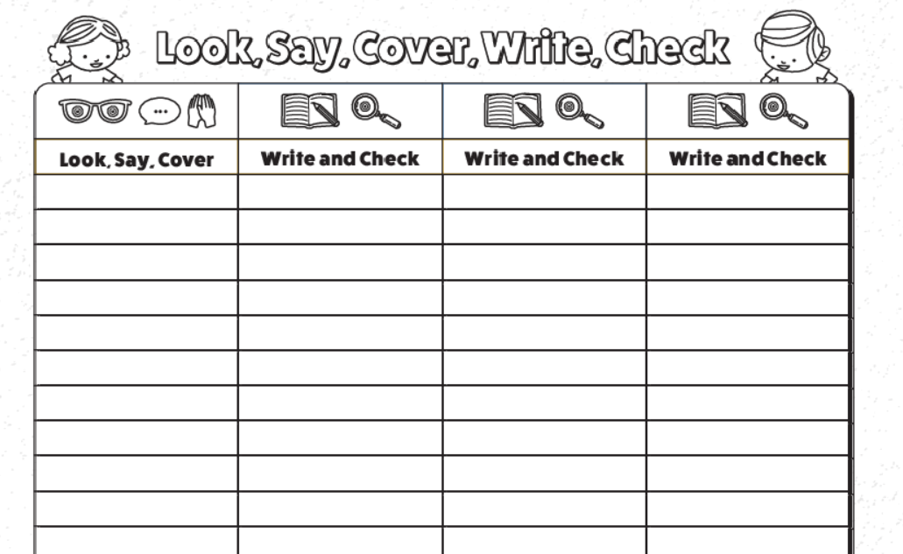

I can create a collage
Can you remember what type of Art we looked at last week? Yes, that is right, sculpture. Today we will be exploring another type of Art called “collage”. Collage involves cutting, ripping and tearing materials and arranging them to create a striking effect. Before we start, take a look at the images below and decide on the style you like the best. Some images use bright colours, others are dull.

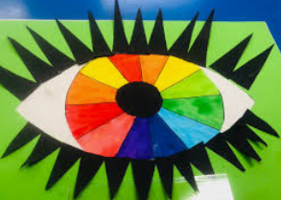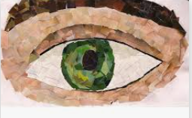

Now you have decided on your style. You will need to get some materials. You will need glue and your choice of material. You now need to place your materials in a way to create an image of an eye.

Good luck and enjoy creating!

