Time and Subject  Monday | Learning Objective | Task/Link/Resources
8.45-9.00  Reading | LO: To practise and consolidate existing reading skills. | Read your individual reading book, either in your head or out loud.
9.00-9.15  Morning Maths | LO: To consolidate recall of number facts.  Revision LO: To compare mass. | Complete today’s Beat That- scroll down below today’s timetable to find the questions. Remember, it is the same one every day for a week. Can you beat your own score?  Morning Maths: In Morning Maths today, you are going to revise your knowledge of mass. Click the link below, choose Summer Term week 11 and select the video Lesson 2 Compare mass:  https://whiterosemaths.com/homelearning/summer-archive/year-3/
9.15-9.45  Spelling | LO: To practise Unit Three RWI spelling words. | This week, we are going to practise adding the prefix auto- to root words. Watch this video to learn how adding auto- changes the meaning of the root word: https://www.youtube.com/watch?v=9IBuM7W0BZY  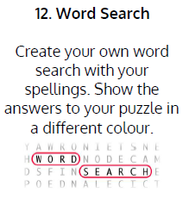  Use the activity above to practise spelling this week’s words:  autobiography, autocue, autograph, automatic, automobile, autopilot
9.45-10.00  Active break | LO: To boost my concentration through movement. | Join in with the Go Noodle clip below to get you moving!  https://www.youtube.com/watch?v=zuQGpGRw02A
10.00-11.00  English | SPaG Revision LO: To explore simple sentences.  LO: To develop an understanding of key characters from The Borrowers. | For today’s SPaG Daily Practice, revise your knowledge of simple sentences:  https://classroom.thenational.academy/lessons/to-explore-simple-sentences-cmwp8r  Follow the link below to have a go at today’s English lesson:  https://classroom.thenational.academy/lessons/to-develop-an-understanding-of-key-characters-from-the-borrowers-cgt36c
11.00- 11.15
Break
11.15-12.15  Maths | LO: To practise my recall of the 2 times table.  LO: To show division and multiplication calculations using pictorial representations. | Follow the link below to practise the 2 times table and get moving!  https://www.bbc.co.uk/teach/supermovers/ks1-maths-the-2-times-table-with-bridget-the-lioness/zrrx92p  Follow the link below to have a go at today’s maths lesson:  https://classroom.thenational.academy/lessons/multiplication-and-division-64r32e
12.15-1.00
Dinner
1.00-1.15  Storytime | LO: To listen to a story for pleasure. | Listen to Chapter 10 of The Green Ember.  https://stories.audible.com/pdp/B00T50R42I?ref=adbl_ent_anon_ds_pdp_plc
1.15-2.30  Topic | LO: To understand what circuit diagrams are. | Follow the link below to have a go at today’s lesson:  https://classroom.thenational.academy/lessons/what-are-circuit-diagrams-6ngk0c
2.30-3.00  Music | LO: To explore 5 beats in a bar. | Follow the link below to have a go at today’s lesson:  https://classroom.thenational.academy/lessons/exploring-5-beats-in-a-bar-cnj3je

Beat That!
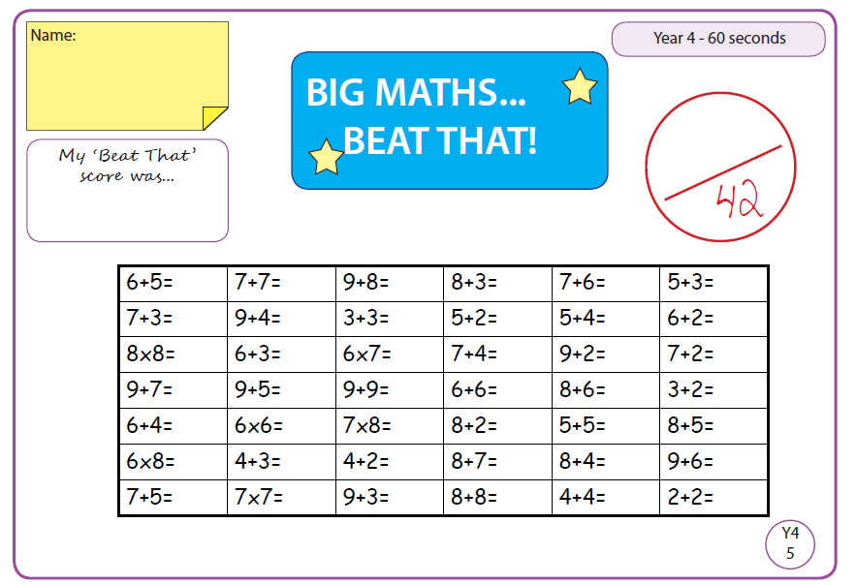

Time and Subject  Tuesday | Learning Objective | Task/Link/Resources
8.45-9.00  Reading | L.O: To practise and consolidate existing reading skills. | Read your individual reading book, either in your head or out loud.
9.00-9.15  Morning Maths | LO: To consolidate recall of number facts.  Revision LO: To add and subtract mass. | Complete today’s Beat That- scroll down below today’s timetable to find the questions. Remember, it is the same one every day for a week. Can you beat your own score?  Morning Maths: In Morning Maths today, you are going to revise your knowledge of measuring mass. Click the link below, choose Summer Term week 11 and select the video Lesson 3 Add and subtract mass:  https://whiterosemaths.com/homelearning/summer-archive/year-3/
9.15-9.45  Spelling | LO: To practise Unit Three RWI spelling words. | This week, we are going to practise adding the prefix auto- to root words.  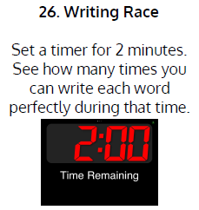  Use Writing Race to practise spelling this week’s words:  autobiography, autocue, autograph, automatic, automobile, autopilot
9.45-10.00  Active break | L.O: To boost my concentration through movement. | Join in with the Go Noodle clip below to get you moving!  https://www.youtube.com/watch?v=M4591BKK-uk
10.00-11.00  English | SPaG Revision LO: To understand what compound sentences are.  LO: To investigate suffixes -ary and -ery. | For today’s SPaG Daily Practice, click the link below to revise your knowledge of compound sentences:  https://classroom.thenational.academy/lessons/to-explore-compound-sentences-6wt3jt  Follow the link below to have a go at today’s English lesson:  https://classroom.thenational.academy/lessons/to-investigate-suffixes-ary-ery-68w6ce
11.00- 11.15
Break
11.15-12.15  Maths | LO: To practise my recall of the 2 times table.  LO: To use bar models to represent word problems. | Follow the link below to practise the 2 times table:  https://www.timestables.co.uk/2-times-table.html  Follow the link below to have a go at today’s maths lesson:  https://classroom.thenational.academy/lessons/representing-word-problems-using-bar-models-c4wpae
12.15-1.00
Dinner
1.00-1.15  Storytime | LO: To listen to a story for pleasure. | Listen to Chapter 11 of The Green Ember.  https://stories.audible.com/pdp/B00T50R42I?ref=adbl_ent_anon_ds_pdp_plc
1.15-2.30  Topic-Science | LO: To understand what insulators and conductors are. | Follow the link below to have a go at today’s lesson:  https://classroom.thenational.academy/lessons/what-are-insulators-and-conductors-6rtp8t
2.30-3.00  French | LO: To practise naming shops in French. | Follow the link below to learn how to say the name of different shops in French:  https://www.youtube.com/watch?v=Cro46M6AuGU

Beat That!

Time and Subject  Wednesday | Learning Objective | Task/Link/Resources
8.45-9.00  Reading | L.O: To practise and consolidate existing reading skills. | Read your individual reading book, either in your head or out loud.
9.00-9.15  Morning Maths | LO: To consolidate recall of number facts.  Revision LO: To understand unit and non-unit fractions. | Complete today’s Beat That- scroll down below today’s timetable to find the questions. Remember, it is the same one every day for a week. Can you beat your own score?  Morning Maths: In Morning Maths today, you are going to revise your knowledge of fractions. Click the link below, choose Week 1 and select the video Lesson 1 Unit and non-unit fractions:  https://whiterosemaths.com/homelearning/summer-archive/year-3/
9.15-9.45  Spelling | LO: To practise Unit Three RWI spelling words. | This week, we are going to practise adding the prefix auto- to root words.  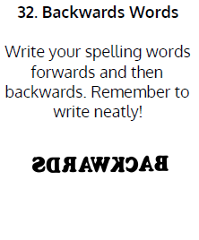  Use Writing Race to practise spelling this week’s words:  autobiography, autocue, autograph, automatic, automobile, autopilot
9.45-10.00  Active break | LO: To boost my concentration through movement. | Join in with the clip below to get you moving!  https://www.youtube.com/watch?v=9xng62RWa_k
10.00-11.00  English | SPaG Revision LO: To explore complex sentences.  LO: To revise our knowledge of word class. | For today’s SPaG Daily Practice, revise your knowledge of complex sentences. Click the link below for today’s lesson:  https://classroom.thenational.academy/lessons/to-explore-complex-sentences-60t66c  Follow the link below to have a go at today’s English lesson:  https://classroom.thenational.academy/lessons/to-revise-our-knowledge-of-word-class-c9k6ct
11.00- 11.15
Break
11.15-12.15  Maths | LO: To practise my recall of the 2 times table.  LO: To use bar models to represent two-step problems. | Follow the link below to practise the 2 times table and get moving!  https://www.youtube.com/watch?v=iiR8hqJeQsw  Follow the link below to have a go at today’s maths lesson:  https://classroom.thenational.academy/lessons/representing-2-step-word-problems-6nhkgt
12.15-1.00
Dinner
1.00-1.15  Storytime | LO: To listen to a story for pleasure. | Listen to Chapter 12 of The Green Ember.  https://stories.audible.com/pdp/B00T50R42I?ref=adbl_ent_anon_ds_pdp_plc
1.15-2.30  Topic-Science | LO: To explore what happens in a circuit when we change the components. | Follow the link to have a go at today’s lesson:  https://classroom.thenational.academy/lessons/what-happens-in-a-circuit-when-we-change-the-components-60wp2r
2.30-3.00  RHE | LO: To understand the need for rules and law in society. | Follow the link to have a go at today’s lesson:  https://classroom.thenational.academy/lessons/the-mayor-making-ceremony-6wwp4c

Beat That!

Time and Subject  Thursday | Learning Objective | Task/Link/Resources
8.45-9.00  Reading | L.O: To practise and consolidate existing reading skills. | Read your individual reading book, either in your head or out loud.
9.00-9.15  Morning Maths | LO: To consolidate recall of number facts.  Revision LO: To use fractions to make a whole. | Complete today’s Beat That- scroll down below today’s timetable to find the questions. Remember, it is the same one every day for a week. Can you beat your own score?  Morning Maths: In Morning Maths today, you are going to revise your knowledge of measuring mass. Click the link below, choose Week 1 and select the video Lesson 2 Making the whole:  https://whiterosemaths.com/homelearning/summer-archive/year-3/
9.15-9.45  Spelling | LO: To practise Unit Three RWI spelling words. | This week, we are going to practise adding the prefix auto- to root words.  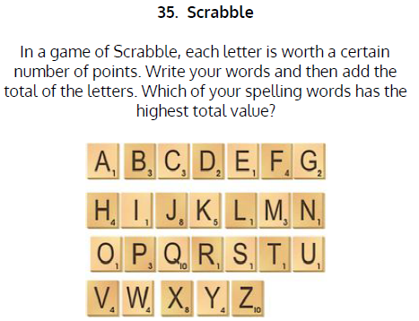  Use Scrabble to practise spelling this week’s words:  autobiography, autocue, autograph, automatic, automobile, autopilot
9.45-10.00  Active break | LO: To boost my concentration through movement. | Join in with the Go Noodle clip below to get you moving!  https://www.youtube.com/watch?v=xjtPMiumixA
10.00-11.00  English | SPaG Revision LO: To understand how to write a complex sentence.  LO: To generate vocabulary for character description. | For today’s SPaG Daily Practice, we are going to revise our knowledge of complex sentences and how to write them. Click the link to have a go at today’s lesson:  https://classroom.thenational.academy/lessons/to-explore-complex-sentences-c8r34r  Follow the link below to have a go at today’s English lesson:  https://classroom.thenational.academy/lessons/to-generate-vocabulary-for-character-description-71h66d
11.00- 11.15
Break
11.15-12.15  Maths | LO: To practise my recall of the 2 times table.  LO: To derive new facts from known multiplication facts. | Follow the link below to practise the 2 times table:  http://www.snappymaths.com/multdiv/2xtable/interactive/newlook/2xtablebtcd.htm  Follow the link below to have a go at today’s lesson:  https://classroom.thenational.academy/lessons/deriving-multiplication-facts-c9k32r
12.15-1.00
Dinner
1.00-1.15  Storytime | LO: To listen to a story for pleasure. | Listen to Chapter 13 of The Green Ember.  https://stories.audible.com/pdp/B00T50R42I?ref=adbl_ent_anon_ds_pdp_plc
1.15-3.00  PE | LO: To learn and perform a dance routine. | Follow the link below to learn a dance routine inspired by Mary Poppins!  https://www.youtube.com/watch?v=hIp15TCx9nw

Beat That!

Time and Subject  Friday | Learning Objective | Task/Link/Resources
8.45-9.00  Reading | L.O: To practise and consolidate existing reading skills. | Read your individual reading book, either in your head or out loud.
9.00-9.15  Morning Maths | LO: To consolidate recall of number facts.  Revision LO:  To understand tenths. | Complete today’s Beat That- scroll down below today’s timetable to find the questions. Remember, it is the same one every day for a week. Can you beat your own score?  Morning Maths: In Morning Maths today, you are going to revise your knowledge of tenths. Click the link below, choose Week 1 and select the video Lesson 3 tenths:  https://whiterosemaths.com/homelearning/summer-archive/year-3/
9.15-9.45  Spelling | LO: To practise Unit Three RWI spelling words. | This week, we are going to practise adding the prefix auto- to root words.  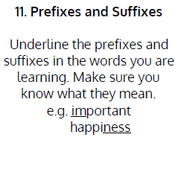  Use Scrabble to practise spelling this week’s words:  autobiography, autocue, autograph, automatic, automobile, autopilot  Spelling Test:  Scroll down below today’s timetable to use the look, cover, write, check sheet to help you to test yourself on this week’s words.
9.45-10.00  Active break | L.O: To boost my concentration through movement. | Join in with the Go Noodle clip to get you moving!  https://www.youtube.com/watch?v=OYL20BXslQc
10.00-11.00  English | SPaG Revision LO: To explore use and identify ‘being’ verbs.  LO: To develop a rich understanding of words associated with large objects. | For today’s SPaG Daily Practice, revise your knowledge of ’being’ verbs. Click the link below to have a go at today’s lesson:  https://classroom.thenational.academy/lessons/to-explore-being-verbs-6mr68r  Follow the link below to have a go at today’s lesson:  https://classroom.thenational.academy/lessons/to-develop-a-rich-understanding-of-words-associated-with-large-objects-6ru68d
11.00- 11.15
Break
11.15-12.15  Maths | LO: To practise my recall of the 2 times table.  LO: To use our times table knowledge to derive division facts. | Follow the link below to practise the 2 times table:  http://www.snappymaths.com/multdiv/2xtable/interactive/newlook/2xmissintd.htm  Follow the link below to have a go at today’s lesson:  https://classroom.thenational.academy/lessons/deriving-division-and-multiplication-facts-6nk62t
12.15-1.00
Dinner
1.00-1.15  Storytime | LO: To listen to a story for pleasure. | Listen to Chapter 14 of The Green Ember.  https://stories.audible.com/pdp/B00T50R42I?ref=adbl_ent_anon_ds_pdp_plc
1.15-3:00  Art | Golden Time  LO: To create optical illusion art. | Have fun creating some optical illusion art:  https://www.youtube.com/watch?v=98OrhVDGlWA

Beat That!

Spelling Test
