Time and Subject | Learning Objective | Task/Link/Resources
8.45-9.00  Reading | L.O: To practise and consolidate existing reading skills. | Read your individual reading book, either in your head or out loud.
9.00-9.15  Morning Maths | LO: To consolidate recall of number facts. | Complete today’s Beat That. You will find today’s Beat That below today’s timetable. Just scroll down! Remember, it is the same one every day for a week so try and beat your score each time!
9.15-9.45  Spelling | LO: To practice Unit Three RWI Spelling words. | Speed write this week’s words- time yourself a minute for each! Check them and correct any mistakes. Write them in different colours or fancy writing, make yourself a poster of each of the words! Circle the consonants and vowels.  Week 5 – adaptable adorable bearable beatable believable breakable changeable comfortable enjoyable
9.45-10.00  Active break | L.O: To boost my concentration through movement. | https://www.youtube.com/watch?v=FRnEDoVRaa0  Join in with the Go Noodle clip above to get you moving!
10.00-11.00  English | LO: To analyse a clip and generate vocabulary part two. | Have a go at today’s lesson by clicking on the link below:  https://classroom.thenational.academy/lessons/to-analyse-a-clip-and-generate-vocabulary-part-2-6mukjd
11.00- 11.15
Break
11.15-12.15  Maths | LO: To use factors to multiply. | Have a go at today’s lesson by clicking on the link below:  https://classroom.thenational.academy/lessons/using-factors-to-multiply-6wtp4r
12.15-1.00
Dinner
1.00-1.15  Storytime | LO: To listen to a story for pleasure. | Continue listening to Anne of Green Gables, remember where you get up to for next time:  https://stories.audible.com/pdp/B01KGL13FI?ref=adbl_ent_anon_ds_pdp_pc_cntr-3-3
1.15-2.30  PE | LO: To learn a dance sequence and develop fitness. | Click on the links below to have a go at today’s lesson:  https://www.youtube.com/watch?v=lc1Ag9m7XQo  https://www.youtube.com/watch?v=GZuEnbSwOto
Monday
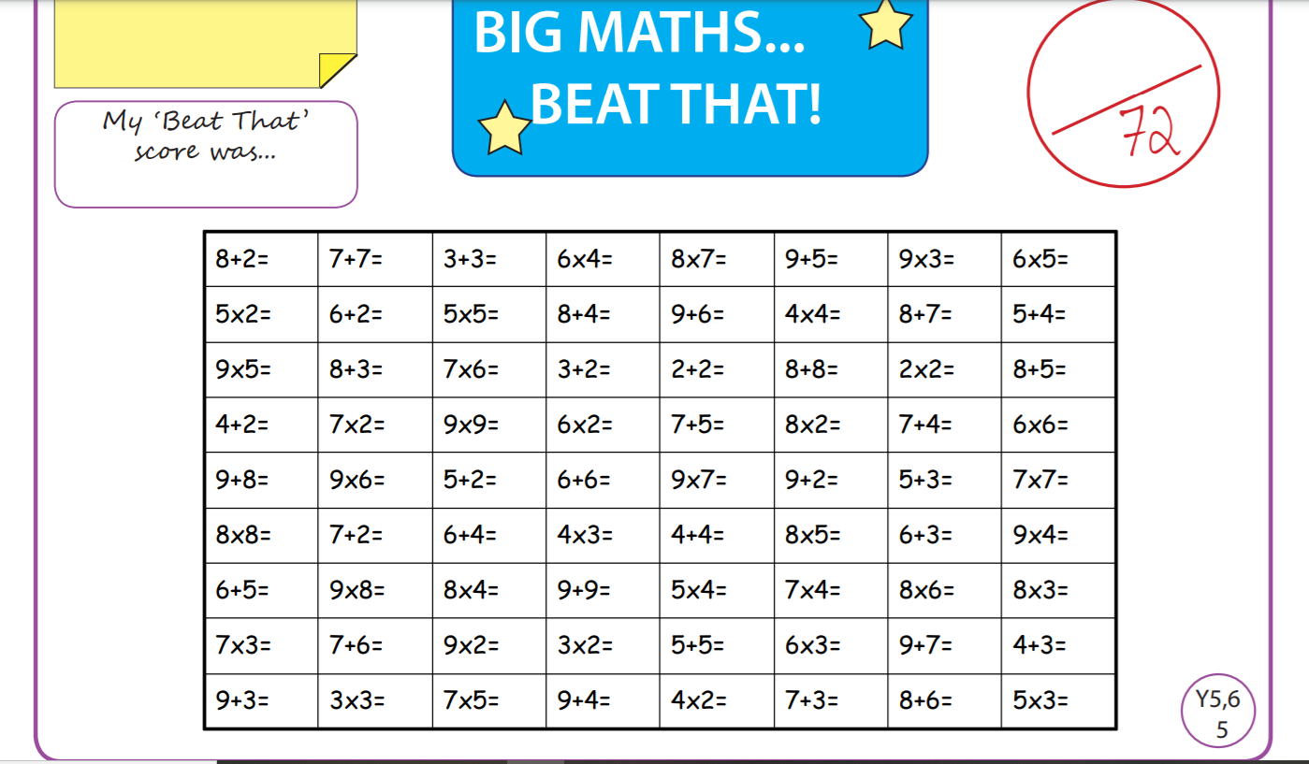

Tuesday
Time and Subject | Learning Objective | Task/Link/Resources
8.45-9.00  Reading | L.O: To practise and consolidate existing reading skills. | Read your individual reading book, either in your head or out loud.
9.00-9.15  Morning Maths | LO: To consolidate recall of number facts. | Complete today’s Beat That. You will find today’s Beat That below today’s timetable. Just scroll down! Remember, it is the same one every day for a week so try and beat your score each time!
9.15-9.45  Spelling | LO: To practice Unit Three RWI Spelling words. | Speed write this week’s words- time yourself a minute for each! Check them and correct any mistakes. Write them in different colours or fancy writing, make yourself a poster of each of the words! Circle the consonants and vowels.  Week 5 – adaptable adorable bearable beatable believable breakable changeable comfortable enjoyable
9.45-10.00  Active break | L.O: To boost my concentration through movement. | https://www.youtube.com/watch?v=7Li2qwdUsxU  Join in with the Go Noodle clip above to get you moving!
10.00-11.00  English | LO: To investigate the suffixes ant and ent. | Have a go at today’s lesson by clicking on the link below:  https://classroom.thenational.academy/lessons/to-investigate-the-suffixes-ant-and-ent-60t6cd
11.00- 11.15
Break
11.15-12.15  Maths | LO: To use multiples to divide. | Have a go at today’s lesson by clicking on the link below:  https://classroom.thenational.academy/lessons/using-multiples-to-divide-6cw3gd
12.15-1.00
Dinner
1.00-1.15  Storytime | LO: To listen to a story for pleasure. | Continue listening to Anne of Green Gables, remember where you get up to for next time:  https://stories.audible.com/pdp/B01KGL13FI?ref=adbl_ent_anon_ds_pdp_pc_cntr-3-3
1.15-2.30  Topic  Science | LO: To learn about contact forces. | Have a go at today’s lesson by clicking on the link below:  https://classroom.thenational.academy/lessons/what-are-contact-forces-74t3gc
2.30-3.00  RHE | LO: To understand the need for rules and laws in a community. | Have a go at today’s lesson by clicking on the link below:  https://classroom.thenational.academy/lessons/the-mayor-making-ceremony-6wwp4c

Wednesday
Time and Subject | Learning Objective | Task/Link/Resources
8.45-9.00  Reading | L.O: To practise and consolidate existing reading skills. | Read your individual reading book, either in your head or out loud.
9.00-9.15  Morning Maths | LO: To consolidate recall of number facts. | Complete today’s Beat That. You will find today’s Beat That below today’s timetable. Just scroll down! Remember, it is the same one every day for a week so try and beat your score each time!
9.15-9.45  Spelling | LO: To practice Unit Three RWI Spelling words. | Speed write this week’s words- time yourself a minute for each! Check them and correct any mistakes. Write them in different colours or fancy writing, make yourself a poster of each of the words! Circle the consonants and vowels.  Week 5 – adaptable adorable bearable beatable believable breakable changeable comfortable enjoyable
9.45-10.00  Active break | L.O: To boost my concentration through movement. | Get out any jitters by shaking:  Your right hand 10 times.  Your left hand 10 times.  Your right leg 10 times.  Your left leg 10 times.  Now count down and do the same for 9 to 1!
10.00-11.00  English | LO: To explore the functions of fronted adverbials. | Have a go at today’s lesson by clicking on the link below:  https://classroom.thenational.academy/lessons/to-explore-the-functions-of-fronted-adverbials-6dhpcc
11.00- 11.15
Break
11.15-12.15  Maths | LO: To solve division problems using short division. | Have a go at today’s lesson by clicking on the link below:  https://classroom.thenational.academy/lessons/short-division-6gt64d
12.15-1.00
Dinner
1.00-1.15  Storytime | LO: To listen to a story for pleasure. | Continue listening to Anne of Green Gables, remember where you get up to for next time:  https://stories.audible.com/pdp/B01KGL13FI?ref=adbl_ent_anon_ds_pdp_pc_cntr-3-3
1.15-2.30  Topic  Science | LO: To investigate gravity. | Have a go at today’s lesson by clicking on the link below:  https://classroom.thenational.academy/lessons/what-are-non-contact-forces-6djkgd
2.30-3.00  Music | LO: To explore ostinatos. | Have a go at today’s lesson by clicking on the link below:  https://classroom.thenational.academy/lessons/to-explore-ostinatos-6wvk8t
Thursday
Time and Subject | Learning Objective | Task/Link/Resources
8.45-9.00  Reading | L.O: To practise and consolidate existing reading skills. | Read your individual reading book, either in your head or out loud.
9.00-9.15  Morning Maths | LO: To consolidate recall of number facts. | Complete today’s Beat That. You will find today’s Beat That below today’s timetable. Just scroll down! Remember, it is the same one every day for a week so try and beat your score each time!
9.15-9.45  Spelling | LO: To practice Unit Three RWI Spelling words. | Speed write this week’s words- time yourself a minute for each! Check them and correct any mistakes. Write them in different colours or fancy writing, make yourself a poster of each of the words! Circle the consonants and vowels.  Week 5 – adaptable adorable bearable beatable believable breakable changeable comfortable enjoyable
9.45-10.00  Active break | L.O: To boost my concentration through movement. | Join in:  https://www.youtube.com/watch?v=40uEcTuqIvM
10.00-11.00  English | LO: To practise conveying character through verb and adverb choices. | Have a go at today’s lesson by clicking on the link below:  https://classroom.thenational.academy/lessons/to-practise-conveying-character-through-verb-and-adverb-choices-cnjkad
11.00- 11.15
Break
11.15-12.15  Maths | LO: To explore division with remainders. | Have a go at today’s lesson by clicking on the link below:  https://classroom.thenational.academy/lessons/division-with-remainders-ccwk6r
12.15-1.00
Dinner
1.00-1.15  Storytime | LO: To listen to a story for pleasure. | Continue listening to Anne of Green Gables, remember where you get up to for next time:  https://stories.audible.com/pdp/B01KGL13FI?ref=adbl_ent_anon_ds_pdp_pc_cntr-3-3
1.15-2.30  Topic  Science | LO: To investigate which factors affect an object’s ability to float. | Have a go at today’s lesson by clicking on the link below:  https://classroom.thenational.academy/lessons/which-factors-affect-an-objects-ability-to-float-ccv3ac
2.30-3.00  French | LO: To develop vocabulary. | Follow the link:  https://www.bbc.co.uk/teach/class-clips-video/french-ks2-favourite-hobbies/z4hxpg8
Friday
Time and Subject | Learning Objective | Task/Link/Resources
8.45-9.00  Reading | L.O: To practise and consolidate existing reading skills. | Read your individual reading book, either in your head or out loud.
9.00-9.15  Morning Maths | LO: To consolidate recall of number facts. | Complete today’s Beat That. You will find today’s Beat That below today’s timetable. Just scroll down! Remember, it is the same one every day for a week so try and beat your score each time!
9.15-9.45  Spelling | LO: To practice Unit Three RWI Spelling words. | Speed write this week’s words- time yourself a minute for each! Check them and correct any mistakes. Write them in different colours or fancy writing, make yourself a poster of each of the words! Circle the consonants and vowels.  Week 5 – adaptable adorable bearable beatable believable breakable changeable comfortable enjoyable  Test yourself using the Look, Cover, Say, Write, Check grid at the bottom.
9.45-10.00  Active break | L.O: To boost my concentration through movement. | Join in:  https://www.youtube.com/watch?v=OYL20BXslQc
10.00-11.00  English | LO: To develop a rich understanding of words associated with hunger or thirst part two. | Have a go at today’s lesson by clicking on the link below:  https://classroom.thenational.academy/lessons/to-develop-a-rich-understanding-of-words-associated-with-hunger-or-thirst-part-2-ctjp8t
11.00- 11.15
Break
11.15-12.15  Maths | LO: To consolidate and review learning. | Have a go at today’s lesson by clicking on the link below:  https://classroom.thenational.academy/lessons/consolidation-and-review-ccr62t
12.15-1.00
Dinner
1.00-1.15  Storytime | LO: To listen to a story for pleasure. | Continue listening to Anne of Green Gables, remember where you get up to for next time:  https://stories.audible.com/pdp/B01KGL13FI?ref=adbl_ent_anon_ds_pdp_pc_cntr-3-3
1.15-3:00  Golden Time Art | LO: To develop drawing skills. | Enjoy today’s session with the link below:  https://www.youtube.com/watch?v=Wvj3HecVX_s&feature=youtu.be
s
