Time and Subject  Monday | Learning Objective | Task/Link/Resources
8.45-9.00  Reading | LO: To practise and consolidate existing reading skills. | Read your individual reading book, either in your head or out loud.
9.00-9.15  Morning Maths | LO: To consolidate recall of number facts.  Revision LO: To multiply a 2-digit number by a 1-digit number. | Complete today’s Beat That- scroll down below today’s timetable to find the questions. Remember, it is the same one every day for a week. Can you beat your own score?  Morning Maths: In Morning Maths today, you are going to revise your knowledge of multiplication and division. Click the link below and select the video Multiply 2-digits by 1-digit (1).  Spring Week 2 - Number: Multiplication & Division | White Rose Maths
9.15-9.45  Spelling | LO: To practise Year 3/4 Common Exception words. | This week, we are going to practise spelling some of our tricky orange words!  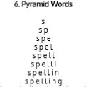  Use Pyramid Words to practise spelling this week’s orange words:  therefore, though, thought, through, various, weight, woman, women.
9.45-10.00  Active break | LO: To boost my concentration through movement. | Join in with the Go Noodle clip below to get you moving!  Not Dog Time Machine - GoNoodle
10.00-11.00  English | SPaG Revision LO: To use fronted adverbials.  LO: To plan the quotes paragraph of a newspaper report. | For today’s SPaG Daily Practice, revise your knowledge of fronted adverbials. Watch the videos and complete activity 1.  Using fronted adverbials - Year 4 - P5 - English - Catch Up Lessons - Home Learning with BBC Bitesize - BBC Bitesize  Follow the link below to have a go at today’s English lesson:  To plan the quotes paragraph of a newspaper report (thenational.academy)
11.00- 11.15
Break
11.15-12.15  Maths | LO: To practise my recall of the 3 times table.  LO: To compare and order angles. | Follow the link below to practise the 3 times table and get moving!  KS2 Maths: The 3 Times Table - BBC Teach  Follow the link below to have a go at today’s maths lesson:  Shape and symmetry: To compare and order angles (thenational.academy)
12.15-1.00
Dinner
1.00-1.15  Storytime | LO: To listen to a story for pleasure. | Listen to Chapter 2 of Ladybird Audio Adventures: The Frozen World:  Ladybird Audio Adventures: The Frozen World - World Book Day
1.15-3.00  Topic- DT | LO: To design for a target market. | Follow the link below to have a go at today’s lesson:  Designing for a target market (thenational.academy)
Beat That!
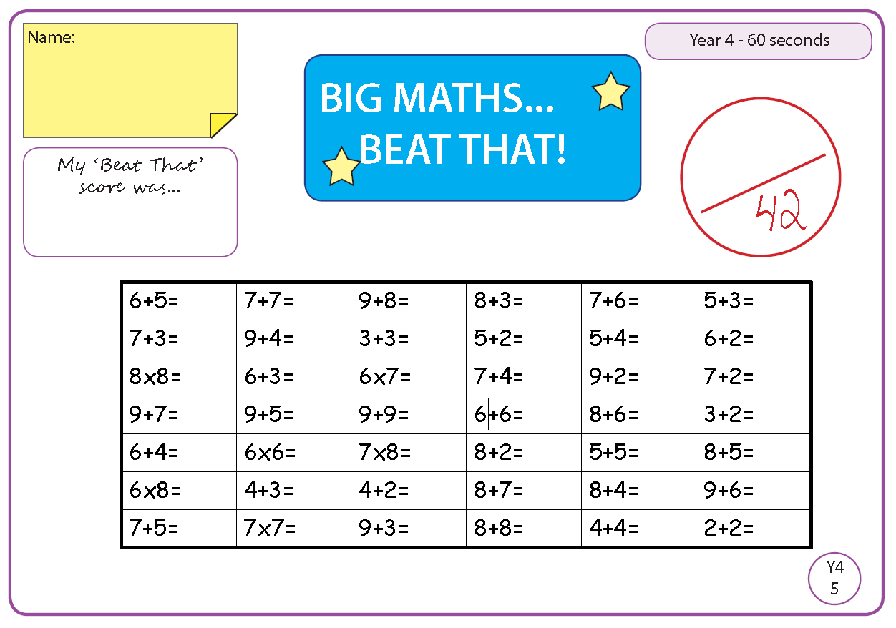
Time and Subject  Tuesday | Learning Objective | Task/Link/Resources
8.45-9.00  Reading | L.O: To practise and consolidate existing reading skills. | Read your individual reading book, either in your head or out loud.
9.00-9.15  Morning Maths | LO: To consolidate recall of number facts.  Revision LO: To multiply a 2-digit number by a 1-digit number. | Complete today’s Beat That- scroll down below today’s timetable to find the questions. Remember, it is the same one every day for a week. Can you beat your own score?  Morning Maths: In Morning Maths today, you are going to revise your knowledge of multiplication and division. Click the link below and select the video Multiply 2-digits by 1-digit.  Spring Week 2 - Number: Multiplication & Division | White Rose Maths
9.15-9.45  Spelling | LO: To practise Year 3/4 Common Exception words. | This week, we are going to practise spelling some of our tricky orange words!  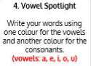  Use Vowel Spotlight to practise spelling this week’s words:  therefore, though, thought, through, various, weight, woman, women.
9.45-10.00  Active break | L.O: To boost my concentration through movement. | Join in with the Go Noodle clip below to get you moving!  I Love Soccer - GoNoodle
10.00-11.00  English | SPaG Revision LO: To use fronted adverbials.  LO: To practise and apply knowledge of homophones. | For today’s SPaG Daily Practice, revise your knowledge of fronted adverbials. Watch the videos and complete activity 2.  Using fronted adverbials - Year 4 - P5 - English - Catch Up Lessons - Home Learning with BBC Bitesize - BBC Bitesize  Follow the link below to have a go at today’s English lesson:  To practise and apply knowledge of homophones, including test (thenational.academy)
11.00- 11.15
Break
11.15-12.15  Maths | LO: To practise my recall of the 3 times table.  LO: To identify right angles. | Follow the link below to practise the 3 times table:  Coconut Multiples - Reinforce Times Tables (topmarks.co.uk)  Follow the link below to have a go at today’s maths lesson:  Shape and symmetry: To identify right angles (thenational.academy)
12.15-1.00
Dinner
1.00-1.15  Storytime | LO: To listen to a story for pleasure. | Listen to Chapter 3 of Ladybird Audio Adventures: The Frozen World:  Ladybird Audio Adventures: The Frozen World - World Book Day
1.15-2.30  Topic- DT | LO: To develop design ideas. | Follow the link below to have a go at today’s lesson:  Developing design ideas (thenational.academy)
2.30-3.00  French | LO: To practise basic French conversation. | Follow the link below to have a go at today’s lesson:  French Language Live Lesson Part One | Learn French with Twinkl - YouTube

Beat That!
Time and Subject  Wednesday | Learning Objective | Task/Link/Resources
8.45-9.00  Reading | L.O: To practise and consolidate existing reading skills. | Read your individual reading book, either in your head or out loud.
9.00-9.15  Morning Maths | LO: To consolidate recall of number facts.  Revision LO: To multiply 3-digit numbers by 1-digit. | Complete today’s Beat That- scroll down below today’s timetable to find the questions. Remember, it is the same one every day for a week. Can you beat your own score?  Morning Maths: In Morning Maths today, you are going to revise your knowledge of multiplication and division. Click the link below and select the video Multiply 3-digits by 1-digit.  Spring Week 2 - Number: Multiplication & Division | White Rose Maths
9.15-9.45  Spelling | LO: To practise Year 3/4 Common Exception words. | This week, we are going to practise spelling some of our tricky orange words.  Use Rainbow Words to practise spelling this week’s words:  therefore, though, thought, through, various, weight, woman, women.
9.45-10.00  Active break | LO: To boost my concentration through movement. | Join in with the Go Noodle clip below to get you moving!  Snack Attack - GoNoodle
10.00-11.00  English | SPaG Revision LO: To use fronted adverbials.  LO: To practise writing direct and reported speech. | For today’s SPaG Daily Practice, revise your knowledge of fronted adverbials. Watch the videos and complete activity 3.  Using fronted adverbials - Year 4 - P5 - English - Catch Up Lessons - Home Learning with BBC Bitesize - BBC Bitesize  Follow the link below to have a go at today’s English lesson:  To practise writing direct and reported speech (thenational.academy)
11.00- 11.15
Break
11.15-12.15  Maths | LO: To practise my recall of the 3 times table.  LO: To identify acute and obtuse angles. | Follow the link below to practise the 3 times table:  3x Table Practice (snappymaths.com)  Follow the link below to have a go at today’s maths lesson:  Shape and symmetry: To identify acute and obtuse angles (thenational.academy)
12.15-1.00
Dinner
1.00-1.15  Storytime | LO: To listen to a story for pleasure. | Listen to Chapter 4 of Ladybird Audio Adventures: The Frozen World:  Ladybird Audio Adventures: The Frozen World - World Book Day
1.15-3.00  Topic- DT | LO: To use ingredients to create your ideas. | Follow the link below to have a go at today’s lesson:  Using ingredients to create your ideas (thenational.academy)

Beat That!
Time and Subject  Thursday | Learning Objective | Task/Link/Resources
8.45-9.00  Reading | L.O: To practise and consolidate existing reading skills. | Read your individual reading book, either in your head or out loud.
9.00-9.15  Morning Maths | LO: To consolidate recall of number facts.  Revision LO: To explore area. | Complete today’s Beat That- scroll down below today’s timetable to find the questions. Remember, it is the same one every day for a week. Can you beat your own score?  Morning Maths: In Morning Maths today, you are going to revise your knowledge of area. Click the link below and select the video What is area?  Spring Week 4 - Measurement: Area | White Rose Maths
9.15-9.45  Spelling | LO: To practise Year 3/4 Common Exception words. | This week, we are going to practise spelling some of our tricky orange words.  Use Bubble Letters to practise spelling this week’s words:  therefore, though, thought, through, various, weight, woman, women.
9.45-10.00  Active break | LO: To boost my concentration through movement. | Join in with the Go Noodle clip below to get you moving!  Let's Unwind - GoNoodle
10.00-11.00  English | SPaG Revision LO: To use fronted adverbials.  LO: To write the quotes paragraph of a newspaper report. | For today’s SPaG Daily Practice, revise your knowledge of fronted adverbials. Watch the videos and complete activity 4.  Using fronted adverbials - Year 4 - P5 - English - Catch Up Lessons - Home Learning with BBC Bitesize - BBC Bitesize  Follow the link below to have a go at today’s English lesson:  To write the quotes paragraph of a newspaper report (thenational.academy)
11.00- 11.15
Break
11.15-12.15  Maths | LO: To practise my recall of the 3 times table.  LO: To investigate angles within shapes. | Follow the link below to practise the 3 times table:  3x Table Beat the Clock (snappymaths.com)  Follow the link below to have a go at today’s lesson:  Shape and symmetry: To investigate angles within shapes (thenational.academy)
12.15-1.00
Dinner
1.00-1.15  Storytime | LO: To listen to a story for pleasure. | Listen to Chapter 1 of Mark Anchovy: Pizza Detective:  Mark Anchovy: Pizza Detective - World Book Day
1.15-3.00  PE | LO: To develop strength and stamina. | Follow the link to have a go at today’s PE activity:  THE COBRA KAI ‘KARATE’ WORKOUT! #GETKIDSMOVING (12mins) - YouTube

Beat That!

Time and Subject  Friday | Learning Objective | Task/Link/Resources
8.45-9.00  Reading | L.O: To practise and consolidate existing reading skills. | Read your individual reading book, either in your head or out loud.
9.00-9.15  Morning Maths | LO: To consolidate recall of number facts.  Revision LO: To find the area. | Complete today’s Beat That- scroll down below today’s timetable to find the questions. Remember, it is the same one every day for a week. Can you beat your own score?  Morning Maths: In Morning Maths today, you are going to revise your knowledge of area. Click the link below and select the video Counting squares.  Spring Week 4 - Measurement: Area | White Rose Maths
9.15-9.45  Spelling | LO: To practise Year 3/4 Common Exception words. | This week, we are going to practise spelling some of our tricky orange words.  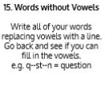  Use Words without Vowels to practise spelling this week’s words:  therefore, though, thought, through, various, weight, woman, women.  Spelling Test:  Scroll down below today’s timetable to use the look, cover, write, check sheet to help you to test yourself on this week’s words.
9.45-10.00  Active break | L.O: To boost my concentration through movement. | Join in with the Go Noodle clip to get you moving!  Emotions Grow and Shrink - GoNoodle
10.00-11.00  English | SPaG Revision LO: To use expanded noun phrases.  LO: To write the closing paragraph of a newspaper report. | For today’s SPaG Daily Practice, revise your knowledge of expanded noun phrases. Watch the videos and complete activity 1.  Expanded noun phrases - Year 4 - P5 - English - Catch Up Lessons - Home Learning with BBC Bitesize - BBC Bitesize  Follow the link below to have a go at today’s lesson:  To write the closing paragraph of a newspaper report (thenational.academy)
11.00- 11.15
Break
11.15-12.15  Maths | LO: To practise my recall of the 3 times table.  LO: To identify angles within shapes. | Follow the link below to practise the 3 times table:  3x Table (Missing Value) Practice (snappymaths.com)  Follow the link below to have a go at today’s lesson:  Shape and symmetry:Identify angles within shapes (thenational.academy)
12.15-1.00
Dinner
1.00-1.15  Storytime | LO: To listen to a story for pleasure. | Listen to Chapter 2 of Mark Anchovy: Pizza Detective:  Mark Anchovy: Pizza Detective - World Book Day
1.15-3:00  Golden Time | LO: To practise mindfulness. | Have a go at this meditation:  Mindfulness Meditation for Kids - 5 Minutes Easy Guided Meditation for Children - YouTube  Have a go at this fun Yoga session:  Saturday Morning Yoga | Pokemon Yoga! - YouTube  You could also choose to complete the art activity included below this week’s timetable.

Beat That!

Spelling Test
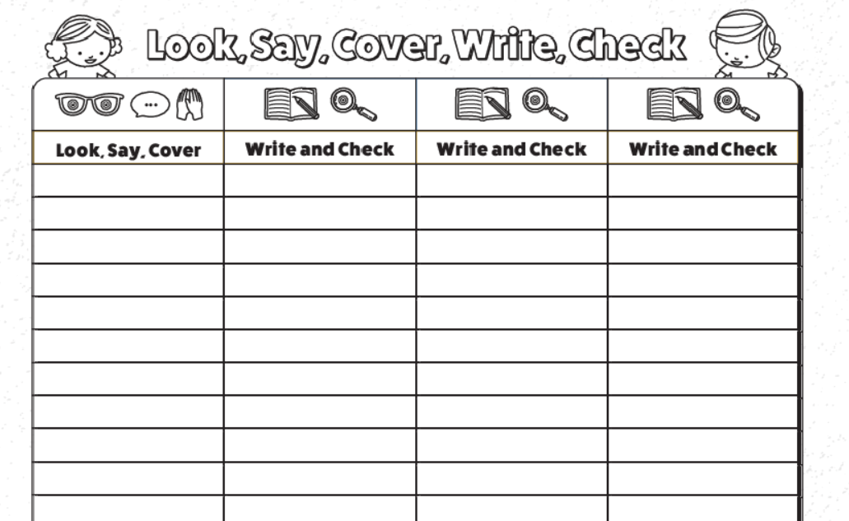

I can create a mosaic.
Can you remember which artist we looked at last week? Yes, that’s right – Gaudi. In today’s lesson we will focus on specifically one of his pieces of artwork - Gaudi’s lizard.
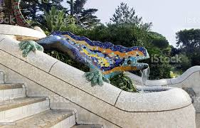
This piece of Gaudi’s art is very famous. It has vibrant colours and is for eye-catching against the plain background. Let’s learn a little bit more about Gaudi. Write down three facts about Gaudi as you watch. . .
https://www.bbc.co.uk/bitesize/clips/zrc87ty

Decorating with tiles was something familiar to Gaudi. We can call this a mosaic. Take a look at the Tate website to see a definition of mosaic.
https://www.tate.org.uk/art/art-terms/m/mosaic#:~:text=A%20mosaic%20is%20a%20picture,inlayed%20into%20floors%20and%20walls
Today’s task is to create a design for simple mosaic. You are going to design on paper so you will need a piece of A4 paper and coloured pencils. When you design your mosaic try to show the individual tiles rather than one coloured line. Your design could be an animal, a plant, a tree or something more abstract. I have included some images below for inspiration.
