Time and Subject  Monday | Learning Objective | Task/Link/Resources
8.45-9.00  Reading | LO: To practise and consolidate existing reading skills. | Read your individual reading book, either in your head or out loud.
9.00-9.15  Morning Maths | LO: To consolidate recall of number facts.  Revision LO: To compare capacity. | Complete today’s Beat That- scroll down below today’s timetable to find the questions. Remember, it is the same one every day for a week. Can you beat your own score?  Morning Maths: In Morning Maths today, you are going to revise your knowledge of capacity. Click the link below, choose Summer Term- Week 12 and select the video Lesson 1 Compare capacity:  https://whiterosemaths.com/homelearning/summer-archive/year-3/
9.15-9.45  Spelling | LO: To practise Year 3/4 common exception words. | This week, we are going to practise spelling some of our tricky orange words!  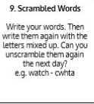  Use Scrambled Words to practise spelling this week’s orange words:  believe, bicycle, breath, breathe, build, busy, business, calendar
9.45-10.00  Active break | LO: To boost my concentration through movement. | Join in with the Go Noodle clip below to get you moving!  https://www.youtube.com/watch?v=d_GNRDic17E
10.00-11.00  English | SPaG Revision LO: To use ‘a’ or ‘an’ appropriately.  LO: To write the diet paragraph of a non-chronological report. | For today’s SPaG Daily Practice, revise when you should use ‘a’ or ‘an’. Click here to have a go at today’s lesson:  https://www.youtube.com/watch?v=lFmPNuR6gxY  Follow the link below to have a go at today’s English lesson:  https://classroom.thenational.academy/lessons/to-write-the-diet-paragraph-of-a-non-chronological-report-69h64e
11.00- 11.15
Break
11.15-12.15  Maths | LO: To practise my recall of the 8 times table.  LO: To apply my knowledge of column addition and subtraction. | Follow the link below to practise the 8 times table and get moving!  https://www.bbc.co.uk/teach/supermovers/ks2-maths-the-8-times-table-with-filbert-fox/z4mrhbk  Follow the link below to have a go at today’s maths lesson:  https://classroom.thenational.academy/lessons/applying-and-consolidating-column-method-for-addition-and-subtraction-cgvpcc
12.15-1.00
Dinner
1.00-1.15  Storytime | LO: To listen to a story for pleasure. | Listen to Chapter 5 of The Green Ember.  https://stories.audible.com/pdp/B00T50R42I?ref=adbl_ent_anon_ds_pdp_plc
1.15-2.30  Topic | LO: To use my knowledge of migration to respond to an important question. | Follow the link below to have a go at today’s lesson:  https://classroom.thenational.academy/lessons/all-migrants-are-forced-to-leave-their-home-to-what-extent-do-you-agree-c8tpac
2.30-3.00  Music | LO: To explore 6 beats in a bar. | Follow the link below to have a go at today’s lesson:  https://classroom.thenational.academy/lessons/exploring-6-beats-in-a-bar-6cw38d

Beat That!
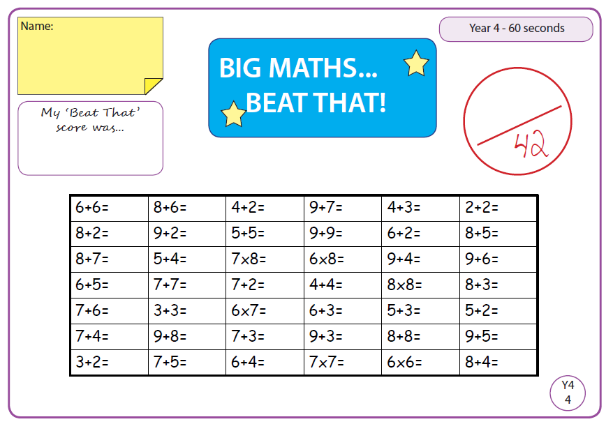

Time and Subject  Tuesday | Learning Objective | Task/Link/Resources
8.45-9.00  Reading | L.O: To practise and consolidate existing reading skills. | Read your individual reading book, either in your head or out loud.
9.00-9.15  Morning Maths | LO: To consolidate recall of number facts.  Revision LO: To add and subtract capacity. | Complete today’s Beat That- scroll down below today’s timetable to find the questions. Remember, it is the same one every day for a week. Can you beat your own score?  Morning Maths: In Morning Maths today, you are going to revise your knowledge of capacity. Click the link below, choose Summer Term- Week 12 and select the video Lesson 2 Add and subtract capacity:  https://whiterosemaths.com/homelearning/summer-archive/year-3/
9.15-9.45  Spelling | LO: To practise Year 3/4 common exception words. | This week, we are going to practise spelling some of our tricky orange words!  Use Scrambled Words to practise spelling this week’s orange words. Can you unscramble the words you scrambled yesterday?  believe, bicycle, breath, breathe, build, busy, business, calendar
9.45-10.00  Active break | L.O: To boost my concentration through movement. | Join in with the Go Noodle clip below to get you moving!  https://www.youtube.com/watch?v=JU0ETGd5dgk
10.00-11.00  English | SPaG Revision LO: To understand what subordinating conjunctions are.  LO: To practise and apply knowledge of more suffixes: Past and present tense. | For today’s SPaG Daily Practice, click the link below to revise your knowledge of subordinating conjunctions:  https://www.bbc.co.uk/bitesize/topics/zwwp8mn/articles/zqk37p3  Follow the link below to have a go at today’s English lesson:  https://classroom.thenational.academy/lessons/to-practise-and-apply-knowledge-of-more-suffixes-past-and-present-tense-including-a-test-74t30c
11.00- 11.15
Break
11.15-12.15  Maths | LO: To practise my recall of the 8 times table.  LO: To use bar models to represent addition and subtraction word problems. | Follow the link below to practise the 8 times table:  https://www.timestables.co.uk/8-times-table.html  Follow the link below to have a go at today’s maths lesson:  https://classroom.thenational.academy/lessons/representing-one-step-word-problems-6mt3ad
12.15-1.00
Dinner
1.00-1.15  Storytime | LO: To listen to a story for pleasure. | Listen to Chapter 6 of The Green Ember.  https://stories.audible.com/pdp/B00T50R42I?ref=adbl_ent_anon_ds_pdp_plc
1.15-2.30  Topic-Science | LO: To understand what static electricity is. | Follow the link below to have a go at today’s lesson:  https://classroom.thenational.academy/lessons/what-is-static-electricity-74tk2t
2.30-3.00  French | LO: To practise naming body parts in French. | Follow the link below to learn ‘Head, Shoulders, Knees and Toes’ in French:  https://www.youtube.com/watch?v=7YEZAwUfaeE

Beat That!

Time and Subject  Wednesday | Learning Objective | Task/Link/Resources
8.45-9.00  Reading | L.O: To practise and consolidate existing reading skills. | Read your individual reading book, either in your head or out loud.
9.00-9.15  Morning Maths | LO: To consolidate recall of number facts.  Revision LO: To understand pictograms. | Complete today’s Beat That- scroll down below today’s timetable to find the questions. Remember, it is the same one every day for a week. Can you beat your own score?  Morning Maths: In Morning Maths today, you are going to revise your knowledge of pictograms. Click the link below, choose Summer Term- Week 12 and select the video Lesson 3 Pictograms:  https://whiterosemaths.com/homelearning/summer-archive/year-3/
9.15-9.45  Spelling | LO: To practise Year 3/4 common exception words. | This week, we are going to practise spelling some of our tricky orange words!  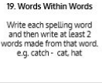  Use Words Within Words to practise spelling this week’s orange words:  believe, bicycle, breath, breathe, build, busy, business, calendar
9.45-10.00  Active break | LO: To boost my concentration through movement. | Join in with the clip below to get you moving!  https://www.youtube.com/watch?v=nUb-ZxbRXKU
10.00-11.00  English | SPaG Revision LO: To understand what coordinating conjunctions are.  LO: To learn about the Angler fish’s habitat. | For today’s SPaG Daily Practice, revise your knowledge of coordinating conjunctions. Click the link below for today’s lesson:  https://www.bbc.co.uk/bitesize/topics/zwwp8mn/articles/z9wvqhv  Follow the link below to have a go at today’s English lesson:  https://classroom.thenational.academy/lessons/to-learn-about-the-angler-fishs-habitat-60u3ec
11.00- 11.15
Break
11.15-12.15  Maths | LO: To practise my recall of the 8 times table.  LO: To use comparison bar models to represent addition and subtraction one-step problems. | Follow the link below to practise the 8 times table and get moving!  https://www.youtube.com/watch?v=SNFXWEXaCQw  Follow the link below to have a go at today’s maths lesson:  https://classroom.thenational.academy/lessons/representing-comparison-word-problems-c9hkgr
12.15-1.00
Dinner
1.00-1.15  Storytime | LO: To listen to a story for pleasure. | Listen to Chapter 7 of The Green Ember.  https://stories.audible.com/pdp/B00T50R42I?ref=adbl_ent_anon_ds_pdp_plc
1.15-2.30  Topic-Science | LO: To explore the different components in an electrical circuit. | Follow the link to have a go at today’s lesson:  https://classroom.thenational.academy/lessons/what-are-the-different-components-in-an-electrical-circuit-cdk34d
2.30-3.00  RHE | LO: To identify people who help in a community. | Follow the link to have a go at today’s lesson:  https://classroom.thenational.academy/lessons/help-is-on-hand-cgtpat

Beat That!

Time and Subject  Thursday | Learning Objective | Task/Link/Resources
8.45-9.00  Reading | L.O: To practise and consolidate existing reading skills. | Read your individual reading book, either in your head or out loud.
9.00-9.15  Morning Maths | LO: To consolidate recall of number facts.  Revision LO: To understand bar charts. | Complete today’s Beat That- scroll down below today’s timetable to find the questions. Remember, it is the same one every day for a week. Can you beat your own score?  Morning Maths: In Morning Maths today, you are going to revise your knowledge of capacity. Click the link below, choose Summer Term- Week 12 and select the video Lesson 4 Bar charts:  https://whiterosemaths.com/homelearning/summer-archive/year-3/
9.15-9.45  Spelling | LO: To practise Year 3/4 common exception words. | This week, we are going to practise spelling some of our tricky orange words!  Use the activity above to practise spelling this week’s orange words:  believe, bicycle, breath, breathe, build, busy, business, calendar
9.45-10.00  Active break | LO: To boost my concentration through movement. | Join in with the Go Noodle clip below to get you moving!  https://www.youtube.com/watch?v=Sk_q_ShHDBM
10.00-11.00  English | SPaG LO: To identify prepositions.  LO: To write the habitat paragraph of a non-chronological report. | For today’s SPaG Daily Practice, we are going to revise our knowledge of prepositions. Click the link to have a go at today’s lesson:  https://www.bbc.co.uk/bitesize/topics/zwwp8mn/articles/zw38srd  Follow the link below to have a go at today’s English lesson:  https://classroom.thenational.academy/lessons/to-write-the-habitat-paragraph-of-a-non-chronological-report-6wt3ar
11.00- 11.15
Break
11.15-12.15  Maths | LO: To practise my recall of the 8 times table.  LO: To use bar models to represent two-step addition and subtraction problems. | Follow the link below to practise the 8 times table:  http://www.snappymaths.com/multdiv/8xtable/interactive/newlook/8xtablebtcd.htm  Follow the link below to have a go at today’s lesson:  https://classroom.thenational.academy/lessons/solving-two-step-word-problems-69k3gr
12.15-1.00
Dinner
1.00-1.15  Storytime | LO: To listen to a story for pleasure. | Listen to Chapter 8 of The Green Ember.  https://stories.audible.com/pdp/B00T50R42I?ref=adbl_ent_anon_ds_pdp_plc
1.15-3.00  PE | LO: To learn and perform a dance routine. | Follow the link below to learn a dance routine inspired by Harry Potter!  https://www.youtube.com/watch?v=btD_HCO1FT4

Beat That!

Time and Subject  Friday | Learning Objective | Task/Link/Resources
8.45-9.00  Reading | L.O: To practise and consolidate existing reading skills. | Read your individual reading book, either in your head or out loud.
9.00-9.15  Morning Maths | LO: To consolidate recall of number facts.  Revision LO:  To measure mass. | Complete today’s Beat That- scroll down below today’s timetable to find the questions. Remember, it is the same one every day for a week. Can you beat your own score?  Morning Maths: In Morning Maths today, you are going to revise your knowledge of measuring mass. Click the link below, choose Summer Term- Week 11 and select the video Lesson 1 Measure mass:  https://whiterosemaths.com/homelearning/summer-archive/year-3/
9.15-9.45  Spelling | LO: To practise Year 3/4 common exception words. | This week, we are going to practise spelling some of our tricky orange words!  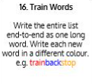  Use Train Words to practise spelling this week’s orange words:  believe, bicycle, breath, breathe, build, busy, business, calendar  Spelling Test:  Scroll down below today’s timetable to use the look, cover, write, check sheet to help you to test yourself on this week’s words.
9.45-10.00  Active break | L.O: To boost my concentration through movement. | Join in with the Go Noodle clip to get you moving!  https://www.youtube.com/watch?v=W387m-ved6o
10.00-11.00  English | SPaG LO: To understand how to write a statement sentence.  LO: To write the closing paragraph of a non-chronological report. | For today’s SPaG Daily Practice, revise your knowledge of statements and how to write them. Click the link below to have a go at today’s lesson:  https://www.bbc.co.uk/bitesize/articles/z97r2nb  Follow the link below to have a go at today’s lesson:  https://classroom.thenational.academy/lessons/to-write-the-closing-paragraph-of-a-non-chronological-report-71gkcd
11.00- 11.15
Break
11.15-12.15  Maths | LO: To practise my recall of the 8 times table.  LO: To apply using bar models to represent addition and subtraction problems. | Follow the link below to practise the 8 times table:  http://www.snappymaths.com/multdiv/8xtable/interactive/newlook/8xmissintd.htm  Follow the link below to have a go at today’s lesson:  https://classroom.thenational.academy/lessons/applying-and-consolidating-word-problems-and-bar-models-70rkcc
12.15-1.00
Dinner
1.00-1.15  Storytime | LO: To listen to a story for pleasure. | Listen to Chapter 9 of The Green Ember.  https://stories.audible.com/pdp/B00T50R42I?ref=adbl_ent_anon_ds_pdp_plc
1.15-3:00  Art | Golden Time  LO: To create images using Pointillism. | Watch this video to learn about Pointillism:  https://www.youtube.com/watch?v=D4hqKPX6d68  Have a go at creating your own pictures using Pointillism. You could use paint or create the same effect with pencil or felt tips!

Beat That!

Spelling Test
