Monday
Time and Subject | Learning Objective | Task/Link/Resources
8.45-9.00  Reading | L.O: To practise and consolidate existing reading skills. | Read your individual reading book, either in your head or out loud.
9.00-9.15  Morning Maths | LO: To consolidate recall of number facts.  Revision LO: To add whole numbers with more than 4 digits. | Complete today’s Beat That. You will find today’s Beat That below today’s timetable. Just scroll down! Remember, it is the same one every day for a week so try and beat your score each time!  We use Morning Maths as a time to revise concepts and keep them at the front of our minds- follow the link below to add whole numbers with more than four digits. Use the first video on the link:  https://whiterosemaths.com/homelearning/year-6/week-3/
9.15-9.45  Spelling | LO: To practice Unit Five RWI Spelling words. | Speed write this week’s words- time yourself a minute for each! Check them and correct any mistakes. Write them in different colours or fancy writing, make yourself a poster of each of the words! Circle the consonants and vowels.  Applied, beautiful, beautifully, busily, busy, copier, crying, happily, happiness, heavier, heavily, hurried, hurries, hurry, mysterious, mystery, reliable, replied, spying, tried, tries, trying.
9.45-10.00  Active break | L.O: To boost my concentration through movement. | https://www.youtube.com/watch?v=lJPvEs8qpQc  Join in with the Go Noodle clip above to get you moving!
10.00-11.00  English | LO: To explore punctuating speech. | Have a go at today’s lesson by clicking on the link below:  https://classroom.thenational.academy/lessons/to-explore-punctuating-speech-cmu32t
11.00- 11.15
Break
11.15-12.15  Maths | LO: To use the formal written method of long division to solve appropriate calculations. | Have a go at today’s lesson by clicking on the link below:  https://classroom.thenational.academy/lessons/use-the-formal-written-method-of-long-division-to-solve-appropriate-calculations-c8wk0c
12.15-1.00
Dinner
1.00-1.15  Storytime | LO: To listen to a story for pleasure. | Listen to today’s story, ‘Turning Dirt into Gold’, on Circle Round:  https://www.npr.org/podcasts/532788972/circle-round?t=1600113424305
1.15-3:00  PE | LO: To develop our fitness and flexibility. | Have a go at today’s lesson by clicking on the links below:  https://www.youtube.com/watch?v=5if4cjO5nxo  https://www.youtube.com/watch?v=5if4cjO5nxo  https://www.youtube.com/watch?v=rtC2qADkBuU
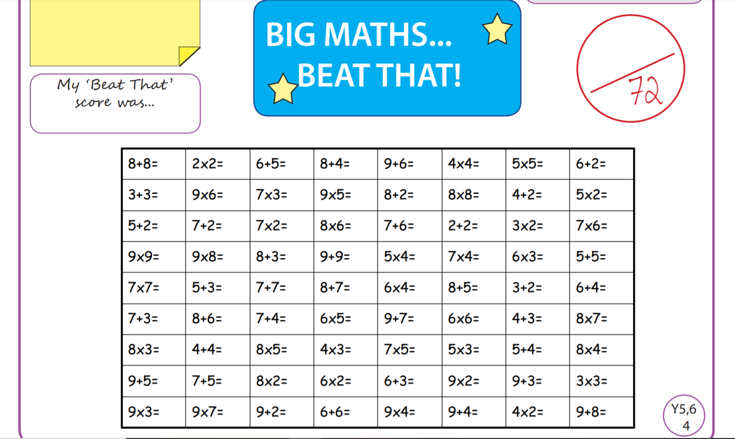
Tuesday
Time and Subject | Learning Objective | Task/Link/Resources
8.45-9.00  Reading | L.O: To practise and consolidate existing reading skills. | Read your individual reading book, either in your head or out loud.
9.00-9.15  Morning Maths | LO: To consolidate recall of number facts.  Revision LO: To subtract whole numbers with more than four digits. | Complete today’s Beat That. You will find today’s Beat That below today’s timetable. Just scroll down! Remember, it is the same one every day for a week so try and beat your score each time!  We use Morning Maths as a time to revise concepts and keep them at the front of our minds- follow the link below to subtract whole numbers with more than four digits, use the second video on the link:  https://whiterosemaths.com/homelearning/year-6/week-3/
9.15-9.45  Spelling | LO: To practice Unit Five RWI Spelling words. | Speed write this week’s words- time yourself a minute for each! Check them and correct any mistakes. Write them in different colours or fancy writing, make yourself a poster of each of the words! Circle the consonants and vowels.  Applied, beautiful, beautifully, busily, busy, copier, crying, happily, happiness, heavier, heavily, hurried, hurries, hurry, mysterious, mystery, reliable, replied, spying, tried, tries, trying.
9.45-10.00  Active break | L.O: To boost my concentration through movement. | https://www.youtube.com/watch?v=1b6axyuaKcY  Join in with the Go Noodle clip above to get you moving!
10.00-11.00  English | LO: To practise and apply knowledge of suffixes, past and present, including a test. | Have a go at today’s lesson by clicking on the link below:  https://classroom.thenational.academy/lessons/to-practise-and-apply-knowledge-of-suffixes-past-and-present-including-test-c4w34e
11.00- 11.15
Break
11.15-12.15  Maths | LO: To solve problems involving division with remainders. | Have a go at today’s lesson by clicking on the link below:  https://classroom.thenational.academy/lessons/solve-problems-involving-division-with-remainders-part-1-6hjp6t
12.15-1.00
Dinner
1.00-1.15  Storytime | LO: To listen to a story for pleasure. | Listen to today’s story, ‘The Forbidden Knot,’ on Circle Round:  https://www.npr.org/podcasts/532788972/circle-round?t=1600113424305
1.15-2.30  Topic  Geography | LO: To understand where food comes from. | Have a go at today’s Geography lesson by clicking on the link below:  https://classroom.thenational.academy/lessons/where-does-our-food-come-from-60t62e
2.30-3.00  RHE | LO: To identify the people who help within a community. | Follow the link below to have a go at today’s lesson:  https://classroom.thenational.academy/lessons/help-is-on-hand-cgtpat  Use the clip below to see why people might need help sometimes:  https://www.bbc.co.uk/bitesize/clips/z73s34j
Wednesday
Time and Subject | Learning Objective | Task/Link/Resources
8.45-9.00  Reading | L.O: To practise and consolidate existing reading skills. | Read your individual reading book, either in your head or out loud.
9.00-9.15  Morning Maths | LO: To consolidate recall of number facts.  Revision LO:  To practise inverse operations using addition and subtraction. | Complete today’s Beat That. You will find today’s Beat That below today’s timetable. Just scroll down! Remember, it is the same one every day for a week so try and beat your score each time!  We use Morning Maths as a time to revise concepts and keep them at the front of our minds- follow the link below to practise inverse operations using addition and subtraction, use the third video on the link below:  https://whiterosemaths.com/homelearning/year-6/week-3/
9.15-9.45  Spelling | LO: To practice Unit Five RWI Spelling words. | Speed write this week’s words- time yourself a minute for each! Check them and correct any mistakes. Write them in different colours or fancy writing, make yourself a poster of each of the words! Circle the consonants and vowels.  Applied, beautiful, beautifully, busily, busy, copier, crying, happily, happiness, heavier, heavily, hurried, hurries, hurry, mysterious, mystery, reliable, replied, spying, tried, tries, trying.
9.45-10.00  Active break | L.O: To boost my concentration through movement. | https://www.youtube.com/watch?v=psUPYR235O8  Join in with the Go Noodle clip above to get you moving!
10.00-11.00  English | LO: To develop our understanding of punctuating speech. | Have a go at today’s lesson by clicking on the link below:  https://classroom.thenational.academy/lessons/to-develop-our-understanding-of-punctuating-speech-6wukcr
11.00- 11.15
Break
11.15-12.15  Maths | LO: To solve problems involving division with remainders part two. | Have a go at today’s lesson by clicking on the link below:  https://classroom.thenational.academy/lessons/solve-problems-involving-division-with-remainders-part-2-74rp8d
12.15-1.00
Dinner
1.00-1.15  Storytime | LO: To listen to a story for pleasure. | Listen to today’s story, ‘The Charming Flute,’ on Circle Round:  https://www.npr.org/podcasts/532788972/circle-round?t=1600113424305
1.15-2.30  Topic  Geography | LO: To explore where globalisation lead us. | Have a go at today’s Geography lesson by clicking on the link below:  https://classroom.thenational.academy/lessons/where-will-globalisation-lead-us-cnjp6c
2.30-3.00  Music | LO: To develop our understanding of compound time. | Have a go at today’s lesson by clicking on the link below:  https://classroom.thenational.academy/lessons/to-develop-our-understanding-of-compound-time-cgt6cr
Thursday
Time and Subject | Learning Objective | Task/Link/Resources
8.45-9.00  Reading | L.O: To practise and consolidate existing reading skills. | Read your individual reading book, either in your head or out loud.
9.00-9.15  Morning Maths | LO: To consolidate recall of number facts.  Revision LO: To work on multi step addition and subtraction problems. | Complete today’s Beat That. You will find today’s Beat That below today’s timetable. Just scroll down! Remember, it is the same one every day for a week so try and beat your score each time!  We use Morning Maths as a time to revise concepts and keep them at the front of our minds- follow the link below to work on multi step addition and subtraction problems. Use the fourth video on the link:  https://whiterosemaths.com/homelearning/year-6/week-3/
9.15-9.45  Spelling | LO: To practice Unit Five RWI Spelling words. | Speed write this week’s words- time yourself a minute for each! Check them and correct any mistakes. Write them in different colours or fancy writing, make yourself a poster of each of the words! Circle the consonants and vowels.  Applied, beautiful, beautifully, busily, busy, copier, crying, happily, happiness, heavier, heavily, hurried, hurries, hurry, mysterious, mystery, reliable, replied, spying, tried, tries, trying.
9.45-10.00  Active break | L.O: To boost my concentration through movement. | https://www.youtube.com/watch?v=FRnEDoVRaa0  Join in with the Go Noodle clip above to get you moving!
10.00-11.00  English | LO: To develop editing skills. | Have a go at today’s lesson by clicking on the link below:  https://classroom.thenational.academy/lessons/to-edit-70vkcd
11.00- 11.15
Break
11.15-12.15  Maths | LO: To represent remainders in different ways, depending on the context of the problem. | Have a go at today’s lesson by clicking on the link below:  https://classroom.thenational.academy/lessons/represent-remainders-in-different-ways-depending-on-the-context-of-the-problem-part-1-chj3et
12.15-1.00
Dinner
1.00-1.15  Storytime | LO: To listen to a story for pleasure. | Listen to today’s story, ‘A Taste of Honey,’ on Circle Round:  https://www.npr.org/podcasts/532788972/circle-round?t=1600113424305
1.15-2.30  Topic  Geography | LO: To look at how globalised our lives are. | Have a go at today’s Geography lesson by clicking on the link below:  https://classroom.thenational.academy/lessons/how-globalised-is-your-life-70rk4t
2.30-3.00  French | LO: To develop vocabulary. | Follow the link below:  https://www.bbc.co.uk/teach/class-clips-video/french-ks2-how-to-introduce-yourself/zf84d6f
Friday
Time and Subject | Learning Objective | Task/Link/Resources
8.45-9.00  Reading | L.O: To practise and consolidate existing reading skills. | Read your individual reading book, either in your head or out loud.
9.00-9.15  Morning Maths | LO: To consolidate recall of number facts.  Revision LO: To add and subtract integers. | Complete today’s Beat That. You will find today’s Beat That below today’s timetable. Just scroll down! Remember, it is the same one every day for a week so try and beat your score each time!  We use Morning Maths as a time to revise concepts and keep them at the front of our minds- follow the link below to add and subtract integers. Use the fifth video on the link:  https://whiterosemaths.com/homelearning/year-6/week-3/
9.15-9.45  Spelling | LO: To practice Unit Five RWI Spelling words. | Speed write this week’s words- time yourself a minute for each! Check them and correct any mistakes. Write them in different colours or fancy writing, make yourself a poster of each of the words! Circle the consonants and vowels.  Applied, beautiful, beautifully, busily, busy, copier, crying, happily, happiness, heavier, heavily, hurried, hurries, hurry, mysterious, mystery, reliable, replied, spying, tried, tries, trying.  Use the Look, Cover, Write, Check resource below to test yourself!
9.45-10.00  Active break | L.O: To boost my concentration through movement. | https://www.youtube.com/watch?v=7Li2qwdUsxU  Join in with the Go Noodle clip above to get you moving!
10.00-11.00  English | LO: To write a narrative. | Have a go at today’s lesson by clicking on the link below:  https://classroom.thenational.academy/lessons/to-write-a-narrative-free-write-c5hp8c
11.00- 11.15
Break
11.15-12.15  Maths | LO: To represent remainders in different ways depending on the context of the problem part two. | Have a go at today’s lesson by clicking on the link below:  https://classroom.thenational.academy/lessons/represent-remainders-in-different-ways-depending-on-the-context-of-the-problem-part-2-ccu32
12.15-1.00
Dinner
1.00-1.15  Storytime | LO: To listen to a story for pleasure. | Listen to today’s story, ‘Naming the Tree,’ on Circle Round:  https://www.npr.org/podcasts/532788972/circle-round?t=1600113424305
1.15-3:00  Golden Time Art | LO: To develop my understanding of aboriginal art. | Have a go at today’s session by following the link below:  https://youtu.be/tXxuOF0qMss
