Time and Subject | Learning Objective | Task/Link/Resources
8.45-9.00  Reading | L.O: To practise and consolidate existing reading skills. | Read your individual reading book, either in your head or out loud.
9.00-9.15  Morning Maths | LO: To consolidate recall of number facts. | Complete today’s Beat That. You will find today’s Beat That below today’s timetable. Just scroll down! Remember, it is the same one every day for a week so try and beat your score each time!
9.15-9.45  Spelling | LO: To practice Unit Two RWI Spelling words. | Speed write this week’s words- time yourself a minute for each! Check them and correct any mistakes. Write them in different colours or fancy writing, make yourself a poster of each of the words! Circle the consonants and vowels.  Week 4 – responsible reversible sensible terrible visible
9.45-10.00  Active break | L.O: To boost my concentration through movement. | https://www.youtube.com/watch?v=388Q44ReOWE  Join in with the Go Noodle clip above to get you moving!
10.00-11.00  English | LO: To plan the first part of a narrative scene. | Have a go at today’s lesson by clicking on the link below:  https://classroom.thenational.academy/lessons/to-plan-the-first-part-of-a-narrative-scene-chj3ge
11.00- 11.15
Break
11.15-12.15  Maths | LO: To develop doubling and halving strategies. | Have a go at today’s lesson by clicking on the link below:  https://classroom.thenational.academy/lessons/doubling-and-halving-strategies-65hpac
12.15-1.00
Dinner
1.00-1.15  Storytime | LO: To listen to a story for pleasure. | Continue listening to Anne of Green Gables, remember where you get up to for next time:  https://stories.audible.com/pdp/B01KGL13FI?ref=adbl_ent_anon_ds_pdp_pc_cntr-3-3
1.15-2.30  PE | LO: To develop our fitness and flexibility. | Have a go at today’s lesson by clicking on the links below:  https://www.youtube.com/watch?v=5if4cjO5nxo  https://www.youtube.com/watch?v=5if4cjO5nxo  https://www.youtube.com/watch?v=rtC2qADkBuU

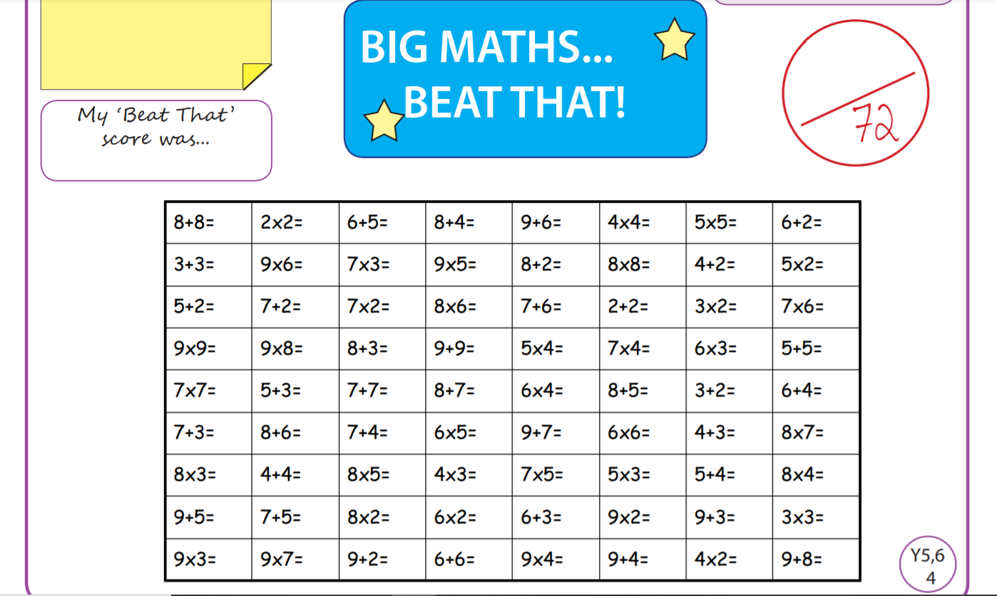

Tuesday
Time and Subject | Learning Objective | Task/Link/Resources
8.45-9.00  Reading | L.O: To practise and consolidate existing reading skills. | Read your individual reading book, either in your head or out loud.
9.00-9.15  Morning Maths | LO: To consolidate recall of number facts. | Complete today’s Beat That. You will find today’s Beat That below today’s timetable. Just scroll down! Remember, it is the same one every day for a week so try and beat your score each time!
9.15-9.45  Spelling | LO: To practice Unit Two RWI Spelling words. | Speed write this week’s words- time yourself a minute for each! Check them and correct any mistakes. Write them in different colours or fancy writing, make yourself a poster of each of the words! Circle the consonants and vowels.  Week 4 – responsible reversible sensible terrible visible
9.45-10.00  Active break | L.O: To boost my concentration through movement. | https://www.youtube.com/watch?v=sNog54ovi8Q  Join in with the Go Noodle clip above to get you moving!
10.00-11.00  English | LO: To practise and apply knowledge of ee sound- ie or ei spelling, including a test. | Have a go at today’s lesson by clicking on the link below:  https://classroom.thenational.academy/lessons/to-practise-and-apply-knowledge-of-ee-sound-ie-or-ei-spelling-including-a-test-6mwkje
11.00- 11.15
Break
11.15-12.15  Maths | LO: To use derived facts to multiply mentally. | Have a go at today’s lesson by clicking on the link below:  https://classroom.thenational.academy/lessons/using-derived-facts-to-multiply-mentally-69j3ct
12.15-1.00
Dinner
1.00-1.15  Storytime | LO: To listen to a story for pleasure. | Continue listening to Anne of Green Gables, remember where you get up to for next time:  https://stories.audible.com/pdp/B01KGL13FI?ref=adbl_ent_anon_ds_pdp_pc_cntr-3-3
1.15-2.30  Topic  History | LO: To write an essay about the Ancient Greeks. | Have a go at today’s lesson by clicking on the link below:  https://classroom.thenational.academy/lessons/extended-writing-what-were-the-achievements-of-the-ancient-greeks-69hp4d
2.30-3.00  RHE | LO: To learn about people who can help in our community. | Have a go at today’s lesson by clicking on today’s lesson:  https://classroom.thenational.academy/lessons/help-is-on-hand-cgtpat

Wednesday
Time and Subject | Learning Objective | Task/Link/Resources
8.45-9.00  Reading | L.O: To practise and consolidate existing reading skills. | Read your individual reading book, either in your head or out loud.
9.00-9.15  Morning Maths | LO: To consolidate recall of number facts. | Complete today’s Beat That. You will find today’s Beat That below today’s timetable. Just scroll down! Remember, it is the same one every day for a week so try and beat your score each time!
9.15-9.45  Spelling | LO: To practice Unit Two RWI Spelling words. | Speed write this week’s words- time yourself a minute for each! Check them and correct any mistakes. Write them in different colours or fancy writing, make yourself a poster of each of the words! Circle the consonants and vowels.  Week 4 – responsible reversible sensible terrible visible
9.45-10.00  Active break | L.O: To boost my concentration through movement. | https://www.youtube.com/watch?v=lJPvEs8qpQc  Join in with the Go Noodle clip above to get you moving!
10.00-11.00  English | LO: To write the first part of a build- up scene. | Have a go at today’s lesson by clicking on the link below:  https://classroom.thenational.academy/lessons/to-write-the-first-part-of-a-build-up-scene-c8t6cr
11.00- 11.15
Break
11.15-12.15  Maths | LO: To calculate flexibly. | Have a go at today’s lesson by clicking on the link below:  https://classroom.thenational.academy/lessons/calculating-flexibly-c8up2d
12.15-1.00
Dinner
1.00-1.15  Storytime | LO: To listen to a story for pleasure. | Continue listening to Anne of Green Gables, remember where you get up to for next time:  https://stories.audible.com/pdp/B01KGL13FI?ref=adbl_ent_anon_ds_pdp_pc_cntr-3-3
1.15-2.30  Topic  Science | LO: To learn what forces are. | Have a go at today’s lesson by clicking on the link below:  https://classroom.thenational.academy/lessons/what-are-forces-6dh3ec
2.30-3.00  Music | LO: To understand syncopated rhythms. | Have a go at today’s lesson by clicking on the link below:  https://classroom.thenational.academy/lessons/to-understand-syncopated-rhythms-70u34t
Thursday
Time and Subject | Learning Objective | Task/Link/Resources
8.45-9.00  Reading | L.O: To practise and consolidate existing reading skills. | Read your individual reading book, either in your head or out loud.
9.00-9.15  Morning Maths | LO: To consolidate recall of number facts. | Complete today’s Beat That. You will find today’s Beat That below today’s timetable. Just scroll down! Remember, it is the same one every day for a week so try and beat your score each time!
9.15-9.45  Spelling | LO: To practice Unit Two RWI Spelling words. | Speed write this week’s words- time yourself a minute for each! Check them and correct any mistakes. Write them in different colours or fancy writing, make yourself a poster of each of the words! Circle the consonants and vowels.  Week 4 – responsible reversible sensible terrible visible
9.45-10.00  Active break | L.O: To boost my concentration through movement. | https://www.youtube.com/watch?v=1b6axyuaKcY  Join in with the Go Noodle clip above to get you moving!
10.00-11.00  English | LO: To plan the second part of a narrative scene. | Have a go at today’s lesson by clicking on the link below:  https://classroom.thenational.academy/lessons/to-plan-the-second-part-of-a-narrative-scene-ccu3gd
11.00- 11.15
Break
11.15-12.15  Maths | LO: To use the formal method for short multiplication. | Have a go at today’s lesson by clicking on the link below:  https://classroom.thenational.academy/lessons/short-multiplication-c8v64c
12.15-1.00
Dinner
1.00-1.15  Storytime | LO: To listen to a story for pleasure. | Continue listening to Anne of Green Gables, remember where you get up to for next time:  https://stories.audible.com/pdp/B01KGL13FI?ref=adbl_ent_anon_ds_pdp_pc_cntr-3-3
1.15-2.30  Topic  Science | LO: To learn how we can measure the size of forces. | Have a go at today’s lesson by clicking on the link below:  https://classroom.thenational.academy/lessons/how-can-we-measure-the-size-of-forces-c4vkcr
2.30-3.00  French | LO: To develop vocabulary. | Follow the link:  https://www.bbc.co.uk/teach/class-clips-video/english-ks2-meet-the-family/zf7tgwx
Friday
Time and Subject | Learning Objective | Task/Link/Resources
8.45-9.00  Reading | L.O: To practise and consolidate existing reading skills. | Read your individual reading book, either in your head or out loud.
9.00-9.15  Morning Maths | LO: To consolidate recall of number facts. | Complete today’s Beat That. You will find today’s Beat That below today’s timetable. Just scroll down! Remember, it is the same one every day for a week so try and beat your score each time!
9.15-9.45  Spelling | LO: To practice Unit Two RWI Spelling words. | Speed write this week’s words- time yourself a minute for each! Check them and correct any mistakes. Write them in different colours or fancy writing, make yourself a poster of each of the words! Circle the consonants and vowels.  Week 4 – responsible reversible sensible terrible visible  Test yourself using the Look, Cover, Say, Write and Check grid at the bottom.
9.45-10.00  Active break | L.O: To boost my concentration through movement. | https://www.youtube.com/watch?v=psUPYR235O8  Join in with the Go Noodle clip above to get you moving!
10.00-11.00  English | LO: To write the second part of a narrative scene. | Have a go at today’s lesson by clicking on the link below:  https://classroom.thenational.academy/lessons/to-write-the-second-part-of-a-narrative-scene-70r34d
11.00- 11.15
Break
11.15-12.15  Maths | LO: To explore long multiplication. | Have a go at today’s lesson by clicking on the link below:  https://classroom.thenational.academy/lessons/long-multiplication-68u38t
12.15-1.00
Dinner
1.00-1.15  Storytime | LO: To listen to a story for pleasure. | Continue listening to Anne of Green Gables, remember where you get up to for next time:  https://stories.audible.com/pdp/B01KGL13FI?ref=adbl_ent_anon_ds_pdp_pc_cntr-3-3
1.15-3:00  Golden Time Art | LO: To develop an appreciation of aboriginal art. | Have a go at today’s session by following the link below:  https://youtu.be/tXxuOF0qMss
