Time and Subject  Monday | Learning Objective | Task/Link/Resources
8.45-9.00  Reading | LO: To practise and consolidate existing reading skills. | Read your individual reading book, either in your head or out loud.
9.00-9.15  Morning Maths | LO: To consolidate recall of number facts.  Revision LO: To make equal groups by grouping. | Complete today’s Beat That- scroll down below today’s timetable to find the questions. Remember, it is the same one every day for a week. Can you beat your own score?  Morning Maths: In Morning Maths today, you are going to revise your knowledge of division. Click the link below and select the video Make equal groups-grouping.  Autumn Week 10 - Number: Multiplication & Division | White Rose Maths
9.15-9.45  Spelling | LO: To practise Unit Fourteen RWI spelling words. | This week, we are going to practise adding the prefix sub-.  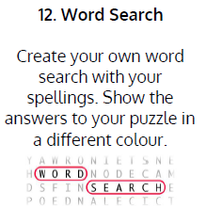  Use Word Search to practise spelling this week’s words:  subdivide, subheading, submarine, submerge, subsoil, subtitle, subway, subzero.
9.45-10.00  Active break | LO: To boost my concentration through movement. | Join in with the Go Noodle clip below to get you moving!  100 FAST: Jumping Jacks - GoNoodle
10.00-11.00  English | SPaG Revision LO: To identify pronouns.  LO: To orally rehearse a section of narrative. | For today’s SPaG Daily Practice, revise your knowledge of pronouns. Watch the video and complete activity 2.  Identifying pronouns - Year 3 - P4 - English - Catch Up Lesson - Home Learning with BBC Bitesize - BBC Bitesize  Follow the link below to have a go at today’s English lesson:  To orally rehearse a section of narrative (thenational.academy)
11.00- 11.15
Break
11.15-12.15  Maths | LO: To practise my recall of the 10 times table.  LO: To read weighing scales with different intervals. | Follow the link below to practise the 10 times table and get moving!  KS1 Maths: The 10 Times Table with Webster the Spider - BBC Teach  Follow the link below to have a go at today’s maths lesson:  Reading weighing scales with different intervals (thenational.academy)
12.15-1.00
Dinner
1.00-1.15  Storytime | LO: To listen to a story for pleasure. | Listen to Chapter 11 of Hotel Flamingo:  Hotel Flamingo - World Book Day
1.15-3.00  Topic- Science | LO: To explore the parts and functions of a plant. | Follow the link below to have a go at today’s lesson:  What are the parts and functions of a plant? (thenational.academy)

Beat That!
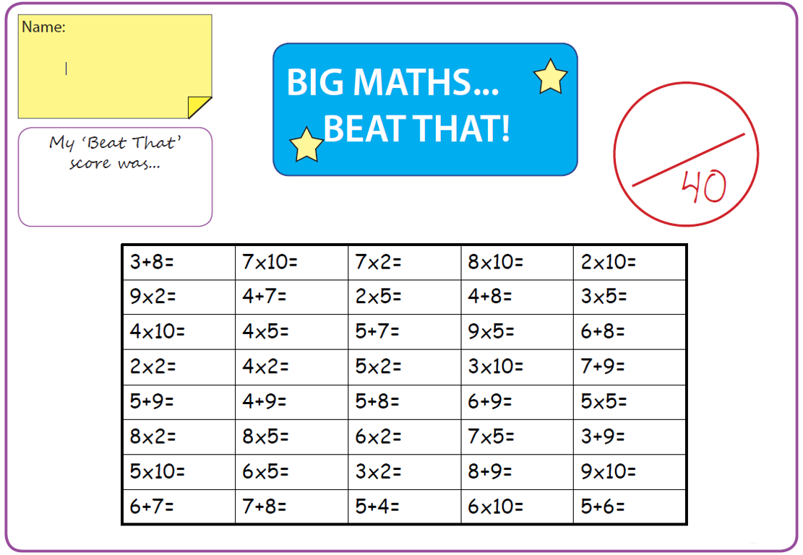
Time and Subject  Tuesday | Learning Objective | Task/Link/Resources
8.45-9.00  Reading | L.O: To practise and consolidate existing reading skills. | Read your individual reading book, either in your head or out loud.
9.00-9.15  Morning Maths | LO: To consolidate recall of number facts.  Revision LO: To divide by 2. | Complete today’s Beat That- scroll down below today’s timetable to find the questions. Remember, it is the same one every day for a week. Can you beat your own score?  Morning Maths: In Morning Maths today, you are going to revise your knowledge of division. Click the link below and select the video Divide by 2.  Autumn Week 10 - Number: Multiplication & Division | White Rose Maths
9.15-9.45  Spelling | LO: LO: To practise Unit Fourteen RWI spelling words. | This week, we are going to practise adding the prefix sub-.  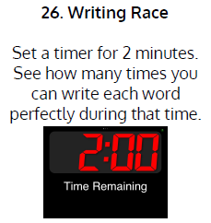  Use Writing Race to practise spelling this week’s words:  subdivide, subheading, submarine, submerge, subsoil, subtitle, subway, subzero.
9.45-10.00  Active break | L.O: To boost my concentration through movement. | Join in with the Go Noodle clip below to get you moving!  Koo Koo Kanga Roo - Dinosaur Stomp (Dance-A-Long) - YouTube
10.00-11.00  English | SPaG Revision LO: To identify pronouns.  LO: To investigate prefixes. | For today’s SPaG Daily Practice, revise your knowledge of pronouns. Watch the video and complete activity 3.  Identifying pronouns - Year 3 - P4 - English - Catch Up Lesson - Home Learning with BBC Bitesize - BBC Bitesize  Follow the link below to have a go at today’s English lesson:  To investigate prefixes (thenational.academy)
11.00- 11.15
Break
11.15-12.15  Maths | LO: To practise my recall of the 10 times table.  LO: To weigh and compare masses in mixed units. | Follow the link below to practise the 10 times table:  Coconut Multiples - Reinforce Times Tables (topmarks.co.uk)  Follow the link below to have a go at today’s maths lesson:  Weighing and comparing masses in mixed units (thenational.academy)
12.15-1.00
Dinner
1.00-1.15  Storytime | LO: To listen to a story for pleasure. | Listen to Chapter 12 of Hotel Flamingo:  Hotel Flamingo - World Book Day
1.15-2.30  Topic- Science | LO: To explore the parts and functions of a flower. | Follow the link below to have a go at today’s lesson:  What are the parts and functions of a flower? (thenational.academy)
2.30-3.00  French | LO: To revise naming colours in French. | Listen to this song to practise naming colours in French:  ♫ La Chanson des Couleurs ♫ French Colors Song ♫ Les Couleurs en Français ♫ Learn French Basics ♫ - YouTube  Play the ‘Colour Labelling in French’ game to test your knowledge:  Crickweb | KS2 French

Beat That!

Time and Subject  Wednesday | Learning Objective | Task/Link/Resources
8.45-9.00  Reading | L.O: To practise and consolidate existing reading skills. | Read your individual reading book, either in your head or out loud.
9.00-9.15  Morning Maths | LO: To consolidate recall of number facts.  Revision LO: To divide by 5. | Complete today’s Beat That- scroll down below today’s timetable to find the questions. Remember, it is the same one every day for a week. Can you beat your own score?  Morning Maths: In Morning Maths today, you are going to revise your knowledge of division. Click the link below and select the video Divide by 5.  Autumn Week 10 - Number: Multiplication & Division | White Rose Maths
9.15-9.45  Spelling | LO: LO: To practise Unit Fourteen RWI spelling words. | This week, we are going to practise adding the prefix sub-.  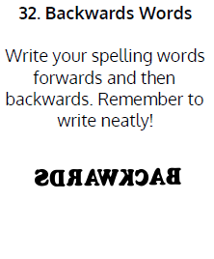  Use Backwards Words to practise spelling this week’s words:  subdivide, subheading, submarine, submerge, subsoil, subtitle, subway, subzero.
9.45-10.00  Active break | LO: To boost my concentration through movement. | Join in with the Go Noodle clip below to get you moving!  Koo Koo Kanga Roo - All I Eat Is Pizza (Dance-A-Long) - YouTube
10.00-11.00  English | SPaG Revision LO: To identify verbs.  LO: To revise our understanding of simple, compound and complex sentences. | For today’s SPaG Daily Practice, revise your knowledge of verbs. Watch the video and complete activity 1.  Identifying verbs - Year 3 - P4 - English - Catch Up Lesson - Home Learning with BBC Bitesize - BBC Bitesize  Follow the link below to have a go at today’s English lesson:  To revise our understanding of simple, compound and complex sentences (thenational.academy)
11.00- 11.15
Break
11.15-12.15  Maths | LO: To practise my recall of the 10 times table.  LO: To estimate masses. | Follow the link below. Watch the 10 times table video and complete the first activity:  The 10 times table - BBC Bitesize  Follow the link below to have a go at today’s maths lesson:  Estimating masses (thenational.academy)
12.15-1.00
Dinner
1.00-1.15  Storytime | LO: To listen to a story for pleasure. | Listen to Chapter 13 of Hotel Flamingo:  Hotel Flamingo - World Book Day
1.15-3.00  Topic- Science | LO: To explore each stage of a plant’s life cycle. | Follow the link to have a go at today’s lesson:  What are the parts of a plant's life cycle? (thenational.academy)

Beat That!
Time and Subject  Thursday | Learning Objective | Task/Link/Resources
8.45-9.00  Reading | L.O: To practise and consolidate existing reading skills. | Read your individual reading book, either in your head or out loud.
9.00-9.15  Morning Maths | LO: To consolidate recall of number facts.  Revision LO: To divide by 10. | Complete today’s Beat That- scroll down below today’s timetable to find the questions. Remember, it is the same one every day for a week. Can you beat your own score?  Morning Maths: In Morning Maths today, you are going to revise your knowledge of division. Click the link below and select the video Divide by 10.  Autumn Week 10 - Number: Multiplication & Division | White Rose Maths
9.15-9.45  Spelling | LO: LO: To practise Unit Fourteen RWI spelling words. | 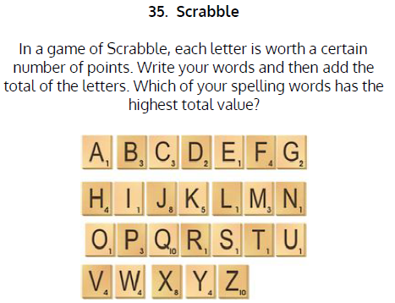  This week, we are going to practise adding the prefix sub-.  Use Scrabble to practise spelling this week’s words:  subdivide, subheading, submarine, submerge, subsoil, subtitle, subway, subzero.
9.45-10.00  Active break | LO: To boost my concentration through movement. | Join in with the Go Noodle clip below to get you moving!  Run The Red Carpet - Hot Ticket | GoNoodle - YouTube
10.00-11.00  English | SPaG Revision LO: To identify verbs.  LO: To generate ideas for writing. | For today’s SPaG Daily Practice, revise your knowledge of verbs. Watch the video and complete activity 2.  Identifying verbs - Year 3 - P4 - English - Catch Up Lesson - Home Learning with BBC Bitesize - BBC Bitesize  Follow the link below to have a go at today’s English lesson:  To generate ideas for writing (thenational.academy)
11.00- 11.15
Break
11.15-12.15  Maths | LO: To practise my recall of the 10 times table.  LO: To measure volume. | Follow the link below. Watch the 10 times table video and complete the second activity:  The 10 times table - BBC Bitesize  Follow the link below to have a go at today’s lesson:  Measuring volume (thenational.academy)
12.15-1.00
Dinner
1.00-1.15  Storytime | LO: LO: To listen to a story for pleasure. | Listen to Chapter 14 of Hotel Flamingo:  Hotel Flamingo - World Book Day
1.15-3.00  PE | LO: To change direction and throw with power and precision. | Follow the link to have a go at today’s PE lesson:  Changing direction and throwing with power and precision (thenational.academy)

Beat That!

Time and Subject  Friday | Learning Objective | Task/Link/Resources
8.45-9.00  Reading | L.O: To practise and consolidate existing reading skills. | Read your individual reading book, either in your head or out loud.
9.00-9.15  Morning Maths | LO: To consolidate recall of number facts.  Revision LO: To multiply by 3. | Complete today’s Beat That- scroll down below today’s timetable to find the questions. Remember, it is the same one every day for a week. Can you beat your own score?  Morning Maths: In Morning Maths today, you are going to revise your knowledge of multiplication. Click the link below and select the video Multiply by 3.  Autumn Week 11 - Number: Multiplication & Division | White Rose Maths
9.15-9.45  Spelling | LO: LO: To practise Unit Fourteen RWI spelling words. | This week, we are going to practise adding the prefix sub-.  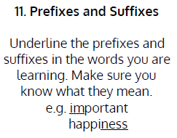  Use Prefixes and Suffixes to practise spelling this week’s words:  subdivide, subheading, submarine, submerge, subsoil, subtitle, subway, subzero.  Spelling Test:  Scroll down below today’s timetable to use the look, cover, write, check sheet to help you to test yourself on this week’s words.
9.45-10.00  Active break | L.O: To boost my concentration through movement. | Join in with the Go Noodle clip to get you moving!  Boom Chicka Boom - Moose Tube | GoNoodle - YouTube
10.00-11.00  English | SPaG Revision LO: To identify verbs.  LO: To develop a rich understanding of words associated with clever or sly traits. | For today’s SPaG Daily Practice, revise your knowledge of verbs. Watch the video and complete activity 3.  Identifying verbs - Year 3 - P4 - English - Catch Up Lesson - Home Learning with BBC Bitesize - BBC Bitesize  Follow the link below to have a go at today’s lesson:  To develop a rich understanding of words associated with clever or sly traits (Part 1) (thenational.academy)
11.00- 11.15
Break
11.15-12.15  Maths | LO: To practise my recall of the 10 times table.  LO: To measure and compare capacities in mixed units. | Follow the link below. Watch the 10 times table video and complete the third activity:  The 10 times table - BBC Bitesize  Follow the link below to have a go at today’s lesson:  Measuring and comparing capacities in mixed units (thenational.academy)
12.15-1.00
Dinner
1.00-1.15  Storytime | LO: To listen to a story for pleasure. | Listen to Chapter 1 of Ladybird Audio Adventures: The Frozen World:  Ladybird Audio Adventures: The Frozen World - World Book Day
1.15-3:00  Golden Time | LO: To practise mindfulness. | Have a go at this meditation:  The Listening Game | Cosmic Kids Zen Den - Mindfulness for kids - YouTube  Have a go at this fun Yoga session:  Alice in Wonderland | A Cosmic Kids Yoga Adventure! - YouTube  You could also choose to complete the art activity included below this week’s timetable.

Beat That!

Spelling Test
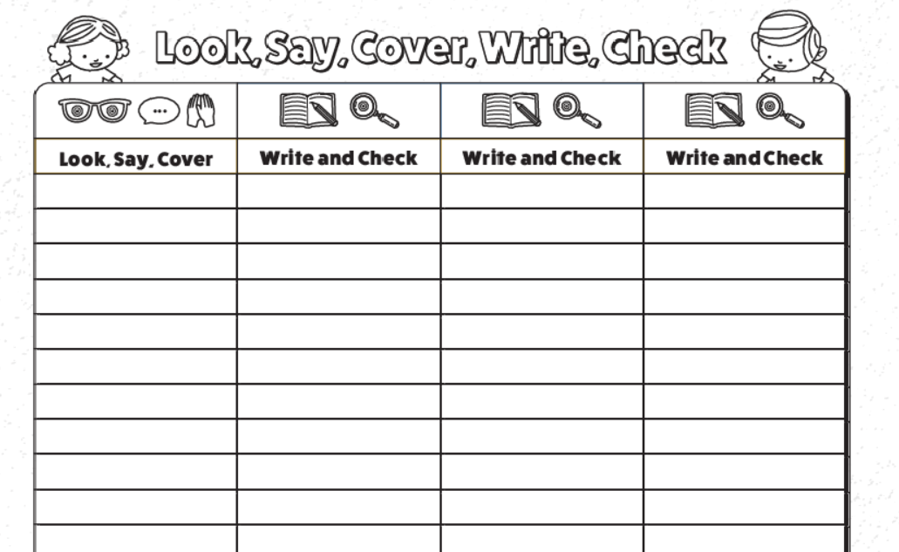

I can create an image in the style of Pablo Picasso.
Today, we will be creating our own image of an eye in the style of Pablo Picasso. Pablo Picasso’s style of drawing is very different to Hector Gonzalez. Can you suggest why? There could be more than one reason.
Pablo Picasso Hector Gonzalez

When I was looking at the differences in the style of drawing, I noticed that one was in colour and the other wasn’t. The drawing by Hector Gonzalez was realistic (looks real with lots of detail). Pablo Picasso seems to have drawn one eye from a side-view and one eye straight on.
I would like you to find some coloured pencils. If you can’t find pencil, you could use coloured pens, felt tips or gel pens. Anything that will add colour!
Your task is to draw eyes in Pablo Picassos style. Again, like last week, you may need to try a few times before you are happy. You could experiment with colour. Pay attention to the thick black outlines of the eye.

I have included some images of what this could look like. . .

Enjoy creating!

