Time and Subject  Monday | Learning Objective | Task/Link/Resources
8.45-9.00  Reading | LO: To practise and consolidate existing reading skills. | Read your individual reading book, either in your head or out loud.
9.00-9.15  Morning Maths | LO: To consolidate recall of number facts.  Revision LO: To identify acute, obtuse and right angles. | Complete today’s Beat That- scroll down below today’s timetable to find the questions. Remember, it is the same one every day for a week. Can you beat your own score?  Morning Maths: In Morning Maths today, you are going to revise your knowledge of angles. Click the link below to find the lesson and activities to complete.  https://www.bbc.co.uk/bitesize/topics/zb6tyrd/articles/zg68k7h
9.15-9.45  Spelling | LO: To practice Unit Two RWI Spelling words. | This week, we are going to practise spelling words ending in -sure. Watch this video to refresh your memory! https://www.bbc.co.uk/bitesize/topics/zt62mnb/articles/z3jpk2p  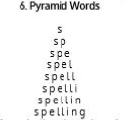  Use Pyramid Writing to practise spelling this week’s unit words:  adventure, capture, closure, creature, enclosure, leisure, measure, mixture, picture, pleasure, puncture, treasure
9.45-10.00  Active break | LO: To boost my concentration through movement. | Join in with the Go Noodle clip below to get you moving!  https://www.youtube.com/watch?v=JdBlXPWM8AI
10.00-11.00  English | SPaG Revision LO: To understand what an expanded noun phrase is.  LO: To edit a non-chronological report. | For today’s SPaG Daily Practice, revise your knowledge of expanded noun phrases. Follow the link to have a go at today’s lesson:  https://www.bbc.co.uk/bitesize/topics/zwwp8mn/articles/z3nfw6f  Follow the link below to have a go at today’s English lesson:  https://classroom.thenational.academy/lessons/to-edit-a-non-chronological-report-6cv3jt
11.00- 11.15
Break
11.15-12.15  Maths | LO: To practise my recall of the 5 times table.  LO: To add using the column method. | Follow the link below to practise the 5 times table and get moving!  https://www.bbc.co.uk/teach/supermovers/ks1-maths-the-5-times-table/zhbm47h  Follow the link below to have a go at today’s maths lesson:  https://classroom.thenational.academy/lessons/adding-using-the-column-method-cmw3cc
12.15-1.00
Dinner
1.00-1.15  Storytime | LO: To listen to a story for pleasure. | Listen to Chapter 11 of Alice’s Adventures in Wonderland.  https://stories.audible.com/pdp/B015D78L0U?ref=adbl_ent_anon_ds_pdp_pc_cntr-3-2
1.15-2.30  Topic-  Geography | LO: To understand what economic migration is. | Follow the link to have a go at today’s lesson:  https://classroom.thenational.academy/lessons/what-is-economic-migration-6tjk6r
2.30-3.00  Music | LO: To explore 3 beats in a bar. | Follow the link below to have a go at today’s lesson:  https://classroom.thenational.academy/lessons/exploring-3-beats-in-a-bar-cmw34r

Beat That!
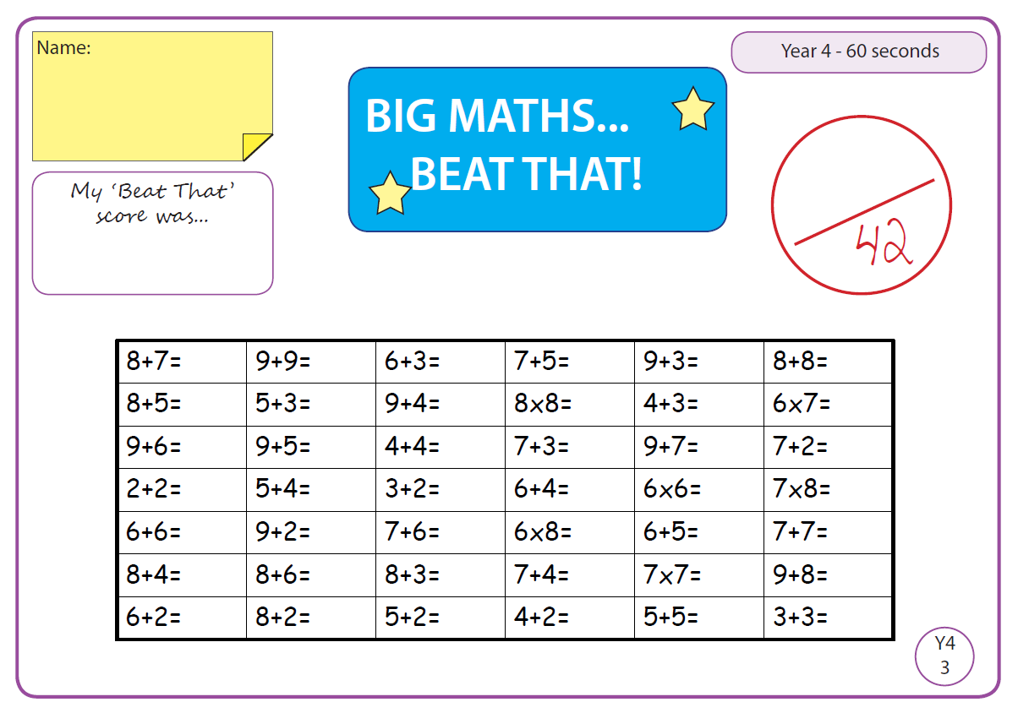

Time and Subject  Tuesday | Learning Objective | Task/Link/Resources
8.45-9.00  Reading | L.O: To practise and consolidate existing reading skills. | Read your individual reading book, either in your head or out loud.
9.00-9.15  Morning Maths | LO: To consolidate recall of number facts.  Revision LO: To explore the properties of 2D shapes. | Complete today’s Beat That- scroll down below today’s timetable to find the questions. Remember, it is the same one every day for a week. Can you beat your own score?  Morning Maths: In Morning Maths today, you are going to revise the properties of 2D shapes. Click the link below to find the lesson and activities to complete.  https://www.bbc.co.uk/bitesize/topics/zjv39j6/articles/ztpwdmn
9.15-9.45  Spelling | LO: To practise Unit Two RWI spelling words. | This week, we are going to practise spelling words ending in -sure.  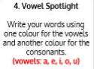  Use Vowel Spotlight to practise spelling this week’s unit words:  adventure, capture, closure, creature, enclosure, leisure, measure, mixture, picture, pleasure, puncture, treasure
9.45-10.00  Active break | L.O: To boost my concentration through movement. | Join in with the Go Noodle clip below to get you moving!  https://www.youtube.com/watch?v=fTzXFPh6CPI
10.00-11.00  English | SPaG Revision LO: To understand homophones.  LO: To investigate more suffixes: Past and present tense. | For today’s SPaG Daily Practice, click the link below to revise your knowledge of homophones:  https://www.bbc.co.uk/bitesize/topics/zqhpk2p/articles/zc84cwx  Follow the link below to have a go at today’s English lesson:  https://classroom.thenational.academy/lessons/to-investigate-more-suffixes-past-and-present-tense-64wp2c
11.00- 11.15
Break
11.15-12.15  Maths | LO: To practise my recall of the 5 times table.  LO: To add using the column method when multiple columns require regrouping. | Follow the link below to practise the 5 times table:  https://www.timestables.co.uk/5-times-table.html  Follow the link below to have a go at today’s maths lesson:  https://classroom.thenational.academy/lessons/adding-using-the-column-method-when-multiple-columns-require-regrouping-cmwpcr
12.15-1.00
Dinner
1.00-1.15  Storytime | LO: To listen to a story for pleasure. | Listen to Chapter 1 of The Green Ember.  https://stories.audible.com/pdp/B00T50R42I?ref=adbl_ent_anon_ds_pdp_plc
1.15-2.30  Topic- Geography | LO: To understand what a refugee is and why some people are refugees. | Follow the link below to have a go at today’s lesson:  https://classroom.thenational.academy/lessons/what-is-a-refugee-ccv3ar
2.30-3.00  French | LO: To name family members in French. | Follow the link below to practise saying the name of family members in French, then have a go at Activity 1:  https://www.bbc.co.uk/bitesize/articles/zgqp7yc

Beat That!

Time and Subject  Wednesday | Learning Objective | Task/Link/Resources
8.45-9.00  Reading | L.O: To practise and consolidate existing reading skills. | Read your individual reading book, either in your head or out loud.
9.00-9.15  Morning Maths | LO: To consolidate recall of number facts.  Revision LO: To find lines of symmetry in 2D shapes. | Complete today’s Beat That- scroll down below today’s timetable to find the questions. Remember, it is the same one every day for a week. Can you beat your own score?  Morning Maths: In Morning Maths today, you are going to revise finding lines of symmetry in 2D shapes. Click the link below to find the lesson and activities to complete.  https://www.bbc.co.uk/bitesize/topics/zrhp34j/articles/z8t72p3
9.15-9.45  Spelling | LO: To practise Unit Two RWI spelling words. | This week, we are going to practise spelling words ending in -sure and -ture.  Use Rainbow Words to practise spelling this week’s unit words:  adventure, capture, closure, creature, enclosure, leisure, measure, mixture, picture, pleasure, puncture, treasure
9.45-10.00  Active break | LO: To boost my concentration through movement. | Join in with the Go Noodle clip below to get you moving!  https://www.youtube.com/watch?v=wPCGfa44bF0
10.00-11.00  English | SPaG Revision LO: To understand how to use an exclamation mark.  LO: To revise our understanding of simple and complex sentences. | For today’s SPaG Daily Practice, revise how to correctly use exclamation marks:  https://www.bbc.co.uk/bitesize/topics/z8x6cj6/articles/z3dcmsg  Follow the link below to have a go at today’s English lesson:  https://classroom.thenational.academy/lessons/to-revise-our-understanding-of-simple-and-compound-sentences-65gkje
11.00- 11.15
Break
11.15-12.15  Maths | LO: To practise my recall of the 5 times table.  LO: To subtract using the column method. | Follow the link below to practise the 5 times table and get moving!  https://www.youtube.com/watch?v=TFcwMi8l040  Follow the link below to have a go at today’s maths lesson:  https://classroom.thenational.academy/lessons/subtracting-using-the-column-method-6mr38r
12.15-1.00
Dinner
1.00-1.15  Storytime | LO: To listen to a story for pleasure. | Listen to Chapter 2 of The Green Ember.  https://stories.audible.com/pdp/B00T50R42I?ref=adbl_ent_anon_ds_pdp_plc
1.15-2.30  Topic | LO: To explore how climate change will affect migration. | Follow the link to have a go at today’s lesson:  https://classroom.thenational.academy/lessons/how-will-climate-change-affect-migration-6dgkgt
2.30-3.00  RHE | LO: To recognise the different groups that make up a community. | Follow the link to have a go at today’s lesson:  https://classroom.thenational.academy/lessons/we-are-a-jigsaw-6cv3ed

Beat That!

Time and Subject  Thursday | Learning Objective | Task/Link/Resources
8.45-9.00  Reading | L.O: To practise and consolidate existing reading skills. | Read your individual reading book, either in your head or out loud.
9.00-9.15  Morning Maths | LO: To consolidate recall of number facts.  Revision LO: To explore the properties of 3D shapes. | Complete today’s Beat That- scroll down below today’s timetable to find the questions. Remember, it is the same one every day for a week. Can you beat your own score?  Morning Maths: In Morning Maths today, you are going to revise the properties of 3D shapes. Click the link below to find the lesson and activities to complete:  https://www.bbc.co.uk/bitesize/topics/zjv39j6/articles/zgqpk2p
9.15-9.45  Spelling | LO: To practise Unit Two RWI spelling words. | This week, we are going to practise spelling words ending in -sure and -ture.  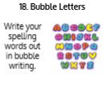  Use the activity above to practise spelling this week’s words:  adventure, capture, closure, creature, enclosure, leisure, measure, mixture, picture, pleasure, puncture, treasure
9.45-10.00  Active break | LO: To boost my concentration through movement. | Join in with the Go Noodle clip below to get you moving!  https://www.youtube.com/watch?v=VPkrrDfWC0o
10.00-11.00  English | SPaG Revision LO: To understand how to use question marks.  LO: To learn about the Angler fish’s diet. | For today’s SPaG Daily Practice, we are going to revise how to use question marks:  https://www.bbc.co.uk/bitesize/topics/z8x6cj6/articles/zcm3qhv  Follow the link below to have a go at today’s English lesson:  https://classroom.thenational.academy/lessons/to-learn-about-the-angler-fishs-diet-6mr32c
11.00- 11.15
Break
11.15-12.15  Maths | LO: To practise my recall of the 5 times table.  LO: To subtract using the column method when multiple columns require regrouping. | Follow the link below to practise the 5 times table:  http://www.snappymaths.com/multdiv/5xtable/interactive/newlook/5xtablebtcd.htm  Follow the link below to have a go at today’s lesson:  https://classroom.thenational.academy/lessons/subtracting-using-the-column-method-when-multiple-columns-require-regrouping-6xh34c
12.15-1.00
Dinner
1.00-1.15  Storytime | LO: To listen to a story for pleasure. | Listen to Chapter 3 of The Green Ember.  https://stories.audible.com/pdp/B00T50R42I?ref=adbl_ent_anon_ds_pdp_plc
1.15-3.00  PE | LO: To learn and perform a dance routine. | Follow the link below to learn a dance routine inspired by Aladdin!  https://www.youtube.com/watch?v=dh97m6-PKRM

Beat That!

Time and Subject  Friday | Learning Objective | Task/Link/Resources
8.45-9.00  Reading | L.O: To practise and consolidate existing reading skills. | Read your individual reading book, either in your head or out loud.
9.00-9.15  Morning Maths | LO: To consolidate recall of number facts.  Revision LO:  To understand what capacity is. | Complete today’s Beat That- scroll down below today’s timetable to find the questions. Remember, it is the same one every day for a week. Can you beat your own score?  Morning Maths: In Morning Maths today, you are going to revise capacity. Click the link below to find the lesson and activities to complete:  https://www.bbc.co.uk/bitesize/topics/zt9k7ty/articles/zp8crdm
9.15-9.45  Spelling | LO: To practise Unit Two RWI spelling words. | This week, we are going to practise spelling words ending in -sure and -ture  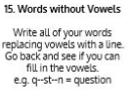  Use Words Without Vowels to practise spelling this week’s words:  adventure, capture, closure, creature, enclosure, leisure, measure, mixture, picture, pleasure, puncture, treasure  Spelling Test:  Scroll down below today’s timetable to use the look, cover, write, check sheet to help you to test yourself on this week’s words.
9.45-10.00  Active break | L.O: To boost my concentration through movement. | Join in with the Go Noodle clip to get you moving!  https://www.youtube.com/watch?v=SY1VL-Jhn90
10.00-11.00  English | SPaG Revision LO: To understand how to write questions.  LO: To develop a rich understanding of words associated with being wet. | For today’s SPaG Daily Practice, revise how to write questions:  https://www.bbc.co.uk/bitesize/topics/zrqqtfr/articles/z2xdng8  Follow the link below to have a go at today’s lesson:  https://classroom.thenational.academy/lessons/to-develop-a-rich-understanding-of-words-associated-with-being-wet-c8w30r
11.00- 11.15
Break
11.15-12.15  Maths | LO: To practise my recall of the 5 times table.  LO: To subtract from multiples of 1000. | Follow the link below to practise the 5 times table:  http://www.snappymaths.com/multdiv/5xtable/interactive/newlook/5xmissintd.htm  Follow the link below to have a go at today’s lesson:  https://classroom.thenational.academy/lessons/subtracting-from-multiples-of-1000-64rkjr
12.15-1.00
Dinner
1.00-1.15  Storytime | LO: To listen to a story for pleasure. | Listen to Chapter 4 of The Green Ember.  https://stories.audible.com/pdp/B00T50R42I?ref=adbl_ent_anon_ds_pdp_plc
1.15-3:00  Art | Golden Time  LO: To create an image of a landscape. | Draw your own landscape pictures:  https://www.youtube.com/watch?v=EJPuP50_ZqM  You could use coloured pencils, felt tips or paint!

Beat That!

Spelling Test
