Monday
Time and Subject | Learning Objective | Task/Link/Resources
8.45-9.00  Reading | L.O: To practise and consolidate existing reading skills. | Read your individual reading book, either in your head or out loud.
9.00-9.15  Morning Maths | LO: To consolidate recall of number facts.  Revision LO: To practise comparing and ordering numbers. | Complete today’s Beat That. You will find today’s Beat That below today’s timetable. Just scroll down! Remember, it is the same one every day for a week so try and beat your score each time!  We use Morning Maths as a time to revise concepts and keep them at the front of our minds- follow the link below to practise comparing and ordering numbers using the 5th video on the link:  https://whiterosemaths.com/homelearning/year-6/week-1/
9.15-9.45  Spelling | LO: To practice Unit Four RWI Spelling words. | Speed write this week’s words- time yourself a minute for each! Check them and correct any mistakes. Write them in different colours or fancy writing, make yourself a poster of each of the words! Circle the consonants and vowels.  Admit, admittance, admitting, begin, beginner, beginning, committed, forbidden, forgetting, forgotten, permitting, prefer, preferred, refer, referred, regret, regrettable, regretted, stop, stoppable, wet, wettest.
9.45-10.00  Active break | L.O: To boost my concentration through movement. | https://www.youtube.com/watch?v=3WnI4UNgSaY  Join in with the Go Noodle clip above to get you moving!
10.00-11.00  English | LO: To develop understanding of the key characters.  SPaG LO: To revise what a pronoun is. | Have a go at today’s lesson by clicking on the link below:  https://classroom.thenational.academy/lessons/to-develop-understanding-of-the-key-characters-c4r34e  SPaG Revision:  Use the link below to revise what a pronoun is:  https://www.bbc.co.uk/bitesize/topics/zwwp8mn/articles/z37xrwx
11.00- 11.15
Break
11.15-12.15  Maths | LO: To use formal written methods for short multiplication, including multiplying decimals. | Have a go at today’s lesson by clicking on the link below:  https://classroom.thenational.academy/lessons/use-formal-written-methods-for-short-multiplication-including-multiplying-decimals-6rvp2r
12.15-1.00
Dinner
1.00-1.15  Storytime | LO: To listen to a story for pleasure. | Listen to Part 6 of Wylderwood, it is 15 minutes long:  http://storiespodcast.com/
1.15-3:00  PE | LO: To develop fitness and strength. | Follow the links below to develop your fitness and strength:  https://www.youtube.com/watch?v=L_A_HjHZxfI  https://www.youtube.com/watch?v=LhYtcadR9nw  https://www.youtube.com/watch?v=T8jI4RnHHf0
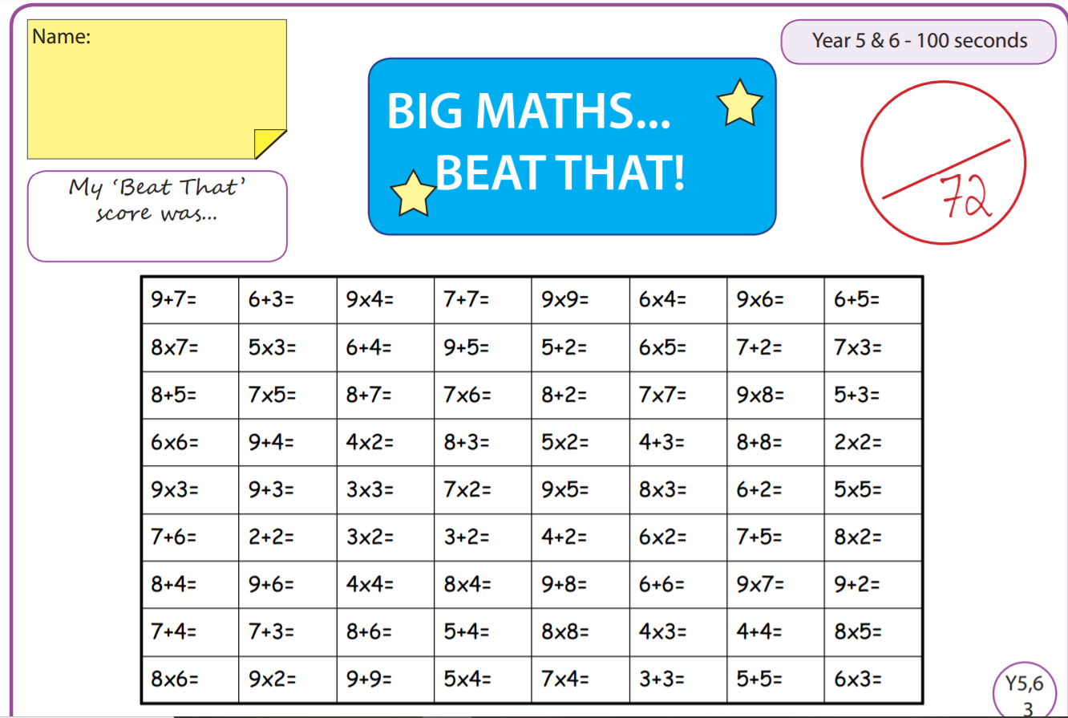
Tuesday
Time and Subject | Learning Objective | Task/Link/Resources
8.45-9.00  Reading | L.O: To practise and consolidate existing reading skills. | Read your individual reading book, either in your head or out loud.
9.00-9.15  Morning Maths | LO: To consolidate recall of number facts.  Revision LO:  To practise rounding numbers to 10, 100 and 1000. | Complete today’s Beat That. You will find today’s Beat That below today’s timetable. Just scroll down! Remember, it is the same one every day for a week so try and beat your score each time!  We use Morning Maths as a time to revise concepts and keep them at the front of our minds- follow the link below to practise rounding numbers to 10, 100 and 1000, use the 1st video on the link:  https://whiterosemaths.com/homelearning/year-6/week-2/
9.15-9.45  Spelling | LO: To practice Unit Four RWI Spelling words. | Speed write this week’s words- time yourself a minute for each! Check them and correct any mistakes. Write them in different colours or fancy writing, make yourself a poster of each of the words! Circle the consonants and vowels.  Admit, admittance, admitting, begin, beginner, beginning, committed, forbidden, forgetting, forgotten, permitting, prefer, preferred, refer, referred, regret, regrettable, regretted, stop, stoppable, wet, wettest.
9.45-10.00  Active break | L.O: To boost my concentration through movement. | https://www.youtube.com/watch?v=GxKb_VHCYdc  Join in with the Go Noodle clip above to get you moving!
10.00-11.00  English | LO: To investigate suffixes, past and present.  SPaG LO: To revise prepositions. | Have a go at today’s lesson by clicking on the link below:  https://classroom.thenational.academy/lessons/to-investigate-suffixes-past-and-present-60rkcc  SPAG Revision:  Use the link below to revise what a preposition is:  https://www.bbc.co.uk/bitesize/topics/zwwp8mn/articles/zw38srd
11.00- 11.15
Break
11.15-12.15  Maths | LO: To multiply by a two digit number using long multiplication. | Have a go at today’s lesson by clicking on the link below:  https://classroom.thenational.academy/lessons/multiply-by-a-two-digit-number-using-long-multiplication-75k3cc
12.15-1.00
Dinner
1.00-1.15  Storytime | LO: To listen to a story for pleasure. | Listen to Part 7 of Wylderwood, it is 16 minutes long:  http://storiespodcast.com/
1.15-2.30  Topic  Geography | LO: To explore what globalisation has to do with fashion. | Have a go at today’s Geography lesson by clicking on the link below:  https://classroom.thenational.academy/lessons/what-does-globalisation-have-to-do-with-fashion-6xjp4d
2.30-3.00  RHE | LO: I can recognise the different groups that make up and contribute to a community. | Follow the link below to have a go at today’s lesson:  https://classroom.thenational.academy/lessons/we-are-a-jigsaw-6cv3ed  When we are learning about our place in the community, it is important that we develop our sense of identity, watch the clip below to see how one young person has done this:  https://www.bbc.co.uk/bitesize/clips/zjn6n39
Wednesday
Time and Subject | Learning Objective | Task/Link/Resources
8.45-9.00  Reading | L.O: To practise and consolidate existing reading skills. | Read your individual reading book, either in your head or out loud.
9.00-9.15  Morning Maths | LO: To consolidate recall of number facts.  Revision LO: To practise rounding any number. | Complete today’s Beat That. You will find today’s Beat That below today’s timetable. Just scroll down! Remember, it is the same one every day for a week so try and beat your score each time!  We use Morning Maths as a time to revise concepts and keep them at the front of our minds- follow the link below to practise rounding any number, use the 2nd video on the link:  https://whiterosemaths.com/homelearning/year-6/week-2/
9.15-9.45  Spelling | LO: To practice Unit Four RWI Spelling words. | Speed write this week’s words- time yourself a minute for each! Check them and correct any mistakes. Write them in different colours or fancy writing, make yourself a poster of each of the words! Circle the consonants and vowels.  Admit, admittance, admitting, begin, beginner, beginning, committed, forbidden, forgetting, forgotten, permitting, prefer, preferred, refer, referred, regret, regrettable, regretted, stop, stoppable, wet, wettest.
9.45-10.00  Active break | L.O: To boost my concentration through movement. | https://www.youtube.com/watch?v=JU0ETGd5dgk  Join in with the Go Noodle clip above to get you moving!
10.00-11.00  English | LO: To explore complex sentences.  SPaG Revision LO: To revise expanded noun phrases. | Have a go at today’s lesson by clicking on the link below:  https://classroom.thenational.academy/lessons/to-explore-complex-sentences-65j30c  SPaG Revision:  Use the link below to revise expanded noun phrases:  https://www.bbc.co.uk/bitesize/topics/zwwp8mn/articles/z3nfw6f
11.00- 11.15
Break
11.15-12.15  Maths | LO: To use formal written methods, including long multiplication to solve a range of problems. | Have a go at today’s lesson by clicking on the link below:  https://classroom.thenational.academy/lessons/use-formal-written-methods-including-long-multiplication-to-solve-a-range-of-problems-61j38r
12.15-1.00
Dinner
1.00-1.15  Storytime | LO: To listen to a story for pleasure. | Listen to Part 8 of Wylderwood, it is 16 minutes long:  http://storiespodcast.com/
1.15-2.30  Topic  Geography | LO: To explore how fashion affects the environment. | Have a go at today’s Geography lesson by clicking on the link below:  https://classroom.thenational.academy/lessons/fashion-research-where-were-my-clothes-made-65h32t
2.30-3.00  Music | LO: To explore compound time. | Have a go at today’s lesson by clicking on the link below:  https://classroom.thenational.academy/lessons/to-explore-compound-time-71h64d
Thursday
Time and Subject | Learning Objective | Task/Link/Resources
8.45-9.00  Reading | L.O: To practise and consolidate existing reading skills. | Read your individual reading book, either in your head or out loud.
9.00-9.15  Morning Maths | LO: To consolidate recall of number facts.  Revision LO: To practise negative numbers in context. | Complete today’s Beat That. You will find today’s Beat That below today’s timetable. Just scroll down! Remember, it is the same one every day for a week so try and beat your score each time!  We use Morning Maths as a time to revise concepts and keep them at the front of our minds- follow the link below to practise negative numbers in context. Use the 3rd video on the link:  https://whiterosemaths.com/homelearning/year-6/week-2/
9.15-9.45  Spelling | LO: To practice Unit Four RWI Spelling words. | Speed write this week’s words- time yourself a minute for each! Check them and correct any mistakes. Write them in different colours or fancy writing, make yourself a poster of each of the words! Circle the consonants and vowels.  Admit, admittance, admitting, begin, beginner, beginning, committed, forbidden, forgetting, forgotten, permitting, prefer, preferred, refer, referred, regret, regrettable, regretted, stop, stoppable, wet, wettest.
9.45-10.00  Active break | L.O: To boost my concentration through movement. | https://www.youtube.com/watch?v=388Q44ReOWE  Join in with the Go Noodle clip above to get you moving!
10.00-11.00  English | LO: To write a character description.  SPaG LO: To explore passive verbs. | Have a go at today’s lesson by clicking on the link below:  https://classroom.thenational.academy/lessons/to-write-a-character-description-68t64r  SPaG:  Use the link below to explore passive verbs:  https://www.bbc.co.uk/bitesize/topics/zwwp8mn/articles/zsx2b82
11.00- 11.15
Break
11.15-12.15  Maths | LO: To explore different mental strategies for division. | Have a go at today’s lesson by clicking on the link below:  https://classroom.thenational.academy/lessons/explore-efficient-mental-strategies-for-division-crvp6e
12.15-1.00
Dinner
1.00-1.15  Storytime | LO: To listen to a story for pleasure. | Start listening to Part 9 of Wylderwood. It is 22 minutes long so you can listen to some today and some tomorrow, remember where you got up to!  http://storiespodcast.com/
1.15-2.30  Topic  Geography | LO: To explore what globalisation has to do with my food. | Have a go at today’s Geography lesson by clicking on the link below:  https://classroom.thenational.academy/lessons/what-does-globalisation-have-to-do-with-food-6wr30t
2.30-3.00  French | LO: To develop vocabulary. | Follow the link:  https://www.bbc.co.uk/teach/class-clips-video/french-ks2-following-directions/z6r3cqt
Friday
Time and Subject | Learning Objective | Task/Link/Resources
8.45-9.00  Reading | L.O: To practise and consolidate existing reading skills. | Read your individual reading book, either in your head or out loud.
9.00-9.15  Morning Maths | LO: To consolidate recall of number facts.  Revision LO: To practise negative numbers. | Complete today’s Beat That. You will find today’s Beat That below today’s timetable. Just scroll down! Remember, it is the same one every day for a week so try and beat your score each time!  We use Morning Maths as a time to revise concepts and keep them at the front of our minds- follow the link below to practise negative numbers, use the 4th video on the link:  https://whiterosemaths.com/homelearning/year-6/week-2/
9.15-9.45  Spelling | LO: To practice Unit Four RWI Spelling words. | Speed write this week’s words- time yourself a minute for each! Check them and correct any mistakes. Write them in different colours or fancy writing, make yourself a poster of each of the words! Circle the consonants and vowels.  Admit, admittance, admitting, begin, beginner, beginning, committed, forbidden, forgetting, forgotten, permitting, prefer, preferred, refer, referred, regret, regrettable, regretted, stop, stoppable, wet, wettest.  Test yourself on this week’s words using the Look, Cover, Check, Write resource below.
9.45-10.00  Active break | L.O: To boost my concentration through movement. | https://www.youtube.com/watch?v=sNog54ovi8Q  Join in with the Go Noodle clip above to get you moving!
10.00-11.00  English | LO: To develop a rich understanding of words associated with looking and seeing.  SPaG LO: To explore statement sentences. | Have a go at today’s lesson by clicking on the link below:  https://classroom.thenational.academy/lessons/to-develop-a-rich-understanding-of-words-associated-with-looking-or-seeing-6gup4c  SPaG:  Use the link below to explore statement sentences:  https://www.bbc.co.uk/bitesize/articles/z97r2nb
11.00- 11.15
Break
11.15-12.15  Maths | LO: To use the formal written method for short division. | Have a go at today’s lesson by clicking on the link below:  https://classroom.thenational.academy/lessons/use-the-formal-written-method-for-short-division-chh64c
12.15-1.00
Dinner
1.00-1.15  Storytime | LO: To listen to a story for pleasure. | Continue listening to Part 9 of Wylderwood.  http://storiespodcast.com/
1.15-3:00  Art for Golden Time | LO: To follow instructions to create a pen drawing. | Follow the link to have a go:  https://www.youtube.com/watch?v=OSUN5vR4QZY
