Time and Subject | Learning Objective | Task/Link/Resources
8.45-9.00  Reading | L.O: To practise and consolidate existing reading skills. | Read your individual reading book, either in your head or out loud.
9.00-9.15  Morning Maths | LO: To consolidate recall of number facts. | Complete today’s Beat That. You will find today’s Beat That below today’s timetable. Just scroll down! Remember, it is the same one every day for a week so try and beat your score each time!
9.15-9.45  Spelling | LO: To practice Unit Two RWI Spelling words. | Speed write this week’s words- time yourself a minute for each! Check them and correct any mistakes.  Write them in different colours or fancy writing, make yourself a poster of each of the words! Circle the consonants and vowels.  Week 3 – credible edible horrible legible possible resistible
9.45-10.00  Active break | L.O: To boost my concentration through movement. | https://www.youtube.com/watch?v=3WnI4UNgSaY  Join in with the Go Noodle clip above to get you moving!
10.00-11.00  English | LO: To analyse a clip and generate vocabulary part one. | Have a go at today’s lesson by clicking on the link below:  https://classroom.thenational.academy/lessons/to-analyse-a-clip-and-generate-vocabulary-part-1-6guk8r
11.00- 11.15
Break
11.15-12.15  Maths | LO: To learn about multiples and factors. | Have a go at today’s lesson by clicking on the link below:  https://classroom.thenational.academy/lessons/multiples-and-factors-6gr32d
12.15-1.00
Dinner
1.00-1.15  Storytime | LO: To listen to a story for pleasure. | Continue listening to Anne of Green Gables, remember where you get up to for next time:  https://stories.audible.com/pdp/B01KGL13FI?ref=adbl_ent_anon_ds_pdp_pc_cntr-3-3
1.15-2.30  PE | LO: To develop fitness and strength. | Follow the links below to develop your fitness and strength:  https://www.youtube.com/watch?v=L_A_HjHZxfI  https://www.youtube.com/watch?v=LhYtcadR9nw  https://www.youtube.com/watch?v=T8jI4RnHHf0

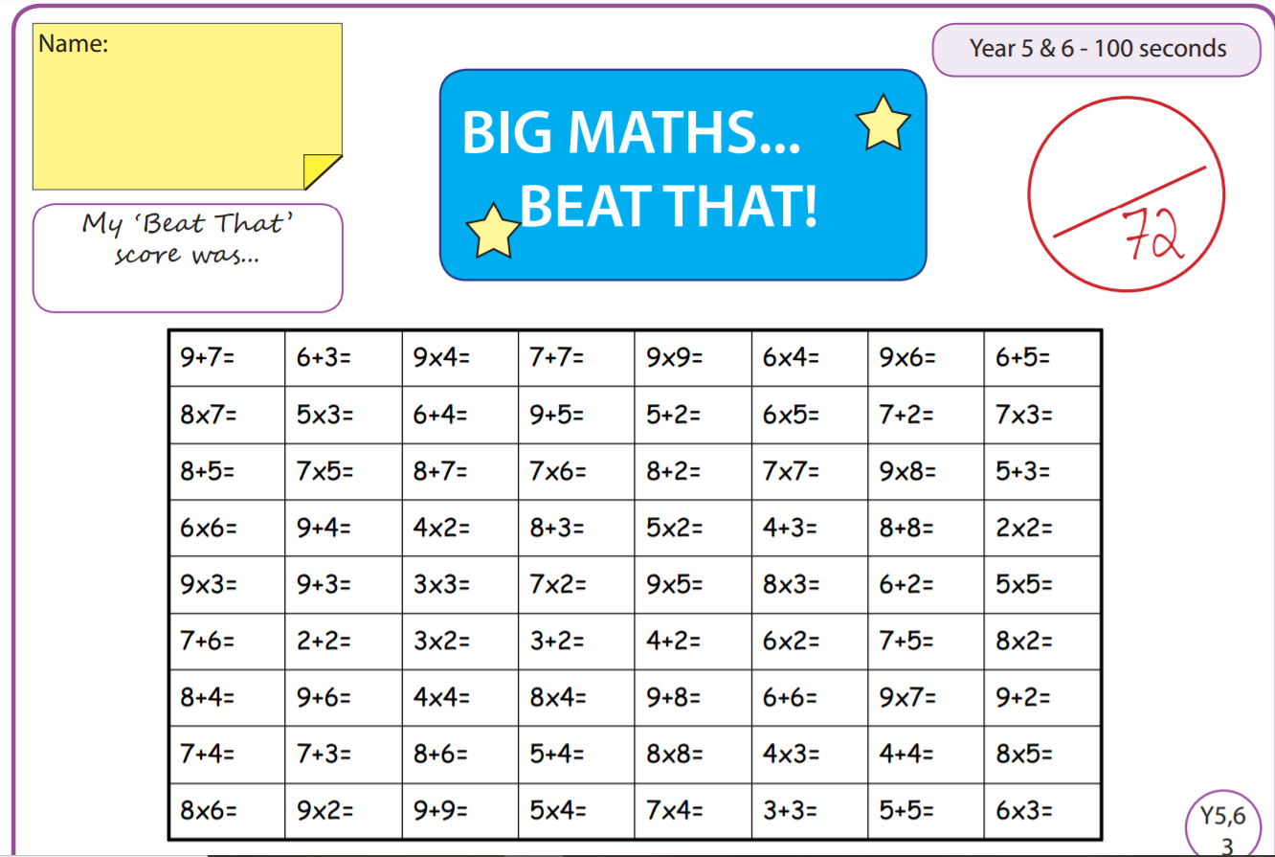

Tuesday
Time and Subject | Learning Objective | Task/Link/Resources
8.45-9.00  Reading | L.O: To practise and consolidate existing reading skills. | Read your individual reading book, either in your head or out loud.
9.00-9.15  Morning Maths | LO: To consolidate recall of number facts. | Complete today’s Beat That. You will find today’s Beat That below today’s timetable. Just scroll down! Remember, it is the same one every day for a week so try and beat your score each time!
9.15-9.45  Spelling | LO: To practice Unit Two RWI Spelling words. | Speed write this week’s words- time yourself a minute for each! Check them and correct any mistakes.  Write them in different colours or fancy writing, make yourself a poster of each of the words! Circle the consonants and vowels.  Week 3 – credible edible horrible legible possible resistible
9.45-10.00  Active break | L.O: To boost my concentration through movement. | https://www.youtube.com/watch?v=vbpzfnEQJjE  Join in with the Go Noodle clip above to get you moving!
10.00-11.00  English | LO: To investigate ee sound – ie or ei spelling. | Have a go at today’s lesson by clicking on the link below:  https://classroom.thenational.academy/lessons/to-investigate-ee-sound-ie-or-ei-spelling-74t3jc
11.00- 11.15
Break
11.15-12.15  Maths | LO: To identify factor pairs. | Have a go at today’s lesson by clicking on the link below:  https://classroom.thenational.academy/lessons/factor-pairs-61k3cd
12.15-1.00
Dinner
1.00-1.15  Storytime | LO: To listen to a story for pleasure. | Continue listening to Anne of Green Gables, remember where you get up to for next time:  https://stories.audible.com/pdp/B01KGL13FI?ref=adbl_ent_anon_ds_pdp_pc_cntr-3-3
1.15-2.30  Topic  History | LO: To learn about the conflicts between Athens and Sparta. | Have a go at today’s lesson by clicking on the link below:  https://classroom.thenational.academy/lessons/who-won-the-peloponnesian-wars-70t3ar
2.30-3.00  RHE | LO: To understand what different groups make up a community. | Have a go at today’s lesson by clicking on the link below:  https://classroom.thenational.academy/lessons/we-are-a-jigsaw-6cv3ed

Wednesday
Time and Subject | Learning Objective | Task/Link/Resources
8.45-9.00  Reading | L.O: To practise and consolidate existing reading skills. | Read your individual reading book, either in your head or out loud.
9.00-9.15  Morning Maths | LO: To consolidate recall of number facts. | Complete today’s Beat That. You will find today’s Beat That below today’s timetable. Just scroll down! Remember, it is the same one every day for a week so try and beat your score each time!
9.15-9.45  Spelling | LO: To practice Unit Two RWI Spelling words. | Speed write this week’s words- time yourself a minute for each! Check them and correct any mistakes.  Write them in different colours or fancy writing, make yourself a poster of each of the words! Circle the consonants and vowels.  Week 3 – credible edible horrible legible possible resistible
9.45-10.00  Active break | L.O: To boost my concentration through movement. | https://www.youtube.com/watch?v=H1R1X6BC7Qw  Join in with the Go Noodle clip above to get you moving!
10.00-11.00  English | LO: To explore expanded noun phrases. | Have a go at today’s lesson by clicking on the link below:  https://classroom.thenational.academy/lessons/to-explore-expanded-noun-phrases-64r3ec
11.00- 11.15
Break
11.15-12.15  Maths | LO: To work with prime numbers. | Have a go at today’s lesson by clicking on the link below:  https://classroom.thenational.academy/lessons/prime-numbers-65j38e
12.15-1.00
Dinner
1.00-1.15  Storytime | LO: To listen to a story for pleasure. | Continue listening to Anne of Green Gables, remember where you get up to for next time:  https://stories.audible.com/pdp/B01KGL13FI?ref=adbl_ent_anon_ds_pdp_pc_cntr-3-3
1.15-2.30  Topic  History | LO: To learn about Alexander the Great. | Have a go at today’s lesson by clicking on the link below:  https://classroom.thenational.academy/lessons/why-was-alexander-so-great-6mtp4r
2.30-3.00  Music | LO: To explore on and off beats in different musical styles. | Have a go at today’s lesson by clicking on the link below:  https://classroom.thenational.academy/lessons/to-explore-on-and-off-beats-in-different-musical-styles-chj32c
Thursday
Time and Subject | Learning Objective | Task/Link/Resources
8.45-9.00  Reading | L.O: To practise and consolidate existing reading skills. | Read your individual reading book, either in your head or out loud.
9.00-9.15  Morning Maths | LO: To consolidate recall of number facts. | Complete today’s Beat That. You will find today’s Beat That below today’s timetable. Just scroll down! Remember, it is the same one every day for a week so try and beat your score each time!
9.15-9.45  Spelling | LO: To practice Unit Two RWI Spelling words. | Speed write this week’s words- time yourself a minute for each! Check them and correct any mistakes.  Write them in different colours or fancy writing, make yourself a poster of each of the words! Circle the consonants and vowels.  Week 3 – credible edible horrible legible possible resistible
9.45-10.00  Active break | L.O: To boost my concentration through movement. | https://www.youtube.com/watch?v=GxKb_VHCYdc  Join in with the Go Noodle clip above to get you moving!
10.00-11.00  English | LO: To practise using speech in complex sentences. | Have a go at today’s lesson by clicking on the link below:  https://classroom.thenational.academy/lessons/to-practise-using-speech-in-complex-sentences-64w3jr
11.00- 11.15
Break
11.15-12.15  Maths | LO: To use prior knowledge of factors and multiples to create chains. | Have a go at today’s lesson by clicking on the link below:  https://classroom.thenational.academy/lessons/factor-and-multiple-chains-6gvp6c
12.15-1.00
Dinner
1.00-1.15  Storytime | LO: To listen to a story for pleasure. | Continue listening to Anne of Green Gables, remember where you get up to for next time:  https://stories.audible.com/pdp/B01KGL13FI?ref=adbl_ent_anon_ds_pdp_pc_cntr-3-3
1.15-2.30  Topic  History | LO: To evaluate the great achievements of the Ancient Greeks. | Have a go at today’s lesson by clicking on the link below:  https://classroom.thenational.academy/lessons/what-were-the-great-achievements-of-the-ancient-greeks-70up8d
2.30-3.00  French | LO: To develop vocabulary. | Follow the link below:  https://www.bbc.co.uk/teach/class-clips-video/french-ks2-how-to-introduce-yourself/zf84d6f
Friday
Time and Subject | Learning Objective | Task/Link/Resources
8.45-9.00  Reading | L.O: To practise and consolidate existing reading skills. | Read your individual reading book, either in your head or out loud.
9.00-9.15  Morning Maths | LO: To consolidate recall of number facts. | Complete today’s Beat That. You will find today’s Beat That below today’s timetable. Just scroll down! Remember, it is the same one every day for a week so try and beat your score each time!
9.15-9.45  Spelling | LO: To practice Unit Two RWI Spelling words. | Speed write this week’s words- time yourself a minute for each! Check them and correct any mistakes.  Write them in different colours or fancy writing, make yourself a poster of each of the words! Circle the consonants and vowels.  Week 3 – credible edible horrible legible possible resistible  Use the Look, Cover, Say, Write, Check grid at the bottom to test yourself.
9.45-10.00  Active break | L.O: To boost my concentration through movement. | https://www.youtube.com/watch?v=JU0ETGd5dgk  Join in with the Go Noodle clip above to get you moving!
10.00-11.00  English | LO: To develop a rich understanding of words associated with hunger or thirst part one. | Have a go at today’s lesson by clicking on the link below:  https://classroom.thenational.academy/lessons/to-develop-a-rich-understanding-of-words-associated-with-hunger-or-thirst-part-1-ctk32d
11.00- 11.15
Break
11.15-12.15  Maths | LO: To multiply and divide by 10. 100 and 1000. | Have a go at today’s lesson by clicking on the link below:  https://classroom.thenational.academy/lessons/multiplying-and-dividing-by-10-100-1000-64t68e
12.15-1.00
Dinner
1.00-1.15  Storytime | LO: To listen to a story for pleasure. | Continue listening to Anne of Green Gables, remember where you get up to for next time:  https://stories.audible.com/pdp/B01KGL13FI?ref=adbl_ent_anon_ds_pdp_pc_cntr-3-3
1.15-3:00  Golden Time Art | LO: To create a pen drawing. | Enjoy the session by following the link below:  https://www.youtube.com/watch?v=OSUN5vR4QZY
