Time and Subject  Monday | Learning Objective | Task/Link/Resources
8.45-9.00  Reading | LO: To practise and consolidate existing reading skills. | Read your individual reading book, either in your head or out loud.
9.00-9.15  Morning Maths | LO: To consolidate recall of number facts.  Revision LO: To practise the 11 and 12 times table. | Complete today’s Beat That- scroll down below today’s timetable to find the questions. Remember, it is the same one every day for a week. Can you beat your own score?  Morning Maths: In Morning Maths today, you are going to revise your knowledge of multiplication and division. Click the link below and select the video 11 and 12 times table.  Spring Week 1 - Number: Multiplication & Division | White Rose Maths
9.15-9.45  Spelling | LO: To practise Year 3/4 common exception words. | This week, we are going to practise some of our tricky orange words.  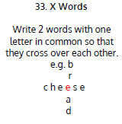  Use X Words to practise spelling this week’s words:  special, straight, strange, strength, suppose, surprise.
9.45-10.00  Active break | LO: To boost my concentration through movement. | Join in with the Go Noodle clip below to get you moving!  Casagrandes Dance Along - YouTube
10.00-11.00  English | SPaG Revision LO: To use co-ordinating conjunctions.  LO: To gather information and evidence for a newspaper report. | For today’s SPaG Daily Practice, revise your knowledge of conjunctions. Watch the videos and complete activity 2.  Using conjunctions - Year 3 - P4 - English - Catch Up Lesson - Home Learning with BBC Bitesize - BBC Bitesize  Follow the link below to have a go at today’s English lesson:  To gather information and evidence for a newspaper report (thenational.academy)
11.00- 11.15
Break
11.15-12.15  Maths | LO: To practise my recall of the 5 times table.  LO: To recognise decimal number bonds. | Follow the link below to practise the 5 times table and get moving!  KS1 Maths: The 5 Times Table - BBC Teach  Follow the link below to have a go at today’s maths lesson:  Decimal Number Bonds (thenational.academy)
12.15-1.00
Dinner
1.00-1.15  Storytime | LO: To listen to a story for pleasure. | Listen to Chapter 6 of Hotel Flamingo:  Hotel Flamingo - World Book Day
1.15-3.00  Topic- Science | LO: To understand how the human anatomy compares to other animals. | Follow the link below to have a go at today’s lesson:  How does human anatomy compare to other animals? (thenational.academy)
Beat That!
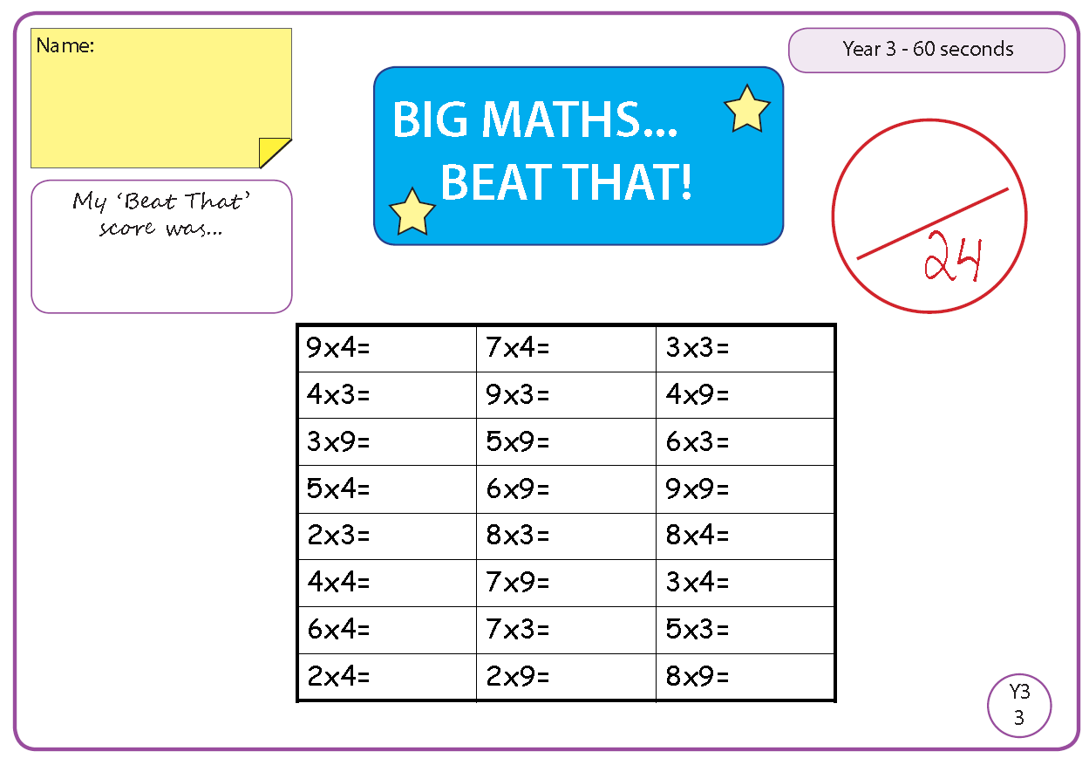
Time and Subject  Tuesday | Learning Objective | Task/Link/Resources
8.45-9.00  Reading | L.O: To practise and consolidate existing reading skills. | Read your individual reading book, either in your head or out loud.
9.00-9.15  Morning Maths | LO: To consolidate recall of number facts.  Revision LO: To multiply 3 numbers. | Complete today’s Beat That- scroll down below today’s timetable to find the questions. Remember, it is the same one every day for a week. Can you beat your own score?  Morning Maths: In Morning Maths today, you are going to revise your knowledge of multiplication and division. Click the link below and select the video Multiply 3 numbers.  Spring Week 1 - Number: Multiplication & Division | White Rose Maths
9.15-9.45  Spelling | LO: To practise Year 3/4 common exception words. | This week, we are going to practise spelling some of our tricky orange words!  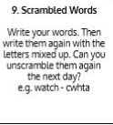  Use Scrambled Words to practise spelling this week’s orange words:  special, straight, strange, strength, suppose, surprise.
9.45-10.00  Active break | L.O: To boost my concentration through movement. | Join in with the Go Noodle clip below to get you moving!  Peanut Butter in a Cup - Moose Tube | GoNoodle - YouTube
10.00-11.00  English | SPaG Revision LO: To use co-ordinating conjunctions.  LO: To practise and apply knowledge of compound words. | For today’s SPaG Daily Practice, revise your knowledge of conjunctions. Watch the videos and complete activity 3.  Using conjunctions - Year 3 - P4 - English - Catch Up Lesson - Home Learning with BBC Bitesize - BBC Bitesize  Follow the link below to have a go at today’s English lesson:  To practise and apply knowledge of compound words, including test (thenational.academy)
11.00- 11.15
Break
11.15-12.15  Maths | LO: To practise my recall of the 5 times table.  LO: To use mental strategies to add and subtract decimals. | Follow the link below to practise the 5 times table:  Coconut Multiples - Reinforce Times Tables (topmarks.co.uk)  Follow the link below to have a go at today’s maths lesson:  Mental Addition and Subtraction (thenational.academy)
12.15-1.00
Dinner
1.00-1.15  Storytime | LO: To listen to a story for pleasure. | Listen to Chapter 7 of Hotel Flamingo:  Hotel Flamingo - World Book Day
1.15-2.30  Topic- Science | LO: To explore whether all teeth are the same. | Follow the link below to have a go at today’s lesson:  Are all teeth the same? (thenational.academy)
2.30-3.00  French | LO: To count to 10 in French. | Listen to this song to practise counting in French:  Numbers Song in French. Une Chanson des Chiffres. - YouTube  Play the ‘Number Labelling in French’ game to test your knowledge:  Crickweb | KS2 French

Beat That!

Time and Subject  Wednesday | Learning Objective | Task/Link/Resources
8.45-9.00  Reading | L.O: To practise and consolidate existing reading skills. | Read your individual reading book, either in your head or out loud.
9.00-9.15  Morning Maths | LO: To consolidate recall of number facts.  Revision LO: To find factor pairs. | Complete today’s Beat That- scroll down below today’s timetable to find the questions. Remember, it is the same one every day for a week. Can you beat your own score?  Morning Maths: In Morning Maths today, you are going to revise your knowledge of multiplication and division. Click the link below and select the video Factor pairs.  Spring Week 1 - Number: Multiplication & Division | White Rose Maths
9.15-9.45  Spelling | LO: To practise Year 3/4 common exception words. | This week, we are going to practise some of our tricky orange words.  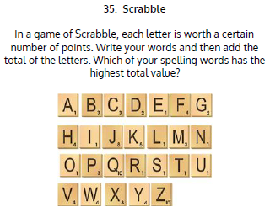  Use Scrabble to practise spelling this week’s words:  special, straight, strange, strength, suppose, surprise.
9.45-10.00  Active break | LO: To boost my concentration through movement. | Join in with the Go Noodle clip below to get you moving!  Hola, Bonjour, HELLO! - Champiverse | GoNoodle - YouTube
10.00-11.00  English | SPaG Revision LO: To use subordinating conjunctions.  LO: To generate formal, journalistic vocabulary. | For today’s SPaG Daily Practice, revise your knowledge of conjunctions. Watch the videos and complete activity 1.  Using subordinating conjunctions - Year 4 - P5 - English - Catch Up Lessons - Home Learning with BBC Bitesize - BBC Bitesize  Follow the link below to have a go at today’s English lesson:  To generate formal, journalistic vocabulary (thenational.academy)
11.00- 11.15
Break
11.15-12.15  Maths | LO: To practise my recall of the 5 times table.  LO: To recognise hundredths. | Follow the link below. Watch the 5 times table video and complete the first activity:  The 5 times table - BBC Bitesize  Follow the link below to have a go at today’s maths lesson:  Recognising Decimal Hundredths (Part 1) (thenational.academy)
12.15-1.00
Dinner
1.00-1.15  Storytime | LO: To listen to a story for pleasure. | Listen to Chapter 8 of Hotel Flamingo:  Hotel Flamingo - World Book Day
1.15-3.00  Topic- Science | LO: To understand how oxygen is transported around the body. | Follow the link below to have a go at today’s lesson:  How is oxygen transported around our bodies? (thenational.academy)

Beat That!

Time and Subject  Thursday | Learning Objective | Task/Link/Resources
8.45-9.00  Reading | L.O: To practise and consolidate existing reading skills. | Read your individual reading book, either in your head or out loud.
9.00-9.15  Morning Maths | LO: To consolidate recall of number facts.  Revision LO: To multiply efficiently. | Complete today’s Beat That- scroll down below today’s timetable to find the questions. Remember, it is the same one every day for a week. Can you beat your own score?  Morning Maths: In Morning Maths today, you are going to revise your knowledge of multiplication and division. Click the link below and select the video Efficient multiplication.  Spring Week 1 - Number: Multiplication & Division | White Rose Maths
9.15-9.45  Spelling | LO: To practise Year 3/4 common exception words. | This week, we are going to practise some of our tricky orange words.  Use Rainbow Words to practise spelling this week’s words:  special, straight, strange, strength, suppose, surprise.
9.45-10.00  Active break | LO: To boost my concentration through movement. | Join in with the Go Noodle clip below to get you moving!  Stay On The Sunny Side - Moose Tube | GoNoodle - YouTube
10.00-11.00  English | SPaG Revision LO: To use subordinating conjunctions.  LO: To plan the opening and chronological recount paragraph of a newspaper report. | For today’s SPaG Daily Practice, revise your knowledge of conjunctions. Watch the videos and complete activity 2.  Using subordinating conjunctions - Year 4 - P5 - English - Catch Up Lessons - Home Learning with BBC Bitesize - BBC Bitesize  Follow the link below to have a go at today’s English lesson:  To plan the opening and chronological recount paragraph of a newspaper report (thenational.academy)
11.00- 11.15
Break
11.15-12.15  Maths | LO: To practise my recall of the 5 times table.  LO: To recognise hundredths. | Follow the link below. Watch the 5 times table video and complete the second activity:  The 5 times table - BBC Bitesize  Follow the link below to have a go at today’s lesson:  Recognising Decimal Hundredths (Part 2) (thenational.academy)
12.15-1.00
Dinner
1.00-1.15  Storytime | LO: To listen to a story for pleasure. | Listen to Chapter 9 of Hotel Flamingo:  Hotel Flamingo - World Book Day
1.15-3.00  PE | LO: To run over obstacles and throw for accuracy. | Follow the link to have a go at today’s PE lesson:  Running over obstacles and throwing for accuracy (thenational.academy)

Beat That!

Time and Subject  Friday | Learning Objective | Task/Link/Resources
8.45-9.00  Reading | L.O: To practise and consolidate existing reading skills. | Read your individual reading book, either in your head or out loud.
9.00-9.15  Morning Maths | LO: To consolidate recall of number facts.  Revision LO: To use written multiplication methods. | Complete today’s Beat That- scroll down below today’s timetable to find the questions. Remember, it is the same one every day for a week. Can you beat your own score?  Morning Maths: In Morning Maths today, you are going to revise your knowledge of multiplication and division. Click the link below and select the video Written Methods.  Spring Week 1 - Number: Multiplication & Division | White Rose Maths
9.15-9.45  Spelling | LO: To practise Year 3/4 common exception words. | This week, we are going to practise some of our tricky orange words.  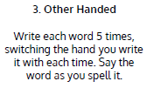  Use Other Handed to practise spelling this week’s words: special, straight, strange, strength, suppose, surprise.  Spelling Test:  Scroll down below today’s timetable to use the look, cover, write, check sheet to help you to test yourself on this week’s words.
9.45-10.00  Active break | L.O: To boost my concentration through movement. | Join in with the Go Noodle clip to get you moving!  Wishy Washy Washer Woman - Moose Tube | GoNoodle - YouTube
10.00-11.00  English | SPaG Revision LO: To use subordinating conjunctions.  LO: To write the opening of a newspaper report. | For today’s SPaG Daily Practice, revise your knowledge of conjunctions. Watch the videos and complete activity 3.  Using subordinating conjunctions - Year 4 - P5 - English - Catch Up Lessons - Home Learning with BBC Bitesize - BBC Bitesize  Follow the link below to have a go at today’s lesson:  To write the opening of a newspaper report (thenational.academy)
11.00- 11.15
Break
11.15-12.15  Maths | LO: To practise my recall of the 5 times table.  LO: To recognise common equivalent decimals. | Follow the link below. Watch the 5 times table video and complete the third activity:  The 5 times table - BBC Bitesize  Follow the link below to have a go at today’s lesson:  Recognising Common Decimal Equivalents (thenational.academy)
12.15-1.00
Dinner
1.00-1.15  Storytime | LO: To listen to a story for pleasure. | Listen to Chapter 10 of Hotel Flamingo:  Hotel Flamingo - World Book Day
1.15-3:00  Golden Time | LO: To design and draw cartoon animals. | Follow the tutorials below to learn how to draw different cartoon animals.  Peacock:  #DrawWithRob 11 Peacock - YouTube  Koala:  #DrawWithRob 48 Koala - YouTube  Mouse:  #DrawWithRob 49 Mouse - YouTube  Turtle:  #DrawWithRob 29 Turtle - YouTube  You could also choose to complete the art activity included below this week’s timetable.

Beat That!

Spelling Test
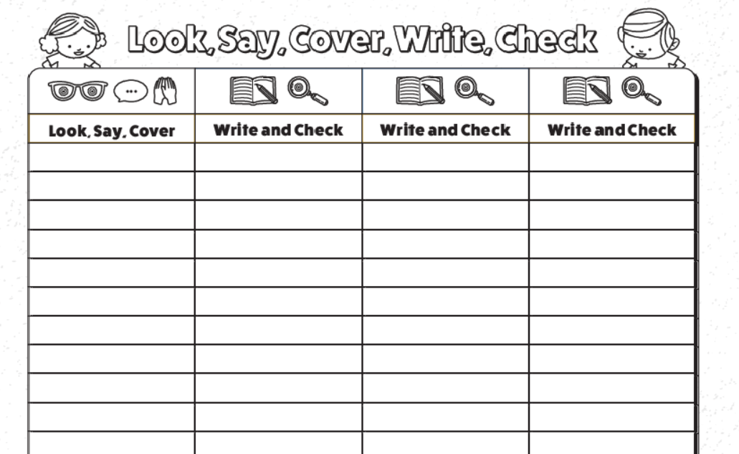

I can create a simple tessellation
Today, we will be continuing out work on Escher. Can you remember the new words we learned last lesson? Yes, that’s right: collage, tessellation and optical illusion.
During our lesson today, we will focus on creating a simple tessellation. We will use Purple Mash to create these. First, you will need to log in to Purple Mash. Click on 2Paint a picture. Then click on pattern and this will open up a new document.

You can experiment creating your own artwork. Take a look at my example below.

This programme can help you start your journey into tessellation. These images start by showing a repeating pattern which is key to include in a tessellation.

Remember to save your work for your teacher to see.

