Time and Subject  Monday | Learning Objective | Task/Link/Resources
8.45-9.00  Reading | LO: To practise and consolidate existing reading skills. | Read your individual reading book, either in your head or out loud.
9.00-9.15  Morning Maths | LO: To consolidate recall of number facts.  Revision LO: To use knowledge of equal groups to multiply. | Complete today’s Beat That- scroll down below today’s timetable to find the questions. Remember, it is the same one every day for a week. Can you beat your own score?  Morning Maths: In Morning Maths today, you are going to revise your knowledge of multiplication. Click the link below and select the video Multiplication-equal groups.  Autumn Week 9 - Number: Multiplication & Division | White Rose Maths
9.15-9.45  Spelling | LO: To practise Year 3/4 common exception words. | This week, we are going to practise some of our tricky orange words.  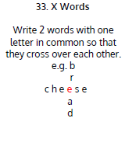  Use X Words to practise spelling this week’s words:  special, straight, strange, strength, suppose, surprise.
9.45-10.00  Active break | LO: To boost my concentration through movement. | Join in with the Go Noodle clip below to get you moving!  Casagrandes Dance Along - YouTube
10.00-11.00  English | SPaG Revision LO: To explore subordinate clauses.  LO: To write the introduction to an explanation text. | For today’s SPaG Daily Practice, revise your knowledge of subordinate clauses. Watch the videos and complete activity 3.  Exploring subordinate clauses - Year 3 - P4 - English - Catch Up Lessons - Home Learning with BBC Bitesize - BBC Bitesize  Follow the link below to have a go at today’s English lesson:  To write the introduction to an explanation text (thenational.academy)
11.00- 11.15
Break
11.15-12.15  Maths | LO: To practise my recall of the 5 times table.  LO: To identify values in 4-digit numbers. | Follow the link below to practise the 5 times table and get moving!  KS1 Maths: The 5 Times Table - BBC Teach  Follow the link below to have a go at today’s maths lesson:  Identifying values in four digit numbers (thenational.academy)
12.15-1.00
Dinner
1.00-1.15  Storytime | LO: To listen to a story for pleasure. | Listen to Chapter 6 of Hotel Flamingo:  Hotel Flamingo - World Book Day
1.15-3.00  Topic- DT | LO: To develop a design brief and to sketch ideas for the product. | Follow the link below to have a go at today’s lesson:  To evaluate existing structures (thenational.academy)

Beat That!
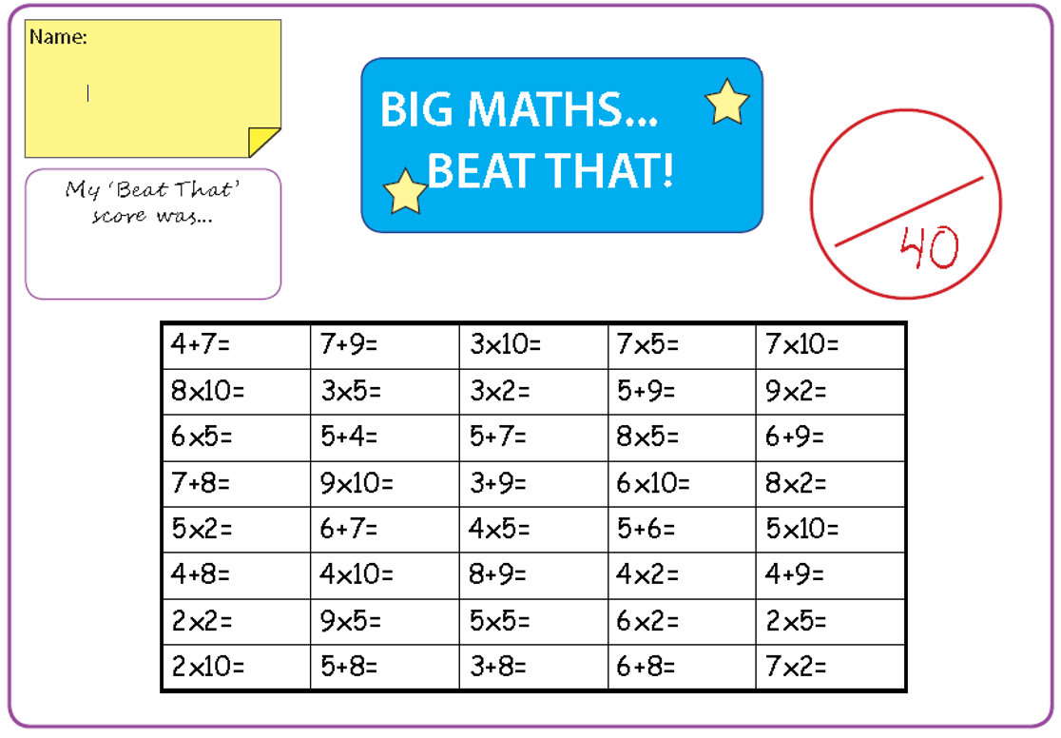
Time and Subject  Tuesday | Learning Objective | Task/Link/Resources
8.45-9.00  Reading | L.O: To practise and consolidate existing reading skills. | Read your individual reading book, either in your head or out loud.
9.00-9.15  Morning Maths | LO: To consolidate recall of number facts.  Revision LO: To use the multiplication symbol. | Complete today’s Beat That- scroll down below today’s timetable to find the questions. Remember, it is the same one every day for a week. Can you beat your own score?  Morning Maths: In Morning Maths today, you are going to revise your knowledge of multiplication. Click the link below and select the video Multiplication using the symbol.  Autumn Week 9 - Number: Multiplication & Division | White Rose Maths
9.15-9.45  Spelling | LO: To practise Year 3/4 common exception words. | This week, we are going to practise spelling some of our tricky orange words!  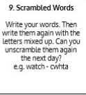  Use Scrambled Words to practise spelling this week’s orange words:  special, straight, strange, strength, suppose, surprise.
9.45-10.00  Active break | L.O: To boost my concentration through movement. | Join in with the Go Noodle clip below to get you moving!  Peanut Butter in a Cup - Moose Tube | GoNoodle - YouTube
10.00-11.00  English | SPaG Revision LO: To explore noun phrases and expanded noun phrases.  LO: To write the first section of an explanation text. | For today’s SPaG Daily Practice, revise your knowledge of noun phrases and expanded noun phrases. Watch the videos and complete activity 1.  Noun phrases and expanded noun phrases - Year 3 - P4 - English - Catch Up Lessons - Home Learning with BBC Bitesize - BBC Bitesize  Follow the link below to have a go at today’s English lesson:  To write the first section of an explanation text (thenational.academy)
11.00- 11.15
Break
11.15-12.15  Maths | LO: To practise my recall of the 5 times table.  LO: To compare 4-digit numbers. | Follow the link below to practise the 5 times table:  Coconut Multiples - Reinforce Times Tables (topmarks.co.uk)  Follow the link below to have a go at today’s maths lesson:  Comparing four digit numbers (thenational.academy)
12.15-1.00
Dinner
1.00-1.15  Storytime | LO: To listen to a story for pleasure. | Listen to Chapter 7 of Hotel Flamingo:  Hotel Flamingo - World Book Day
1.15-2.30  Topic- DT | LO: To explore contexts and purposes of structures. | Follow this link to have a go at today’s lesson:  To explore contexts and purposes of structures (thenational.academy)
2.30-3.00  French | LO: To count to 10 in French. | Listen to this song to practise counting in French:  Numbers Song in French. Une Chanson des Chiffres. - YouTube  Play the ‘Number Labelling in French’ game to test your knowledge:  Crickweb | KS2 French
Beat That!
Time and Subject  Wednesday | Learning Objective | Task/Link/Resources
8.45-9.00  Reading | L.O: To practise and consolidate existing reading skills. | Read your individual reading book, either in your head or out loud.
9.00-9.15  Morning Maths | LO: To consolidate recall of number facts.  Revision LO: To multiply using arrays. | Complete today’s Beat That- scroll down below today’s timetable to find the questions. Remember, it is the same one every day for a week. Can you beat your own score?  Morning Maths: In Morning Maths today, you are going to revise your knowledge of multiplication. Click the link below and select the video Using arrays.  Autumn Week 9 - Number: Multiplication & Division | White Rose Maths
9.15-9.45  Spelling | LO: To practise Year 3/4 common exception words. | This week, we are going to practise some of our tricky orange words.  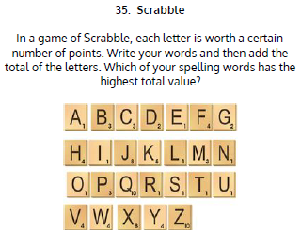  Use Scrabble to practise spelling this week’s words:  special, straight, strange, strength, suppose, surprise.
9.45-10.00  Active break | LO: To boost my concentration through movement. | Join in with the Go Noodle clip below to get you moving!  Hola, Bonjour, HELLO! - Champiverse | GoNoodle - YouTube
10.00-11.00  English | SPaG Revision LO: To explore noun phrases and expanded noun phrases.  LO: To edit an explanation text. | For today’s SPaG Daily Practice, revise your knowledge of noun phrases and expanded noun phrases. Watch the videos and complete activity 2.  Noun phrases and expanded noun phrases - Year 3 - P4 - English - Catch Up Lessons - Home Learning with BBC Bitesize - BBC Bitesize  Follow the link below to have a go at today’s English lesson:  To edit an explanation text (thenational.academy)
11.00- 11.15
Break
11.15-12.15  Maths | LO: To practise my recall of the 5 times table.  LO: To compare and order 4-digit numbers. | Follow the link below. Watch the 5 times table video and complete the first activity:  The 5 times table - BBC Bitesize  Follow the link below to have a go at today’s maths lesson:  Comparing and ordering four digit numbers (thenational.academy)
12.15-1.00
Dinner
1.00-1.15  Storytime | LO: To listen to a story for pleasure. | Listen to Chapter 8 of Hotel Flamingo:  Hotel Flamingo - World Book Day
1.15-2.30  Topic- Science | LO: To learn about what plants need to grow. | Follow the link below to have a go at today’s lesson:  What conditions could we change to investigate the growth of a plant? (thenational.academy)

Beat That!

Time and Subject  Thursday | Learning Objective | Task/Link/Resources
8.45-9.00  Reading | L.O: To practise and consolidate existing reading skills. | Read your individual reading book, either in your head or out loud.
9.00-9.15  Morning Maths | LO: To consolidate recall of number facts.  Revision LO: To recall the 2 times table. | Complete today’s Beat That- scroll down below today’s timetable to find the questions. Remember, it is the same one every day for a week. Can you beat your own score?  Morning Maths: In Morning Maths today, you are going to revise your knowledge of multiplication. Click the link below and select the video 2 times table.  Autumn Week 9 - Number: Multiplication & Division | White Rose Maths
9.15-9.45  Spelling | LO: To practise Year 3/4 common exception words. | This week, we are going to practise some of our tricky orange words.  Use Rainbow Words to practise spelling this week’s words:  special, straight, strange, strength, suppose, surprise.
9.45-10.00  Active break | LO: To boost my concentration through movement. | Join in with the Go Noodle clip below to get you moving!  Stay On The Sunny Side - Moose Tube | GoNoodle - YouTube
10.00-11.00  English | SPaG Revision LO: To explore noun phrases and expanded noun phrases.  LO: To write the second section of an explanation text. | For today’s SPaG Daily Practice, revise your knowledge of noun phrases and expanded noun phrases. Watch the videos and complete activity 3.  Noun phrases and expanded noun phrases - Year 3 - P4 - English - Catch Up Lessons - Home Learning with BBC Bitesize - BBC Bitesize  Follow the link below to have a go at today’s English lesson:  To write the second section of an explanation text (thenational.academy)
11.00- 11.15
Break
11.15-12.15  Maths | LO: To practise my recall of the 5 times table.  LO: To add and subtract 1000. | Follow the link below. Watch the 5 times table video and complete the second activity:  The 5 times table - BBC Bitesize  Follow the link below to have a go at today’s lesson:  Adding and subtracting 1000 (thenational.academy)
12.15-1.00
Dinner
1.00-1.15  Storytime | LO: To listen to a story for pleasure. | Listen to Chapter 9 of Hotel Flamingo:  Hotel Flamingo - World Book Day
1.15-3.00  PE | LO: To run over obstacles and throw for accuracy. | Follow the link to have a go at today’s PE lesson:  Running over obstacles and throwing for accuracy (thenational.academy)

Beat That!
Time and Subject  Friday | Learning Objective | Task/Link/Resources
8.45-9.00  Reading | L.O: To practise and consolidate existing reading skills. | Read your individual reading book, either in your head or out loud.
9.00-9.15  Morning Maths | LO: To consolidate recall of number facts.  Revision LO: To make equal groups by sharing. | Complete today’s Beat That- scroll down below today’s timetable to find the questions. Remember, it is the same one every day for a week. Can you beat your own score?  Morning Maths: In Morning Maths today, you are going to revise your knowledge of division. Click the link below and select the video Make equal groups-sharing.  Autumn Week 10 - Number: Multiplication & Division | White Rose Maths
9.15-9.45  Spelling | LO: To practise Year 3/4 common exception words. | This week, we are going to practise some of our tricky orange words.  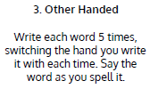  Use Other Handed to practise spelling this week’s words: special, straight, strange, strength, suppose, surprise.  Spelling Test:  Scroll down below today’s timetable to use the look, cover, write, check sheet to help you to test yourself on this week’s words.
9.45-10.00  Active break | L.O: To boost my concentration through movement. | Join in with the Go Noodle clip to get you moving!  Wishy Washy Washer Woman - Moose Tube | GoNoodle - YouTube
10.00-11.00  English | SPaG Revision LO: To identify pronouns.  LO: To develop reading for pleasure through book recommendations. | For today’s SPaG Daily Practice, revise your knowledge of pronouns. Watch the video and complete activity 1.  Identifying pronouns - Year 3 - P4 - English - Catch Up Lesson - Home Learning with BBC Bitesize - BBC Bitesize  Follow the link below to have a go at today’s lesson:  To develop reading for pleasure through book recommendations (thenational.academy)
11.00- 11.15
Break
11.15-12.15  Maths | LO: To practise my recall of the 5 times table.  LO: To round to the nearest multiple of 1000. | Follow the link below. Watch the 5 times table video and complete the third activity:  The 5 times table - BBC Bitesize  Follow the link below to have a go at today’s lesson:  Rounding to the nearest multiple of 1000 (thenational.academy)
12.15-1.00
Dinner
1.00-1.15  Storytime | LO: To listen to a story for pleasure. | Listen to Chapter 10 of Hotel Flamingo:  Hotel Flamingo - World Book Day
1.15-3:00  Golden Time | LO: To design and draw cartoon animals. | Follow the tutorials below to learn how to draw different cartoon animals.  Peacock:  #DrawWithRob 11 Peacock - YouTube  Koala:  #DrawWithRob 48 Koala - YouTube  Mouse:  #DrawWithRob 49 Mouse - YouTube  Turtle:  #DrawWithRob 29 Turtle - YouTube  You could also choose to complete the art activity included below this week’s timetable.

Beat That!

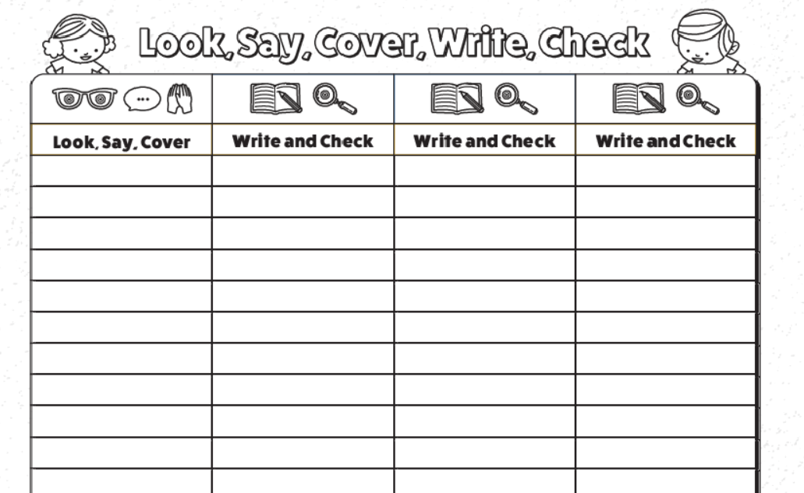
Spelling Test

I can sketch lightly to create a realistic image of an eye.

I can sketch lightly to create a realistic image of an eye
Today, we will practise our sketching techniques. I would like you to get an A4 piece of paper and fold it in half to make a booklet. On the front cover, write your name and draw a quick self-portrait so we know who the booklet belongs to.
During today’s lesson we will focus on the Artist Hector Gonzalez. View his graphite drawing below to rejog your mind.
Watch the tutorial below on how to draw an eye and have a go yourself. You will need to pause the video as you watch it.
Pay attention to the shading. Can you find the darkest parts of the eye?
https://www.youtube.com/watch?v=U1LkuBdsVBg
Make sure you get your shape (outline) correct before adding detail, you may need to practise this a few times.

