Time and Subject  Monday | Learning Objective | Task/Link/Resources
8.45-9.00  Reading | LO: To practise and consolidate existing reading skills. | Read your individual reading book, either in your head or out loud.
9.00-9.15  Morning Maths | LO: To consolidate recall of number facts.  Revision LO: To practise mental addition methods. | Complete today’s Beat That- scroll down below today’s timetable to find the questions. Remember, it is the same one every day for a week. Can you beat your own score?  Morning Maths: In Morning Maths today, you are going to revise using the near doubles mental addition strategy. Click the link below to find the lesson and activities to complete.  https://www.bbc.co.uk/bitesize/topics/znj7hyc/articles/zrws47h
9.15-9.45  Spelling | LO: To practice Year 3/4 common exception words. | This week, we are going to practise spelling some of our tricky orange words!  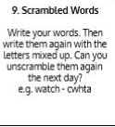  Use Scrambled Words to practise spelling this week’s orange words:  accident, accidentally, actual, actually, address, answer, appear, arrive
9.45-10.00  Active break | LO: To boost my concentration through movement. | Join in with the Go Noodle clip below to get you moving!  https://www.youtube.com/watch?v=Y9LLfv7yauM
10.00-11.00  English | SPaG Revision LO: To use apostrophes for contraction.  LO: To learn about Anglerfish and their appearance. | For today’s SPaG Daily Practice, revise your knowledge of using apostrophes for contraction. Click the link below, watch the video and complete Activity 1 and Activity 2:  https://www.bbc.co.uk/bitesize/articles/zddbn9q  Follow the link below to have a go at today’s English lesson:  https://classroom.thenational.academy/lessons/to-learn-about-the-anglerfish-and-their-appearance-cthk8c
11.00- 11.15
Break
11.15-12.15  Maths | LO: To practise my recall of the 4 times table.  LO: To derive addition and subtraction facts. | Follow the link below to practise the 4 times table and get moving!  https://www.bbc.co.uk/teach/supermovers/ks1-maths-the-4-times-table-with-cyril-the-swan/zmsw382  Follow the link below to have a go at today’s maths lesson:  https://classroom.thenational.academy/lessons/deriving-addition-and-subtraction-facts-6xk30t
12.15-1.00
Dinner
1.00-1.15  Storytime | LO: To listen to a story for pleasure. | Listen to Chapter 6 of Alice’s Adventures in Wonderland.  https://stories.audible.com/pdp/B015D78L0U?ref=adbl_ent_anon_ds_pdp_pc_cntr-3-2
1.15-2.30  Topic | LO: To understand what migration is. | Follow the link below to have a go at today’s lesson:  https://classroom.thenational.academy/lessons/what-is-migration-71j68r
2.30-3.00  Music | LO: To explore 4 beats and 2 beats in a bar. | Follow the link below to have a go at today’s lesson:  https://classroom.thenational.academy/lessons/exploring-4-beats-and-2-beats-in-a-bar-75j3er

Beat That!
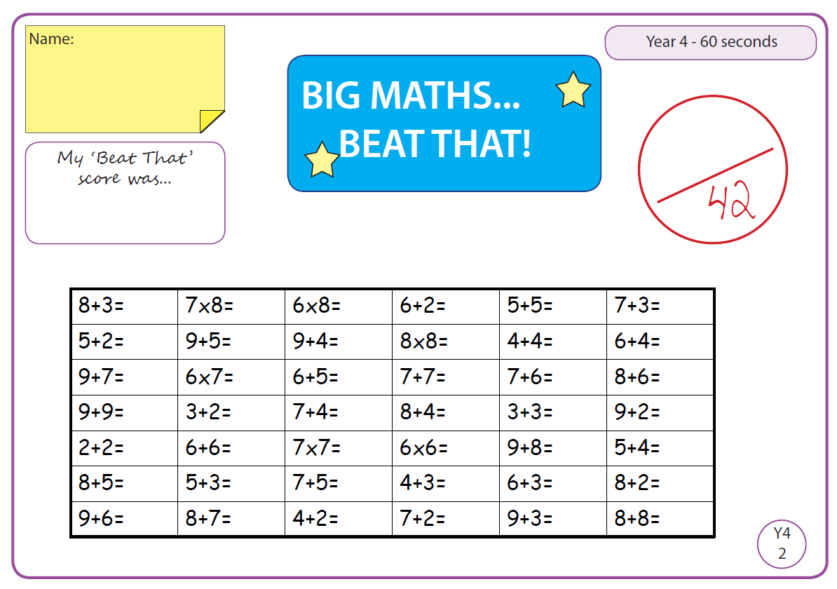

Time and Subject  Tuesday | Learning Objective | Task/Link/Resources
8.45-9.00  Reading | L.O: To practise and consolidate existing reading skills. | Read your individual reading book, either in your head or out loud.
9.00-9.15  Morning Maths | LO: To consolidate recall of number facts.  Revision LO: To practise mental strategies for addition and subtraction. | Complete today’s Beat That- scroll down below today’s timetable to find the questions. Remember, it is the same one every day for a week. Can you beat your own score?  Morning Maths: In Morning Maths today, you are going to revise adding and subtracting using compensating. Click the link below to find the lesson and activities to complete.  https://www.bbc.co.uk/bitesize/topics/znj7hyc/articles/zfbqnrd
9.15-9.45  Spelling | LO: To practice Year 3/4 common exception words. | This week, we are going to practise spelling some of our tricky orange words!  Use Scrambled Words to practise spelling this week’s orange words. Can you unscramble the words you scrambled yesterday?  accident, accidentally, actual, actually, address, answer, appear, arrive
9.45-10.00  Active break | L.O: To boost my concentration through movement. | Join in with the Go Noodle clip below to get you moving!  https://www.youtube.com/watch?v=Hl5dRW4E9hc
10.00-11.00  English | SPaG Revision LO: To use apostrophes for possession.  LO: To practise and apply knowledge of suffixes: Past and present tense. | For today’s SPaG Daily Practice, click the link below to revise your knowledge of apostrophes for possession:  https://www.bbc.co.uk/bitesize/articles/zng8r2p  Follow the link below to have a go at today’s English lesson:  https://classroom.thenational.academy/lessons/to-practise-and-apply-knowledge-of-suffixes-past-and-present-tense-including-a-test-60wk8e
11.00- 11.15
Break
11.15-12.15  Maths | LO: To practise my recall of the 4 times table.  LO: To derive addition and subtraction facts using given calculations | Follow the link below to practise the 4 times table:  https://www.timestables.co.uk/4-times-table.html  Follow the link below to have a go at today’s maths lesson:  https://classroom.thenational.academy/lessons/deriving-addition-and-subtraction-facts-by-using-given-calculations-cru3jd
12.15-1.00
Dinner
1.00-1.15  Storytime | LO: To listen to a story for pleasure. | Listen to Chapter 7 of Alice’s Adventures in Wonderland.  https://stories.audible.com/pdp/B015D78L0U?ref=adbl_ent_anon_ds_pdp_pc_cntr-3-2
1.15-2.30  Topic- History | LO: To explore how migrants vary. | Follow the link below to have a go at today’s lesson:  https://classroom.thenational.academy/lessons/how-do-migrants-vary-64wk0c
2.30-3.00  French | LO: To practise saying colours in French. | Follow the link below to revise how to say colours in French:  https://www.youtube.com/watch?v=acvUtipaC5Y  Test your knowledge by playing this game:  http://www.crickweb.co.uk/ks2french.html

Beat That!

Time and Subject  Wednesday | Learning Objective | Task/Link/Resources
8.45-9.00  Reading | L.O: To practise and consolidate existing reading skills. | Read your individual reading book, either in your head or out loud.
9.00-9.15  Morning Maths | LO: To consolidate recall of number facts.  Revision LO: To practise using column addition to add 3-digit numbers. | Complete today’s Beat That- scroll down below today’s timetable to find the questions. Remember, it is the same one every day for a week. Can you beat your own score?  Morning Maths: In Morning Maths today, you are going to revise adding numbers using column addition. Click the link below to find the lesson and activities to complete.  https://www.bbc.co.uk/bitesize/articles/z72dwty
9.15-9.45  Spelling | LO: To practise Year 3/4 common exception words. | This week, we are going to practise spelling some of our tricky orange words!  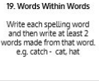  Use Words Within Words to practise spelling this week’s orange words:  accident, accidentally, actual, actually, address, answer, appear, arrive
9.45-10.00  Active break | LO: To boost my concentration through movement. | Join in with the clip below to get you moving!  https://www.youtube.com/watch?v=388Q44ReOWE
10.00-11.00  English | SPaG Revision LO: To use commas in a list.  LO: To practise using formal conjunctions. | For today’s SPaG Daily Practice, revise how to correctly use commas in a list. Click the link below, watch the video and complete Activity 1 and Activity 2:  https://www.bbc.co.uk/bitesize/articles/zjs8wty  Follow the link below to have a go at today’s English lesson:  https://classroom.thenational.academy/lessons/to-practise-using-formal-conjunctions-61gk6c
11.00- 11.15
Break
11.15-12.15  Maths | LO: To practise my recall of the 4 times table.  LO: To choose appropriate addition strategies. | Follow the link below to practise the 4 times table and get moving!  https://www.youtube.com/watch?v=LT3t-uLB9qs  Follow the link below to have a go at today’s maths lesson:  https://classroom.thenational.academy/lessons/choosing-appropriate-addition-strategies-6wwkad
12.15-1.00
Dinner
1.00-1.15  Storytime | LO: To listen to a story for pleasure. | Listen to Chapter 8 of Alice’s Adventures in Wonderland.  https://stories.audible.com/pdp/B015D78L0U?ref=adbl_ent_anon_ds_pdp_pc_cntr-3-2
1.15-2.30  Topic | LO: To understand how migration affects people and places. | Follow the link to have a go at today’s lesson:  https://classroom.thenational.academy/lessons/how-does-migration-affect-people-and-places-69k30t
2.30-3.00  RHE | LO: To understand my roles and responsibilities as a citizen in my community. | Follow the link to have a go at today’s lesson:  https://classroom.thenational.academy/lessons/i-roll-with-my-role-65h3gr

Beat That!

Time and Subject  Thursday | Learning Objective | Task/Link/Resources
8.45-9.00  Reading | L.O: To practise and consolidate existing reading skills. | Read your individual reading book, either in your head or out loud.
9.00-9.15  Morning Maths | LO: To consolidate recall of number facts.  Revision LO: To find fractions of amounts. | Complete today’s Beat That- scroll down below today’s timetable to find the questions. Remember, it is the same one every day for a week. Can you beat your own score?  Morning Maths: In Morning Maths today, you are going to revise finding fractions of amounts. Click the link below to find the lesson and activities to complete:  https://www.bbc.co.uk/bitesize/articles/z78g47h
9.15-9.45  Spelling | LO: To practise Year 3/4 common exception words. | This week, we are going to practise spelling some of our tricky orange words!  Use the activity above to practise spelling this week’s orange words:  accident, accidentally, actual, actually, address, answer, appear, arrive
9.45-10.00  Active break | LO: To boost my concentration through movement. | Join in with the Go Noodle clip below to get you moving!  https://www.youtube.com/watch?v=7Li2qwdUsxU
10.00-11.00  English | SPaG Revision LO: To use commas in a list.  LO: To write the opening paragraph of a non-chronological report. | For today’s SPaG Daily Practice, we are going to continue with yesterday’s learning about commas in a list. Click the link below, watch the video again and complete Activity 3:  https://www.bbc.co.uk/bitesize/articles/zjs8wty  Follow the link below to have a go at today’s English lesson:  https://classroom.thenational.academy/lessons/to-write-the-opening-paragraph-of-a-non-chronological-report-6hh3ce
11.00- 11.15
Break
11.15-12.15  Maths | LO: To practise my recall of the 4 times table.  LO: To choose appropriate subtraction strategies. | Follow the link below to practise the 4 times table:  http://www.snappymaths.com/multdiv/4xtable/interactive/newlook/4xtablebtcd.htm  Follow the link below to have a go at today’s lesson:  https://classroom.thenational.academy/lessons/choosing-appropriate-subtraction-strategies-6nh3gc
12.15-1.00
Dinner
1.00-1.15  Storytime | LO: To listen to a story for pleasure. | Listen to Chapter 9 of Alice’s Adventures in Wonderland.  https://stories.audible.com/pdp/B015D78L0U?ref=adbl_ent_anon_ds_pdp_pc_cntr-3-2
1.15-3.00  PE | LO: To learn and perform a dance routine. | Follow the link below to learn a dance routine inspired by The Greatest Showman!  https://www.youtube.com/watch?v=EJmpCH9p2X8

Beat That!

Time and Subject  Friday | Learning Objective | Task/Link/Resources
8.45-9.00  Reading | L.O: To practise and consolidate existing reading skills. | Read your individual reading book, either in your head or out loud.
9.00-9.15  Morning Maths | LO: To consolidate recall of number facts.  Revision LO:  To identify sides and vertices in 2D shapes. | Complete today’s Beat That- scroll down below today’s timetable to find the questions. Remember, it is the same one every day for a week. Can you beat your own score?  Morning Maths: In Morning Maths today, you are going to revise the properties of 2D shapes. Click the link below to find the lesson and activities to complete:  https://www.bbc.co.uk/bitesize/articles/zq6p7yc
9.15-9.45  Spelling | LO: To practise Year 3/4 common exception words. | This week, we are going to practise spelling some of our tricky orange words!  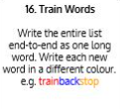  Use the Train Words to practise spelling this week’s orange words:  accident, accidentally, actual, actually, address, answer, appear, arrive  Spelling Test:  Scroll down below today’s timetable to use the look, cover, write, check sheet to help you to test yourself on this week’s words.
9.45-10.00  Active break | L.O: To boost my concentration through movement. | Join in with the Go Noodle clip to get you moving!  https://www.youtube.com/watch?v=CzO3aIe0Rps
10.00-11.00  English | SPaG Revision LO: To identify the four sentence types.  LO: To write the appearance paragraph of a non-chronological report. | For today’s SPaG Daily Practice, revise your knowledge of the four sentence types. Click the link below, watch the video and complete Activities 1, 2 and 3:  https://www.bbc.co.uk/bitesize/articles/z7b3trd  Follow the link below to have a go at today’s lesson:  https://classroom.thenational.academy/lessons/to-write-the-appearance-paragraph-of-a-non-chronological-report-cmv34r
11.00- 11.15
Break
11.15-12.15  Maths | LO: To practise my recall of the 4 times table.  LO: To apply our knowledge of deriving related number facts. | Follow the link below to practise the 4 times table:  http://www.snappymaths.com/multdiv/4xtable/interactive/newlook/4xmissintd.htm  Follow the link below to have a go at today’s lesson:  https://classroom.thenational.academy/lessons/applying-and-consolidating-related-number-facts-and-appropriate-strategies-6dgkct
12.15-1.00
Dinner
1.00-1.15  Storytime | LO: To listen to a story for pleasure. | Listen to Chapter 10 of Alice’s Adventures in Wonderland.  https://stories.audible.com/pdp/B015D78L0U?ref=adbl_ent_anon_ds_pdp_pc_cntr-3-2
1.15-3:00  Art | Golden Time  LO: To develop sketching skills. | Have a go at creating this piece of art:  https://www.youtube.com/watch?v=aR78oUoxYEI

Beat That!

Spelling Test
