Monday
Time and Subject | Learning Objective | Task/Link/Resources
8.45-9.00  Reading | L.O: To practise and consolidate existing reading skills. | Read your individual reading book, either in your head or out loud.
9.00-9.15  Morning Maths | LO: To consolidate recall of number facts.  Revision LO: To revise what a factor is. | Complete today’s Beat That. You will find today’s Beat That below today’s timetable. Just scroll down! Remember, it is the same one every day for a week so try and beat your score each time!  We use Morning Maths as a time to revise concepts and keep them at the front of our minds- follow the link below to revise factors!  https://www.bbc.co.uk/bitesize/topics/zfq7hyc/articles/zp6wfcw
9.15-9.45  Spelling | LO: To practice Unit Three RWI Spelling words. | Speed write this week’s words- time yourself a minute for each! Check them and correct any mistakes. Write them in different colours or fancy writing, make yourself a poster of each of the words! Circle the consonants and vowels.  Achieve, achievement, amazement, beautiful, beauty, careful, careless, definitely, deceitful, government, judgement, immediately, thoroughly, thoroughness, thoughtful, thoughtless.  The link below might give you a helping hand:  https://www.bbc.co.uk/bitesize/topics/zt62mnb/articles/z9f2b82
9.45-10.00  Active break | L.O: To boost my concentration through movement. | https://www.youtube.com/watch?v=Imhi98dHa5w  Join in with the Go Noodle clip above to get you moving!
10.00-11.00  English | LO: To develop knowledge of compound and complex sentences.  SPaG LO: To develop an understanding of relative clauses. | Follow the link below to have a go at today’s lesson:  https://classroom.thenational.academy/lessons/to-develop-our-knowledge-of-compound-and-complex-sentences-cgu62d  SPaG  Use the link below to learn all about relative clauses.  https://www.bbc.co.uk/bitesize/topics/zwwp8mn/articles/zsrt4qt
11.00- 11.15
Break
11.15-12.15  Maths | LO: To identify properties of numbers. | Follow the link below to have a go at today’s lesson:  https://classroom.thenational.academy/lessons/identify-properties-of-numbers-6wv34t
12.15-1.00
Dinner
1.00-1.15  Storytime | LO: To listen to a story for pleasure. | http://storiespodcast.com/  Carry on listening to Part Three from where you left off on Friday.
1.15-2.30  PE | LO: To develop my fitness and strength. | Follow the links below to develop your fitness and strength:  https://www.youtube.com/watch?v=dhCM0C6GnrY  https://imoves.com/home-learning/1433  https://www.youtube.com/user/CosmicKidsYoga
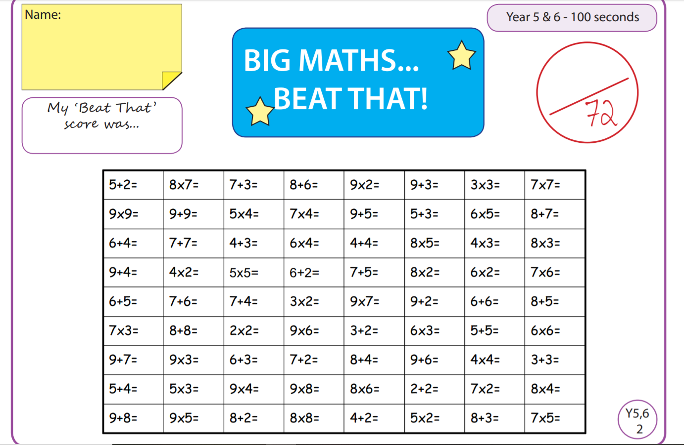
Tuesday
Time and Subject | Learning Objective | Task/Link/Resources
8.45-9.00  Reading | L.O: To practise and consolidate existing reading skills. | Read your individual reading book, either in your head or out loud.
9.00-9.15  Morning Maths | LO: To consolidate recall of number facts.  Revision LO: To recap numbers to 10, 000. | Complete today’s Beat That. You will find today’s Beat That below today’s timetable. Just scroll down! Remember, it is the same one every day for a week so try and beat your score each time!  We use Morning Maths as a time to revise concepts and keep them at the front of our minds- follow the link below and look at the first video to revise numbers to 10,000.  https://whiterosemaths.com/homelearning/year-6/week-1/
9.15-9.45  Spelling | LO: To practice Unit Three RWI Spelling words. | Speed write this week’s words- time yourself a minute for each! Check them and correct any mistakes. Write them in different colours or fancy writing, make yourself a poster of each of the words! Circle the consonants and vowels.  Achieve, achievement, amazement, beautiful, beauty, careful, careless, definitely, deceitful, government, judgement, immediately, thoroughly, thoroughness, thoughtful, thoughtless.
9.45-10.00  Active break | L.O: To boost my concentration through movement. | https://www.youtube.com/watch?v=vbpzfnEQJjE  Join in with the Go Noodle clip above to get you moving!
10.00-11.00  English | LO: To practise and apply knowledge of homophones.  SPaG LO: To develop understanding and knowledge of coordinating conjunctions. | Follow the link below to have a go at today’s lesson:  https://classroom.thenational.academy/lessons/to-practise-and-apply-knowledge-of-homophones-including-test-69hk0d  SPaG  Follow the link below to find out about coordinating conjunctions:  https://www.bbc.co.uk/bitesize/topics/zwwp8mn/articles/z9wvqhv  This video and song from Grammarsaurus will help you:  https://www.youtube.com/watch?v=hIVL38Is5Ac
11.00- 11.15
Break
11.15-12.15  Maths | LO: I can multiply a decimal number by a whole number. | Follow the link below to have a go at today’s lesson:  https://classroom.thenational.academy/lessons/multiply-a-decimal-number-by-a-whole-number-6mwpcd
12.15-1.00
Dinner
1.00-1.15  Storytime | LO: To listen to a story for pleasure. | http://storiespodcast.com/  Start listening to Part 4 of Wylderwood, it is 20 minutes long so you can listen to some today and some tomorrow, remember where you get up to!
1.15-2.30  Topic  Geography | LO: To understand what globalisation is. | Follow the link below to have a go at today’s Geography lesson:  https://classroom.thenational.academy/lessons/what-is-globalisation-c8tk2e
2.30-3.00  RHE | LO: To explore roles and responsibilities within a community. | Follow the link below to have a go at today’s lesson:  https://classroom.thenational.academy/lessons/i-roll-with-my-role-65h3gr
Wednesday
Time and Subject | Learning Objective | Task/Link/Resources
8.45-9.00  Reading | L.O: To practise and consolidate existing reading skills. | Read your individual reading book, either in your head or out loud.
9.00-9.15  Morning Maths | LO: To consolidate recall of number facts.  Revision LO: To revise numbers to 100,000. | Complete today’s Beat That. You will find today’s Beat That below today’s timetable. Just scroll down! Remember, it is the same one every day for a week so try and beat your score each time!  We use Morning Maths as a time to revise concepts and keep them at the front of our minds- follow the link below to revise numbers to 100,000 using the second video.  https://whiterosemaths.com/homelearning/year-6/week-1/
9.15-9.45  Spelling | LO: To practice Unit Three RWI Spelling words. | Speed write this week’s words- time yourself a minute for each! Check them and correct any mistakes. Write them in different colours or fancy writing, make yourself a poster of each of the words! Circle the consonants and vowels.  Achieve, achievement, amazement, beautiful, beauty, careful, careless, definitely, deceitful, government, judgement, immediately, thoroughly, thoroughness, thoughtful, thoughtless.  This video might help you:  https://www.youtube.com/watch?v=rwJmQdq6Om4
9.45-10.00  Active break | L.O: To boost my concentration through movement. | https://www.youtube.com/watch?v=H1R1X6BC7Qw  Join in with the Go Noodle clip above to get you moving!
10.00-11.00  English | LO: To write a setting description.  SPaG LO: To develop understanding of subordinating conjunctions. | Follow the link below to have a go at today’s lesson:  https://classroom.thenational.academy/lessons/to-write-a-setting-description-part-1-6gup2c  SPaG  Follow the link below to explore subordinating conjunctions:  https://www.bbc.co.uk/bitesize/topics/zwwp8mn/articles/zqk37p3  This video and song from Grammarsaurus will help:  https://www.youtube.com/watch?v=FK2Gyto5gTQ
11.00- 11.15
Break
11.15-12.15  Maths | LO: To solve multiplication problems using known and derived facts. | Follow the link below to have a go at today’s lesson:  https://classroom.thenational.academy/lessons/solve-multiplication-problems-using-known-and-derived-facts-6ngk2t
12.15-1.00
Dinner
1.00-1.15  Storytime | LO: To listen to a story for pleasure. | http://storiespodcast.com/  Continue listening to Part 4 of Wylderwood.
1.15-2.30  Topic  Geography | LO: To explore how globalisation has changed the way we communicate. | Follow the link below to have a go at today’s Geography lesson:  https://classroom.thenational.academy/lessons/how-has-globalisation-changed-the-way-we-communicate-60u66c
2.30-3.00  Music | LO: To explore changes in metre. | Have a go at today’s lesson by clicking on the link below:  https://classroom.thenational.academy/lessons/to-explore-changes-in-metre-cnhk0c
Thursday
Time and Subject | Learning Objective | Task/Link/Resources
8.45-9.00  Reading | L.O: To practise and consolidate existing reading skills. | Read your individual reading book, either in your head or out loud.
9.00-9.15  Morning Maths | LO: To consolidate recall of number facts.  Revision LO: To revise numbers to a million. | Complete today’s Beat That. You will find today’s Beat That below today’s timetable. Just scroll down! Remember, it is the same one every day for a week so try and beat your score each time!  We use Morning Maths as a time to revise concepts and keep them at the front of our minds- follow the link below to revise numbers to a million:  https://whiterosemaths.com/homelearning/year-6/week-1/
9.15-9.45  Spelling | LO: To practice Unit Three RWI Spelling words. | Speed write this week’s words- time yourself a minute for each! Check them and correct any mistakes. Write them in different colours or fancy writing, make yourself a poster of each of the words! Circle the consonants and vowels.  Achieve, achievement, amazement, beautiful, beauty, careful, careless, definitely, deceitful, government, judgement, immediately, thoroughly, thoroughness, thoughtful, thoughtless.
9.45-10.00  Active break | L.O: To boost my concentration through movement. | https://www.youtube.com/watch?v=BQ9q4U2P3ig  Join in with the Go Noodle clip above to get you moving!
10.00-11.00  English | LO: To plan a setting description.  SPaG LO: To develop understanding of fronted adverbials and how they are used. | Follow the link below to have a go at today’s lesson:  https://classroom.thenational.academy/lessons/to-plan-a-setting-description-c9jp6d  SPaG  Use the link below to learn about Fronted Adverbials:  https://www.bbc.co.uk/bitesize/topics/zwwp8mn/articles/zp937p3
11.00- 11.15
Break
11.15-12.15  Maths | LO: To use efficient strategies to multiply numbers including decimals. | Follow the link below to have a go at today’s lesson:  https://classroom.thenational.academy/lessons/use-efficient-strategies-to-multiply-numbers-including-decimals-6rr3at
12.15-1.00
Dinner
1.00-1.15  Storytime | LO: To listen to a story for pleasure. | Start listening to Part 5 of Wylderwood, it is about 20 minutes long so you can listen to some today and some tomorrow, remember where you get up to!  http://storiespodcast.com/
1.15-2.30  Topic  Geography | LO: To learn about how globalisation affects trade. | Follow the link below to have a go at today’s Geography lesson:  https://classroom.thenational.academy/lessons/how-does-globalisation-affect-trade-crt64e
2.30-3.00  Golden Time Art | LO: To learn about how to draw using perspective. | Follow the link below to find out all about how to draw using perspective- use what you have learnt to draw another landmark but this time from a different time zone to the one you did last week. You will be continuing with this tomorrow afternoon:  https://www.bbc.co.uk/bitesize/clips/zvq6sbk
Friday
Time and Subject | Learning Objective | Task/Link/Resources
8.45-9.00  Reading | L.O: To practise and consolidate existing reading skills. | Read your individual reading book, either in your head or out loud.
9.00-9.15  Morning Maths | LO: To consolidate recall of number facts.  Revision LO: to revise numbers to 10 million. | Complete today’s Beat That. You will find today’s Beat That below today’s timetable. Just scroll down! Remember, it is the same one every day for a week so try and beat your score each time!  We use Morning Maths as a time to revise concepts and keep them at the front of our minds- follow the link below to revise numbers to 10 million:  https://whiterosemaths.com/homelearning/year-6/week-1/
9.15-9.45  Spelling | LO: To practice Unit Three RWI Spelling words. | Speed write this week’s words- time yourself a minute for each! Check them and correct any mistakes. Write them in different colours or fancy writing, make yourself a poster of each of the words! Circle the consonants and vowels.  Achieve, achievement, amazement, beautiful, beauty, careful, careless, definitely, deceitful, government, judgement, immediately, thoroughly, thoroughness, thoughtful, thoughtless.  Spelling Test: Use the sheet below today’s Beat That to test yourself using look, cover, write and check!
9.45-10.00  Active break | L.O: To boost my concentration through movement. | https://www.youtube.com/watch?v=dh-9k8XfLzY  Join in with the Go Noodle clip above to get you moving!
10.00-11.00  English | LO: To write a setting description. | https://classroom.thenational.academy/lessons/to-write-a-setting-description-part-2-74t3ad  Follow the link above to have a go at today’s lesson. Think about all of the SPaG we have been doing so far to include in your work.
11.00- 11.15
Break
11.15-12.15  Maths | LO: To practise multiplication and division skills. | Follow the link below to have a go at today’s lesson:  https://classroom.thenational.academy/lessons/practise-multiplication-and-division-skills-64vp2e
12.15-1.00
Dinner
1.00-1.15  Storytime | LO: To listen to a story for pleasure. | Continue listening to Part 5 of Wylderwood!  http://storiespodcast.com/
1.15-3.00  Golden Time Art | LO: To learn how to use perspective when drawing. | Continue with the Art project we started yesterday, using colour to create your masterpiece. By the end of this afternoon, you will have this week’s and last week’s land marks from across two different time zones. Here is the link for a recap:  https://www.bbc.co.uk/bitesize/clips/zvq6sbk

