Time and Subject | Learning Objective | Task/Link/Resources
8.45-9.00  Reading | L.O: To practise and consolidate existing reading skills. | Read your individual reading book, either in your head or out loud.
9.00-9.15  Morning Maths | LO: To consolidate recall of number facts. | Complete today’s Beat That. You will find today’s Beat That below today’s timetable. Just scroll down! Remember, it is the same one every day for a week so try and beat your score each time!
9.15-9.45  Spelling | LO: To practice Unit One RWI Spelling words. | Speed write this week’s words- time yourself a minute for each! Check them and correct any mistakes.  Write them in different colours or fancy writing, make yourself a poster of each of the words! Circle the consonants and vowels.  Week 2 – lamb limb numb subtle thumb tomb
9.45-10.00  Active break | L.O: To boost my concentration through movement. | https://www.youtube.com/watch?v=Imhi98dHa5w  Join in with the Go Noodle clip above to get you moving!
10.00-11.00  English | LO: To plan the first part of an opening scene. | Have a go at today’s lesson by clicking on the link below:  https://classroom.thenational.academy/lessons/to-plan-the-first-part-of-an-opening-scene-60rkjt
11.00- 11.15
Break
11.15-12.15  Maths | LO: To use rounding to estimate. | Have a go at today’s lesson by clicking on the link below:  https://classroom.thenational.academy/lessons/rounding-to-estimate-ccr62d
12.15-1.00
Dinner
1.00-1.15  Storytime | LO: To listen to a story for pleasure. | Continue listening to Anne of Green Gables, remember where you get up to for next time:  https://stories.audible.com/pdp/B01KGL13FI?ref=adbl_ent_anon_ds_pdp_pc_cntr-3-3
1.15-2.30  PE | LO: To develop my fitness and strength. | Follow the links below to develop your fitness and strength:  https://www.youtube.com/watch?v=dhCM0C6GnrY  https://imoves.com/home-learning/1433  https://www.youtube.com/user/CosmicKidsYoga
Monday
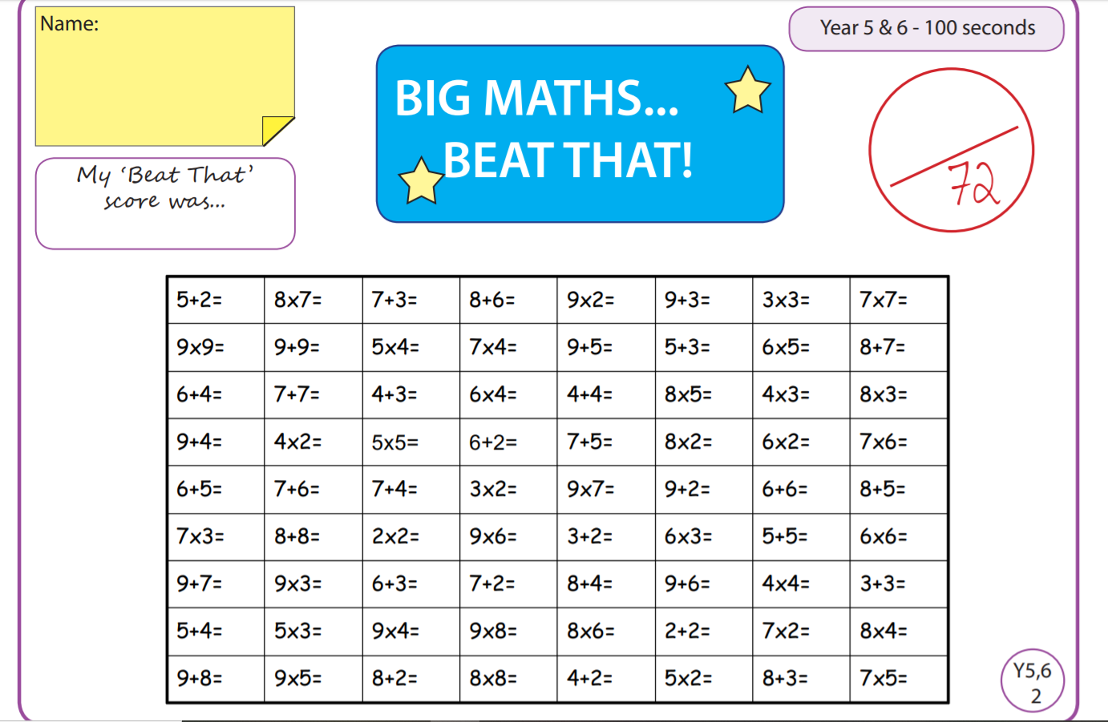

Tuesday
Time and Subject | Learning Objective | Task/Link/Resources
8.45-9.00  Reading | L.O: To practise and consolidate existing reading skills. | Read your individual reading book, either in your head or out loud.
9.00-9.15  Morning Maths | LO: To consolidate recall of number facts. | Complete today’s Beat That. You will find today’s Beat That below today’s timetable. Just scroll down! Remember, it is the same one every day for a week so try and beat your score each time!
9.15-9.45  Spelling | LO: To practice Unit One RWI Spelling words. | Speed write this week’s words- time yourself a minute for each! Check them and correct any mistakes.  Write them in different colours or fancy writing, make yourself a poster of each of the words! Circle the consonants and vowels.  Week 2 – lamb limb numb subtle thumb tomb
9.45-10.00  Active break | L.O: To boost my concentration through movement. | https://www.youtube.com/watch?v=vbpzfnEQJjE  Join in with the Go Noodle clip above to get you moving!
10.00-11.00  English | LO: To practise and apply knowledge of suffixes- tion, cian, sion, ssion. | Have a go at today’s lesson by clicking on the link below:  https://classroom.thenational.academy/lessons/to-practise-and-apply-knowledge-of-suffixes-tion-cian-sion-ssion-6ngp4c
11.00- 11.15
Break
11.15-12.15  Maths | LO: To add using the column method. | Have a go at today’s lesson by clicking on the link below:  https://classroom.thenational.academy/lessons/adding-using-the-column-method-6wt64c
12.15-1.00
Dinner
1.00-1.15  Storytime | LO: To listen to a story for pleasure. | Continue listening to Anne of Green Gables, remember where you get up to for next time:  https://stories.audible.com/pdp/B01KGL13FI?ref=adbl_ent_anon_ds_pdp_pc_cntr-3-3
1.15-2.30  Topic  History | LO: To learn about the development of democracy. | Have a go at today’s lesson by clicking on the link below:  https://classroom.thenational.academy/lessons/what-was-athenian-democracy-6wu64d
2.30-3.00  RHE | LO: To understand the roles and responsibilities I have as a citizen in my community. | Have a go at today’s lesson by clicking on the link below:  https://classroom.thenational.academy/lessons/i-roll-with-my-role-65h3gr

Wednesday
Time and Subject | Learning Objective | Task/Link/Resources
8.45-9.00  Reading | L.O: To practise and consolidate existing reading skills. | Read your individual reading book, either in your head or out loud.
9.00-9.15  Morning Maths | LO: To consolidate recall of number facts. | Complete today’s Beat That. You will find today’s Beat That below today’s timetable. Just scroll down! Remember, it is the same one every day for a week so try and beat your score each time!
9.15-9.45  Spelling | LO: To practice Unit One RWI Spelling words. | Speed write this week’s words- time yourself a minute for each! Check them and correct any mistakes.  Write them in different colours or fancy writing, make yourself a poster of each of the words! Circle the consonants and vowels.  Week 2 – lamb limb numb subtle thumb tomb
9.45-10.00  Active break | L.O: To boost my concentration through movement. | https://www.youtube.com/watch?v=H1R1X6BC7Qw  Join in with the Go Noodle clip above to get you moving!
10.00-11.00  English | LO: To write the first part of the opening. | Have a go at today’s lesson by clicking on the link below:  https://classroom.thenational.academy/lessons/to-write-the-first-part-of-the-opening-74w38r
11.00- 11.15
Break
11.15-12.15  Maths | LO: To subtract using the column method. | Have a go at today’s lesson by clicking on the link below:  https://classroom.thenational.academy/lessons/subtracting-using-the-column-method-6xj32d
12.15-1.00
Dinner
1.00-1.15  Storytime | LO: To listen to a story for pleasure. | Continue listening to Anne of Green Gables, remember where you get up to for next time:  https://stories.audible.com/pdp/B01KGL13FI?ref=adbl_ent_anon_ds_pdp_pc_cntr-3-3
1.15-2.30  Topic  History | LO: To explore religious beliefs of Ancient Greeks. | Have a go at today’s lesson by clicking on the link below:  https://classroom.thenational.academy/lessons/what-did-the-greeks-believe-6wwp6d
2.30-3.00  Music | LO: To understand the difference between on and off beats. | Have a go at today’s lesson by clicking on the link below:  https://classroom.thenational.academy/lessons/to-understand-the-difference-between-on-and-off-beats-crr3gd
Thursday
Time and Subject | Learning Objective | Task/Link/Resources
8.45-9.00  Reading | L.O: To practise and consolidate existing reading skills. | Read your individual reading book, either in your head or out loud.
9.00-9.15  Morning Maths | LO: To consolidate recall of number facts. | Complete today’s Beat That. You will find today’s Beat That below today’s timetable. Just scroll down! Remember, it is the same one every day for a week so try and beat your score each time!
9.15-9.45  Spelling | LO: To practice Unit One RWI Spelling words. | Speed write this week’s words- time yourself a minute for each! Check them and correct any mistakes.  Write them in different colours or fancy writing, make yourself a poster of each of the words! Circle the consonants and vowels.  Week 2 – lamb limb numb subtle thumb tomb
9.45-10.00  Active break | L.O: To boost my concentration through movement. | https://www.youtube.com/watch?v=BQ9q4U2P3ig  Join in with the Go Noodle clip above to get you moving!
10.00-11.00  English | LO: To plan the second part of the opening. | Have a go at today’s lesson by clicking on the link below:  https://classroom.thenational.academy/lessons/to-plan-the-second-part-of-the-opening-cnk3ee
11.00- 11.15
Break
11.15-12.15  Maths | LO: To problem solve using the column method. | Have a go at today’s lesson by clicking on the link below:  https://classroom.thenational.academy/lessons/problem-solving-using-the-column-method-c8up6c
12.15-1.00
Dinner
1.00-1.15  Storytime | LO: To listen to a story for pleasure. | Continue listening to Anne of Green Gables, remember where you get up to for next time:  https://stories.audible.com/pdp/B01KGL13FI?ref=adbl_ent_anon_ds_pdp_pc_cntr-3-3
1.15-2.30  Topic  History | LO: To learn about the Ancient Greek philosophers. | Have a go at today’s lesson by clicking on the link below:  https://classroom.thenational.academy/lessons/who-were-the-ancient-greek-philosophers-cthkac
2.30-3.00  French | LO: To develop my vocabulary. | Follow the link:  https://www.bbc.co.uk/teach/class-clips-video/french-ks2-following-directions/z6r3cqt
Friday
Time and Subject | Learning Objective | Task/Link/Resources
8.45-9.00  Reading | L.O: To practise and consolidate existing reading skills. | Read your individual reading book, either in your head or out loud.
9.00-9.15  Morning Maths | LO: To consolidate recall of number facts. | Complete today’s Beat That. You will find today’s Beat That below today’s timetable. Just scroll down! Remember, it is the same one every day for a week so try and beat your score each time!
9.15-9.45  Spelling | LO: To practice Unit One RWI Spelling words. | Speed write this week’s words- time yourself a minute for each! Check them and correct any mistakes.  Write them in different colours or fancy writing, make yourself a poster of each of the words! Circle the consonants and vowels.  Week 2 – lamb limb numb subtle thumb tomb  Use the Look, Cover, Say, Write and Check grid at the very bottom to test yourself.
9.45-10.00  Active break | L.O: To boost my concentration through movement. | https://www.youtube.com/watch?v=dh-9k8XfLzY  Join in with the Go Noodle clip above to get you moving!
10.00-11.00  English | LO: To write the second part of the opening. | Have a go at today’s lesson by clicking on the link below:  https://classroom.thenational.academy/lessons/to-write-the-second-part-of-the-opening-6cv62d
11.00- 11.15
Break
11.15-12.15  Maths | LO: To solve multi step problems using addition and subtraction. | Have a go at today’s lesson by clicking on the link below:  https://classroom.thenational.academy/lessons/solving-multi-step-addition-and-subtraction-problems-ctk66d
12.15-1.00
Dinner
1.00-1.15  Storytime | LO: To listen to a story for pleasure. | Continue listening to Anne of Green Gables, remember where you get up to for next time:  https://stories.audible.com/pdp/B01KGL13FI?ref=adbl_ent_anon_ds_pdp_pc_cntr-3-3
1.15-3:00  Golden Time Art | LO: To use perspective when drawing. | Enjoy learning how to draw with perspective using the link below:  https://www.bbc.co.uk/bitesize/clips/zvq6sbk
