Time and Subject  Monday | Learning Objective | Task/Link/Resources
8.45-9.00  Reading | LO: To practise and consolidate existing reading skills. | Read your individual reading book, either in your head or out loud.
9.00-9.15  Morning Maths | LO: To consolidate recall of number facts.  Revision LO: To divide by 100. | Complete today’s Beat That- scroll down below today’s timetable to find the questions. Remember, it is the same one every day for a week. Can you beat your own score?  Morning Maths: In Morning Maths today, you are going to revise your knowledge of division. Click the link below and select the video Divide by 100.  Week 10 - Number: Multiplication & Division | White Rose Maths
9.15-9.45  Spelling | LO: To practise Unit 13 RWI spelling words. | This week, we are going to practise adding the suffix -ion.  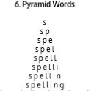  Use Pyramid Words to practise spelling this week’s words:  admission, confession, depression, discussion, expression, impression, permission, possession, procession, progressions, submission.
9.45-10.00  Active break | LO: To boost my concentration through movement. | Join in with the Go Noodle clip below to get you moving!  Champtastic Disco Brain - Champiverse | GoNoodle - YouTube
10.00-11.00  English | SPaG Revision LO: To revise different types of sentences.  LO: To identify the features of a newspaper report. | For today’s SPaG Daily Practice, revise your knowledge of sentences. Watch the video and complete activity 1.  Writing longer sentences - Year 4 - P5 - English - Catch Up Lessons - Home Learning with BBC Bitesize - BBC Bitesize  Follow the link below to have a go at today’s English lesson:  To identify the features of a newspaper report (thenational.academy)
11.00- 11.15
Break
11.15-12.15  Maths | LO: To practise my recall of the 2 times table.  LO: To recognise decimal tenths. | Follow the link below to practise the 2 times table and get moving!  KS1 Maths: The 2 Times Table with Bridget the Lioness - BBC Teach  Follow the link below to have a go at today’s maths lesson:  Recognising Decimal Tenths (Part 1) (thenational.academy)
12.15-1.00
Dinner
1.00-1.15  Storytime | LO: To listen to a story for pleasure. | Listen to Chapter 1 of Hotel Flamingo:  Hotel Flamingo - World Book Day
1.15-3.00  Topic- History | LO: To explore how life in Britain stayed the same after the Roman invasion. | Follow the link below to have a go at today’s lesson:  In what ways did life in Britain remain the same after the Roman invasion? (thenational.academy)
Beat That!
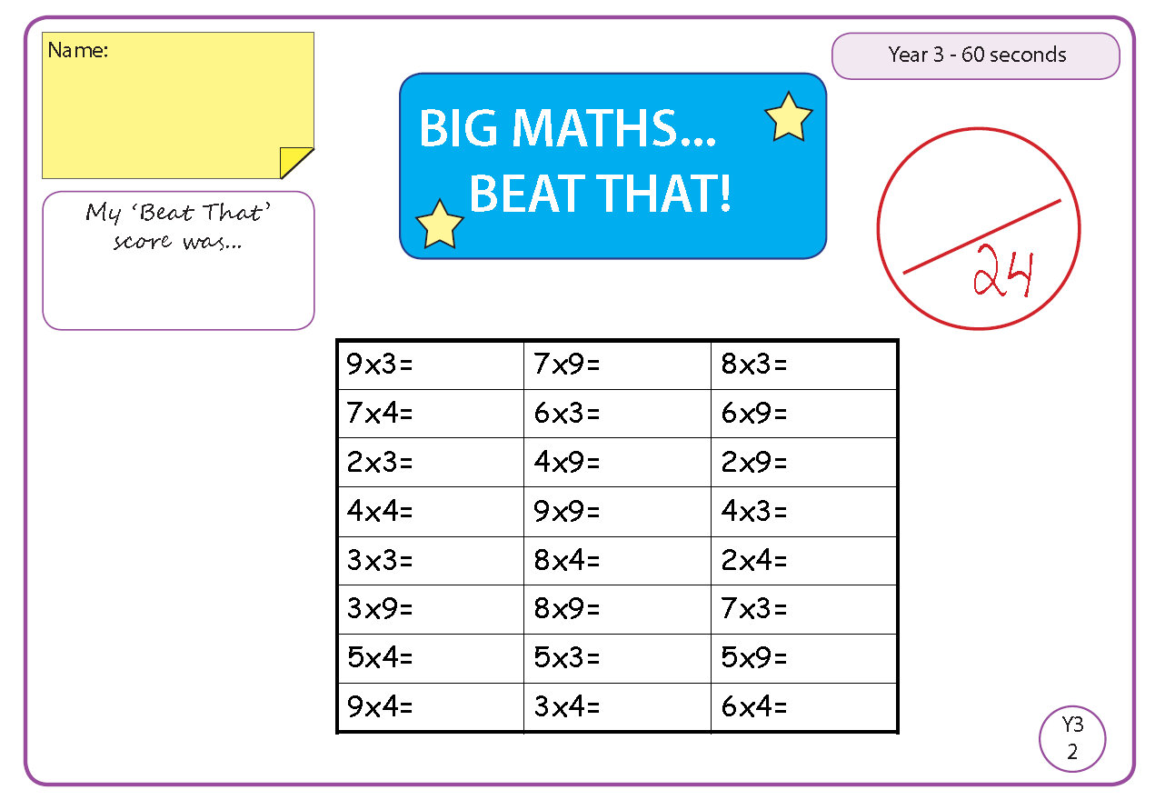

Time and Subject  Tuesday | Learning Objective | Task/Link/Resources
8.45-9.00  Reading | LO: To practise and consolidate existing reading skills. | Read your individual reading book, either in your head or out loud.
9.00-9.15  Morning Maths | LO: To consolidate recall of number facts.  Revision LO: To divide a number by 1 and itself. | Complete today’s Beat That- scroll down below today’s timetable to find the questions. Remember, it is the same one every day for a week. Can you beat your own score?  Morning Maths: In Morning Maths today, you are going to revise your knowledge of division. Click the link below and select the video Divide by 1 and itself.  Autumn Week 11 - Number: Multiplication & Division | White Rose Maths
9.15-9.45  Spelling | LO: To practise Unit 13 RWI spelling words. | This week, we are going to practise adding the suffix -ion.  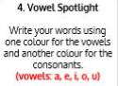  Use Vowel Spotlight to practise spelling this week’s words:  admission, confession, depression, discussion, expression, impression, permission, possession, procession, progressions, submission.
9.45-10.00  Active break | L.O: To boost my concentration through movement. | Join in with the Go Noodle clip below to get you moving!  Purple Stew - Moose Tube | GoNoodle - YouTube
10.00-11.00  English | SPaG Revision LO: To revise different types of sentences.  LO: To investigate compound nouns. | For today’s SPaG Daily Practice, revise your knowledge of sentences. Watch the video and complete activity 2.  Writing longer sentences - Year 4 - P5 - English - Catch Up Lessons - Home Learning with BBC Bitesize - BBC Bitesize  Follow the link below to have a go at today’s English lesson:  To investigate compound nouns (thenational.academy)
11.00- 11.15
Break
11.15-12.15  Maths | LO: To practise my recall of the 2 times table.  LO: To recognise decimal tenths. | Follow the link below to practise the 2 times table:  Coconut Multiples - Reinforce Times Tables (topmarks.co.uk)  Follow the link below to have a go at today’s maths lesson:  Recognising decimal tenths (Part 2) (thenational.academy)
12.15-1.00
Dinner
1.00-1.15  Storytime | LO: To listen to a story for pleasure. | Listen to Chapter 2 of Hotel Flamingo:  Hotel Flamingo - World Book Day
1.15-2.30  Topic | LO: To understand the purpose and function of organs. | Follow the link below to have a go at today’s lesson:  What are organs and why do we need them? (thenational.academy)
2.30-3.00  French | LO: To revise naming parts of the body in French. | Follow the link below to have a go at today’s lesson:  Parts of the Body - KS2 French - BBC Bitesize - BBC Bitesize
Beat That!
Time and Subject  Wednesday | Learning Objective | Task/Link/Resources
8.45-9.00  Reading | LO: To practise and consolidate existing reading skills. | Read your individual reading book, either in your head or out loud.
9.00-9.15  Morning Maths | LO: To consolidate recall of number facts.  Revision LO: To multiply and divide by 3. | Complete today’s Beat That- scroll down below today’s timetable to find the questions. Remember, it is the same one every day for a week. Can you beat your own score?  Morning Maths: In Morning Maths today, you are going to revise your knowledge of multiplication and division. Click the link below and select the video Multiply and divide by 3.  Autumn Week 11 - Number: Multiplication & Division | White Rose Maths
9.15-9.45  Spelling | LO: To practise Unit 13 RWI spelling words. | This week, we are going to practise adding the suffix -ion.  Use Rainbow Words to practise spelling this week’s words:  admission, confession, depression, discussion, expression, impression, permission, possession, procession, progressions, submission.
9.45-10.00  Active break | LO: To boost my concentration through movement. | Join in with the Go Noodle clip below to get you moving!  Beaver Call - Moose Tube | GoNoodle - YouTube
10.00-11.00  English | SPaG Revision LO: To revise different types of sentences.  LO: To revise speech punctuation. | For today’s SPaG Daily Practice, revise your knowledge of sentences. Watch the video and complete activity 3.  Writing longer sentences - Year 4 - P5 - English - Catch Up Lessons - Home Learning with BBC Bitesize - BBC Bitesize  Follow the link below to have a go at today’s English lesson:  To revise speech punctuation (thenational.academy)
11.00- 11.15
Break
11.15-12.15  Maths | LO: To practise my recall of the 2 times table.  LO: To compare decimals. | Follow the link below. Watch the 2 times table video and complete the first activity:  The 2 times table - BBC Bitesize  Follow the link below to have a go at today’s maths lesson:  Comparing Decimals (thenational.academy)
12.15-1.00
Dinner
1.00-1.15  Storytime | LO: To listen to a story for pleasure. | Listen to Chapter 3 of Hotel Flamingo:  Hotel Flamingo - World Book Day
1.15-3.00  Topic- Science | LO: To explore the major bones in the human body. | Follow the link below to have a go at today’s lesson:  What are the major bones in the human body? (thenational.academy)
Beat That!

Time and Subject  Thursday | Learning Objective | Task/Link/Resources
8.45-9.00  Reading | LO: To practise and consolidate existing reading skills. | Read your individual reading book, either in your head or out loud.
9.00-9.15  Morning Maths | LO: To consolidate recall of number facts.  Revision LO: To revise the 3 times table. | Complete today’s Beat That- scroll down below today’s timetable to find the questions. Remember, it is the same one every day for a week. Can you beat your own score?  Morning Maths: In Morning Maths today, you are going to revise your knowledge of division. Click the link below and select the video The 3 times table.  Autumn Week 11 - Number: Multiplication & Division | White Rose Maths
9.15-9.45  Spelling | LO: To practise Unit 13 RWI spelling words. | This week, we are going to practise adding the suffix -ion.  Use Bubble Letters to practise spelling this week’s words:  admission, confession, depression, discussion, expression, impression, permission, possession, procession, progressions, submission.
9.45-10.00  Active break | LO: To boost my concentration through movement. | Join in with the Go Noodle clip below to get you moving!  A-Moose-Ta-Cha - Moose Tube | GoNoodle - YouTube
10.00-11.00  English | SPaG Revision LO: To revise different types of sentences.  LO: To identify the features of a newspaper report. | For today’s SPaG Daily Practice, revise your knowledge of sentences. Watch the video and complete activity 4.  Writing longer sentences - Year 4 - P5 - English - Catch Up Lessons - Home Learning with BBC Bitesize - BBC Bitesize  Follow the link below to have a go at today’s English lesson:  To identify the features of a newspaper report (thenational.academy)
11.00- 11.15
Break
11.15-12.15  Maths | LO: To practise my recall of the 2 times table.  LO: To round decimals. | Follow the link below. Watch the 2 times table video and complete the second activity:  The 2 times table - BBC Bitesize  Follow the link below to have a go at today’s lesson:  Rounding Decimals (Part 1) (thenational.academy)
12.15-1.00
Dinner
1.00-1.15  Storytime | LO: To listen to a story for pleasure. | Listen to Chapter 4 of Hotel Flamingo:  Hotel Flamingo - World Book Day
1.15-3.00  PE | LO: To take part in basic running, jumping and throwing activities. | Follow the link to have a go at today’s PE lesson:  An introduction to running, jumping and throwing (thenational.academy)
Beat That!

Time and Subject  Friday | Learning Objective | Task/Link/Resources
8.45-9.00  Reading | LO: To practise and consolidate existing reading skills. | Read your individual reading book, either in your head or out loud.
9.00-9.15  Morning Maths | LO: To consolidate recall of number facts.  Revision LO: To multiply and divide by 6. | Complete today’s Beat That- scroll down below today’s timetable to find the questions. Remember, it is the same one every day for a week. Can you beat your own score?  Morning Maths: In Morning Maths today, you are going to revise your knowledge of multiplication and division. Click the link below and select the video Multiply and divide by 6.  Autumn Week 11 - Number: Multiplication & Division | White Rose Maths
9.15-9.45  Spelling | LO: To practise Unit 13 RWI spelling words. | This week, we are going to practise adding the suffix -ion.  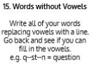  Use Words without Vowels to practise spelling this week’s words:  admission, confession, depression, discussion, expression, impression, permission, possession, procession, progressions, submission.  Spelling Test:  Scroll down below today’s timetable to use the look, cover, write, check sheet to help you to test yourself on this week’s words.
9.45-10.00  Active break | L.O: To boost my concentration through movement. | Join in with the Go Noodle clip to get you moving!  Blast Off - Fresh Start Fitness | GoNoodle - YouTube
10.00-11.00  English | SPaG Revision LO: To use co-ordinating conjunctions.  LO: To develop a rich understanding of words associated with feeling surprised. | For today’s SPaG Daily Practice, revise your knowledge of conjunctions. Watch the videos and complete activity 1.  Coordinating conjunctions - Year 4 - P5- English - Catch Up Lessons - Home Learning with BBC Bitesize - BBC Bitesize  Follow the link below to have a go at today’s lesson:  To develop a rich understanding of words associated with feeling surprised (thenational.academy)
11.00- 11.15
Break
11.15-12.15  Maths | LO: To practise my recall of the 2 times table.  LO: To round decimals. | Follow the link below. Watch the 2 times table video and complete the third activity:  The 2 times table - BBC Bitesize  Follow the link below to have a go at today’s lesson:  Rounding Decimals (Part 2) (thenational.academy)
12.15-1.00
Dinner
1.00-1.15  Storytime | LO: To listen to a story for pleasure. | Listen to Chapter 5 of Hotel Flamingo:  Hotel Flamingo - World Book Day
1.15-3:00  Golden Time | LO: To practise mindfulness. | Have a go at this meditation:  Guided Meditation for Kids | BODY SCAN | Mindfulness for Children - YouTube  Have a go at this fun Yoga session:  Saturday Morning Yoga | Harry Potter Yoga Adventure ⚡️ - YouTube  You could also choose to complete the art activity included below this week’s timetable.

Beat That!

Spelling Test
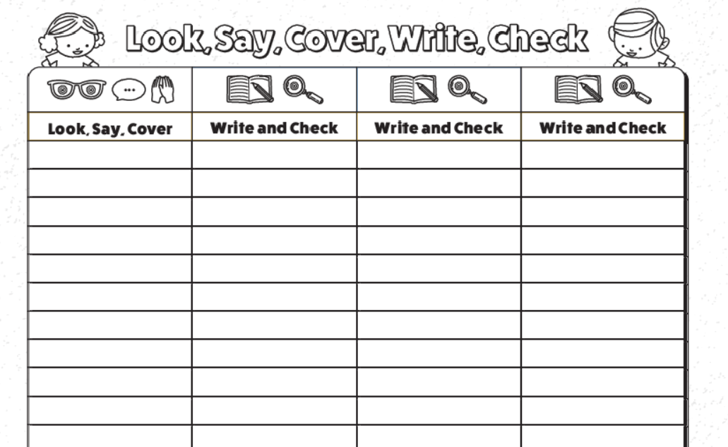

I can discuss my responses to Art.
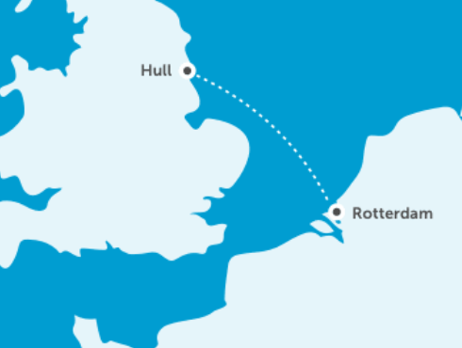
Today, you will need to use your imagination.
Aboard, aboard, aboard! We are going to take a trip across the North Sea to the Netherlands.
Escher’s work was focused on the idea of impossible reality - artwork which was inspired by mathematics and explored infinity and optical illusion. He also produced a lot of artwork which involved tessellation. Use the internet to find a definition of optical illusion and tessellation.
Now we are in the Netherlands. I can tell you the artist (or one of them) we are focussing on. His name is Escher. He lived in the Netherlands and he was Dutch. He is famous for creating collages based on tessellation. Take a look at the link below for an explanation of collage:
https://www.tate.org.uk/art/art-terms/c/collage
Hopefully, you found the meaning of tessellation and this is an arrangement of shapes closely fitted together. This can create an optical illusion which is something that decieves (tricks) the eye into by looking different to what it is. Below is a simple example, they are all lines but it appears to be a hole.

Now, let’s take a look at some of his collages using tessellation.
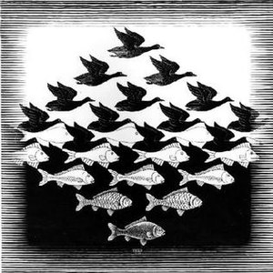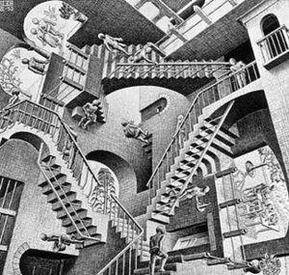
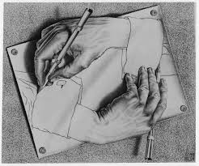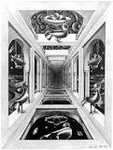
Write down your responses to his artwork.
Your likes/dislikes - I like how the bird gradually changes to a fish.
Questions that you may have - What material did he use?
A statement about his work - I like the detail on his hands.
A feeling – The 4th piece of art makes me feel confused.

