Time and Subject  Monday | Learning Objective | Task/Link/Resources
8.45-9.00  Reading | LO: To practise and consolidate existing reading skills. | Read your individual reading book, either in your head or out loud.
9.00-9.15  Morning Maths | LO: To consolidate recall of number facts.  Revision LO: To add two 3-digit numbers. | Complete today’s Beat That- scroll down below today’s timetable to find the questions. Remember, it is the same one every day for a week. Can you beat your own score?  Morning Maths: In Morning Maths today, you are going to revise your knowledge of addition. Click the link below and select the video Add two 3-digit numbers - crossing 10 or 100.  Week 7 - Number: Addition & Subtraction | White Rose Maths
9.15-9.45  Spelling | LO: To practise Unit Thirteen RWI spelling words. | This week, we are going to practise adding the prefix super-.  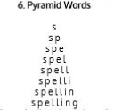  Use Pyramid Words to practise spelling this week’s words:  superglue, superhero, superhuman, superman, supermarket, supersize, supersonic, superwoman.
9.45-10.00  Active break | LO: To boost my concentration through movement. | Join in with the Go Noodle clip below to get you moving!  Purple Stew - Moose Tube | GoNoodle - YouTube
10.00-11.00  English | SPaG Revision LO: To use conjunctions.  LO: To use precise vocabulary. | For today’s SPaG Daily Practice, revise your knowledge of conjunctions. Watch the video and complete activity 1.  Using conjunctions - Year 3 - P4 - English - Catch Up Lesson - Home Learning with BBC Bitesize - BBC Bitesize  Follow the link below to have a go at today’s English lesson:  To use precise vocabulary (thenational.academy)
11.00- 11.15
Break
11.15-12.15  Maths | LO: To practise my recall of the 2 times table.  LO: To apply a range of strategies to mentally calculate addition. | Follow the link below to practise the 2 times table and get moving!  KS1 Maths: The 2 Times Table with Bridget the Lioness - BBC Teach  Follow the link below to have a go at today’s maths lesson:  Applying a range of strategies to mentally calculate addition (thenational.academy)
12.15-1.00
Dinner
1.00-1.15  Storytime | LO: To listen to a story for pleasure. | Listen to Chapter 1 of Hotel Flamingo:  Hotel Flamingo - World Book Day
1.15-3.00  Topic- DT | LO: To investigate shell structures. | Follow the link below to have a go at today’s lesson:  To investigate structures (thenational.academy)
Beat That!
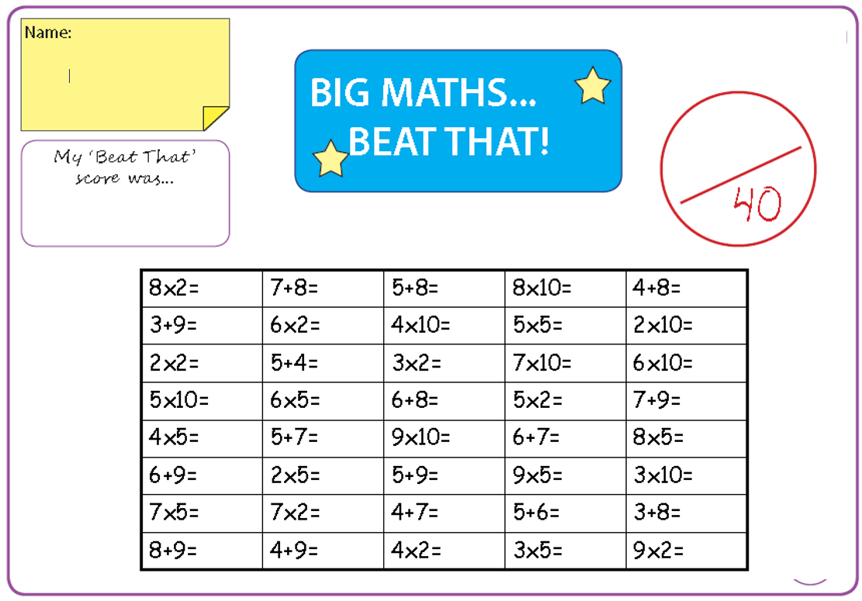
Time and Subject  Tuesday | Learning Objective | Task/Link/Resources
8.45-9.00  Reading | L.O: To practise and consolidate existing reading skills. | Read your individual reading book, either in your head or out loud.
9.00-9.15  Morning Maths | LO: To consolidate recall of number facts.  Revision LO: To subtract a 3-digit number from a 3-digit number. | Complete today’s Beat That- scroll down below today’s timetable to find the questions. Remember, it is the same one every day for a week. Can you beat your own score?  Morning Maths: In Morning Maths today, you are going to revise your knowledge of subtraction. Click the link below and select the video Subtract a 3-digit number from a 3-digit number- no exchange.  Autumn Week 8 - Number: Addition & Subtraction | White Rose Maths
9.15-9.45  Spelling | LO: To practise Unit Thirteen RWI spelling words. | This week, we are going to practise adding the prefix super-.  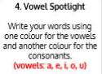  Use Vowel Spotlight to practise spelling this week’s words:  superglue, superhero, superhuman, superman, supermarket, supersize, supersonic, superwoman.
9.45-10.00  Active break | L.O: To boost my concentration through movement. | Join in with the Go Noodle clip below to get you moving!  Beaver Call - Moose Tube | GoNoodle - YouTube
10.00-11.00  English | SPaG Revision LO: To use conjunctions.  LO: To practise and apply knowledge of compound words. | For today’s SPaG Daily Practice, revise your knowledge of conjunctions. Watch the video and complete activity 2.  Using conjunctions - Year 3 - P4 - English - Catch Up Lesson - Home Learning with BBC Bitesize - BBC Bitesize  Follow the link below to have a go at today’s English lesson:  To practise and apply knowledge of compound words, including test (thenational.academy)
11.00- 11.15
Break
11.15-12.15  Maths | LO: To practise my recall of the 2 times table.  LO: To use a range of strategies to mentally calculate subtraction. | Follow the link below to practise the 2 times table:  Coconut Multiples - Reinforce Times Tables (topmarks.co.uk)  Follow the link below to have a go at today’s maths lesson:  Applying a range of strategies to mentally calculate subtraction (thenational.academy)
12.15-1.00
Dinner
1.00-1.15  Storytime | LO: To listen to a story for pleasure. | Listen to Chapter 2 of Hotel Flamingo:  Hotel Flamingo - World Book Day
1.15-2.30  Topic- DT | LO: To construct nets to create 3D shapes. | Follow the link below to have a go at today’s lesson:  To construct nets to create 3D shapes (thenational.academy)
2.30-3.00  French | LO: To revise naming parts of the body in French. | Follow the link below to have a go at today’s lesson:  Parts of the Body - KS2 French - BBC Bitesize - BBC Bitesize

Beat That
Time and Subject  Wednesday | Learning Objective | Task/Link/Resources
8.45-9.00  Reading | L.O: To practise and consolidate existing reading skills. | Read your individual reading book, either in your head or out loud.
9.00-9.15  Morning Maths | LO: To consolidate recall of number facts.  Revision LO: To subtract a 3-digit number from a 3-digit number. | Complete today’s Beat That- scroll down below today’s timetable to find the questions. Remember, it is the same one every day for a week. Can you beat your own score?  Morning Maths: In Morning Maths today, you are going to revise your knowledge of subtraction. Click the link below and select the video Subtract a 3-digit number from a 3-digit number- exchange.  Autumn Week 8 - Number: Addition & Subtraction | White Rose Maths
9.15-9.45  Spelling | LO: To practise Unit Thirteen RWI spelling words. | This week, we are going to practise adding the prefix super-.  Use Rainbow Words to practise spelling this week’s words:  superglue, superhero, superhuman, superman, supermarket, supersize, supersonic, superwoman.
9.45-10.00  Active break | LO: To boost my concentration through movement. | Join in with the Go Noodle clip below to get you moving!  A-Moose-Ta-Cha - Moose Tube | GoNoodle - YouTube
10.00-11.00  English | SPaG Revision LO: To use conjunctions.  LO: To orally explain a process. | For today’s SPaG Daily Practice, revise your knowledge of conjunctions. Watch the video and complete activity 3.  Using conjunctions - Year 3 - P4 - English - Catch Up Lesson - Home Learning with BBC Bitesize - BBC Bitesize  Follow the link below to have a go at today’s English lesson:  To orally explain a process (thenational.academy)
11.00- 11.15
Break
11.15-12.15  Maths | LO: To practise my recall of the 2 times table.  LO: To apply addition and subtraction strategies within context. | Follow the link below. Watch the 2 times table video and complete the first activity:  The 2 times table - BBC Bitesize  Follow the link below to have a go at today’s maths lesson:  Applying addition and subtraction strategies within context (thenational.academy)
12.15-1.00
Dinner
1.00-1.15  Storytime | LO: To listen to a story for pleasure. | Listen to Chapter 3 of Hotel Flamingo:  Hotel Flamingo - World Book Day
1.15-3.00  Topic-DT | LO: To evaluate existing structures. | Follow the link to have a go at today’s lesson:  To evaluate existing structures (thenational.academy)

Beat That!
Time and Subject  Thursday | Learning Objective | Task/Link/Resources
8.45-9.00  Reading | L.O: To practise and consolidate existing reading skills. | Read your individual reading book, either in your head or out loud.
9.00-9.15  Morning Maths | LO: To consolidate recall of number facts.  Revision LO: To estimate answers to calculations. | Complete today’s Beat That- scroll down below today’s timetable to find the questions. Remember, it is the same one every day for a week. Can you beat your own score?  Morning Maths: In Morning Maths today, you are going to revise your knowledge of estimation. Click the link below and select the video Estimate answers to calculations.  Autumn Week 8 - Number: Addition & Subtraction | White Rose Maths
9.15-9.45  Spelling | LO: To practise Unit Thirteen RWI spelling words. | This week, we are going to practise adding the prefix super-.  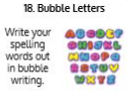  Use Bubble Letters to practise spelling this week’s words:  superglue, superhero, superhuman, superman, supermarket, supersize, supersonic, superwoman.
9.45-10.00  Active break | LO: To boost my concentration through movement. | Join in with the Go Noodle clip below to get you moving!  Blast Off - Fresh Start Fitness | GoNoodle - YouTube
10.00-11.00  English | SPaG Revision LO: To explore subordinate clauses.  LO: To plan an explanation text. | For today’s SPaG Daily Practice, revise your knowledge of subordinate clauses. Watch the videos and complete activity 1.  Exploring subordinate clauses - Year 3 - P4 - English - Catch Up Lessons - Home Learning with BBC Bitesize - BBC Bitesize  Follow the link below to have a go at today’s English lesson:  To plan an explanation text (thenational.academy)
11.00- 11.15
Break
11.15-12.15  Maths | LO: To practise my recall of the 2 times table.  LO: To use commutativity and associativity to multiply. | Follow the link below. Watch the 2 times table video and complete the second activity:  The 2 times table - BBC Bitesize  Follow the link below to have a go at today’s lesson:  Using commutativity and associativity to multiply (thenational.academy)
12.15-1.00
Dinner
1.00-1.15  Storytime | LO: To listen to a story for pleasure. | Listen to Chapter 4 of Hotel Flamingo:  Hotel Flamingo - World Book Day
1.15-3.00  PE | LO: To take part in basic running, jumping and throwing activities. | Follow the link to have a go at today’s PE lesson:  An introduction to running, jumping and throwing (thenational.academy)
Beat That!
Time and Subject  Friday | Learning Objective | Task/Link/Resources
8.45-9.00  Reading | L.O: To practise and consolidate existing reading skills. | Read your individual reading book, either in your head or out loud.
9.00-9.15  Morning Maths | LO: To consolidate recall of number facts.  Revision LO: To check answers. | Complete today’s Beat That- scroll down below today’s timetable to find the questions. Remember, it is the same one every day for a week. Can you beat your own score?  Morning Maths: In Morning Maths today, you are going to revise your knowledge of addition and subtraction. Click the link below and select the video Check answers.  Autumn Week 8 - Number: Addition & Subtraction | White Rose Maths
9.15-9.45  Spelling | LO: To practise Unit Thirteen RWI spelling words. | 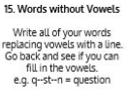  This week, we are going to practise adding the prefix super-.  Use Words without Vowels to practise spelling this week’s words:  superglue, superhero, superhuman, superman, supermarket, supersize, supersonic, superwoman.  Spelling Test:  Scroll down below today’s timetable to use the look, cover, write, check sheet to help you to test yourself on this week’s words.
9.45-10.00  Active break | L.O: To boost my concentration through movement. | Join in with the Go Noodle clip to get you moving!  Champtastic Disco Brain - Champiverse | GoNoodle - YouTube
10.00-11.00  English | SPaG Revision LO: To explore subordinate clauses.  LO: To practise complex and compound sentences. | For today’s SPaG Daily Practice, revise your knowledge of subordinate clauses. Watch the videos and complete activity 2.  Exploring subordinate clauses - Year 3 - P4 - English - Catch Up Lessons - Home Learning with BBC Bitesize - BBC Bitesize  Follow the link below to have a go at today’s lesson:  To practise complex and compound sentences (thenational.academy)
11.00- 11.15
Break
11.15-12.15  Maths | LO: To practise my recall of the 2 times table.  LO: To use doubling or halving to calculate efficiently. | Follow the link below. Watch the 2 times table video and complete the third activity:  The 2 times table - BBC Bitesize  Follow the link below to have a go at today’s lesson:  Using doubling or halving to calculate efficiently (thenational.academy)
12.15-1.00
Dinner
1.00-1.15  Storytime | LO: To listen to a story for pleasure. | Listen to Chapter 5 of Hotel Flamingo:  Hotel Flamingo - World Book Day
1.15-3:00  Golden Time | LO: To practise mindfulness. | Have a go at this meditation:  Guided Meditation for Kids | BODY SCAN | Mindfulness for Children - YouTube  Have a go at this fun Yoga session:  Saturday Morning Yoga | Harry Potter Yoga Adventure ⚡️ - YouTube  You could also choose to complete the art activity included below this week’s timetable.

Beat That

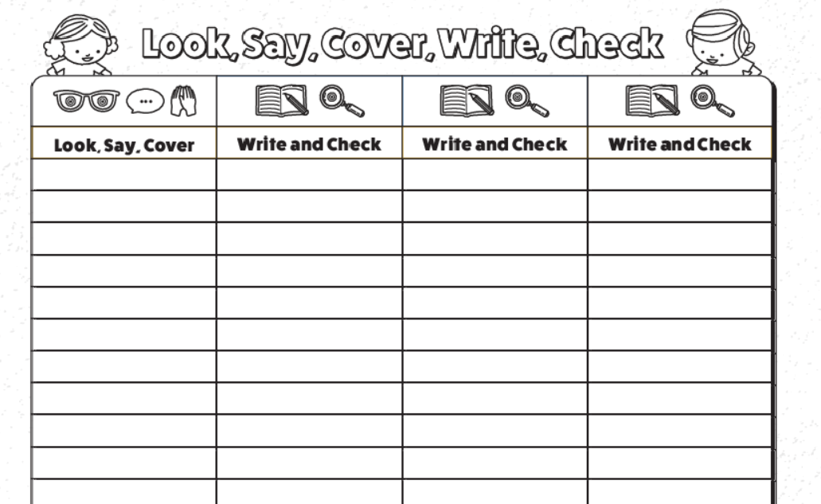
Spelling Test

I can discuss my response to Art.
Our theme over the next few weeks will be eyes. What do you think of when I say the word eyes? You could record your ideas as a mind map or just say them out loud.
Before we start, I would like you to recap on your colours. Can you name the primary colours? Can you name the secondary and tertiary colours? We know that when colours are mixed they make another colour. You could practise this if you have the three primary colours at home.
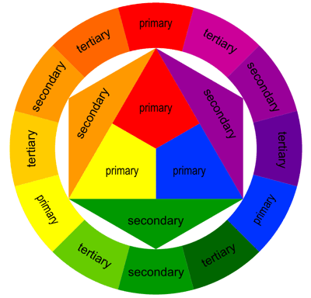
Take a look on the next page at the two artists. Spend time looking in detail at each image. Your task is to record your initial responses on a piece of paper, these are things you may like/dislike about each image, it could be a question that pops into your head or a statement about what you can see e.g. The artist has used graphite.

Today, we will be looking at two artists and their impression of eyes. Remember Art is your impression, you can create, you are the leader in your learning. Art is an expressive journey.

Hector Gonzalez

Pablo Picasso

