Time and Subject  Monday | Learning Objective | Task/Link/Resources
8.45-9.00  Reading | LO: To practise and consolidate existing reading skills. | Read your individual reading book, either in your head or out loud.
9.00-9.15  Morning Maths | LO: To consolidate recall of number facts.  Revision LO: To consolidate my understanding of the value of each digit in a 4-digit number. | Complete today’s Beat That- scroll down below today’s timetable to find the questions. Remember, it is the same one every day for a week. Can you beat your own score?  Morning Maths: In Morning Maths today, you are going to revise your knowledge of place value. Click the link below to find the lesson and activities to complete.  https://www.bbc.co.uk/bitesize/topics/zsjqtfr/articles/z9w3g82
9.15-9.45  Spelling | LO: To practise Unit One RWI Spelling words. | This week, we are revising spelling words with the prefixes in-, dis- and un- and learning to add the prefix mis-. Watch this video to refresh your memory! https://www.bbc.co.uk/teach/class-clips-video/english-ks2-wonderful-words-prefixes/zknd7nb  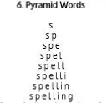  Use pyramid writing to practise spelling this week’s unit words:  disagree, inactive, inhuman, misbehave, mislead, mismatch, misplace, misprint, misspell, mistreat, mistrust, misunderstand, undo, unfair, unkind
9.45-10.00  Active break | LO: To boost my concentration through movement. | Join in with the Go Noodle clip below to get you moving!  https://www.youtube.com/watch?v=3WnI4UNgSaY
10.00-11.00  English | SPaG Revision LO: To identify proper and common nouns.  LO: To identify the features of a non-chronological report. | For today’s SPaG Daily Practice, revise your knowledge of proper and common nouns. Click the link below, watch the video and complete Activity 1 and Activity 2:  https://www.bbc.co.uk/bitesize/articles/zjrdwty  Follow the link below to have a go at today’s English lesson:  https://classroom.thenational.academy/lessons/to-identify-the-features-of-a-non-chronological-report-c4uket
11.00- 11.15
Break
11.15-12.15  Maths | LO: To practise my recall of the 3 times table.  LO: To round numbers to the nearest 10. | Follow the link below to practise the 3 times table and get moving!  https://www.bbc.co.uk/teach/supermovers/ks2-maths-the-3-times-table/z6sw382  Follow the link below to have a go at today’s maths lesson:  https://classroom.thenational.academy/lessons/rounding-numbers-to-the-nearest-10-c4uk8c
12.15-1.00
Dinner
1.00-1.15  Storytime | LO: To listen to a story for pleasure. | Listen to Chapter 1 of Alice’s Adventures in Wonderland.  https://stories.audible.com/pdp/B015D78L0U?ref=adbl_ent_anon_ds_pdp_pc_cntr-3-2
1.15-2.30  Topic | LO: To recall key facts about Tutankhamun and his life. | Follow the links below to learn about Tutankhamun, before making a mind map of the important facts you have learned:  https://www.bbc.co.uk/bitesize/topics/zg87xnb/articles/zvmkhbk  https://www.youtube.com/watch?v=ULofBtBAJn4  Follow this tutorial to have a go at drawing Tutankhamun’s mask:  https://www.youtube.com/watch?v=GY1yQ_xH6xg  You could use paint, coloured pencils or collage to complete your mask.
2.30-3.00  Music | LO: To understand pulse and rhythm. | Follow the link below to have a go at today’s lesson:  https://classroom.thenational.academy/lessons/understanding-pulse-and-rhythm-6tjkjd

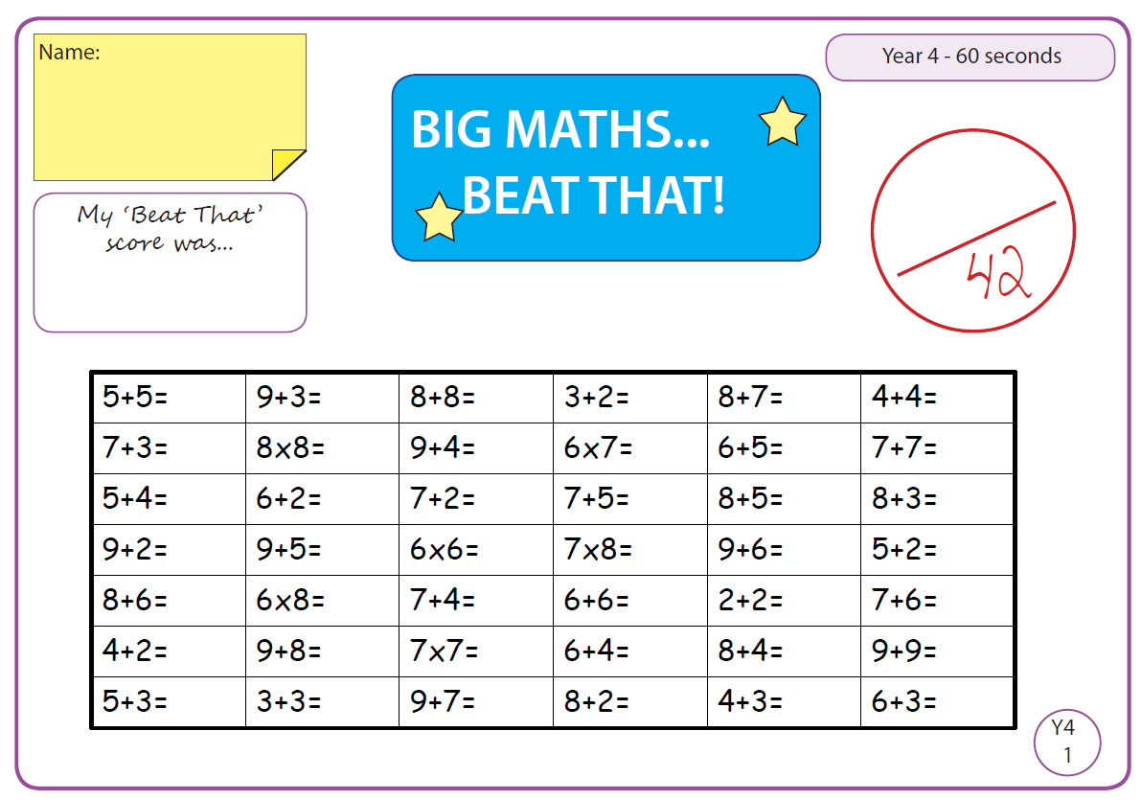
Beat That!

Time and Subject  Tuesday | Learning Objective | Task/Link/Resources
8.45-9.00  Reading | L.O: To practise and consolidate existing reading skills. | Read your individual reading book, either in your head or out loud.
9.00-9.15  Morning Maths | LO: To consolidate recall of number facts.  Revision LO: To find 1, 10, 100 and 1000 more or less than a 4-digit number. | Complete today’s Beat That- scroll down below today’s timetable to find the questions. Remember, it is the same one every day for a week. Can you beat your own score?  Morning Maths: In Morning Maths today, you are going to revise finding 1, 10, 100 and 1000 more or less than a 4-digit number. Click the link below to find the lesson and activities to complete.  https://www.bbc.co.uk/bitesize/articles/zd9hpg8
9.15-9.45  Spelling | LO: To practice Unit One RWI Spelling words. | This week, we are revising spelling words with the prefixes in-, dis- and un- and learning to add the prefix mis-.  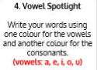  Use Vowel Spotlight to practise spelling this week’s unit words:  disagree, inactive, inhuman, misbehave, mislead, mismatch, misplace, misprint, misspell, mistreat, mistrust, misunderstand, undo, unfair, unkind
9.45-10.00  Active break | L.O: To boost my concentration through movement. | Join in with the Go Noodle clip to get you moving!  https://www.youtube.com/watch?v=BQ9q4U2P3ig
10.00-11.00  English | SPaG Revision LO: To identify adjectives.  LO: To investigate suffixes: Past and present tense | For today’s SPaG Daily Practice, click the link below to revise your knowledge of adjectives:  https://www.bbc.co.uk/bitesize/topics/zrqqtfr/articles/zy2r6yc  Follow the link below to have a go at today’s English lesson:  https://classroom.thenational.academy/lessons/to-investigate-suffixes-past-and-present-tense-60up6e
11.00- 11.15
Break
11.15-12.15  Maths | LO: To practise my recall of the 3 times table.  LO: To round numbers to the nearest 100. | Follow the link below to practise the 3 times table:  https://www.timestables.co.uk/3-times-table.html  Follow the link below to have a go at today’s maths lesson:  https://classroom.thenational.academy/lessons/rounding-numbers-to-the-nearest-100-crv36c
12.15-1.00
Dinner
1.00-1.15  Storytime | LO: To listen to a story for pleasure. | Listen to Chapter 2 of Alice’s Adventures in Wonderland.  https://stories.audible.com/pdp/B015D78L0U?ref=adbl_ent_anon_ds_pdp_pc_cntr-3-2
1.15-2.30  Topic- History | LO: To explore who the Ancient Egyptians were. | Follow the link below to have a go at today’s lesson:  https://www.bbc.co.uk/bitesize/articles/zqrkg7h
2.30-3.00  French | LO: To practise introducing yourself in French. | Follow the link below to revise how to introduce yourself in French:  https://www.youtube.com/watch?v=VMt3dxpYYx8

Beat That!

Time and Subject  Wednesday | Learning Objective | Task/Link/Resources
8.45-9.00  Reading | L.O: To practise and consolidate existing reading skills. | Read your individual reading book, either in your head or out loud.
9.00-9.15  Morning Maths | LO: To consolidate recall of number facts.  Revision LO: To use my knowledge of place value to complete a number line to 1000. | Complete today’s Beat That- scroll down below today’s timetable to find the questions. Remember, it is the same one every day for a week. Can you beat your own score?  Morning Maths: In Morning Maths today, you are going to revise placing numbers on a number line to 1000. Follow the link below and choose the video ‘Numbers to 1000’:  https://whiterosemaths.com/homelearning/year-4/week-1/
9.15-9.45  Spelling | LO: To practise Unit One RWI Spelling words. | This week, we are revising spelling words with the prefixes in-, dis- and un- and learning to add the prefix mis-.  Use Rainbow Words to practise spelling this week’s unit words:  disagree, inactive, inhuman, misbehave, mislead, mismatch, misplace, misprint, misspell, mistreat, mistrust, misunderstand, undo, unfair, unkind
9.45-10.00  Active break | LO: To boost my concentration through movement. | Join in with the Go Noodle clip below to get you moving!  https://www.youtube.com/watch?v=KhfkYzUwYFk
10.00-11.00  English | SPaG Revision LO: To identify verbs.  LO: To explore simple and compound sentences. | For today’s SPaG Daily Practice, revise your knowledge of verbs. Click the link below, watch the video and complete Activity 1 and Activity 2:  https://www.bbc.co.uk/bitesize/articles/zfc2mfr  Follow the link below to have a go at today’s English lesson:  https://classroom.thenational.academy/lessons/to-explore-simple-and-compound-sentences-6hk3ed
11.00- 11.15
Break
11.15-12.15  Maths | LO: To practise my recall of the 3 times table.  LO: To round numbers to the nearest 1000. | Follow the link below to practise the 3 times table and get moving!  https://www.youtube.com/watch?v=t03yW7Oxsoc  Follow the link below to have a go at today’s maths lesson:  https://classroom.thenational.academy/lessons/rounding-numbers-to-the-nearest-1000-crr66d
12.15-1.00
Dinner
1.00-1.15  Storytime | LO: To listen to a story for pleasure. | Listen to Chapter 3 of Alice’s Adventures in Wonderland.  https://stories.audible.com/pdp/B015D78L0U?ref=adbl_ent_anon_ds_pdp_pc_cntr-3-2
1.15-2.30  Topic | LO: To explore what life was like for the Ancient Egyptians. | For today’s history lesson, your task is to write a diary entry imagining you are a child living in Ancient Egypt. Make sure that you include:  - What you spend your day doing  - What your house is like  - What you eat  These links below will help you:  https://www.bbc.co.uk/bitesize/topics/zg87xnb/articles/zr4s8xs/  https://www.youtube.com/watch?v=lZOPWSXMvzI  https://www.bbc.co.uk/bitesize/topics/zg87xnb/articles/z4m8pg8
2.30-3.00  RHE | LO: To understand what a community is and consider the benefits of being part of a community. | Follow the link below to have a go at today’s lesson:  https://classroom.thenational.academy/lessons/community-care-cctp8c

Beat That!

Time and Subject  Thursday | Learning Objective | Task/Link/Resources
8.45-9.00  Reading | L.O: To practise and consolidate existing reading skills. | Read your individual reading book, either in your head or out loud.
9.00-9.15  Morning Maths | LO: To consolidate recall of number facts.  Revision LO: To multiply and divide by 0, 1, 10 and 100. | Complete today’s Beat That- scroll down below today’s timetable to find the questions. Remember, it is the same one every day for a week. Can you beat your own score?  Morning Maths: In Morning Maths today, you are going to revise multiplying and dividing by 0, 1 ,10 and 100. Click the link below to find the lesson and activities to complete:  https://www.bbc.co.uk/bitesize/topics/z36tyrd/articles/z2fkwxs
9.15-9.45  Spelling | LO: To practise Unit One RWI Spelling words. | This week, we are revising spelling words with the prefixes in-, dis- and un- and learning to add the prefix mis-.  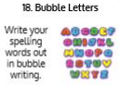  Use Bubble Letters to practise spelling this week’s unit words:  disagree, inactive, inhuman, misbehave, mislead, mismatch, misplace, misprint, misspell, mistreat, mistrust, misunderstand, undo, unfair, unkind
9.45-10.00  Active break | LO: To boost my concentration through movement. | Join in with the Go Noodle clip below to get you moving!  https://www.youtube.com/watch?v=1b6axyuaKcY
10.00-11.00  English | SPaG Revision LO: To identify adverbs.  LO: To develop and generate subject specific vocabulary. | For today’s SPaG Daily Practice, click the link below to revise your knowledge of adverbs:  https://www.bbc.co.uk/bitesize/topics/zwwp8mn/articles/zgsgxfr  Follow the link below to have a go at today’s English lesson:  https://classroom.thenational.academy/lessons/to-develop-and-generate-subject-specific-vocabulary-c8ukad
11.00- 11.15
Break
11.15-12.15  Maths | LO: To practise my recall of the 3 times table.  LO: To apply my knowledge of place value and rounding. | Follow the link below to practise the 3 times table:  http://www.snappymaths.com/multdiv/3xtable/interactive/newlook/3xtablebtcd.htm  Follow the link below to have a go at today’s lesson:  https://classroom.thenational.academy/lessons/finding-the-odd-one-out-75j36r
12.15-1.00
Dinner
1.00-1.15  Storytime | LO: To listen to a story for pleasure. | Listen to Chapter 4 of Alice’s Adventures in Wonderland.  https://stories.audible.com/pdp/B015D78L0U?ref=adbl_ent_anon_ds_pdp_pc_cntr-3-2
1.15-3.00  PE | LO: To learn and perform a dance routine. | Follow the link below to learn a dance routine inspired by Shrek!  https://www.youtube.com/watch?v=Btxws8qvYAA

Beat That!

Time and Subject  Friday | Learning Objective | Task/Link/Resources
8.45-9.00  Reading | L.O: To practise and consolidate existing reading skills. | Read your individual reading book, either in your head or out loud.
9.00-9.15  Morning Maths | LO: To consolidate recall of number facts.  Revision LO:  To practise mental methods to add 2-digit numbers. | Complete today’s Beat That- scroll down below today’s timetable to find the questions. Remember, it is the same one every day for a week. Can you beat your own score?  Morning Maths: In Morning Maths today, you are going to revise using mental addition methods. Click the link below to find the lesson and activities to complete:  https://www.bbc.co.uk/bitesize/topics/znj7hyc/articles/zkgjpg8
9.15-9.45  Spelling | LO: To practise Unit One RWI Spelling words. | This week, we are revising spelling words with the prefixes in-, dis- and un- and learning to add the prefix mis-.  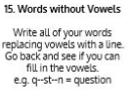  Use Words Without Vowels to practise spelling this week’s unit words:  disagree, inactive, inhuman, misbehave, mislead, mismatch, misplace, misprint, misspell, mistreat, mistrust, misunderstand, undo, unfair, unkind  Spelling Test:  Scroll down below today’s timetable to use the look, cover, write, check sheet to help you to test yourself on this week’s words.
9.45-10.00  Active break | L.O: To boost my concentration through movement. | Join in with the Go Noodle clip to get you moving!  https://www.youtube.com/watch?v=aEIpC4e2aBY
10.00-11.00  English | SPaG Revision LO: To develop my understanding of pronouns.  LO: To develop a rich understanding of words associated with water. | For today’s SPaG Daily Practice, click the link below to revise your knowledge of pronouns.  https://www.bbc.co.uk/bitesize/topics/zwwp8mn/articles/z37xrwx  Follow the link below to have a go at today’s lesson:  https://classroom.thenational.academy/lessons/to-develop-a-rich-understanding-of-words-associated-with-water-c8r34r
11.00- 11.15
Break
11.15-12.15  Maths | LO: To practise my recall of the 3 times table.  LO: To use my place value knowledge to reason with 4-digit numbers. | Follow the link below to practise the 3 times table:  http://www.snappymaths.com/multdiv/3xtable/interactive/newlook/3xmissintd.htm  Follow the link below to have a go at today’s lesson:  https://classroom.thenational.academy/lessons/applying-and-consolidating-reasoning-with-4-digit-numbers-64t30d
12.15-1.00
Dinner
1.00-1.15  Storytime | LO: To listen to a story for pleasure. | Listen to Chapter 5 of Alice’s Adventures in Wonderland.  https://stories.audible.com/pdp/B015D78L0U?ref=adbl_ent_anon_ds_pdp_pc_cntr-3-2
1.15-3:00  Art | Golden Time  LO: To develop skills in drawing landscapes. | Create your own landscape drawing like Ken Done:  https://www.bbc.co.uk/bitesize/clips/zdsb9j6

Beat That!

Spelling Test
