Time and Subject | Learning Objective | Task/Link/Resources
8.45-9.00  Reading | L.O: To practise and consolidate existing reading skills. | Read your individual reading book, either in your head or out loud.
9.00-9.15  Morning Maths | LO: To consolidate recall of number facts.  Revision LO: To revise facts about decimals. | Complete today’s Beat That. You will find today’s Beat That below today’s timetable. Just scroll down! Remember, it is the same one every day for a week so try and beat your score each time!  We use Morning Maths as a time to revise concepts and keep them at the front of our minds- follow this link to do a bit of revision on decimals before our lesson later on today!  https://www.bbc.co.uk/bitesize/topics/zsjqtfr/articles/zsbd7p3
9.15-9.45  Spelling | LO: To practice Unit Two RWI Spelling words. | Speed write this week’s words- time yourself a minute for each! Check them and correct any mistakes. Write them in different colours or fancy writing, make yourself a poster of each of the words! Circle the consonants and vowels.  Appreciate, creation, creating, cycling, faded, famous, grimy, grizzly, joker, making, nicest, observant, persuaded, sensed, sensible, slimy, smiled, tasted, trader.  This link might give you a helping hand for this spelling rule:  https://www.bbc.co.uk/bitesize/topics/zqqsw6f/articles/zcb8k7h
9.45-10.00  Active break | L.O: To boost my concentration through movement. | https://www.youtube.com/watch?v=Y9LLfv7yauM  Join in with the Go Noodle clip above to get you moving!
10.00-11.00  English | LO: To build knowledge of the historical context of the narrative.  SPaG LO: To explore sentence structure. | https://classroom.thenational.academy/lessons/to-build-knowledge-of-the-historical-context-of-the-narrative-crt68r  Follow the link to have a go at today’s English lesson!  SPAG  https://www.bbc.co.uk/bitesize/topics/z88t97h/articles/zsv64qt  Follow the link to have a go at today’s SPaG lesson!
11.00- 11.15
Break
11.15-12.15  Maths | LO: I can represent decimal numbers in a variety of ways. | https://classroom.thenational.academy/lessons/represent-decimal-numbers-in-a-variety-of-ways-cmv6ae  Follow the link to have a go at today’s Maths lesson!
12.15-1.00
Dinner
1.00-1.15  Storytime | LO: To listen to a story for pleasure. | http://storiespodcast.com/  The link here is for a chapter of a story called Wylderwood, it is 24 minutes long, so you can listen to part of it today and part of it tomorrow. Remember where you get up to ready to carry on tomorrow!
1.15-2.30  PE | LO: To develop my fitness and flexibility. | Use the links below to develop your fitness and flexibility!  https://www.youtube.com/watch?v=L_A_HjHZxfI  https://imoves.com/home-learning/1534  https://www.youtube.com/watch?v=X655B4ISakg

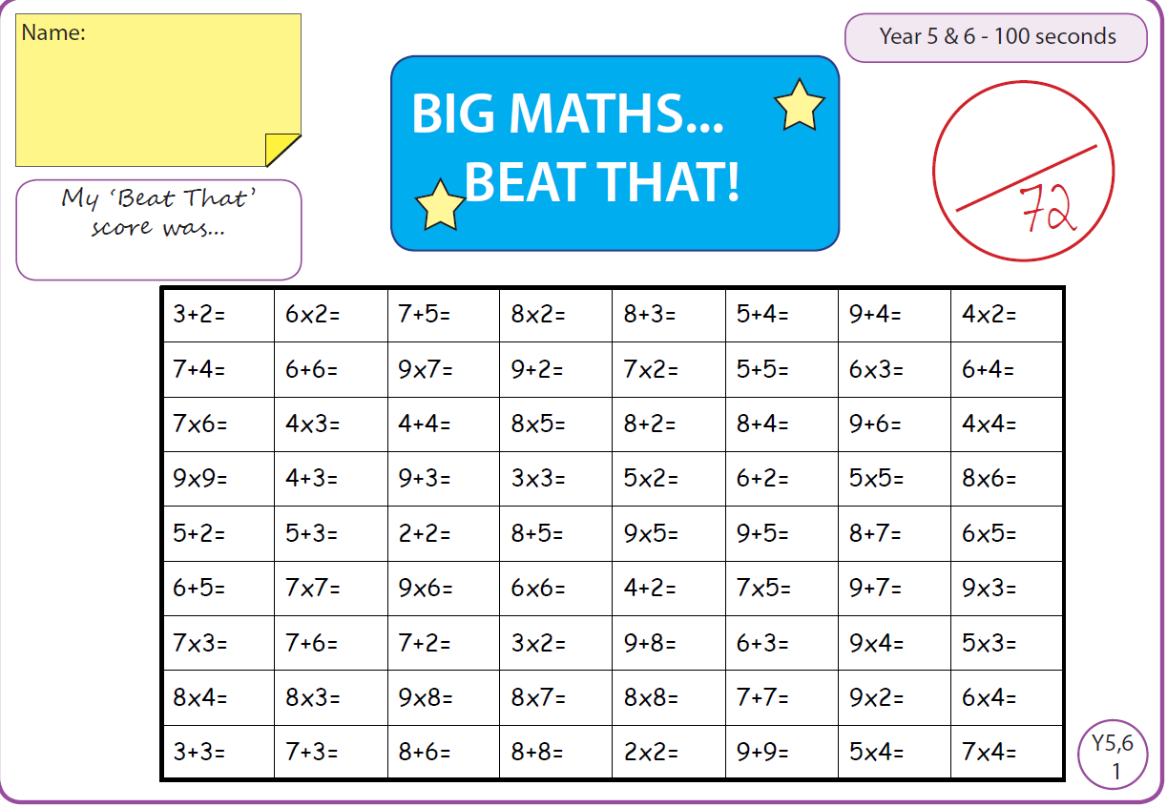

Tuesday
Time and Subject | Learning Objective | Task/Link/Resources
8.45-9.00  Reading | L.O: To practise and consolidate existing reading skills. | Read your individual reading book, either in your head or out loud.
9.00-9.15  Morning Maths | LO: To consolidate recall of number facts.  Revision LO: to multiply and divide by 0, 1, 10 and 100 | Complete today’s Beat That. You will find today’s Beat That below today’s timetable. Just scroll down! Remember, it is the same one every day for a week so try and beat your score each time!  We use Morning Maths as a time to revise concepts and keep them at the front of our minds- have a go at revising how to multiply and divide by 0, 1, 10 and 100 using the link below:  https://www.bbc.co.uk/bitesize/topics/z36tyrd/articles/z2fkwxs
9.15-9.45  Spelling | LO: To practice Unit Two RWI Spelling words. | Speed write this week’s words- time yourself a minute for each! Check them and correct any mistakes. Write them in different colours or fancy writing, make yourself a poster of each of the words! Circle the consonants and vowels.  Appreciate, creation, creating, cycling, faded, famous, grimy, grizzly, joker, making, nicest, observant, persuaded, sensed, sensible, slimy, smiled, tasted, trader.  Check out the link below to support your work on this spelling rule:  https://www.bbc.co.uk/bitesize/topics/zqqsw6f/articles/zqcpv9q
9.45-10.00  Active break | L.O: To boost my concentration through movement. | https://www.youtube.com/watch?v=OPLWyZMRNn0  Join in with the Go Noodle clip above to get you moving!
10.00-11.00  English | LO: To investigate homophones. | The video below will help you to revise homophones ready for the lesson today:  https://www.bbc.co.uk/bitesize/topics/zp7mn39/articles/z7mvbdm  Follow the link below to have a go at today’s lesson about homophones.  https://classroom.thenational.academy/lessons/to-investigate-homophones-6wuk6c
11.00- 11.15
Break
11.15-12.15  Maths | LO: To explore place value to three decimal places. | Follow the link below to have a go at today’s lesson:  https://classroom.thenational.academy/lessons/place-value-to-3-decimal-places-6crpat
12.15-1.00
Dinner
1.00-1.15  Storytime | LO: To listen to a story for pleasure. | Finish off listening to Chapter One from Wylderwood.  http://storiespodcast.com/
1.15-2.30  Topic  Geography | LO: To understand what hemispheres are. | https://classroom.thenational.academy/lessons/what-are-the-hemispheres-6grp8e  Follow the link above to have a go at today’s Geography lesson!  The video below might help you out too:  https://www.bbc.co.uk/bitesize/topics/zvsfr82/articles/zd4rmfr
2.30-3.00  RHE | LO: I understand the meaning and the benefits of living in a community. | https://classroom.thenational.academy/lessons/community-care-cctp8c  Follow the link above to have a go at today’s RHE lesson!  Follow these links below to see how team work is part of being in a community.  Part One https://www.bbc.co.uk/bitesize/clips/zsbfb9q  Part Two https://www.bbc.co.uk/bitesize/clips/zg8c87h

Wednesday
Time and Subject | Learning Objective | Task/Link/Resources
8.45-9.00  Reading | L.O: To practise and consolidate existing reading skills. | Read your individual reading book, either in your head or out loud.
9.00-9.15  Morning Maths | LO: To consolidate recall of number facts.  Revision LO: To explore mental strategies for multiplication. | Complete today’s Beat That. You will find today’s Beat That below today’s timetable. Just scroll down! Remember, it is the same one every day for a week so try and beat your score each time!  We use Morning Maths as a time to revise concepts and keep them at the front of our minds- follow the link below to revise mental strategies for multiplication!  https://www.bbc.co.uk/bitesize/topics/z36tyrd/articles/zwghk2p
9.15-9.45  Spelling | LO: To practice Unit Two RWI Spelling words. | Speed write this week’s words- time yourself a minute for each! Check them and correct any mistakes. Write them in different colours or fancy writing, make yourself a poster of each of the words! Circle the consonants and vowels.  Appreciate, creation, creating, cycling, faded, famous, grimy, grizzly, joker, making, nicest, observant, persuaded, sensed, sensible, slimy, smiled, tasted, trader.  The link below might help you out with this spelling rule:  https://www.bbc.co.uk/bitesize/topics/zqqsw6f/articles/zcsyjty
9.45-10.00  Active break | L.O: To boost my concentration through movement. | https://www.youtube.com/watch?v=7pUAdYWud10  Join in with the Go Noodle clip above to get you moving!
10.00-11.00  English | LO: To explore simple and compound sentences.  SPaG LO: To develop understanding of the function of verbs. | Follow the link below to have a go at today’s English lesson:  https://classroom.thenational.academy/lessons/to-explore-simple-and-compound-sentences-74tp8t  Knowing what a verb does is really crucial when forming sentences, consolidate your knowledge with the link below:  https://www.bbc.co.uk/bitesize/topics/zwwp8mn/articles/zpxhdxs
11.00- 11.15
Break
11.15-12.15  Maths | LO: To multiply by 10, 100 and 1000, involving decimals. | Follow the link below to have a go at today’s Maths lesson:  https://classroom.thenational.academy/lessons/multiply-and-divide-by-10-100-and-1000-involving-decimals-64wk6r  Watch the clip below to give you a helping hand:  https://www.bbc.co.uk/bitesize/clips/zcnyr82
12.15-1.00
Dinner
1.00-1.15  Storytime | LO: To listen to a story for pleasure. | Start listening to Part Two of the Wylderwood, it is 26 minutes long, so you can listen to some today and some tomorrow, remember where you get up to!  http://storiespodcast.com/
1.15-2.30  Topic  Geography | LO: To explore different time zones. | Follow the link below to have a go at today’s Geography lesson:  https://classroom.thenational.academy/lessons/what-time-is-it-in-different-countries-c8w34r  The video below might help you out too:  https://www.bbc.co.uk/bitesize/topics/zvsfr82/articles/zjk46v4
2.30-3.00  Music | LO: To understand the difference between three and four time. | Have a go at today’s lesson by clicking on the link below:  https://classroom.thenational.academy/lessons/to-understand-the-difference-between-three-and-four-time-crrkac
Thursday
Time and Subject | Learning Objective | Task/Link/Resources
8.45-9.00  Reading | L.O: To practise and consolidate existing reading skills. | Read your individual reading book, either in your head or out loud.
9.00-9.15  Morning Maths | LO: To consolidate recall of number facts. | Complete today’s Beat That. You will find today’s Beat That below today’s timetable. Just scroll down! Remember, it is the same one every day for a week so try and beat your score each time!  We use Morning Maths as a time to revise concepts and keep them at the front of our minds- recall your understanding about place value using the link below:  https://www.bbc.co.uk/bitesize/topics/zsjqtfr/articles/z9w3g82
9.15-9.45  Spelling | LO: To practice Unit Two RWI Spelling words. | Speed write this week’s words- time yourself a minute for each! Check them and correct any mistakes. Write them in different colours or fancy writing, make yourself a poster of each of the words! Circle the consonants and vowels.  Appreciate, creation, creating, cycling, faded, famous, grimy, grizzly, joker, making, nicest, observant, persuaded, sensed, sensible, slimy, smiled, tasted, trader.
9.45-10.00  Active break | L.O: To boost my concentration through movement. | https://www.youtube.com/watch?v=Hl5dRW4E9hc  Join in with the Go Noodle clip above to get you moving!
10.00-11.00  English | LO: To generate descriptive vocabulary.  SPaG LO: To recap and develop understanding of how adverbs are used. | Follow the link below to have a go at today’s lesson:  https://classroom.thenational.academy/lessons/to-generate-descriptive-vocabulary-cmv62c  SPAG  Use the link below to develop your understanding of adverbs.  https://www.bbc.co.uk/bitesize/topics/zwwp8mn/articles/zgsgxfr
11.00- 11.15
Break
11.15-12.15  Maths | LO: I can multiply and divide by 10, 100 and 1000 within context. | Follow the link below to have a go at today’s lesson:  https://classroom.thenational.academy/lessons/multiply-and-divide-by-10-100-and-1000-with-in-context-c4t68t
12.15-1.00
Dinner
1.00-1.15  Storytime | LO: To listen to a story for pleasure. | Continue listening to Part Two of the Wylderwood:  http://storiespodcast.com/
1.15-2.30  Topic  Geography | LO: To explore the Geography of the Arctic and Antarctica. | Follow the link below to have a go at today’s Geography lesson:  https://classroom.thenational.academy/lessons/what-is-the-geography-of-the-arctic-and-antarctic-69gk4d  In class we are looking at the continents too, use the clip below to help with this:  https://www.bbc.co.uk/bitesize/topics/zvsfr82/articles/znm7vk7
2.30-3.00  French | LO: To develop vocabulary. | Follow the link below:  https://www.bbc.co.uk/teach/class-clips-video/french-ks2-modern-routines/zjynvk7
Friday
Time and Subject | Learning Objective | Task/Link/Resources
8.45-9.00  Reading | L.O: To practise and consolidate existing reading skills. | Read your individual reading book, either in your head or out loud.
9.00-9.15  Morning Maths | LO: To consolidate recall of number facts.  Revision LO:  To recap column addition. | Complete today’s Beat That. You will find today’s Beat That below today’s timetable. Just scroll down! Remember, it is the same one every day for a week so try and beat your score each time!  We use Morning Maths as a time to revise concepts and keep them at the front of our minds- follow the link below to recap column addition:  https://www.bbc.co.uk/bitesize/topics/zy2mn39/articles/z3kmrwx
9.15-9.45  Spelling | LO: To practice Unit Two RWI Spelling words. | Speed write this week’s words- time yourself a minute for each! Check them and correct any mistakes. Write them in different colours or fancy writing, make yourself a poster of each of the words! Circle the consonants and vowels.  Appreciate, creation, creating, cycling, faded, famous, grimy, grizzly, joker, making, nicest, observant, persuaded, sensed, sensible, slimy, smiled, tasted, trader.  Use the look, cover, write, check sheet at the end of today’s timetable to help you to test yourself on this week’s words.
9.45-10.00  Active break | L.O: To boost my concentration through movement. | https://www.youtube.com/watch?v=aEIpC4e2aBY  Join in with the Go Noodle clip above to get you moving!
10.00-11.00  English | LO: To develop a rich understanding of words associated with cities.  SPaG LO: To develop an understanding of modal verbs. | Follow the link below to have a go at today’s lesson:  https://classroom.thenational.academy/lessons/to-develop-a-rich-understanding-of-words-associated-with-cities-71k36c  SPaG  Follow the link below to find out all about modal verbs.  https://www.bbc.co.uk/bitesize/topics/zwwp8mn/articles/zps4pbk
11.00- 11.15
Break
11.15-12.15  Maths | LO: To understand the terms common factor and common multiple as properties of a number. | Follow the link below to have a go at today’s lesson:  https://classroom.thenational.academy/lessons/understand-the-terms-common-factor-and-common-multiple-as-properties-of-a-number-cdk68c
12.15-1.00
Dinner
1.00-1.15  Storytime | LO: To listen to a story for pleasure. | http://storiespodcast.com/  Start listening to Part Three of the Wylderwood, it is 2o minutes long, so you can listen to some today and some on Monday, remember where you get up to!
1.15-3:00  Golden Time Art | LO: To create a landscape drawing inspired by geography work. | In Geography, we have been learning about different time zones around the world, choose a famous landmark from around the world and use the tutorial below to create your own version of it:  https://www.bbc.co.uk/bitesize/clips/zdsb9j6
