Monday
Time and Subject | Learning Objective | Task/Link/Resources
8.45-9.00  Reading | L.O: To practise and consolidate existing reading skills. | Read your individual reading book, either in your head or out loud.
9.00-9.15  Morning Maths | LO: To consolidate recall of number facts.  Revision LO: To add decimals with the same number of decimal places. | Complete today’s Beat That. You will find today’s Beat That below today’s timetable. Just scroll down! Remember, it is the same one every day for a week so try and beat your score each time!  We use Morning Maths as a time to revise concepts and keep them at the front of our minds- follow this link to add decimals with the same number of decimal places, click on Summer Term Week Eight and use the third video on that link:  https://whiterosemaths.com/homelearning/summer-archive/year-5/
9.15-9.45  Spelling | LO: To practice Unit Nine RWI Spelling words. | Speed write this week’s words- time yourself a minute for each! Check them and correct any mistakes. Write them in different colours or fancy writing, make yourself a poster of each of the words! Circle the consonants and vowels.  Achieve, achievement, believe, ceiling, conceive, deceive, deceive, mischievous, niece, nieces, perceive, perceived, piece, pieces, pieced, protein.
9.45-10.00  Active break | L.O: To boost my concentration through movement. | https://www.youtube.com/watch?v=Y9LLfv7yauM  Join in with the Go Noodle clip above to get you moving!
10.00-11.00  English | LO: To write the main body of my letter part two. | Have a go at today’s lesson by clicking on the link below:  https://classroom.thenational.academy/lessons/to-write-the-main-body-of-my-letter-part-2-cnjkat
11.00- 11.15
Break
11.15-12.15  Maths | LO: To calculate and convert units of area. | Have a go at today’s lesson by clicking on the link below:  https://classroom.thenational.academy/lessons/decimals-and-measures-calculation-and-conversion-of-units-of-area-c4ukar
12.15-1.00
Dinner
1.00-1.15  Storytime | LO: To listen to a story for pleasure. | This week we are continuing to listen to Hyperspace High Crash Landing, remember where you get up to each day:  https://stories.audible.com/pdp/B00FL4S5FC?ref=adbl_ent_anon_ds_pdp_pc_cntr-4-4
1.15-2.30  PE | LO: To develop fitness and learn a dance sequence. | Have a go at today’s lesson by clicking on the links below:  https://www.youtube.com/watch?v=GHahd8rQ0hg  https://www.youtube.com/watch?v=4wSYo8guYPs
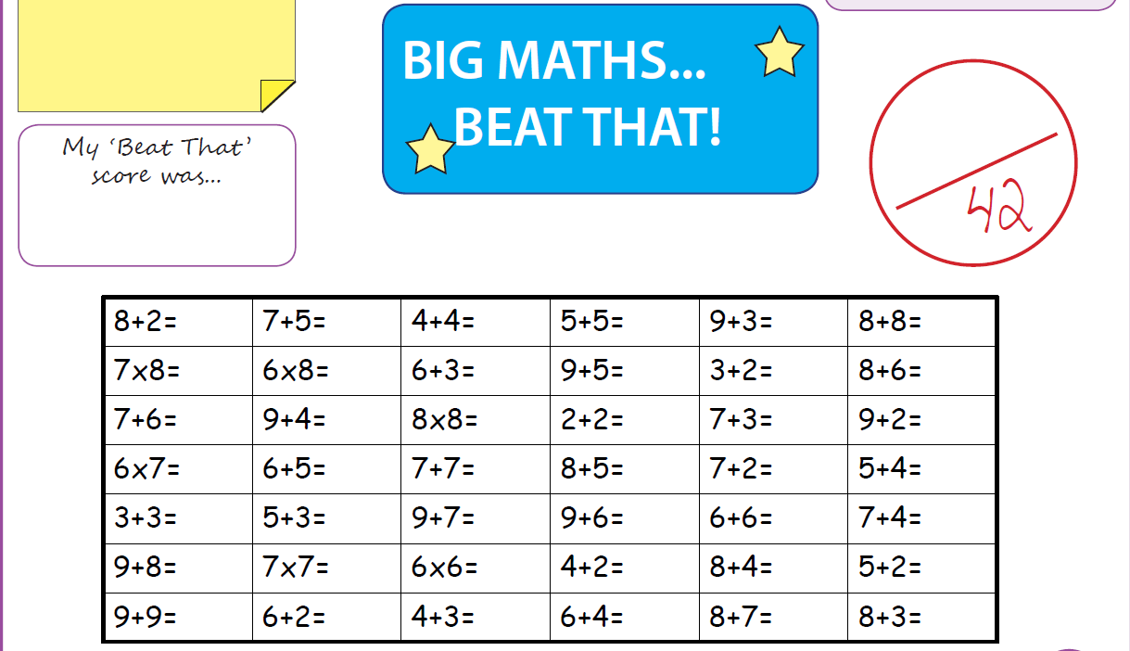
Tuesday
Time and Subject | Learning Objective | Task/Link/Resources
8.45-9.00  Reading | L.O: To practise and consolidate existing reading skills. | Read your individual reading book, either in your head or out loud.
9.00-9.15  Morning Maths | LO: To consolidate recall of number facts.  Revision LO: To add decimals with a different number of decimal places. | Complete today’s Beat That. You will find today’s Beat That below today’s timetable. Just scroll down! Remember, it is the same one every day for a week so try and beat your score each time!  We use Morning Maths as a time to revise concepts and keep them at the front of our minds- follow this link to add decimals with a different number of decimal places. Click on Summer Term Week 8 and click on the fourth video on that link:  https://whiterosemaths.com/homelearning/summer-archive/year-5/
9.15-9.45  Spelling | LO: To practice Unit Nine RWI Spelling words. | Speed write this week’s words- time yourself a minute for each! Check them and correct any mistakes. Write them in different colours or fancy writing, make yourself a poster of each of the words! Circle the consonants and vowels.  Achieve, achievement, believe, ceiling, conceive, deceive, deceive, mischievous, niece, nieces, perceive, perceived, piece, pieces, pieced, protein.
9.45-10.00  Active break | L.O: To boost my concentration through movement. | https://www.youtube.com/watch?v=OPLWyZMRNn0  Join in with the Go Noodle clip above to get you moving!
10.00-11.00  English | LO: To plan and write the closing of a letter. | Have a go at today’s lesson by clicking on the link below:  https://classroom.thenational.academy/lessons/to-plan-and-write-the-closing-of-a-letter-60t66t
11.00- 11.15
Break
11.15-12.15  Maths | LO: To use decimals and measure to calculate the volume of cubes and cuboids. | Have a go at today’s lesson by clicking on the link below:  https://classroom.thenational.academy/lessons/decimals-and-measures-the-volume-of-cubes-and-cuboids-cdh3cr
12.15-1.00
Dinner
1.00-1.15  Storytime | LO: To listen to a story for pleasure. | This week we are continuing to listen to Hyperspace High Crash Landing, remember where you get up to each day:  https://stories.audible.com/pdp/B00FL4S5FC?ref=adbl_ent_anon_ds_pdp_pc_cntr-4-4
1.15-2.30  Topic  History. | LO: To learn how the Shang Dynasty ended. | Have a go at today’s History lesson by clicking on the link below:  https://classroom.thenational.academy/lessons/how-did-the-shang-dynasty-end-71hpct
2.30-3.00  RHE | LO: To explore laws. | Have a go at today’s lesson by clicking the link below:  https://classroom.thenational.academy/lessons/rules-rule-6rrpcc
Wednesday
Time and Subject | Learning Objective | Task/Link/Resources
8.45-9.00  Reading | L.O: To practise and consolidate existing reading skills. | Read your individual reading book, either in your head or out loud.
9.00-9.15  Morning Maths | LO: To consolidate recall of number facts.  Revision LO: To subtract decimals with the same number of decimal places. | Complete today’s Beat That. You will find today’s Beat That below today’s timetable. Just scroll down! Remember, it is the same one every day for a week so try and beat your score each time!  We use Morning Maths as a time to revise concepts and keep them at the front of our minds- follow this link to subtract decimals with the same number of decimal places. Click on Summer Term Week 9 and use the first video on that link:  https://whiterosemaths.com/homelearning/summer-archive/year-5/
9.15-9.45  Spelling | LO: To practice Unit Nine RWI Spelling words. | Speed write this week’s words- time yourself a minute for each! Check them and correct any mistakes. Write them in different colours or fancy writing, make yourself a poster of each of the words! Circle the consonants and vowels.  Achieve, achievement, believe, ceiling, conceive, deceive, deceive, mischievous, niece, nieces, perceive, perceived, piece, pieces, pieced, protein.
9.45-10.00  Active break | L.O: To boost my concentration through movement. | https://www.youtube.com/watch?v=7pUAdYWud10  Join in with the Go Noodle clip above to get you moving!
10.00-11.00  English | LO: To edit our letter. | Have a go at today’s lesson by clicking on the link below:  https://classroom.thenational.academy/lessons/to-edit-our-letter-70uket
11.00- 11.15
Break
11.15-12.15  Maths | LO: To convert between standard measures. | Have a go at today’s lesson by clicking on the link below:  https://classroom.thenational.academy/lessons/decimals-and-measures-convert-between-standard-measures-6cupac
12.15-1.00
Dinner
1.00-1.15  Storytime | LO: To listen to a story for pleasure. | This week we are continuing to listen to Hyperspace High Crash Landing, remember where you get up to each day:  https://stories.audible.com/pdp/B00FL4S5FC?ref=adbl_ent_anon_ds_pdp_pc_cntr-4-4
1.15-2.30  Topic  History. | LO: To explore how empires collapse. | Have a go at today’s History lesson by clicking on the link below:  https://classroom.thenational.academy/lessons/how-do-empires-collapse-cgvkcc
2.30-3.00  Music | LO: To learn how to harmonise. | Have a go at today’s lesson by clicking on the link below:  https://classroom.thenational.academy/lessons/learning-how-to-harmonise-75k64t
Thursday

Time and Subject | Learning Objective | Task/Link/Resources
8.45-9.00  Reading | L.O: To practise and consolidate existing reading skills. | Read your individual reading book, either in your head or out loud.
9.00-9.15  Morning Maths | LO: To consolidate recall of number facts.  Revision LO: To subtract decimals with a different number of decimal places. | Complete today’s Beat That. You will find today’s Beat That below today’s timetable. Just scroll down! Remember, it is the same one every day for a week so try and beat your score each time!  We use Morning Maths as a time to revise concepts and keep them at the front of our minds- follow this link to subtract decimals with a different number of decimal places, click on Summer Term Week 9 and use the second video on that link:  https://whiterosemaths.com/homelearning/summer-archive/year-5/
9.15-9.45  Spelling | LO: To practice Unit Nine RWI Spelling words. | Speed write this week’s words- time yourself a minute for each! Check them and correct any mistakes. Write them in different colours or fancy writing, make yourself a poster of each of the words! Circle the consonants and vowels.  Achieve, achievement, believe, ceiling, conceive, deceive, deceive, mischievous, niece, nieces, perceive, perceived, piece, pieces, pieced, protein.
9.45-10.00  Active break | L.O: To boost my concentration through movement. | https://www.youtube.com/watch?v=Hl5dRW4E9hc  Join in with the Go Noodle clip above to get you moving!
10.00-11.00  English | LO: To find out about the positive impact of the windrush community on Modern Britain. | Have a go at today’s lesson by clicking on the link below:  https://classroom.thenational.academy/lessons/to-research-the-positive-impact-of-the-windrush-community-on-modern-britain-6xjpac
11.00- 11.15
Break
11.15-12.15  Maths | LO: To solve problems including the conversion units of measure. | Have a go at today’s lesson by clicking on the link below:  https://classroom.thenational.academy/lessons/decimals-and-measures-solving-problems-including-the-conversion-of-standard-units-of-measure-6nhp8e
12.15-1.00
Dinner
1.00-1.15  Storytime | LO: To listen to a story for pleasure. | This week we are continuing to listen to Hyperspace High Crash Landing, remember where you get up to each day:  https://stories.audible.com/pdp/B00FL4S5FC?ref=adbl_ent_anon_ds_pdp_pc_cntr-4-4
1.15-2.30  Topic | LO: To explore the great accomplishments of the Shang Dynasty. | Have a go at today’s History lesson by clicking on the link below:  https://classroom.thenational.academy/lessons/what-were-the-great-accomplishments-of-the-shang-dynasty-cmu66c
2.30-3.00  French | LO: To develop vocabulary. | Follow the link:  https://www.french-games.net/frenchgames/four-in-a-row?topic=Colours&level=primary
Friday
Time and Subject | Learning Objective | Task/Link/Resources
8.45-9.00  Reading | L.O: To practise and consolidate existing reading skills. | Read your individual reading book, either in your head or out loud.
9.00-9.15  Morning Maths | LO: To consolidate recall of number facts.  Revision LO: To multiply decimals by 10, 100 and 1000. | Complete today’s Beat That. You will find today’s Beat That below today’s timetable. Just scroll down! Remember, it is the same one every day for a week so try and beat your score each time!  We use Morning Maths as a time to revise concepts and keep them at the front of our minds- follow this link to multiply decimals by 10, 100 and 1000. Click on Summer Term Week 9 and use the third video on that link:  https://whiterosemaths.com/homelearning/summer-archive/year-5/
9.15-9.45  Spelling | LO: To practice Unit Nine RWI Spelling words. | Speed write this week’s words- time yourself a minute for each! Check them and correct any mistakes. Write them in different colours or fancy writing, make yourself a poster of each of the words! Circle the consonants and vowels.  Achieve, achievement, believe, ceiling, conceive, deceive, deceive, mischievous, niece, nieces, perceive, perceived, piece, pieces, pieced, protein.  Test yourself using the Look, Say, Cover, Write, Check grid at the very bottom of the week.
9.45-10.00  Active break | L.O: To boost my concentration through movement. | https://www.youtube.com/watch?v=aEIpC4e2aBY  Join in with the Go Noodle clip above to get you moving!
10.00-11.00  English | LO: To develop reading for pleasure. | Have a go at today’s lesson by clicking on the link below:  https://classroom.thenational.academy/lessons/to-develop-reading-for-pleasure-74v3cd
11.00- 11.15
Break
11.15-12.15  Maths | LO: To convert between units of time. | Have a go at today’s lesson by clicking on the link below:  https://classroom.thenational.academy/lessons/decimals-and-measures-convert-between-units-of-time-c4r66c
12.15-1.00
Dinner
1.00-1.15  Storytime | LO: To listen to a story for pleasure. | This week we are continuing to listen to Hyperspace High Crash Landing, remember where you get up to each day:  https://stories.audible.com/pdp/B00FL4S5FC?ref=adbl_ent_anon_ds_pdp_pc_cntr-4-4
1.15-3:00  Golden Time Art | LO: To practise drawing skills by drawing an animal. | Enjoy today’s session following the link below:  https://emilyfellah.co.uk/resources/
