Time and Subject | Learning Objective | Task/Link/Resources
8.45-9.00  Reading | L.O: To practise and consolidate existing reading skills. | Read your individual reading book, either in your head or out loud.
9.00-9.15  Morning Maths | LO: To consolidate recall of number facts. | Complete today’s Beat That. You will find today’s Beat That below today’s timetable. Just scroll down! Remember, it is the same one every day for a week so try and beat your score each time!
9.15-9.45  Spelling | LO: To practice Unit Six RWI Spelling words. | Speed write this week’s words- time yourself a minute for each! Check them and correct any mistakes. Write them in different colours or fancy writing, make yourself a poster of each of the words! Circle the consonants and vowels.  Week 11 – absent ancient confident decent dependent different efficient frequent
9.45-10.00  Active break | L.O: To boost my concentration through movement. | https://www.youtube.com/watch?v=Y9LLfv7yauM  Join in with the Go Noodle clip above to get you moving!
10.00-11.00  English | LO: To plan a persuasive letter. | Have a go at today’s lesson by clicking on the link below:  https://classroom.thenational.academy/lessons/to-plan-a-persuasive-letter-71hk4e
11.00- 11.15
Break
11.15-12.15  Maths | LO: To understand what percentage means and find simple percent. | Have a go at today’s lesson by clicking on the link below:  https://classroom.thenational.academy/lessons/understanding-percentage-6gvpad
12.15-1.00
Dinner
1.00-1.15  Storytime | LO: To listen to a story for pleasure. | Continue listening to The Adventures of Alice in Wonderland, remember where you got up to for next time:  https://stories.audible.com/pdp/B015D78L0U?ref=adbl_ent_anon_ds_pdp_pc_cntr-3-2
1.15-2.30  PE | LO: To develop fitness and learn a dance sequence. | Have a go at today’s lesson by clicking on the links below:  https://www.youtube.com/watch?v=GHahd8rQ0hg  https://www.youtube.com/watch?v=4wSYo8guYPs

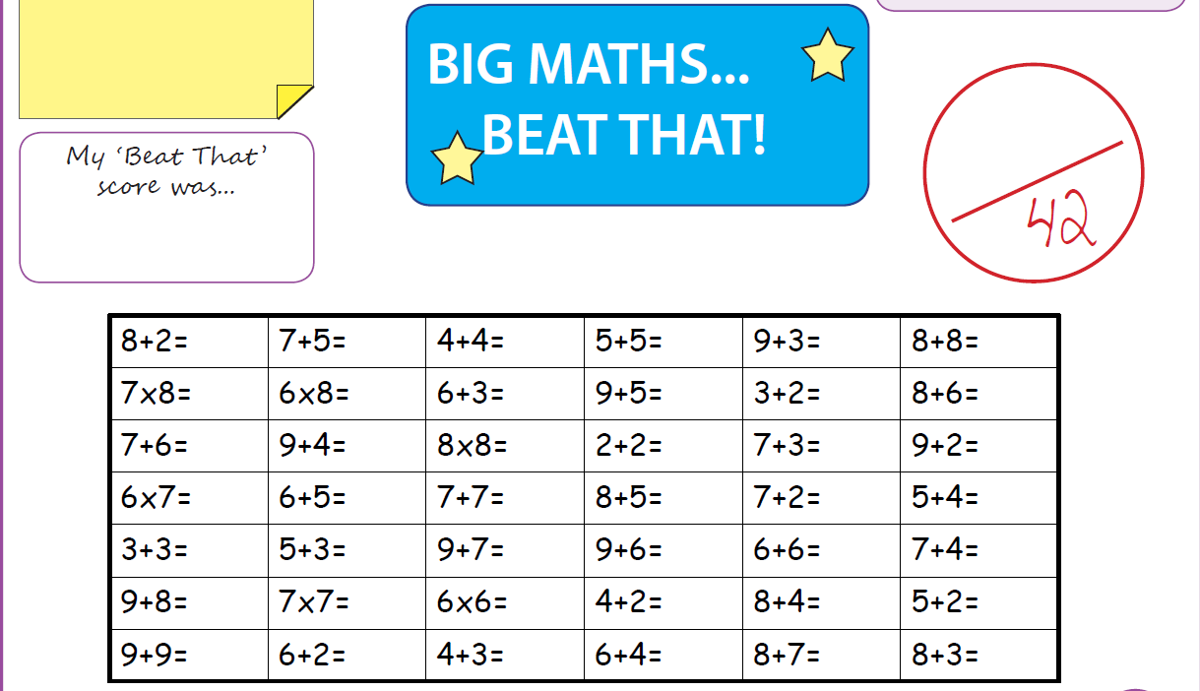

Tuesday
Time and Subject | Learning Objective | Task/Link/Resources
8.45-9.00  Reading | L.O: To practise and consolidate existing reading skills. | Read your individual reading book, either in your head or out loud.
9.00-9.15  Morning Maths | LO: To consolidate recall of number facts. | Complete today’s Beat That. You will find today’s Beat That below today’s timetable. Just scroll down! Remember, it is the same one every day for a week so try and beat your score each time!
9.15-9.45  Spelling | LO: To practice Unit Six RWI Spelling words. | Speed write this week’s words- time yourself a minute for each! Check them and correct any mistakes. Write them in different colours or fancy writing, make yourself a poster of each of the words! Circle the consonants and vowels.  Week 11 – absent ancient confident decent dependent different efficient frequent
9.45-10.00  Active break | L.O: To boost my concentration through movement. | https://www.youtube.com/watch?v=OPLWyZMRNn0  Join in with the Go Noodle clip above to get you moving!
10.00-11.00  English | LO: To practise and apply knowledge of suffixes ant and ent, including a test. | Have a go at today’s lesson by clicking on the link below:  https://classroom.thenational.academy/lessons/to-practise-and-apply-knowledge-suffixes-ant-and-ent-including-a-test-6cvk4d
11.00- 11.15
Break
11.15-12.15  Maths | LO: To work out percentage as a fraction and a decimal. | Have a go at today’s lesson by clicking on the link below:  https://classroom.thenational.academy/lessons/percentage-as-a-fraction-and-decimal-6mrk0r
12.15-1.00
Dinner
1.00-1.15  Storytime | LO: To listen to a story for pleasure. | Continue listening to The Adventures of Alice in Wonderland, remember where you got up to for next time:  https://stories.audible.com/pdp/B015D78L0U?ref=adbl_ent_anon_ds_pdp_pc_cntr-3-2
1.15-2.30  Topic  Geography | LO: To learn how Freiburg became sustainability. | Have a go at today’s lesson by clicking on the link below:  https://classroom.thenational.academy/lessons/how-did-freiburg-become-more-sustainable-74wkec
2.30-3.00  RHE | LO: To look at safety signs outside to know how to keep safe. | Have a go at today’s lesson by clicking on the link below:  https://classroom.thenational.academy/lessons/rules-rule-6rrpcc

Wednesday
Time and Subject | Learning Objective | Task/Link/Resources
8.45-9.00  Reading | L.O: To practise and consolidate existing reading skills. | Read your individual reading book, either in your head or out loud.
9.00-9.15  Morning Maths | LO: To consolidate recall of number facts. | Complete today’s Beat That. You will find today’s Beat That below today’s timetable. Just scroll down! Remember, it is the same one every day for a week so try and beat your score each time!
9.15-9.45  Spelling | LO: To practice Unit Six RWI Spelling words. | Speed write this week’s words- time yourself a minute for each! Check them and correct any mistakes. Write them in different colours or fancy writing, make yourself a poster of each of the words! Circle the consonants and vowels.  Week 11 – absent ancient confident decent dependent different efficient frequent
9.45-10.00  Active break | L.O: To boost my concentration through movement. | https://www.youtube.com/watch?v=7pUAdYWud10  Join in with the Go Noodle clip above to get you moving!
10.00-11.00  English | LO: To develop an understanding of how to use formal conjunctions. | Have a go at today’s lesson by clicking on the link below:  https://classroom.thenational.academy/lessons/to-develop-an-understanding-of-how-to-use-formal-conjunctions-cnjkac
11.00- 11.15
Break
11.15-12.15  Maths | LO: To understand how percentage is used in daily life. | Have a go at today’s lesson by clicking on the link below:  https://classroom.thenational.academy/lessons/understanding-percent-in-the-world-70uk0e
12.15-1.00
Dinner
1.00-1.15  Storytime | LO: To listen to a story for pleasure. | Continue listening to The Adventures of Alice in Wonderland, remember where you got up to for next time:  https://stories.audible.com/pdp/B015D78L0U?ref=adbl_ent_anon_ds_pdp_pc_cntr-3-2
1.15-2.30  Topic  Geography | LO: To learn how we will produce and use energy differently in the future. | Have a go at today’s lesson by clicking on today’s link:  https://classroom.thenational.academy/lessons/how-will-we-produce-and-use-energy-differently-in-the-future-60tpcd
2.30-3.00  Music | LO: To compose call and response patterns. | Have a go at today’s lesson by clicking on the link below:  https://classroom.thenational.academy/lessons/to-compose-call-and-response-patterns-60r36c
Thursday
Time and Subject | Learning Objective | Task/Link/Resources
8.45-9.00  Reading | L.O: To practise and consolidate existing reading skills. | Read your individual reading book, either in your head or out loud.
9.00-9.15  Morning Maths | LO: To consolidate recall of number facts. | Complete today’s Beat That. You will find today’s Beat That below today’s timetable. Just scroll down! Remember, it is the same one every day for a week so try and beat your score each time!
9.15-9.45  Spelling | LO: To practice Unit Six RWI Spelling words. | Speed write this week’s words- time yourself a minute for each! Check them and correct any mistakes. Write them in different colours or fancy writing, make yourself a poster of each of the words! Circle the consonants and vowels.  Week 11 – absent ancient confident decent dependent different efficient frequent
9.45-10.00  Active break | L.O: To boost my concentration through movement. | https://www.youtube.com/watch?v=Hl5dRW4E9hc  Join in with the Go Noodle clip above to get you moving!
10.00-11.00  English | LO: To write a persuasive letter. | Have a go at today’s lesson by clicking on the link below:  https://classroom.thenational.academy/lessons/to-write-a-persuasive-letter-ccw68r
11.00- 11.15
Break
11.15-12.15  Maths | LO: To find a percent of a quantity. | Have a go at today’s lesson by clicking on the link below:  https://classroom.thenational.academy/lessons/finding-percent-of-a-quantity-6xh36d
12.15-1.00
Dinner
1.00-1.15  Storytime | LO: To listen to a story for pleasure. | Continue listening to The Adventures of Alice in Wonderland, remember where you got up to for next time:  https://stories.audible.com/pdp/B015D78L0U?ref=adbl_ent_anon_ds_pdp_pc_cntr-3-2
1.15-2.30  Topic  Geography | LO: To learn how sustainable my community is. | Have a go at today’s lesson by clicking on the link below:  https://classroom.thenational.academy/lessons/how-sustainable-is-my-community-cdk3jt
2.30-3.00  French | LO: To practise vocabulary. | Follow the link:  https://www.french-games.net/frenchgames/four-in-a-row?topic=Colours&level=primary
Friday
Time and Subject | Learning Objective | Task/Link/Resources
8.45-9.00  Reading | L.O: To practise and consolidate existing reading skills. | Read your individual reading book, either in your head or out loud.
9.00-9.15  Morning Maths | LO: To consolidate recall of number facts. | Complete today’s Beat That. You will find today’s Beat That below today’s timetable. Just scroll down! Remember, it is the same one every day for a week so try and beat your score each time!
9.15-9.45  Spelling | LO: To practice Unit Six RWI Spelling words. | Speed write this week’s words- time yourself a minute for each! Check them and correct any mistakes. Write them in different colours or fancy writing, make yourself a poster of each of the words! Circle the consonants and vowels.  Week 11 – absent ancient confident decent dependent different efficient frequent  Test yourself using the Look, Cover, Say, Write and Check grid below!
9.45-10.00  Active break | L.O: To boost my concentration through movement. | https://www.youtube.com/watch?v=aEIpC4e2aBY  Join in with the Go Noodle clip above to get you moving!
10.00-11.00  English | LO: To write a persuasive letter, free write. | Have a go at today’s lesson by clicking on the link below:  https://classroom.thenational.academy/lessons/to-write-a-persuasive-letter-free-write-6rrk4r
11.00- 11.15
Break
11.15-12.15  Maths | LO: To problem solve by finding a percent of a quantity. | Have a go at today’s lesson by clicking on the link below:  https://classroom.thenational.academy/lessons/finding-percent-of-a-quantity-problem-solving-c9h38d
12.15-1.00
Dinner
1.00-1.15  Storytime | LO: To listen to a story for pleasure. | Finish listening to The Adventures of Alice in Wonderland, remember where you got up to for next time:  https://stories.audible.com/pdp/B015D78L0U?ref=adbl_ent_anon_ds_pdp_pc_cntr-3-2
1.15-3:00  Golden Time Art | LO: To draw an animal. | Enjoy today’s session by clicking on the link below:  https://youtu.be/iH4YAz1QPZU
