WB 15.3.21
Monday | Area of Learning | Task/Link/Resources
Time
9.00-10.00 | Literacy  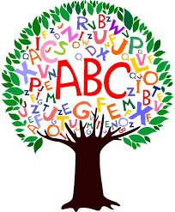 | To write a caption to show action in a story  In this lesson, we will write labels and captions to show action in the story.  https://classroom.thenational.academy/lessons/to-write-a-caption-to-show-action-in-a-story-6ww66t
10.00-10.30
Playtime
10.30-11.30 | Mathematics | Sorting 2D shapes  In this lesson, we will introduce the names and properties of some simple 2D shapes. We will use those properties to sort the shapes. During your daily exercise go on a 2D shape walk and spot shapes in the environment. Which 2D shapes can you spot inside your home?  https://classroom.thenational.academy/lessons/sorting-2d-shapes-cdh3et
11.30-12.00 | Active break | Alan the camel  https://www.youtube.com/watch?v=QuL3lhsU1Bs
12.00-1.00
Lunchtime
1.00-2.00 | Understanding The World | Spring Art
2.00-2.15
Playtime

2.15-2.30 | Storytime | Owl Babies  https://www.booktrust.org.uk/books-and-reading/have-some-fun/storybooks-and-games/owl-babies/

Tuesday | Area of Learning | Task/Link/Resources
Time
9.00-10.00 | Literacy | To box up a story to show what happens  In this lesson, we will create a box plan for our story focusing on the action and what is happenin  https://classroom.thenational.academy/lessons/to-box-up-a-story-to-show-what-happens-6mvkjd
10.00-10.30
Playtime
10.30-11.30 | Mathematics | Creating patterns with shapes  In this lesson, we will be making and spotting different repeating patterns. Draw or use natural resources or your toys to create your own repeating patterns.  https://classroom.thenational.academy/lessons/creating-patterns-with-shapes-ctj3gc
11.30-12.00 | Active break | Stezze The Parrot  https://www.youtube.com/watch?v=LIBz0IdOFiQ&list=PL8snGkhBF7ng6WUUGkeTlYyb2EREkjaoW&index=13
12.00-1.00
Lunchtime
1.00-2.00 | Understanding The World | Construct a beanstalk  In today's lesson we will combine different media in order to create a representation of a beanstalk. The three key areas of development that this lesson links to are expressive arts and design, physical development and understanding the world.  https://classroom.thenational.academy/lessons/construct-a-beanstalk-6th38r
2.00-2.15
Playtime

2.15-2.30 | Storytime | Lulu loves stories  https://www.booktrust.org.uk/books-and-reading/have-some-fun/storybooks-and-games/lulu-loves-stories/

Wednesday | Area of Learning | Task/Link/Resources
Time
9.00-10.00 | Literacy | To write a story to show action (Part 1)  In this lesson, we will write a story showing clear action.  https://classroom.thenational.academy/lessons/to-write-a-story-to-show-action-part-1-61jkjd
10.00-10.30
Playtime
10.30-11.30 | Mathematics | Finding 3D shapes in the environment  In this lesson, we will learn the names of simple 3D shapes. Can you find any out and about or in your home?  https://classroom.thenational.academy/lessons/finding-3d-shapes-in-the-environment-c9j64c
11.30-12.00 | Active break | Andy’s wild Workouts  https://www.bbc.co.uk/programmes/p06tmrxr
12.00-1.00
Lunchtime
1.00-2.00 | Understanding The World | The Veggie Patch (Part 2)  In this lesson, we will visit the veggie patch again to see how high our plants have grown. We will use the image of growing plants to explore pitch and use an action game to reinforce the learning we did around the beat earlier on in the unit.  https://classroom.thenational.academy/lessons/the-veggie-patch-part-2-cgvkgd
2.00-2.15
Playtime

2.15-2.30 | Storytime | The Boy on the Bus  https://www.booktrust.org.uk/books-and-reading/have-some-fun/storybooks-and-games/the-boy-on-the-bus/

Thursday | Area of Learning | Task/Link/Resources
Time
9.00-10.00 | Literacy | To write a story to show action (Part 2)  In this lesson, we will continue writing our story showing clear action.  https://classroom.thenational.academy/lessons/to-write-a-story-to-show-action-part-2-71k64r
10.00-10.30
Playtime
10.30-11.30 | Mathematics | Describing 3D shapes  In this lesson, we will look closely at the properties of 3D shapes and talk about them, using new language to describe them.  https://classroom.thenational.academy/lessons/describing-3d-shapes-crwk2e
11.30-12.00 | Active break | Andy’s Wild Workouts  https://www.bbc.co.uk/programmes/p06tmrxy
12.00-1.00
Lunchtime
1.00-2.00 | Understanding The World | Jack and the Beanstalk (Part 1)  In this lesson, we will be taking an imaginative journey through the traditional tale "Jack and the Beanstalk". We will use the footsteps of the characters in the story to explore note duration. We will climb the beanstalk and develop our understanding of pitch as we climb higher and higher.  https://classroom.thenational.academy/lessons/jack-and-the-beanstalk-part-1-cdhpce
2.00-2.15
Playtime

2.15-2.30 | Storytime | Rumble in the Jungle  https://www.booktrust.org.uk/books-and-reading/have-some-fun/storybooks-and-games/rumble-in-the-jungle/

Friday | Area of Learning | Task/Link/Resources
Time
9.00-10.00 | Literacy | To write a story to show action (Part 3)  In this lesson, we will finish writing our story showing clear action.  https://classroom.thenational.academy/lessons/to-write-a-story-to-show-action-part-3-6dgk2r
10.00-10.30
Playtime
10.30-11.30 | Mathematics | Revision and practise  In this lesson, we will practise some of the concepts of shape and pattern.  https://classroom.thenational.academy/lessons/revision-and-practise-71jk6t
11.30-12.00 | Active break | PE with Joe  https://www.youtube.com/watch?v=tSi2ix1i180
12.00-1.00
Lunchtime
1.00-2.00 | Understanding The World | Spring Bee Art  18. Potato Masher Bees  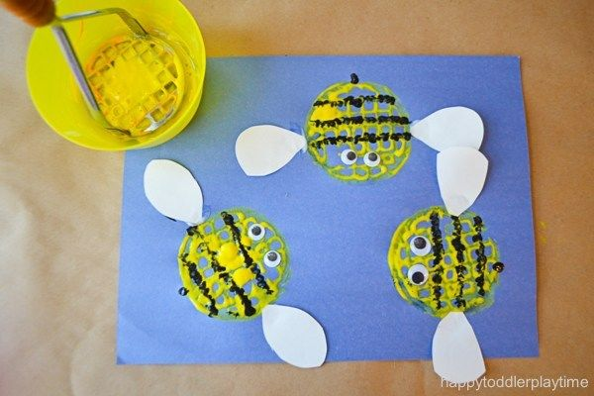  This is another spring painting idea that uses something you might not expect: a potato masher! Turns out the pattern on the masher is perfect for making cute little bees! Wonder what else you could make?  You will need:  - Yellow and black Washable Kids Paints  - Blue and white Construction Paper  - Q-Tips  - Glue  - Googly Eyes  - Rounded Potato Masher  - Scissors  - Bowls for the paint
2.00-2.15
Playtime

2.15-2.30 | Storytime | The Dragon Machine  https://www.booktrust.org.uk/books-and-reading/have-some-fun/storybooks-and-games/the-dragon-machine/

