Monday
Time and Subject | Learning Objective | Task/Link/Resources
8.45-9.00  Reading | L.O: To practise and consolidate existing reading skills. | Read your individual reading book, either in your head or out loud.
9.00-9.15  Morning Maths | LO: To consolidate recall of number facts.  Revision LO:  To understand thousandths. | Complete today’s Beat That. You will find today’s Beat That below today’s timetable. Just scroll down! Remember, it is the same one every day for a week so try and beat your score each time!  We use Morning Maths as a time to revise concepts and keep them at the front of our minds- follow this link to understand thousandths, click on Summer Term Week 7 and use the second video on this link:  https://whiterosemaths.com/homelearning/summer-archive/year-5/
9.15-9.45  Spelling | LO: To practice Unit Eight RWI Spelling words. | Speed write this week’s words- time yourself a minute for each! Check them and correct any mistakes. Write them in different colours or fancy writing, make yourself a poster of each of the words! Circle the consonants and vowels.  Knowledgeable, lamb, rustle, rustled, solemn, solemnly, subtlest, talk, talking, whistle, thistle.
9.45-10.00  Active break | L.O: To boost my concentration through movement. | https://www.youtube.com/watch?v=Y9LLfv7yauM  Join in with the Go Noodle clip above to get you moving!
10.00-11.00  English | LO: To generate vocabulary. | Have a go at today’s lesson by clicking on the link below:  https://classroom.thenational.academy/lessons/to-generate-vocabulary-ccw36d
11.00- 11.15
Break
11.15-12.15  Maths | LO: To use decimals and measures to generate and describe linear number. | Have a go at today’s lesson by clicking on the link below:  https://classroom.thenational.academy/lessons/decimals-and-measures-to-generate-and-describe-linear-number-6xh3je
12.15-1.00
Dinner
1.00-1.15  Storytime | LO: To listen to a story for pleasure. | This week we are continuing to listen to Hyperspace High Crash Landing, remember where you get up to each day:  https://stories.audible.com/pdp/B00FL4S5FC?ref=adbl_ent_anon_ds_pdp_pc_cntr-4-4
1.15-3:00  PE | LO: To develop strength and learn a dance sequence. | Have a go at today’s lesson by clicking on the links below:  https://www.youtube.com/watch?v=_o4enAQlAn0  https://www.youtube.com/watch?v=nGs-r4G-XmI
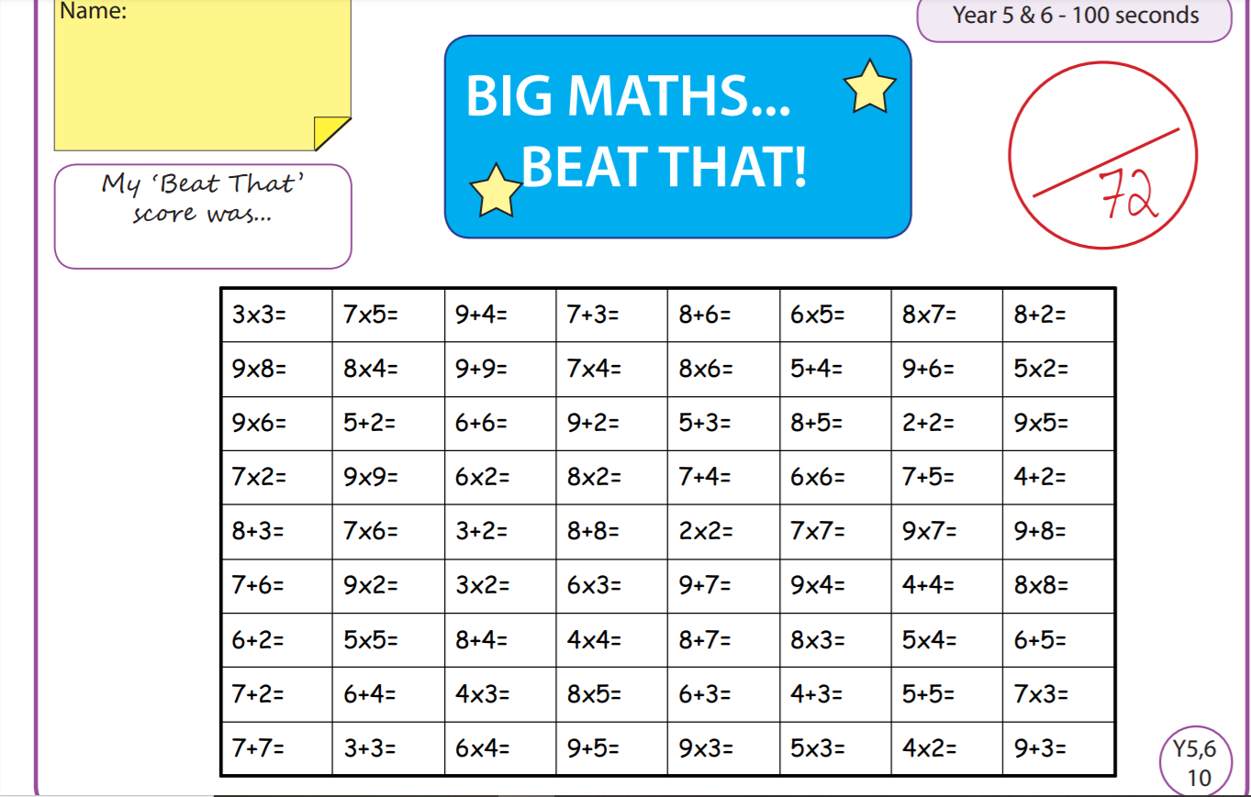
Tuesday
Time and Subject | Learning Objective | Task/Link/Resources
8.45-9.00  Reading | L.O: To practise and consolidate existing reading skills. | Read your individual reading book, either in your head or out loud.
9.00-9.15  Morning Maths | LO: To consolidate recall of number facts.  Revision LO: To round decimals. | Complete today’s Beat That. You will find today’s Beat That below today’s timetable. Just scroll down! Remember, it is the same one every day for a week so try and beat your score each time!  We use Morning Maths as a time to revise concepts and keep them at the front of our minds- follow this link to round decimals, click on Summer Term Week 7 and click on the third video on that link:  https://whiterosemaths.com/homelearning/summer-archive/year-5/
9.15-9.45  Spelling | LO: To practice Unit Eight RWI Spelling words. | Speed write this week’s words- time yourself a minute for each! Check them and correct any mistakes. Write them in different colours or fancy writing, make yourself a poster of each of the words! Circle the consonants and vowels.  Knowledgeable, lamb, rustle, rustled, solemn, solemnly, subtlest, talk, talking, whistle, thistle.
9.45-10.00  Active break | L.O: To boost my concentration through movement. | https://www.youtube.com/watch?v=OPLWyZMRNn0  Join in with the Go Noodle clip above to get you moving!
10.00-11.00  English | LO: To investigate suffixes le, el, al and il, including a test. | Have a go at today’s lesson by clicking on the link below:  https://classroom.thenational.academy/lessons/to-investigate-suffixes-le-el-al-il-including-test-cct32c
11.00- 11.15
Break
11.15-12.15  Maths | LO: To understand decimals and measures as standard units. | Have a go at today’s lesson by clicking on the link below:  https://classroom.thenational.academy/lessons/decimals-and-measures-standard-units-cdjk0r
12.15-1.00
Dinner
1.00-1.15  Storytime | LO: To listen to a story for pleasure. | This week we are continuing to listen to Hyperspace High Crash Landing, remember where you get up to each day:  https://stories.audible.com/pdp/B00FL4S5FC?ref=adbl_ent_anon_ds_pdp_pc_cntr-4-4
1.15-2.30  Topic  History. | LO: To explore what the Shang people believed. | Have a go at today’s History lesson by clicking on the link below:  https://classroom.thenational.academy/lessons/what-did-the-shang-people-believe-cth3ed
2.30-3.00  RHE | LO: To learn how to reduce the risk of fire in the home. | Have a go at today’s lesson by clicking on the link below:  https://classroom.thenational.academy/lessons/fireproof-64t3er
Wednesday
Time and Subject | Learning Objective | Task/Link/Resources
8.45-9.00  Reading | L.O: To practise and consolidate existing reading skills. | Read your individual reading book, either in your head or out loud.
9.00-9.15  Morning Maths | LO: To consolidate recall of number facts.  Revision LO:  To order and compare decimals. | Complete today’s Beat That. You will find today’s Beat That below today’s timetable. Just scroll down! Remember, it is the same one every day for a week so try and beat your score each time!  We use Morning Maths as a time to revise concepts and keep them at the front of our minds- follow this link to order and compare decimals, click on Summer Term Week 7 and use the fourth video on that link:  https://whiterosemaths.com/homelearning/summer-archive/year-5/
9.15-9.45  Spelling | LO: To practice Unit Eight RWI Spelling words. | Speed write this week’s words- time yourself a minute for each! Check them and correct any mistakes. Write them in different colours or fancy writing, make yourself a poster of each of the words! Circle the consonants and vowels.  Knowledgeable, lamb, rustle, rustled, solemn, solemnly, subtlest, talk, talking, whistle, thistle.
9.45-10.00  Active break | L.O: To boost my concentration through movement. | https://www.youtube.com/watch?v=7pUAdYWud10  Join in with the Go Noodle clip above to get you moving!
10.00-11.00  English | LO: To write the opening of a letter. | Have a go at today’s lesson by clicking on the link below:  https://classroom.thenational.academy/lessons/to-write-the-opening-of-a-letter-71jk2t
11.00- 11.15
Break
11.15-12.15  Maths | LO: To convert standard lengths. | Have a go at today’s lesson by clicking on the link below:  https://classroom.thenational.academy/lessons/decimals-and-measures-convert-standard-lengths-60tkad
12.15-1.00
Dinner
1.00-1.15  Storytime | LO: To listen to a story for pleasure. | This week we are continuing to listen to Hyperspace High Crash Landing, remember where you get up to each day:  https://stories.audible.com/pdp/B00FL4S5FC?ref=adbl_ent_anon_ds_pdp_pc_cntr-4-4
1.15-2.30  Topic  History | LO: To learn how Shang people’s beliefs were similar and different to other people’s at the time. | Have a go at today’s History lesson by clicking on the link below:  https://classroom.thenational.academy/lessons/how-were-shang-peoples-beliefs-similar-and-different-to-other-peoples-at-the-time-70v3jc
2.30-3.00  Music | LO: To explore singing in thirds. | Have a go at today’s lesson by clicking on the link below:  https://classroom.thenational.academy/lessons/to-explore-singing-in-thirds-6wu68e
Thursday
Time and Subject | Learning Objective | Task/Link/Resources
8.45-9.00  Reading | L.O: To practise and consolidate existing reading skills. | Read your individual reading book, either in your head or out loud.
9.00-9.15  Morning Maths | LO: To consolidate recall of number facts.  Revision LO: To understand percentages. | Complete today’s Beat That. You will find today’s Beat That below today’s timetable. Just scroll down! Remember, it is the same one every day for a week so try and beat your score each time!  We use Morning Maths as a time to revise concepts and keep them at the front of our minds- follow this link to understand percentages. Click on Summer Term Week and use the first video on that link:  https://whiterosemaths.com/homelearning/summer-archive/year-5/
9.15-9.45  Spelling | LO: To practice Unit Eight RWI Spelling words. | Speed write this week’s words- time yourself a minute for each! Check them and correct any mistakes. Write them in different colours or fancy writing, make yourself a poster of each of the words! Circle the consonants and vowels.  Knowledgeable, lamb, rustle, rustled, solemn, solemnly, subtlest, talk, talking, whistle, thistle.
9.45-10.00  Active break | L.O: To boost my concentration through movement. | https://www.youtube.com/watch?v=Hl5dRW4E9hc  Join in with the Go Noodle clip above to get you moving!
10.00-11.00  English | LO: To plan the main body of my letter. | Have a go at today’s lesson by clicking on the link below:  https://classroom.thenational.academy/lessons/to-plan-the-main-body-of-my-letter-74tpcd
11.00- 11.15
Break
11.15-12.15  Maths | LO: To use decimals and measures when solving problems with length. | Have a go at today’s lesson by clicking on the link below:  https://classroom.thenational.academy/lessons/decimals-and-measures-solving-problems-with-length-cdk32e
12.15-1.00
Dinner
1.00-1.15  Storytime | LO: To listen to a story for pleasure. | This week we are continuing to listen to Hyperspace High Crash Landing, remember where you get up to each day:  https://stories.audible.com/pdp/B00FL4S5FC?ref=adbl_ent_anon_ds_pdp_pc_cntr-4-4
1.15-2.30  Topic  History | LO: To learn who Fu Hao was. | Have a go at today’s History lesson by clicking on the link below:  https://classroom.thenational.academy/lessons/who-was-fu-hao-6hhp4r
2.30-3.00  French | LO: To develop vocabulary. | Follow the link:  https://www.bbc.co.uk/teach/class-clips-video/french-ks2-painting-together/z72gd6f
Friday
Time and Subject | Learning Objective | Task/Link/Resources
8.45-9.00  Reading | L.O: To practise and consolidate existing reading skills. | Read your individual reading book, either in your head or out loud.
9.00-9.15  Morning Maths | LO: To consolidate recall of number facts.  Revision LO: To understand percentages as fractions and decimals. | Complete today’s Beat That. You will find today’s Beat That below today’s timetable. Just scroll down! Remember, it is the same one every day for a week so try and beat your score each time!  We use Morning Maths as a time to revise concepts and keep them at the front of our minds- follow this link to understand percentages as fractions and decimals, click on Summer Term Week 8 and use the second video on that link:  https://whiterosemaths.com/homelearning/summer-archive/year-5/
9.15-9.45  Spelling | LO: To practice Unit Eight RWI Spelling words. | Speed write this week’s words- time yourself a minute for each! Check them and correct any mistakes. Write them in different colours or fancy writing, make yourself a poster of each of the words! Circle the consonants and vowels.  Knowledgeable, lamb, rustle, rustled, solemn, solemnly, subtlest, talk, talking, whistle, thistle.  Test yourself using the Look, Say, Cover, Write, Check grid at the bottom of the week.
9.45-10.00  Active break | L.O: To boost my concentration through movement. | https://www.youtube.com/watch?v=aEIpC4e2aBY  Join in with the Go Noodle clip above to get you moving!
10.00-11.00  English | LO: To write the main body of my letter part one. | Have a go at today’s lesson by clicking on the link below:  https://classroom.thenational.academy/lessons/to-write-the-main-body-of-my-letter-part-1-6hh3ar
11.00- 11.15
Break
11.15-12.15  Maths | LO: To calculate the area of parallelograms and triangles. | Have a go at today’s lesson by clicking on the link below:  https://classroom.thenational.academy/lessons/decimals-and-measures-calculating-the-area-of-parallelograms-and-triangles-ccu32c
12.15-1.00
Dinner
1.00-1.15  Storytime | LO: To listen to a story for pleasure. | This week we are continuing to listen to Hyperspace High Crash Landing, remember where you get up to each day:  https://stories.audible.com/pdp/B00FL4S5FC?ref=adbl_ent_anon_ds_pdp_pc_cntr-4-4
1.15-3:00  Golden Time Art | LO: To draw an animal. | Enjoy today’s session by clicking on the link below:  https://youtu.be/iH4YAz1QPZU

