Time and Subject | Learning Objective | Task/Link/Resources
8.45-9.00  Reading | L.O: To practise and consolidate existing reading skills. | Read your individual reading book, either in your head or out loud.
9.00-9.15  Morning Maths | LO: To consolidate recall of number facts. | Complete today’s Beat That. You will find today’s Beat That below today’s timetable. Just scroll down! Remember, it is the same one every day for a week so try and beat your score each time!
9.15-9.45  Spelling | LO: To practice Unit Five RWI Spelling words. | Speed write this week’s words- time yourself a minute for each! Check them and correct any mistakes. Write them in different colours or fancy writing, make yourself a poster of each of the words! Circle the consonants and vowels.  Week 10 - reasonably responsibly sensibly suitably terribly tolerably understandably visibly
9.45-10.00  Active break | L.O: To boost my concentration through movement. | https://www.youtube.com/watch?v=Y9LLfv7yauM  Join in with the Go Noodle clip above to get you moving!
10.00-11.00  English | LO: To understand the features of a persuasive letter. | Have a go at today’s lesson by clicking on the link below:  https://classroom.thenational.academy/lessons/to-understand-the-features-of-a-persuasive-letter-74tk4d
11.00- 11.15
Break
11.15-12.15  Maths | LO: To add and subtract fractions fluently. | Have a go at today’s lesson by clicking on the link below:  https://classroom.thenational.academy/lessons/add-and-subtract-fractions-fluency-75j3jc
12.15-1.00
Dinner
1.00-1.15  Storytime | LO: To listen to a story for pleasure. | Continue listening to The Adventures of Alice in Wonderland, remember where you got up to for next time:  https://stories.audible.com/pdp/B015D78L0U?ref=adbl_ent_anon_ds_pdp_pc_cntr-3-2
1.15-2.30  PE | LO: To develop strength and learn a dance sequence. | Have a go at today’s lesson by clicking on the links below:  https://www.youtube.com/watch?v=_o4enAQlAn0  https://www.youtube.com/watch?v=nGs-r4G-XmI

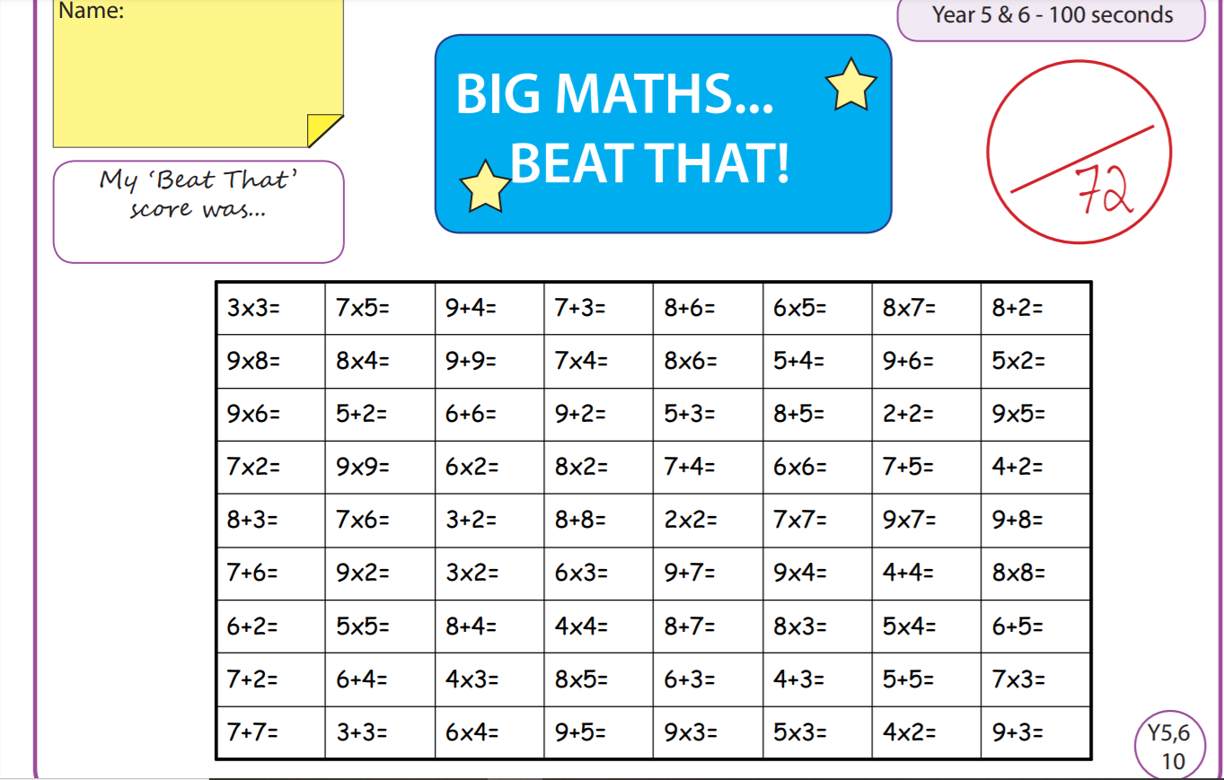

Tuesday
Time and Subject | Learning Objective | Task/Link/Resources
8.45-9.00  Reading | L.O: To practise and consolidate existing reading skills. | Read your individual reading book, either in your head or out loud.
9.00-9.15  Morning Maths | LO: To consolidate recall of number facts. | Complete today’s Beat That. You will find today’s Beat That below today’s timetable. Just scroll down! Remember, it is the same one every day for a week so try and beat your score each time!
9.15-9.45  Spelling | LO: To practice Unit Five RWI Spelling words. | Speed write this week’s words- time yourself a minute for each! Check them and correct any mistakes. Write them in different colours or fancy writing, make yourself a poster of each of the words! Circle the consonants and vowels.  Week 10 - reasonably responsibly sensibly suitably terribly tolerably understandably visibly
9.45-10.00  Active break | L.O: To boost my concentration through movement. | https://www.youtube.com/watch?v=OPLWyZMRNn0  Join in with the Go Noodle clip above to get you moving!
10.00-11.00  English | LO: To further investigate suffixes ant and ent. | Have a go at today’s lesson by clicking on the link below:  https://classroom.thenational.academy/lessons/to-further-investigate-suffixes-ant-and-ent-c5jk4e
11.00- 11.15
Break
11.15-12.15  Maths | LO: To multiply a fraction by a whole number. | Have a go at today’s lesson by clicking on the link below:  https://classroom.thenational.academy/lessons/multiply-a-fraction-by-a-whole-number-cgup2t
12.15-1.00
Dinner
1.00-1.15  Storytime | LO: To listen to a story for pleasure. | Continue listening to The Adventures of Alice in Wonderland, remember where you got up to for next time:  https://stories.audible.com/pdp/B015D78L0U?ref=adbl_ent_anon_ds_pdp_pc_cntr-3-2
1.15-2.30  Topic  Geography | LO: To learn how we produce energy. | Have a go at today’s lesson by clicking on the link below:  https://classroom.thenational.academy/lessons/how-do-we-produce-energy-part-1-c9hp2c
2.30-3.00  RHE | LO: To reduce the risk of fire in the home by identifying risks and rectifying them. | Have a go at today’s lesson by clicking on the link below:  https://classroom.thenational.academy/lessons/fireproof-64t3er

Wednesday
Time and Subject | Learning Objective | Task/Link/Resources
8.45-9.00  Reading | L.O: To practise and consolidate existing reading skills. | Read your individual reading book, either in your head or out loud.
9.00-9.15  Morning Maths | LO: To consolidate recall of number facts. | Complete today’s Beat That. You will find today’s Beat That below today’s timetable. Just scroll down! Remember, it is the same one every day for a week so try and beat your score each time!
9.15-9.45  Spelling | LO: To practice Unit Five RWI Spelling words. | Speed write this week’s words- time yourself a minute for each! Check them and correct any mistakes. Write them in different colours or fancy writing, make yourself a poster of each of the words! Circle the consonants and vowels.  Week 10 - reasonably responsibly sensibly suitably terribly tolerably understandably visibly
9.45-10.00  Active break | L.O: To boost my concentration through movement. | https://www.youtube.com/watch?v=7pUAdYWud10  Join in with the Go Noodle clip above to get you moving!
10.00-11.00  English | LO: To explore pronouns. | Have a go at today’s lesson by clicking on the link below:  https://classroom.thenational.academy/lessons/to-explore-pronouns-75h38c
11.00- 11.15
Break
11.15-12.15  Maths | LO: To multiply a mixed number fraction. | Have a go at today’s lesson by clicking on the link below:  https://classroom.thenational.academy/lessons/multiply-a-mixed-number-fraction-6njk6t
12.15-1.00
Dinner
1.00-1.15  Storytime | LO: To listen to a story for pleasure. | Continue listening to The Adventures of Alice in Wonderland, remember where you got up to for next time:  https://stories.audible.com/pdp/B015D78L0U?ref=adbl_ent_anon_ds_pdp_pc_cntr-3-2
1.15-2.30  Topic  Geography | LO: To learn how we produce energy part 2. | Have a go at today’s lesson by clicking on the link below:  https://classroom.thenational.academy/lessons/how-do-we-produce-energypart-2-ccv3gd
2.30-3.00  Music | LO: To understand the role of percussion in programmatic music. | Have a go at today’s lesson by clicking on the link below:  https://classroom.thenational.academy/lessons/to-understand-the-rcole-of-percussion-in-programmatic-music-c8r3ac
Thursday
Time and Subject | Learning Objective | Task/Link/Resources
8.45-9.00  Reading | L.O: To practise and consolidate existing reading skills. | Read your individual reading book, either in your head or out loud.
9.00-9.15  Morning Maths | LO: To consolidate recall of number facts. | Complete today’s Beat That. You will find today’s Beat That below today’s timetable. Just scroll down! Remember, it is the same one every day for a week so try and beat your score each time!
9.15-9.45  Spelling | LO: To practice Unit Five RWI Spelling words. | Speed write this week’s words- time yourself a minute for each! Check them and correct any mistakes. Write them in different colours or fancy writing, make yourself a poster of each of the words! Circle the consonants and vowels.  Week 10 - reasonably responsibly sensibly suitably terribly tolerably understandably visibly
9.45-10.00  Active break | L.O: To boost my concentration through movement. | https://www.youtube.com/watch?v=Hl5dRW4E9hc  Join in with the Go Noodle clip above to get you moving!
10.00-11.00  English | LO: To generate points to use in our persuasive letter. | Have a go at today’s lesson by clicking on the link below:  https://classroom.thenational.academy/lessons/to-generate-points-to-use-in-our-persuasive-letter-6muk2d
11.00- 11.15
Break
11.15-12.15  Maths | LO: To find fractions of quantity. | Have a go at today’s lesson by clicking on the link below:  https://classroom.thenational.academy/lessons/fractions-of-quantities-1-6wuk6r
12.15-1.00
Dinner
1.00-1.15  Storytime | LO: To listen to a story for pleasure. | Continue listening to The Adventures of Alice in Wonderland, remember where you got up to for next time:  https://stories.audible.com/pdp/B015D78L0U?ref=adbl_ent_anon_ds_pdp_pc_cntr-3-2
1.15-2.30  Topic  Geography | LO: To learn about Curitiba. | Have a go at today’s lesson by clicking on the link below:  https://classroom.thenational.academy/lessons/what-is-special-about-curitiba-crtkjr
2.30-3.00  French | LO: To develop vocabulary. | Follow the link:  https://www.bbc.co.uk/teach/class-clips-video/french-ks2-painting-together/z72gd6f
Friday
Time and Subject | Learning Objective | Task/Link/Resources
8.45-9.00  Reading | L.O: To practise and consolidate existing reading skills. | Read your individual reading book, either in your head or out loud.
9.00-9.15  Morning Maths | LO: To consolidate recall of number facts. | Complete today’s Beat That. You will find today’s Beat That below today’s timetable. Just scroll down! Remember, it is the same one every day for a week so try and beat your score each time!
9.15-9.45  Spelling | LO: To practice Unit Five RWI Spelling words. | Speed write this week’s words- time yourself a minute for each! Check them and correct any mistakes. Write them in different colours or fancy writing, make yourself a poster of each of the words! Circle the consonants and vowels.  Week 10 - reasonably responsibly sensibly suitably terribly tolerably understandably visibly  Test yourself using the Look, Cover, Say, Write and Check grid below!
9.45-10.00  Active break | L.O: To boost my concentration through movement. | https://www.youtube.com/watch?v=aEIpC4e2aBY  Join in with the Go Noodle clip above to get you moving!
10.00-11.00  English | LO: To develop a rich understanding of words associated with feeling surprised. | Have a go at today’s lesson by clicking on the link below:  https://classroom.thenational.academy/lessons/to-develop-a-rich-understanding-of-words-associated-with-feeling-surprised-65jp2t
11.00- 11.15
Break
11.15-12.15  Maths | LO: To find fractions of quantities such as measures and in other contexts. | Have a go at today’s lesson by clicking on the link below:  https://classroom.thenational.academy/lessons/fractions-of-quantities-part-2-cmt36t
12.15-1.00
Dinner
1.00-1.15  Storytime | LO: To listen to a story for pleasure. | Continue listening to The Adventures of Alice in Wonderland, remember where you got up to for next time:  https://stories.audible.com/pdp/B015D78L0U?ref=adbl_ent_anon_ds_pdp_pc_cntr-3-2
1.15-3:00  Golden Time Art | LO: To draw a self-portrait. | Enjoy today’s session by clicking on the link below:  https://www.youtube.com/watch?v=wfosxuah1uk
