Time and Subject | Learning Objective | Task/Link/Resources
8.45-9.00  Reading | L.O: To practise and consolidate existing reading skills. | Read your individual reading book, either in your head or out loud.
9.00-9.15  Morning Maths | LO: To consolidate recall of number facts. | Complete today’s Beat That. You will find today’s Beat That below today’s timetable. Just scroll down! Remember, it is the same one every day for a week so try and beat your score each time!
9.15-9.45  Spelling | LO: To practice Unit One RWI Spelling words. | Speed write this week’s words- time yourself a minute for each!  Write them in different colours or fancy writing, make yourself a poster of each of the words! Circle the consonants and vowels.  Week 1 – bomb comb debt climb crumb doubt
9.45-10.00  Active break | L.O: To boost my concentration through movement. | https://www.youtube.com/watch?v=Y9LLfv7yauM  Join in with the Go Noodle clip above to get you moving!
10.00-11.00  English | LO: To understand the historical context of Oliver Twist. | Have a go at today’s lesson by clicking on the link below:  https://classroom.thenational.academy/lessons/to-understand-the-historical-context-of-oliver-twist-75jkgd
11.00- 11.15
Break
11.15-12.15  Maths | LO: To use and explain addition strategies. | Have a go at today’s lesson by clicking on the link below:  https://classroom.thenational.academy/lessons/using-and-explaining-addition-strategies-60t6ce
12.15-1.00
Dinner
1.00-1.15  Storytime | LO: To listen to a story for pleasure. | Start listening to Anne of Green Gables, remember where you get up to for tomorrow:  https://stories.audible.com/pdp/B01KGL13FI?ref=adbl_ent_anon_ds_pdp_pc_cntr-3-3
1.15-2.30  PE | LO: To develop my fitness and flexibility. | Use the links below to develop your fitness and flexibility!  https://www.youtube.com/watch?v=L_A_HjHZxfI  https://imoves.com/home-learning/1534  https://www.youtube.com/watch?v=X655B4ISakg
Monday
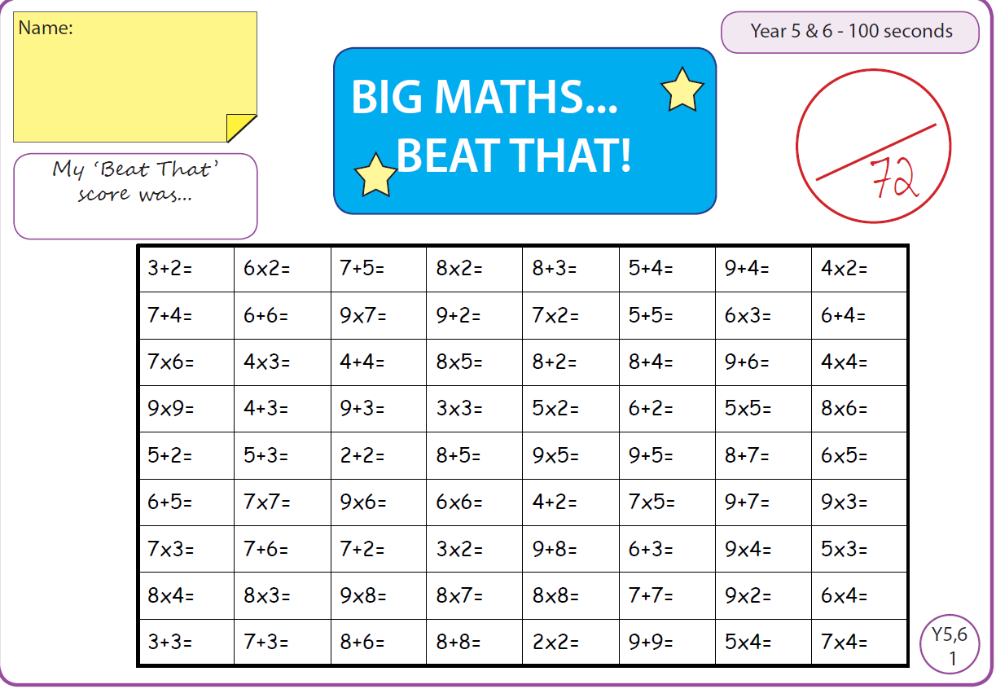

Tuesday
Time and Subject | Learning Objective | Task/Link/Resources
8.45-9.00  Reading | L.O: To practise and consolidate existing reading skills. | Read your individual reading book, either in your head or out loud.
9.00-9.15  Morning Maths | LO: To consolidate recall of number facts. | Complete today’s Beat That. You will find today’s Beat That below today’s timetable. Just scroll down! Remember, it is the same one every day for a week so try and beat your score each time!
9.15-9.45  Spelling | LO: To practice Unit One RWI Spelling words. | Speed write this week’s words- time yourself a minute for each! Check them and correct any mistakes.  Write them in different colours or fancy writing, make yourself a poster of each of the words! Circle the consonants and vowels.  Week 1 – bomb comb debt climb crumb doubt
9.45-10.00  Active break | L.O: To boost my concentration through movement. | https://www.youtube.com/watch?v=OPLWyZMRNn0  Join in with the Go Noodle clip above to get you moving!
10.00-11.00  English | LO: To investigate suffixes- tion, cian, sion, ssion. | Have a go at today’s lesson by clicking on the link below:  https://classroom.thenational.academy/lessons/to-investigate-suffixes-tion-cian-sion-ssion-c8up2c
11.00- 11.15
Break
11.15-12.15  Maths | LO: To use and explain addition and subtraction strategies. | Have a go at today’s lesson by clicking on the link below:  https://classroom.thenational.academy/lessons/using-and-explaining-addition-and-subtraction-strategies-6hk38c
12.15-1.00
Dinner
1.00-1.15  Storytime | LO: To listen to a story for pleasure. | Continue listening to Anne of Green Gables, remember where you get up to for tomorrow:  https://stories.audible.com/pdp/B01KGL13FI?ref=adbl_ent_anon_ds_pdp_pc_cntr-3-3
1.15-2.30  Topic  History | LO: To learn how Ancient Greece was organised. | Have a go at today’s lesson by clicking on the link below:  https://classroom.thenational.academy/lessons/how-was-ancient-greece-organised-6mv3jr
2.30-3.00  RHE | LO: To understand what community is. | Have a go at today’s lesson by clicking on the link below:  https://classroom.thenational.academy/lessons/community-care-cctp8c

Wednesday
Time and Subject | Learning Objective | Task/Link/Resources
8.45-9.00  Reading | L.O: To practise and consolidate existing reading skills. | Read your individual reading book, either in your head or out loud.
9.00-9.15  Morning Maths | LO: To consolidate recall of number facts. | Complete today’s Beat That. You will find today’s Beat That below today’s timetable. Just scroll down! Remember, it is the same one every day for a week so try and beat your score each time!
9.15-9.45  Spelling | LO: To practice Unit One RWI Spelling words. | Speed write this week’s words- time yourself a minute for each! Check them and correct any mistakes.  Write them in different colours or fancy writing, make yourself a poster of each of the words! Circle the consonants and vowels.  Week 1 – bomb comb debt climb crumb doubt
9.45-10.00  Active break | L.O: To boost my concentration through movement. | https://www.youtube.com/watch?v=7pUAdYWud10  Join in with the Go Noodle clip above to get you moving!
10.00-11.00  English | LO: To explore word class. | Have a go at today’s lesson by clicking on the link below:  https://classroom.thenational.academy/lessons/to-explore-word-class-68tkjc
11.00- 11.15
Break
11.15-12.15  Maths | LO: To add and subtract using multiples of 10, 100, 1000, 10 000 and 100 000. | Have a go at today’s lesson by clicking on the link below:  https://classroom.thenational.academy/lessons/adding-and-subtracting-using-multiples-of-10-100-1000-10-000-and-100-000-60upcc
12.15-1.00
Dinner
1.00-1.15  Storytime | LO: To listen to a story for pleasure. | Continue listening to Anne of Green Gables, remember where you get up to for next time:  https://stories.audible.com/pdp/B01KGL13FI?ref=adbl_ent_anon_ds_pdp_pc_cntr-3-3
1.15-2.30  Topic  History. | LO: To learn how we know about so much about Ancient Greece. | Have a go at today’s lesson by clicking on the link below:  https://classroom.thenational.academy/lessons/why-do-we-know-so-much-about-ancient-greece-75h6ce
2.30-3.00  Music | LO: To understand how to maintain the pulse using the voice and body. | https://classroom.thenational.academy/lessons/to-understand-how-to-maintain-the-pulse-using-the-voice-and-body-60up2d  Have a go at today’s lesson by clicking on the link above.
Thursday
Time and Subject | Learning Objective | Task/Link/Resources
8.45-9.00  Reading | L.O: To practise and consolidate existing reading skills. | Read your individual reading book, either in your head or out loud.
9.00-9.15  Morning Maths | LO: To consolidate recall of number facts. | Complete today’s Beat That. You will find today’s Beat That below today’s timetable. Just scroll down! Remember, it is the same one every day for a week so try and beat your score each time!
9.15-9.45  Spelling | LO: To practice Unit One RWI Spelling words. | Speed write this week’s words- time yourself a minute for each! Check them and correct any mistakes.  Write them in different colours or fancy writing, make yourself a poster of each of the words! Circle the consonants and vowels.  Week 1 – bomb comb debt climb crumb doubt
9.45-10.00  Active break | L.O: To boost my concentration through movement. | https://www.youtube.com/watch?v=Hl5dRW4E9hc  Join in with the Go Noodle clip above to get you moving!
10.00-11.00  English | LO: To analyse a film clip and generate vocabulary. | Have a go at today’s lesson by clicking on the link below:  https://classroom.thenational.academy/lessons/to-analyse-a-film-clip-and-generate-vocabulary-6nh3gr
11.00- 11.15
Break
11.15-12.15  Maths | LO: To add and subtract using the round and adjust strategy. | Have a go at today’s lesson by clicking on the link below:  https://classroom.thenational.academy/lessons/adding-and-subtracting-using-the-round-and-adjust-strategy-chk64e
12.15-1.00
Dinner
1.00-1.15  Storytime | LO: To listen to a story for pleasure. | Continue listening to Anne of Green Gables, remember where you get up to for next time:  https://stories.audible.com/pdp/B01KGL13FI?ref=adbl_ent_anon_ds_pdp_pc_cntr-3-3
1.15-2.30  Topic  History | LO: To learn about the most important contributions of the Ancient Greek. | Have a go at today’s lesson by clicking on the link below:  https://classroom.thenational.academy/lessons/what-was-the-golden-age-of-greece-68vpad
2.30-3.00  French | LO: To develop my vocabulary. | Follow the link below:  https://www.bbc.co.uk/teach/class-clips-video/french-ks2-modern-routines/zjynvk7
Friday
Time and Subject | Learning Objective | Task/Link/Resources
8.45-9.00  Reading | L.O: To practise and consolidate existing reading skills. | Read your individual reading book, either in your head or out loud.
9.00-9.15  Morning Maths | LO: To consolidate recall of number facts. | Complete today’s Beat That. You will find today’s Beat That below today’s timetable. Just scroll down! Remember, it is the same one every day for a week so try and beat your score each time!
9.15-9.45  Spelling | LO: To practice Unit One RWI Spelling words. | Speed write this week’s words- time yourself a minute for each! Check them and correct any mistakes.  Write them in different colours or fancy writing, make yourself a poster of each of the words! Circle the consonants and vowels.  Week 1 – bomb comb debt climb crumb doubt  Use the Look, Cover, Say, Write and Check grid at the bottom to test yourself!
9.45-10.00  Active break | L.O: To boost my concentration through movement. | https://www.youtube.com/watch?v=aEIpC4e2aBY  Join in with the Go Noodle clip above to get you moving!
10.00-11.00  English | LO: To develop a rich understanding of words associated with meals. | Have a go at today’s lesson by clicking on the link below:  https://classroom.thenational.academy/lessons/to-develop-a-rich-understanding-of-words-associated-with-meals-6mw68d
11.00- 11.15
Break
11.15-12.15  Maths | LO: To add and subtract using partitioning. | Have a go at today’s lesson by clicking on the link below:  https://classroom.thenational.academy/lessons/adding-and-subtracting-using-partitioning-61h3cd
12.15-1.00
Dinner
1.00-1.15  Storytime | LO: To listen to a story for pleasure. | Continue listening to Anne of Green Gables, remember where you get up to for next time:  https://stories.audible.com/pdp/B01KGL13FI?ref=adbl_ent_anon_ds_pdp_pc_cntr-3-3
1.15-3:00  Golden Time Art | LO: To create a landscape. | Enjoy creating a landscape using the link below:  https://www.bbc.co.uk/bitesize/clips/zdsb9j6
