Time and Subject  Monday | Learning Objective | Task/Link/Resources
8.45-9.00  Reading | LO: To practise and consolidate existing reading skills. | Read your individual reading book, either in your head or out loud.
9.00-9.15  Morning Maths | LO: To consolidate recall of number facts.  Revision LO: To find the perimeter of a rectangle. | Complete today’s Beat That- scroll down below today’s timetable to find the questions. Remember, it is the same one every day for a week. Can you beat your own score?  Morning Maths: In Morning Maths today, you are going to revise your knowledge of measure. Click the link below and select the video Perimeter of a rectangle.  Week 9 - Measurement: Length & Perimeter | White Rose Maths
9.15-9.45  Spelling | LO: To practise Unit 12 RWI spelling words. | This week, we are going to practise adding ir- to words beginning with r. Watch this video to help you to learn this spelling rule:  English KS2: Prefixes - BBC Teach  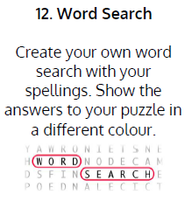  Use Word Search to practise spelling this week’s words:  irregular, irresistible, irrelevant, irresponsible
9.45-10.00  Active break | LO: To boost my concentration through movement. | Join in with the brain break to get you moving!  https://www.bbc.co.uk/teach/supermovers/just-for-fun-the-next-step-l1/zhy2cqt
10.00-11.00  English | SPaG LO: To use standard English.  LO: To engage with a text. | For today’s SPaG Daily Practice, follow the link below to practise using standard English:  KS2 Standard English | How to use Formal or Informal Writing (educationquizzes.com)  Follow the link below to have a go at today’s English lesson:  To engage with a text (thenational.academy)
11.00- 11.15
Break
11.15-12.15  Maths | LO: To practise my recall of the 7 times table.  LO: To compare two unit fractions using an area model. | Follow the link below to practise the 7 times table and get moving!  https://www.bbc.co.uk/teach/supermovers/ks2-maths-the-7-times-table-with-moonbeam/zjp8y9q  Follow the link below to have a go at today’s maths lesson:  What do you notice when comparing two unit fractions using an area model? (thenational.academy)
12.15-1.00
Dinner
1.00-1.15  Storytime | LO: To listen to a story for pleasure. | Listen to Chapter 5 of Jukebox Joyride.  Audible Stories: Free Audiobooks for Kids | Audible.com
1.15-2.30  Topic-  History | LO: To understand what the Romans believed. | Follow the link to watch the video for today’s lesson:  What did the Romans believe? (thenational.academy)

Beat That!
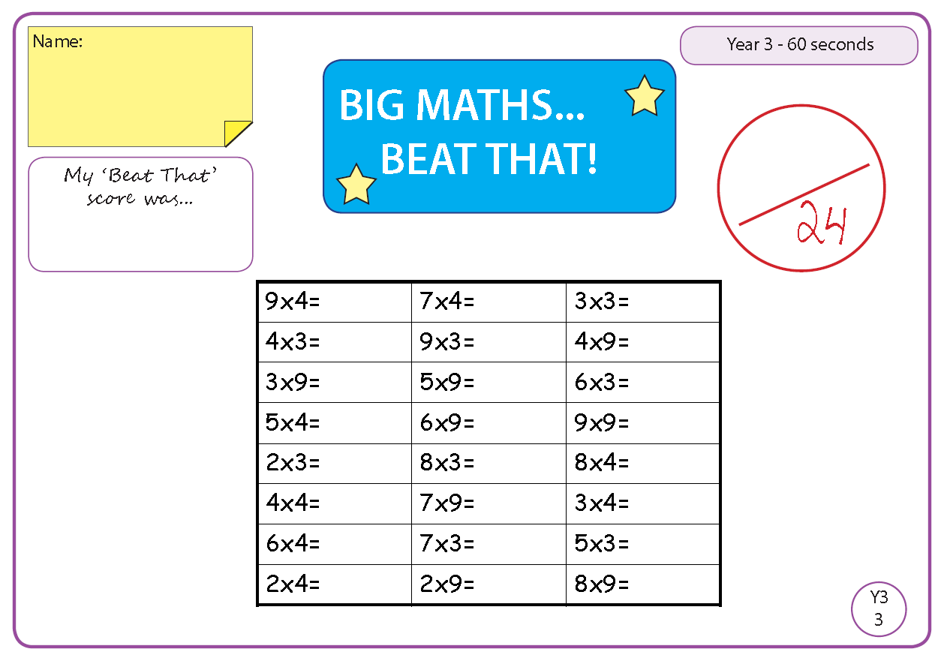

Time and Subject  Tuesday | Learning Objective | Task/Link/Resources
8.45-9.00  Reading | L.O: To practise and consolidate existing reading skills. | Read your individual reading book, either in your head or out loud.
9.00-9.15  Morning Maths | LO: To consolidate recall of number facts.  Revision LO: To find the perimeter of rectilinear shapes. | Complete today’s Beat That- scroll down below today’s timetable to find the questions. Remember, it is the same one every day for a week. Can you beat your own score?  Morning Maths: In Morning Maths today, you are going to revise your knowledge of measure. Click the link below and select the video Perimeter of rectilinear shapes.  Week 9 - Measurement: Length & Perimeter | White Rose Maths
9.15-9.45  Spelling | LO: To practise Unit 12 RWI spelling words. | 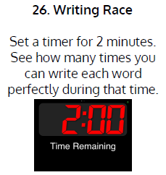  This week, we are going to practise adding ir- to words beginning with r.  Use Writing Race to practise spelling this week’s words:  irregular, irresistible, irrelevant, irresponsible
9.45-10.00  Active break | L.O: To boost my concentration through movement. | Join in with the brain break to get you moving!  https://www.bbc.co.uk/teach/supermovers/just-for-fun-blue-planet-ii-l1/zfkf7nb
10.00-11.00  English | SPaG LO: To use standard English.  LO: To read and answer questions on a text. | For today’s SPaG Daily Practice, have a go at the question below.  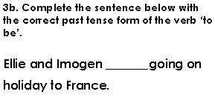  Follow the link below to have a go at today’s English lesson:  To read and answer questions on a text (Part 1) (thenational.academy)
11.00- 11.15
Break
11.15-12.15  Maths | LO: To practise my recall of the 7 times table.  LO: To compare two unit fractions on a number line. | Follow the link below to practise the 7 times table:  https://www.timestables.co.uk/7-times-table.html  Follow the link below to have a go at today’s maths lesson:  What do you notice when comparing two unit fractions on a numberline? (thenational.academy)
12.15-1.00
Dinner
1.00-1.15  Storytime | LO: To listen to a story for pleasure. | Listen to Chapter 6 of Jukebox Joyride.  Audible Stories: Free Audiobooks for Kids | Audible.com
1.15-2.30  Topic-  History. | LO: To explore how Roman beliefs were similar to those of the Ancient Greeks. | Follow the link below to have a go at today’s lesson:  How were Roman beliefs similar to those of the Ancient Greeks? (thenational.academy)
2.30-3.00  French | LO: To practise naming colours in French. | Follow the link below to have a go at today’s lesson:  Colours - KS2 French - BBC Bitesize - BBC Bitesize

Beat That!

Time and Subject  Wednesday | Learning Objective | Task/Link/Resources
8.45-9.00  Reading | L.O: To practise and consolidate existing reading skills. | Read your individual reading book, either in your head or out loud.
9.00-9.15  Morning Maths | LO: To consolidate recall of number facts.  Revision LO: To multiply by 10. | Complete today’s Beat That- scroll down below today’s timetable to find the questions. Remember, it is the same one every day for a week. Can you beat your own score?  Morning Maths: In Morning Maths today, you are going to revise your knowledge of measure. Click the link below and select the video Multiply by 10.  Week 10 - Number: Multiplication & Division | White Rose Maths
9.15-9.45  Spelling | LO: To practise Unit 12 RWI spelling words. | 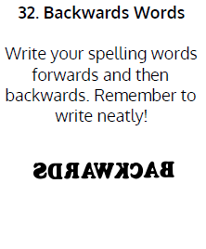  This week, we are going to practise adding ir- to words beginning with r.  Use Backwards Words to practise spelling this week’s words:  irregular, irresistible, irrelevant, irresponsible
9.45-10.00  Active break | LO: To boost my concentration through movement. | Join in with the brain break to get you moving!  https://www.bbc.co.uk/teach/supermovers/just-for-fun-homebros-l1/z6cpwty
10.00-11.00  English | SPaG LO: To use standard English.  LO: To read and answer questions on a text. | For today’s SPaG Daily Practice, have a go at the question below:  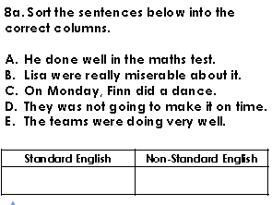  Follow the link below to have a go at today’s English lesson:  To read and answer questions on a text (Part 2) (thenational.academy)
11.00- 11.15
Break
11.15-12.15  Maths | LO: To practise my recall of the 7 times table.  LO: To compare two non-unit fractions with the same numerator. | Follow the link below to practise the 7 times table and get moving!  https://www.youtube.com/watch?v=psDIXscv2G0  Follow the link below to have a go at today’s maths lesson:  Use What You Know to Compare Two Non-Unit Fractions With the Same Numerator (thenational.academy)
12.15-1.00
Dinner
1.00-1.15  Storytime | LO: To listen to a story for pleasure. | Listen to Chapter 7 of Jukebox Joyride.  Audible Stories: Free Audiobooks for Kids | Audible.com
1.15-2.30  Topic- History. | LO: To understand why the Romans left Britain. | Follow the link to have a go at today’s lesson:  Why did the Romans leave Britain? (thenational.academy)
2.30-3.00  RHE | LO: To explore interest rates. | Follow the link to have a go at today’s lesson:  Growing money (thenational.academy)

Beat That!

Time and Subject  Thursday | Learning Objective | Task/Link/Resources
8.45-9.00  Reading | L.O: To practise and consolidate existing reading skills. | Read your individual reading book, either in your head or out loud.
9.00-9.15  Morning Maths | LO: To consolidate recall of number facts.  Revision LO: To multiply by 100. | Complete today’s Beat That- scroll down below today’s timetable to find the questions. Remember, it is the same one every day for a week. Can you beat your own score?  Morning Maths: In Morning Maths today, you are going to revise your knowledge of measure. Click the link below and select the video Multiply by 100.  Week 10 - Number: Multiplication & Division | White Rose Maths
9.15-9.45  Spelling | LO: To practise Unit 12 RWI spelling words. | This week, we are going to practise adding ir- to words beginning with r.  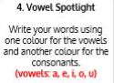  Use Vowel Spotlight to practise spelling this week’s words:  irregular, irresistible, irrelevant, irresponsible
9.45-10.00  Active break | LO: To boost my concentration through movement. | Join in with the brain break to get you moving!  https://www.bbc.co.uk/teach/supermovers/just-for-fun-match-of-the-Day-l1/z6dy2sg
10.00-11.00  English | SPaG LO: To use standard English.  LO: To read and answer questions on a text. | For today’s SPaG Daily Practice, have a go at the question below.  Follow the link below to have a go at today’s English lesson:  To read and answer questions on a text (Part 3) (thenational.academy)
11.00- 11.15
Break
11.15-12.15  Maths | LO: To practise my recall of the 7 times table.  LO: To understand what factors are. | Follow the link below to practise the 7 times table:  http://www.snappymaths.com/multdiv/7xtable/interactive/newlook/7xtablebtcd.htm  Follow the link below to have a go at today’s lesson:  What are factors? - BBC Bitesize
12.15-1.00
Dinner
1.00-1.15  Storytime | LO: To listen to a story for pleasure. | Listen to Chapter 8 of Jukebox Joyride.  Audible Stories: Free Audiobooks for Kids | Audible.com
1.15-3.00  PE | LO: To build strength and stamina. | Follow the link to have a go at today’s PE activity:  'AVENGERS INFINITY WAR TRAINING ACADEMY' - TONY STARK HIIT WORKOUT - YouTube

Beat That!

Time and Subject  Friday | Learning Objective | Task/Link/Resources
8.45-9.00  Reading | L.O: To practise and consolidate existing reading skills. | Read your individual reading book, either in your head or out loud.
9.00-9.15  Morning Maths | LO: To consolidate recall of number facts.  Revision LO:  To divide by 10. | Complete today’s Beat That- scroll down below today’s timetable to find the questions. Remember, it is the same one every day for a week. Can you beat your own score?  Morning Maths: In Morning Maths today, you are going to revise your knowledge of measure. Click the link below and select the video Divide by 10.  Week 10 - Number: Multiplication & Division | White Rose Maths
9.15-9.45  Spelling | LO: To practise Unit 12 RWI spelling words. | This week, we are going to practise adding ir- to words beginning with r.  Use Bubble Letters to practise spelling this week’s words:  irregular, irresistible, irrelevant, irresponsible  Spelling Test:  Scroll down below today’s timetable to use the look, cover, write, check sheet to help you to test yourself on this week’s words.
9.45-10.00  Active break | L.O: To boost my concentration through movement. | Join in with the brain break to get you moving!  https://www.bbc.co.uk/teach/supermovers/just-for-fun-springwatch-l1/z6f7rj6
10.00-11.00  English | SPaG LO: To use standard English.  LO: To engage with the text. | For today’s SPaG Daily Practice, have a go at the question below:  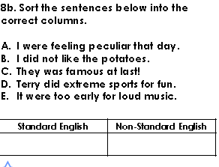  Follow the link below to have a go at today’s lesson:  To engage with the text and to complete an independent activity (thenational.academy)
11.00- 11.15
Break
11.15-12.15  Maths | LO: To practise my recall of the 7 times table.  LO: To explore number sequences. | Follow the link below to practise the 7 times table:  http://www.snappymaths.com/multdiv/7xtable/interactive/newlook/7xmissintd.htm  Follow the link below to have a go at today’s lesson:  What is a number sequence? - BBC Bitesize
12.15-1.00
Dinner
1.00-1.15  Storytime | LO: To listen to a story for pleasure. | Listen to Chapter 9 of Jukebox Joyride.  Audible Stories: Free Audiobooks for Kids | Audible.com
1.15-3:00  Mindfulness | LO: To practise mindfulness. | Have a go at this meditation:  https://family.gonoodle.com/activities/lets-unwind  Have a go at creating some mindfulness art:  https://www.youtube.com/watch?v=qBwHUKHUdD8  Have a go at this relaxing Yoga session:  https://www.youtube.com/watch?v=bRgvrnuijdE

Beat That!
Spelling Test
