Time and Subject  Monday | Learning Objective | Task/Link/Resources
8.45-9.00  Reading | LO: To practise and consolidate existing reading skills. | Read your individual reading book, either in your head or out loud.
9.00-9.15  Morning Maths | LO: To consolidate recall of number facts.  Revision LO: To solve mixed addition and subtraction problems. | Complete today’s Beat That- scroll down below today’s timetable to find the questions. Remember, it is the same one every day for a week. Can you beat your own score?  Morning Maths: In Morning Maths today, you are going to revise your knowledge of addition and subtraction. Click the link below and select the video Mixed addition and subtraction problems.  https://whiterosemaths.com/homelearning/year-3/week-6-number-addition-subtraction/
9.15-9.45  Spelling | LO: To practise Unit Twelve RWI spelling words. | This week, we are going to practise adding the prefix anti-.  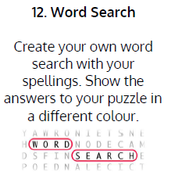  Use Word Search to practise spelling this week’s words:  antibiotic, antifreeze, antisocial, anticlockwise, anticlimax, antiseptic
9.45-10.00  Active break | LO: To boost my concentration through movement. | Join in with the brain break to get you moving!  https://www.bbc.co.uk/teach/supermovers/just-for-fun-the-next-step-l1/zhy2cqt
10.00-11.00  English | SPaG LO: To use standard English.  LO: To engage with a text. | For today’s SPaG Daily Practice, follow the link below to practise using standard English:  KS2 Standard English | How to use Formal or Informal Writing (educationquizzes.com)  Follow the link below to have a go at today’s English lesson:  To identify the features of an explanation text (thenational.academy)
11.00- 11.15
Break
11.15-12.15  Maths | LO: To practise my recall of the 8 times table.  LO: To compare the size of parts when the whole is defined using familiar context. | Follow the link below to practise the 8 times table and get moving!  8 Times Table Song (Learning is Fun The Todd & Ziggy Way!) - YouTube  Follow the link below to have a go at today’s maths lesson:  Compare the size of parts when the whole is defined using familiar contexts (thenational.academy)
12.15-1.00
Dinner
1.00-1.15  Storytime | LO: To listen to a story for pleasure. | Listen to Chapter 6 of Sovereign:  Audible Stories: Free Audiobooks for Kids | Audible.com
1.15-2.30  Topic-  RHE | LO: To understand why we have money. | Follow the link to watch the video for today’s lesson:  Money, money, money (thenational.academy)

Beat That!
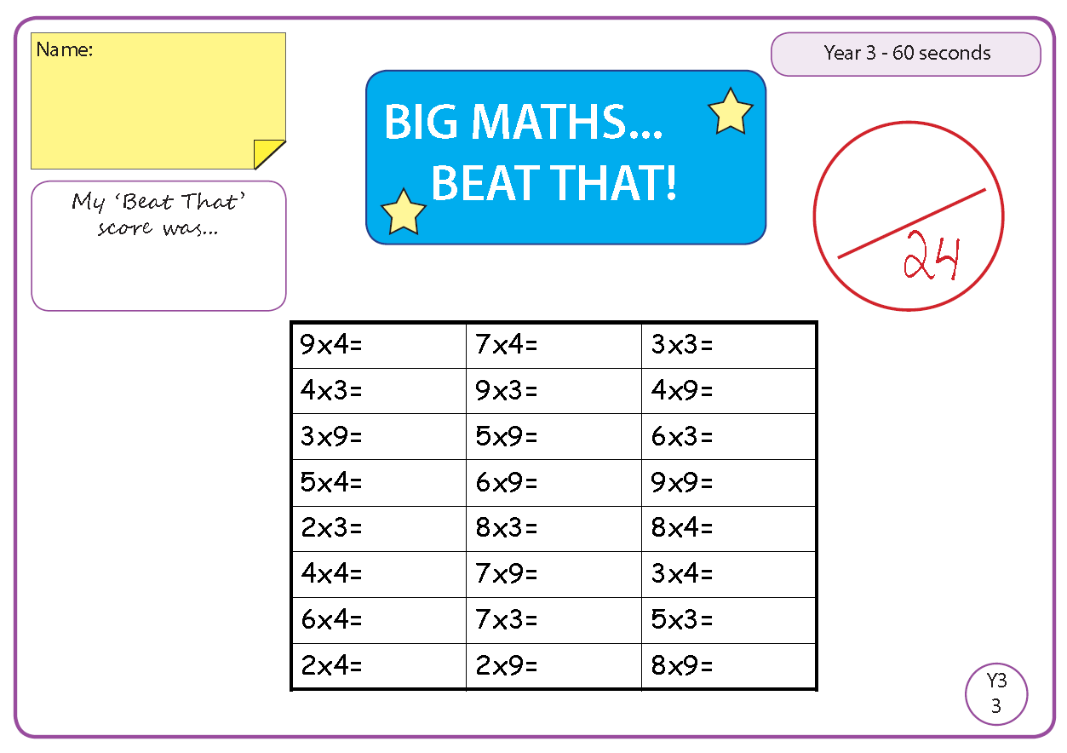

Time and Subject  Tuesday | Learning Objective | Task/Link/Resources
8.45-9.00  Reading | L.O: To practise and consolidate existing reading skills. | Read your individual reading book, either in your head or out loud.
9.00-9.15  Morning Maths | LO: To consolidate recall of number facts.  Revision LO: To add and subtract 2-digit and 3-digit numbers. | Complete today’s Beat That- scroll down below today’s timetable to find the questions. Remember, it is the same one every day for a week. Can you beat your own score?  Morning Maths: In Morning Maths today, you are going to revise your knowledge of addition and subtraction. Click the link below and select the video Add and subtract 2-digit and 3-digit numbers - not crossing 10 or 100.  Week 7 - Number: Addition & Subtraction | White Rose Maths
9.15-9.45  Spelling | LO: To practise Unit Twelve RWI spelling words. | 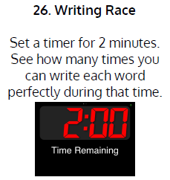  This week, we are going to practise adding the prefix anti-.  Use Writing Race to practise spelling this week’s words:  antibiotic, antifreeze, antisocial, anticlockwise, anticlimax, antiseptic
9.45-10.00  Active break | L.O: To boost my concentration through movement. | Join in with the brain break to get you moving!  https://www.bbc.co.uk/teach/supermovers/just-for-fun-blue-planet-ii-l1/zfkf7nb
10.00-11.00  English | SPaG LO: To use standard English.  LO: To explore compound words. | For today’s SPaG Daily Practice, have a go at the question below.  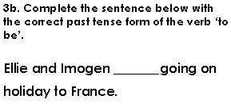  Follow the link below to have a go at today’s English lesson:  To explore compound words (thenational.academy)
11.00- 11.15
Break
11.15-12.15  Maths | LO: To practise my recall of the 8 times table.  LO: To explore that size of part is relative to the size of the whole using familiar contexts. | Follow the link below to practise the 8 times table:  8x Table Practice (snappymaths.com)  Follow the link below to have a go at today’s maths lesson:  Explore that size of part is relative to the size of the whole using familiar contexts (thenational.academy)
12.15-1.00
Dinner
1.00-1.15  Storytime | LO: To listen to a story for pleasure. | Listen to Chapter 7 of Sovereign:  Audible Stories: Free Audiobooks for Kids | Audible.com
1.15-2.30  Topic-  RHE | LO: To explore interest rates. | Follow the link below to have a go at today’s lesson:  Growing money (thenational.academy)
2.30-3.00  French | LO: To practise naming colours in French. | Follow the link below to have a go at today’s lesson:  Colours - KS2 French - BBC Bitesize - BBC Bitesize

Beat That!

Time and Subject  Wednesday | Learning Objective | Task/Link/Resources
8.45-9.00  Reading | L.O: To practise and consolidate existing reading skills. | Read your individual reading book, either in your head or out loud.
9.00-9.15  Morning Maths | LO: To consolidate recall of number facts.  Revision LO: To add 2-digit and 3-digit numbers. | Complete today’s Beat That- scroll down below today’s timetable to find the questions. Remember, it is the same one every day for a week. Can you beat your own score?  Morning Maths: In Morning Maths today, you are going to revise your knowledge of addition. Click the link below and select the video Add 2-digit and 3-digit numbers - crossing 10 or 100.  Week 7 - Number: Addition & Subtraction | White Rose Maths
9.15-9.45  Spelling | LO: To practise Unit Twelve RWI spelling words. | 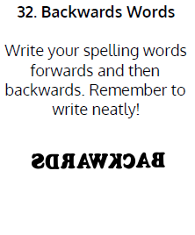  This week, we are going to practise adding the prefix anti-.  Use Backwards Words to practise spelling this week’s words:  antibiotic, antifreeze, antisocial, anticlockwise, anticlimax, antiseptic
9.45-10.00  Active break | LO: To boost my concentration through movement. | Join in with the brain break to get you moving!  https://www.bbc.co.uk/teach/supermovers/just-for-fun-homebros-l1/z6cpwty
10.00-11.00  English | SPaG LO: To use standard English.  LO: To explore using apostrophes for plural possession. | For today’s SPaG Daily Practice, have a go at the question below:  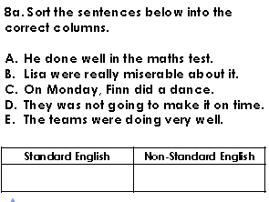  Follow the link below to have a go at today’s English lesson:  To explore using apostrophes for plural possession (thenational.academy)
11.00- 11.15
Break
11.15-12.15  Maths | LO: To practise my recall of the 8 times table.  LO: To consider part whole relationships within the context of quantity models. | Follow the link below to practise the 8 times table:  https://www.timestables.co.uk/8-times-table.html  Follow the link below to have a go at today’s maths lesson:  Consider part whole relationships within the context of quantity models (thenational.academy)
12.15-1.00
Dinner
1.00-1.15  Storytime | LO: To listen to a story for pleasure. | Listen to Chapter 8 of Sovereign:  Audible Stories: Free Audiobooks for Kids | Audible.com
1.15-3.00  RHE | LO: To explore gender stereotypes. | Follow the link to have a go at today’s lesson:  Men and women at work (thenational.academy)

Beat That!

Time and Subject  Thursday | Learning Objective | Task/Link/Resources
8.45-9.00  Reading | L.O: To practise and consolidate existing reading skills. | Read your individual reading book, either in your head or out loud.
9.00-9.15  Morning Maths | LO: To consolidate recall of number facts.  Revision LO: To subtract a 2-digit number from a 3-digit number. | Complete today’s Beat That- scroll down below today’s timetable to find the questions. Remember, it is the same one every day for a week. Can you beat your own score?  Morning Maths: In Morning Maths today, you are going to revise your knowledge of subtraction. Click the link below and select the video Subtract a 2-digit number from a 3-digit number - crossing 10 or 100.  Week 7 - Number: Addition & Subtraction | White Rose Maths
9.15-9.45  Spelling | LO: To practise Unit Twelve RWI spelling words. | This week, we are going to practise adding the prefix anti-.  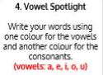  Use Vowel Spotlight to practise spelling this week’s words:  antibiotic, antifreeze, antisocial, anticlockwise, anticlimax, antiseptic
9.45-10.00  Active break | LO: To boost my concentration through movement. | Join in with the brain break to get you moving!  https://www.bbc.co.uk/teach/supermovers/just-for-fun-match-of-the-Day-l1/z6dy2sg
10.00-11.00  English | SPaG LO: To use standard English.  LO: To understand and sequence how bees make honey. | For today’s SPaG Daily Practice, have a go at the question below.  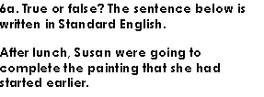  Follow the link below to have a go at today’s English lesson:  To understand and sequence how bees make honey (thenational.academy)
11.00- 11.15
Break
11.15-12.15  Maths | LO: To practise my recall of the 8 times table.  LO: To build a whole when a part is known. | Follow the link below to practise the 8 times table and get moving!  https://www.bbc.co.uk/teach/supermovers/ks2-maths-the-8-times-table-with-filbert-fox/z4mrhbk  Follow the link below to have a go at today’s lesson:  Build a whole when a part is known (thenational.academy)
12.15-1.00
Dinner
1.00-1.15  Storytime | LO: To listen to a story for pleasure. | Listen to Chapter 9 of Sovereign:  Audible Stories: Free Audiobooks for Kids | Audible.com
1.15-3.00  PE | LO: To build strength and stamina. | Follow the link to have a go at today’s PE activity:  'AVENGERS INFINITY WAR TRAINING ACADEMY' - TONY STARK HIIT WORKOUT - YouTube

Beat That!

Time and Subject  Friday | Learning Objective | Task/Link/Resources
8.45-9.00  Reading | L.O: To practise and consolidate existing reading skills. | Read your individual reading book, either in your head or out loud.
9.00-9.15  Morning Maths | LO: To consolidate recall of number facts.  Revision LO:  To add two 3-digit numbers. | Complete today’s Beat That- scroll down below today’s timetable to find the questions. Remember, it is the same one every day for a week. Can you beat your own score?  Morning Maths: In Morning Maths today, you are going to revise your knowledge of subtraction. Click the link below and select the video Add two 3-digit numbers - not crossing 10 or 100.  Week 7 - Number: Addition & Subtraction | White Rose Maths
9.15-9.45  Spelling | LO: To practise Unit Twelve RWI spelling words. | This week, we are going to practise adding the prefix anti-.  Use Bubble Letters to practise spelling this week’s words:  antibiotic, antifreeze, antisocial, anticlockwise, anticlimax, antiseptic  Spelling Test:  Scroll down below today’s timetable to use the look, cover, write, check sheet to help you to test yourself on this week’s words.
9.45-10.00  Active break | L.O: To boost my concentration through movement. | Join in with the brain break to get you moving!  https://www.bbc.co.uk/teach/supermovers/just-for-fun-springwatch-l1/z6f7rj6
10.00-11.00  English | SPaG LO: To use standard English.  LO: To develop a rich understanding of words associated with trying hard. | For today’s SPaG Daily Practice, have a go at the question below:  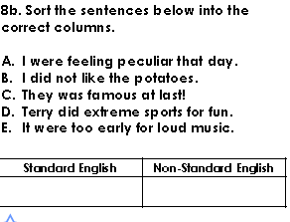  Follow the link below to have a go at today’s lesson:  To develop a rich understanding of words associated with trying hard (thenational.academy)
11.00- 11.15
Break
11.15-12.15  Maths | LO: To practise my recall of the 8 times table.  LO: To explore different contexts for building a whole when a part is known. | Follow the link below to practise the 8 times table:  http://www.snappymaths.com/multdiv/8xtable/interactive/newlook/8xmissintd.htm  Follow the link below to have a go at today’s lesson:  Explore different contexts for building a whole when a part is known (thenational.academy)
12.15-1.00
Dinner
1.00-1.15  Storytime | LO: To listen to a story for pleasure. | Listen to Chapter 10 of Sovereign:  Audible Stories: Free Audiobooks for Kids | Audible.com
1.15-3:00  Mindfulness | LO: To practise mindfulness. | Have a go at this meditation:  https://family.gonoodle.com/activities/lets-unwind  Have a go at creating some mindfulness art:  https://www.youtube.com/watch?v=qBwHUKHUdD8  Have a go at this relaxing Yoga session:  https://www.youtube.com/watch?v=bRgvrnuijdE

Beat That!
Spelling Test
