Time and Subject  Monday | Learning Objective | Task/Link/Resources
8.45-9.00  Reading | LO: To practise and consolidate existing reading skills. | Read your individual reading book, either in your head or out loud.
9.00-9.15  Morning Maths | LO: To consolidate recall of number facts.  Revision LO: To find equivalent lengths. | Complete today’s Beat That- scroll down below today’s timetable to find the questions. Remember, it is the same one every day for a week. Can you beat your own score?  Morning Maths: In Morning Maths today, you are going to revise your knowledge of measure. Click the link below and select the video Equivalent lengths mm and cm.  Week 8 - Measurement: Length & Perimeter | White Rose Maths
9.15-9.45  Spelling | LO: To practise Year 3/4 Common Exception Words. | This week, we are going to practise some of our tricky orange words.  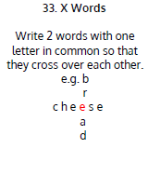  Use X Words to practise spelling this week’s words:  purpose, promise, quarter, question, recent, regular, reign, remember, sentence, separate
9.45-10.00  Active break | LO: To boost my concentration through movement. | Join in with this brain break to get you moving!  https://www.bbc.co.uk/teach/supermovers/just-for-fun-the-vamps-l1/z48y2sg
10.00-11.00  English | SPaG LO: To identify modifying adjectives and nouns.  LO: To write the climax. | For today’s SPaG Daily Practice, watch this video to learn about modifying adjectives and nouns:  Modifying Nouns with Adjectives and Nouns - YouTube  Follow the link below to have a go at today’s English lesson:  To write the climax (thenational.academy)
11.00- 11.15
Break
11.15-12.15  Maths | LO: To practise my recall of the 9 times table.  LO: To begin to compare non-unit fractions. | Follow the link below to practise the 9 times table and get moving!  https://www.bbc.co.uk/teach/supermovers/ks2-maths-the-9-times-table/zr2gt39  Follow the link below to have a go at today’s maths lesson:  Beginning to compare non-unit fractions (thenational.academy)
12.15-1.00
Dinner
1.00-1.15  Storytime | LO: To listen to a story for pleasure. | Listen to Chapter 17 of House of Teeth.  Audible Stories: Free Audiobooks for Kids | Audible.com
1.15-2.30  Topic-  History | LO: To explore how the Romans conquered Britain. | Follow the link below to have a go at today’s lesson:  How did the Romans conquer Britain? (thenational.academy)

Beat That!
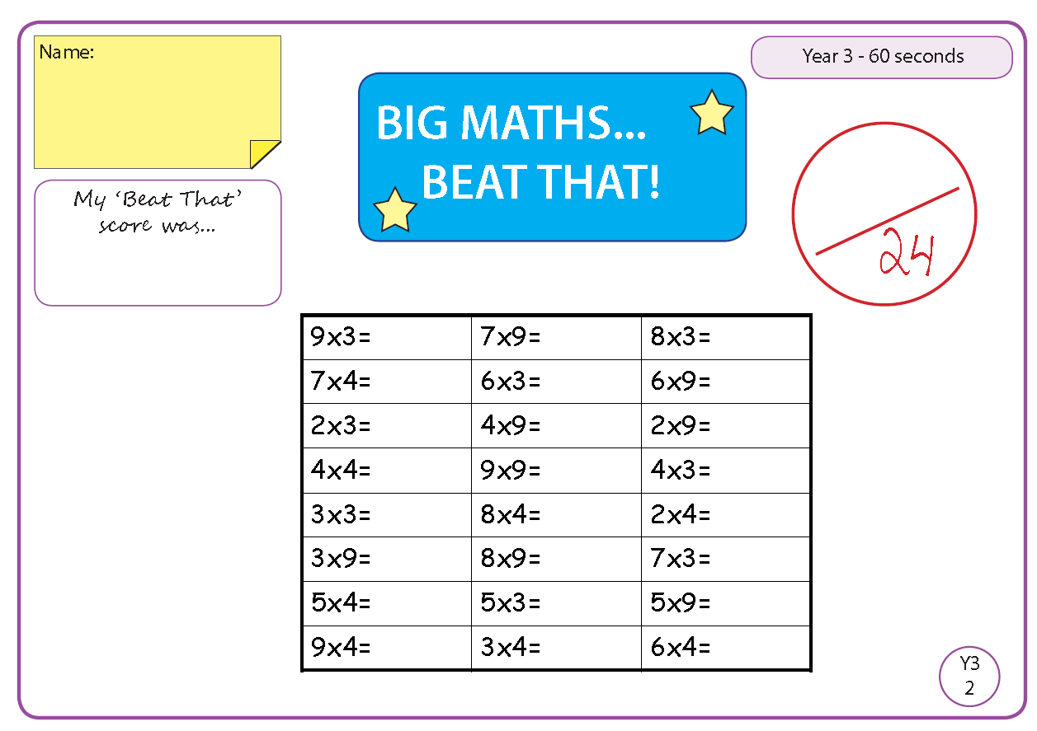

Time and Subject  Tuesday | Learning Objective | Task/Link/Resources
8.45-9.00  Reading | L.O: To practise and consolidate existing reading skills. | Read your individual reading book, either in your head or out loud.
9.00-9.15  Morning Maths | LO: To consolidate recall of number facts.  Revision LO: To use kilometres. | Complete today’s Beat That- scroll down below today’s timetable to find the questions. Remember, it is the same one every day for a week. Can you beat your own score?  Morning Maths: In Morning Maths today, you are going to revise your knowledge of measure. Click the link below and select the video Kilometres.  Week 8 - Measurement: Length & Perimeter | White Rose Maths
9.15-9.45  Spelling | LO: To practise Year 3/4 Common Exception Words. | This week, we are going to practise some of our tricky orange words.  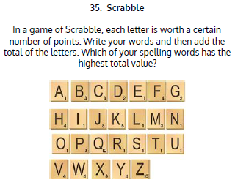  Use Scrabble to practise spelling this week’s words:  purpose, promise, quarter, question, recent, regular, reign, remember, sentence, separate
9.45-10.00  Active break | L.O: To boost my concentration through movement. | Join in with this brain break to get you moving!  https://www.bbc.co.uk/teach/supermovers/just-for-fun-danger-mouse-l1/z6mcpg8
10.00-11.00  English | SPaG LO: To identify modifying adjectives and nouns.  LO: To practise and apply knowledge of double consonants. | For today’s SPaG Daily Practice, revise your knowledge of modifying adjectives and nouns by answering the question below:  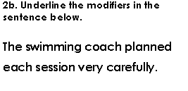  Follow the link below to have a go at today’s English lesson:  To practise and apply knowledge of double consonants (thenational.academy)
11.00- 11.15
Break
11.15-12.15  Maths | LO: To practise my recall of the 9 times table.  LO: To compare two fractions using equivalence to 1 whole. | Follow the link below to practise the 9 times table:  https://www.timestables.co.uk/9-times-table.html  Follow the link below to have a go at today’s maths lesson:  Using Equivalence to 1 to Compare Non-Unit Fractions (thenational.academy)
12.15-1.00
Dinner
1.00-1.15  Storytime | LO: To listen to a story for pleasure. | Listen to Chapter 1 of Jukebox Joyride.  Audible Stories: Free Audiobooks for Kids | Audible.com
1.15-2.30  Topic-  History | LO: To understand why Boudicca lead a revolt against the Romans. | Follow the link below to have a go at today’s lesson:  Why did Boudicca lead a revolt against the Romans? (thenational.academy)
2.30-3.00  French | LO: To name learn how to talk about what clothes you are wearing in French. | Follow the link below to have a go at today’s lesson:  Clothes and Accessories - KS2 French - BBC Bitesize - BBC Bitesize

Beat That!

Time and Subject  Wednesday | Learning Objective | Task/Link/Resources
8.45-9.00  Reading | L.O: To practise and consolidate existing reading skills. | Read your individual reading book, either in your head or out loud.
9.00-9.15  Morning Maths | LO: To consolidate recall of number facts.  Revision LO: To add lengths. | Complete today’s Beat That- scroll down below today’s timetable to find the questions. Remember, it is the same one every day for a week. Can you beat your own score?  Morning Maths: In Morning Maths today, you are going to revise your knowledge of measure. Click the link below and select the video Add lengths.  Week 8 - Measurement: Length & Perimeter | White Rose Maths
9.15-9.45  Spelling | LO: To practise Year 3/4 Common Exception Words. | This week, we are going to practise some of our tricky orange words.  Use Rainbow Words to practise spelling this week’s words:  purpose, promise, quarter, question, recent, regular, reign, remember, sentence, separate
9.45-10.00  Active break | LO: To boost my concentration through movement. | Join in with this brain break to get you moving!  https://www.bbc.co.uk/teach/supermovers/just-for-fun-alex-scott-l1/zj4pwty
10.00-11.00  English | SPaG LO: To identify modifying adjectives and nouns.  LO: To generate vocabulary for the ending. | For today’s SPaG Daily Practice, revise your knowledge of modifying adjectives and nouns by answering the question below:  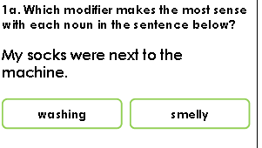  Follow the link below to have a go at today’s English lesson:  To generate vocabulary for the ending (thenational.academy)
11.00- 11.15
Break
11.15-12.15  Maths | LO: To practise my recall of the 9 times table.  LO: To compare two fractions with the same denominator. | Follow the link below to practise the 9 times table and get moving!  https://www.youtube.com/watch?v=3p-ZIcTxtxw  Follow the link below to have a go at today’s maths lesson:  Use Several Methods to Compare Two Fractions with the Same Denominator (thenational.academy)
12.15-1.00
Dinner
1.00-1.15  Storytime | LO: To listen to a story for pleasure. | Listen to Chapter 2 of Jukebox Joyride.  Audible Stories: Free Audiobooks for Kids | Audible.com
1.15-2.30  Topic- History. | LO: To understand how the Romans changed Britain. | Follow the link to have a go at today’s lesson:  How did the Romans change Britain? (thenational.academy)
2.30-3.00  RHE | LO: To understand how jobs are categorised. | Follow the link to have a go at today’s lesson:  Employment (thenational.academy)

Beat That!

Time and Subject  Thursday | Learning Objective | Task/Link/Resources
8.45-9.00  Reading | L.O: To practise and consolidate existing reading skills. | Read your individual reading book, either in your head or out loud.
9.00-9.15  Morning Maths | LO: To consolidate recall of number facts.  Revision LO: To subtract lengths. | Complete today’s Beat That- scroll down below today’s timetable to find the questions. Remember, it is the same one every day for a week. Can you beat your own score?  Morning Maths: In Morning Maths today, you are going to revise your knowledge of measure. Click the link below and select the video Subtract lengths.  Week 8 - Measurement: Length & Perimeter | White Rose Maths
9.15-9.45  Spelling | LO: To practise Year 3/4 Common Exception Words. | week, we are going to practise some of our tricky orange words.  Use Rainbow Words to practise spelling this week’s words:  purpose, promise, quarter, question, recent, regular, reign, remember, sentence, separate
9.45-10.00  Active break | LO: To boost my concentration through movement. | Join in with this brain break to get you moving!  https://www.bbc.co.uk/teach/supermovers/pshe-super-mood-movers-giving-something-back/zjwyp4j
10.00-11.00  English | SPaG LO: To identify modifying adjectives and nouns.  LO: To plan the ending. | For today’s SPaG Daily Practice, revise your knowledge of modifying adjectives and nouns by answering the question below:  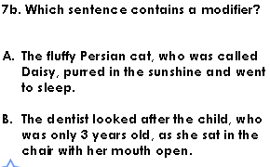  Follow the link below to have a go at today’s English lesson:  To plan the ending (thenational.academy)
11.00- 11.15
Break
11.15-12.15  Maths | LO: To practise my recall of the 9 times table.  LO: To compare fractions with the same denominator. | Follow the link below to practise the 9 times table:  http://www.snappymaths.com/multdiv/9xtable/interactive/newlook/9xmissintd.htm  Follow the link below to have a go at today’s lesson:  Can We Easily Compare Two Fractions With the Same Denominator? (thenational.academy)
12.15-1.00
Dinner
1.00-1.15  Storytime | LO: To listen to a story for pleasure. | Listen to Chapter 3 of Jukebox Joyride.  Audible Stories: Free Audiobooks for Kids | Audible.com
1.15-3.00  PE | LO: To build strength and stamina. | Follow the link to have a go at today’s PE activity:  HARRY POTTER 'HOGWARTS' SCHOOL WORKOUT - YouTube

Beat That!

Time and Subject  Friday | Learning Objective | Task/Link/Resources
8.45-9.00  Reading | L.O: To practise and consolidate existing reading skills. | Read your individual reading book, either in your head or out loud.
9.00-9.15  Morning Maths | LO: To consolidate recall of number facts.  Revision LO:  To measure perimeter. | Complete today’s Beat That- scroll down below today’s timetable to find the questions. Remember, it is the same one every day for a week. Can you beat your own score?  Morning Maths: In Morning Maths today, you are going to revise your knowledge of measure. Click the link below and select the video Measure perimeter.  Week 9 - Measurement: Length & Perimeter | White Rose Maths
9.15-9.45  Spelling | LO: To practise Year 3/4 Common Exception Words. | This week, we are going to practise some of our tricky orange words.  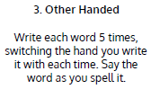  Use Other Handed to practise spelling this week’s words:  purpose, promise, quarter, question, recent, regular, reign, remember, sentence, separate  Spelling Test:  Scroll down below today’s timetable to use the look, cover, write, check sheet to help you to test yourself on this week’s words.
9.45-10.00  Active break | L.O: To boost my concentration through movement. | Join in with this brain break to get you moving!  https://www.bbc.co.uk/teach/supermovers/pshe-super-mood-movers-look-after-yourself/zx2gydm
10.00-11.00  English | SPaG LO: To identify modifying adjectives and nouns.  LO: To write the ending. | For today’s SPaG Daily Practice, revise your knowledge of modifying adjectives and nouns by answering the question below:  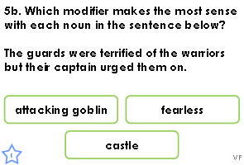  Follow the link below to have a go at today’s lesson:  To write the ending (thenational.academy)
11.00- 11.15
Break
11.15-12.15  Maths | LO: To practise my recall of the 9 times table.  LO: To order non-unit fractions with the same denominator. | Follow the link below to practise the 9 times table:  http://www.snappymaths.com/multdiv/9xtable/interactive/newlook/9xmissintd.htm  Follow the link below to have a go at today’s lesson:  Order Several Non-Unit Fractions with the Same Denominator and Apply this Understanding (thenational.academy)
12.15-1.00
Dinner
1.00-1.15  Storytime | LO: To listen to a story for pleasure. | Listen to Chapter 4 of Jukebox Joyride.  Audible Stories: Free Audiobooks for Kids | Audible.com
1.15-3:00  Mindfulness | LO: To practise mindfulness. | Have a go at this meditation:  https://family.gonoodle.com/activities/on-and-off  Have a go at creating some mindfulness art:  https://www.youtube.com/watch?v=7o6w_Czrff4  Have a go at this relaxing Yoga session:  https://www.youtube.com/watch?v=U9Q6FKF12Qs
Beat That!

Spelling Test
