Time and Subject  Monday | Learning Objective | Task/Link/Resources
8.45-9.00  Reading | LO: To practise and consolidate existing reading skills. | Read your individual reading book, either in your head or out loud.
9.00-9.15  Morning Maths | LO: To consolidate recall of number facts.  Revision LO: To add and subtract 100s. | Complete today’s Beat That- scroll down below today’s timetable to find the questions. Remember, it is the same one every day for a week. Can you beat your own score?  Morning Maths: In Morning Maths today, you are going to revise your knowledge of addition and subtraction. Click the link below and select the video Add and subtract 100s.  https://whiterosemaths.com/homelearning/year-3/week-6-number-addition-subtraction/
9.15-9.45  Spelling | LO: To practise Year 3/4 Common Exception Words. | This week, we are going to practise some of our tricky orange words.  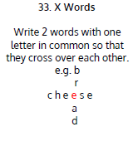  Use X Words to practise spelling this week’s words:  purpose, promise, quarter, question, recent, regular, reign, remember, sentence, separate
9.45-10.00  Active break | LO: To boost my concentration through movement. | Join in with this brain break to get you moving!  https://www.bbc.co.uk/teach/supermovers/just-for-fun-the-vamps-l1/z48y2sg
10.00-11.00  English | SPaG LO: To identify modifying adjectives and nouns.  LO: To engage with the text. | For today’s SPaG Daily Practice, watch this video to learn about modifying adjectives and nouns:  Modifying Nouns with Adjectives and Nouns - YouTube  Follow the link below to have a go at today’s English lesson:  To engage with the text (thenational.academy)
11.00- 11.15
Break
11.15-12.15  Maths | LO: To practise my recall of the 5 times table.  LO: To explore the whole and part relationship. | Follow the link below to practise the 5 times table and get moving!  https://www.bbc.co.uk/teach/supermovers/ks1-maths-the-5-times-table/zhbm47h  Follow the link below to have a go at today’s maths lesson:  Explore the whole and part relationship in familiar contexts, using area, linear and quality models (thenational.academy)
12.15-1.00
Dinner
1.00-1.15  Storytime | LO: To listen to a story for pleasure. | Listen to Chapter 1 of Sovereign:  Audible Stories: Free Audiobooks for Kids | Audible.com
1.15-2.30  Topic-  Science | LO: To explore what we do with data. | Follow the link below to have a go at today’s lesson:  What can we do with data we collect? (thenational.academy)
Beat That!
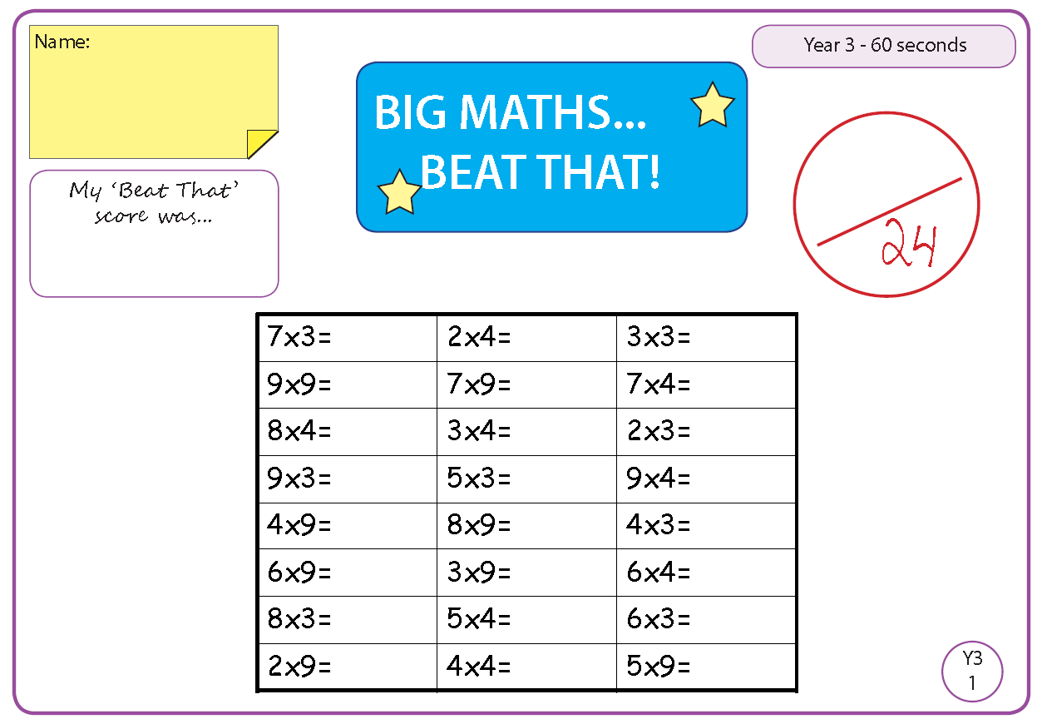

Time and Subject  Tuesday | Learning Objective | Task/Link/Resources
8.45-9.00  Reading | L.O: To practise and consolidate existing reading skills. | Read your individual reading book, either in your head or out loud.
9.00-9.15  Morning Maths | LO: To consolidate recall of number facts.  Revision LO: To identify patterns. | Complete today’s Beat That- scroll down below today’s timetable to find the questions. Remember, it is the same one every day for a week. Can you beat your own score?  Morning Maths: In Morning Maths today, you are going to revise your knowledge of number. Click the link below and select the video Spot the pattern- making it explicit.  https://whiterosemaths.com/homelearning/year-3/week-6-number-addition-subtraction/
9.15-9.45  Spelling | LO: To practise Year 3/4 Common Exception Words. | This week, we are going to practise some of our tricky orange words.  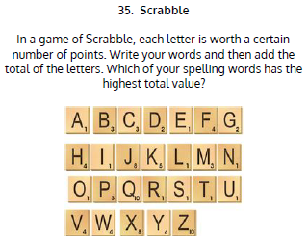  Use Scrabble to practise spelling this week’s words:  purpose, promise, quarter, question, recent, regular, reign, remember, sentence, separate
9.45-10.00  Active break | L.O: To boost my concentration through movement. | Join in with this brain break to get you moving!  https://www.bbc.co.uk/teach/supermovers/just-for-fun-danger-mouse-l1/z6mcpg8
10.00-11.00  English | SPaG LO: To identify modifying adjectives and nouns.  LO: To answer questions on the text. | For today’s SPaG Daily Practice, revise your knowledge of modifying adjectives and nouns by answering the question below:  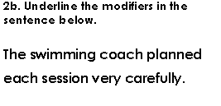  Follow the link below to have a go at today’s English lesson:  To answer questions on the text, orally and in written form (thenational.academy)
11.00- 11.15
Break
11.15-12.15  Maths | LO: To practise my recall of the 5 times table.  LO: To explore the whole and part relationship. | Follow the link below to practise the 5 times table:  https://www.timestables.co.uk/5-times-table.html  Follow the link below to have a go at today’s maths lesson:  Explore the whole and part relationship and generalise that a part is always smaller than the whole (thenational.academy)
12.15-1.00
Dinner
1.00-1.15  Storytime | LO: To listen to a story for pleasure. | Listen to Chapter 2 of Sovereign:  Audible Stories: Free Audiobooks for Kids | Audible.com
1.15-2.30  Topic-  Science | LO: To explore how we can communicate our results. | Follow the link below to have a go at today’s lesson:  How can we communicate our results? (thenational.academy)
2.30-3.00  French | LO: To name learn how to talk about what clothes you are wearing in French. | Follow the link below to have a go at today’s lesson:  Clothes and Accessories - KS2 French - BBC Bitesize - BBC Bitesize

Beat That!

Time and Subject  Wednesday | Learning Objective | Task/Link/Resources
8.45-9.00  Reading | L.O: To practise and consolidate existing reading skills. | Read your individual reading book, either in your head or out loud.
9.00-9.15  Morning Maths | LO: To consolidate recall of number facts.  Revision LO: To add 2-digit numbers. | Complete today’s Beat That- scroll down below today’s timetable to find the questions. Remember, it is the same one every day for a week. Can you beat your own score?  Morning Maths: In Morning Maths today, you are going to revise your knowledge of addition. Click the link below and select the video Add two 2-digit numbers - crossing 10 - add 1s and 10s.  https://whiterosemaths.com/homelearning/year-3/week-6-number-addition-subtraction/
9.15-9.45  Spelling | LO: To practise Year 3/4 Common Exception Words. | This week, we are going to practise some of our tricky orange words.  Use Rainbow Words to practise spelling this week’s words:  purpose, promise, quarter, question, recent, regular, reign, remember, sentence, separate
9.45-10.00  Active break | LO: To boost my concentration through movement. | Join in with this brain break to get you moving!  https://www.bbc.co.uk/teach/supermovers/just-for-fun-alex-scott-l1/zj4pwty
10.00-11.00  English | SPaG LO: To identify modifying adjectives and nouns.  LO: To analyse a character. | For today’s SPaG Daily Practice, revise your knowledge of modifying adjectives and nouns by answering the question below:  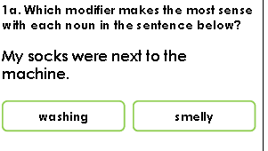  Follow the link below to have a go at today’s English lesson:  To analyse a character (thenational.academy)
11.00- 11.15
Break
11.15-12.15  Maths | LO: To practise my recall of the 5 times table.  LO: To explore the concept of equal and unequal parts. | Follow the link below to practise the 5 times table and get moving!  https://www.youtube.com/watch?v=TFcwMi8l040  Follow the link below to have a go at today’s maths lesson:  Explore the Concept of 'Equal' and 'Unequal' Parts (thenational.academy)
12.15-1.00
Dinner
1.00-1.15  Storytime | LO: To listen to a story for pleasure. | Listen to Chapter 3 of Sovereign:  Audible Stories: Free Audiobooks for Kids | Audible.com
1.15-2.30  Topic- Science | LO: To explore how we record an entire investigation. | Follow the link to have a go at today’s lesson:  How can we record an entire investigation? (thenational.academy)
2.30-3.00  RHE | LO: To understand how jobs are categorised. | Follow the link to have a go at today’s lesson:  Employment (thenational.academy)

Beat That!

Time and Subject  Thursday | Learning Objective | Task/Link/Resources
8.45-9.00  Reading | L.O: To practise and consolidate existing reading skills. | Read your individual reading book, either in your head or out loud.
9.00-9.15  Morning Maths | LO: To consolidate recall of number facts.  Revision LO: To subtract a 2-digit number from a 2-digit number. | Complete today’s Beat That- scroll down below today’s timetable to find the questions. Remember, it is the same one every day for a week. Can you beat your own score?  Morning Maths: In Morning Maths today, you are going to revise your knowledge of subtraction. Click the link below and select the video Subtract a 2-digit number from a 2-digit number - crossing 10 - subtract 1s and 10s  https://whiterosemaths.com/homelearning/year-3/week-6-number-addition-subtraction/
9.15-9.45  Spelling | LO: To practise Year 3/4 Common Exception Words. | week, we are going to practise some of our tricky orange words.  Use Rainbow Words to practise spelling this week’s words:  purpose, promise, quarter, question, recent, regular, reign, remember, sentence, separate
9.45-10.00  Active break | LO: To boost my concentration through movement. | Join in with this brain break to get you moving!  https://www.bbc.co.uk/teach/supermovers/pshe-super-mood-movers-giving-something-back/zjwyp4j
10.00-11.00  English | SPaG LO: To identify modifying adjectives and nouns.  LO: To explore one of the main themes. | For today’s SPaG Daily Practice, revise your knowledge of modifying adjectives and nouns by answering the question below:  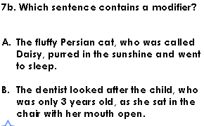  Follow the link below to have a go at today’s English lesson:  To explore one of the main themes (thenational.academy)
11.00- 11.15
Break
11.15-12.15  Maths | LO: To practise my recall of the 5 times table.  LO: To embed the concept of equal parts and unequal parts. | Follow the link below to practise the 5 times table:  http://www.snappymaths.com/multdiv/5xtable/interactive/newlook/5xtablebtcd.htm  Follow the link below to have a go at today’s lesson:  Embed the concept of equal parts and unequal parts (thenational.academy)
12.15-1.00
Dinner
1.00-1.15  Storytime | LO: To listen to a story for pleasure. | Listen to Chapter 4 of Sovereign:  Audible Stories: Free Audiobooks for Kids | Audible.com
1.15-3.00  PE | LO: To build strength and stamina. | Follow the link to have a go at today’s PE activity:  HARRY POTTER 'HOGWARTS' SCHOOL WORKOUT - YouTube

Beat That!

Time and Subject  Friday | Learning Objective | Task/Link/Resources
8.45-9.00  Reading | L.O: To practise and consolidate existing reading skills. | Read your individual reading book, either in your head or out loud.
9.00-9.15  Morning Maths | LO: To consolidate recall of number facts.  Revision LO:  To solve mixed addition and subtraction problems. | Complete today’s Beat That- scroll down below today’s timetable to find the questions. Remember, it is the same one every day for a week. Can you beat your own score?  Morning Maths: In Morning Maths today, you are going to revise your knowledge of addition and subtraction. Click the link below and select the video Mixed addition and subtraction problems  https://whiterosemaths.com/homelearning/year-3/week-6-number-addition-subtraction/
9.15-9.45  Spelling | LO: To practise Year 3/4 Common Exception Words. | This week, we are going to practise some of our tricky orange words.  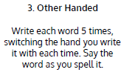  Use Other Handed to practise spelling this week’s words:  purpose, promise, quarter, question, recent, regular, reign, remember, sentence, separate  Spelling Test:  Scroll down below today’s timetable to use the look, cover, write, check sheet to help you to test yourself on this week’s words.
9.45-10.00  Active break | L.O: To boost my concentration through movement. | Join in with this brain break to get you moving!  https://www.bbc.co.uk/teach/supermovers/pshe-super-mood-movers-look-after-yourself/zx2gydm
10.00-11.00  English | SPaG LO: To identify modifying adjectives and nouns.  LO: To explore genre. | For today’s SPaG Daily Practice, revise your knowledge of modifying adjectives and nouns by answering the question below:  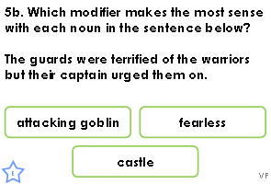  Follow the link below to have a go at today’s lesson:  To explore genre (thenational.academy)
11.00- 11.15
Break
11.15-12.15  Maths | LO: To practise my recall of the 5 times table.  LO: To develop understanding that equal sized parts do not have to look the same. | Follow the link below to practise the 5 times table:  http://www.snappymaths.com/multdiv/5xtable/interactive/newlook/5xmissintd.htm  Follow the link below to have a go at today’s lesson:  Develop understanding that equal sized parts do not have to look the same (thenational.academy)
12.15-1.00
Dinner
1.00-1.15  Storytime | LO: To listen to a story for pleasure. | Listen to Chapter 5 of Sovereign:  Audible Stories: Free Audiobooks for Kids | Audible.com
1.15-3:00  Mindfulness | LO: To practise mindfulness. | Have a go at this meditation:  https://family.gonoodle.com/activities/on-and-off  Have a go at creating some mindfulness art:  https://www.youtube.com/watch?v=7o6w_Czrff4  Have a go at this relaxing Yoga session:  https://www.youtube.com/watch?v=U9Q6FKF12Qs
Beat That!
Spelling Test
