Time and Subject  Monday | Learning Objective | Task/Link/Resources
8.45-9.00  Reading | LO: To practise and consolidate existing reading skills. | Read your individual reading book, either in your head or out loud.
9.00-9.15  Morning Maths | LO: To consolidate recall of number facts.  Revision LO: To subtract two 4-digit numbers (with exchange) | Complete today’s Beat That- scroll down below today’s timetable to find the questions. Remember, it is the same one every day for a week. Can you beat your own score?  Morning Maths: In Morning Maths today, you are going to revise your knowledge of subtraction. Click the link below and select the video Subtract two 4-digit numbers (more than one exchange)  Week 7 - Number: Addition & Subtraction | White Rose Maths
9.15-9.45  Spelling | LO: To practise Unit Eleven RWI Spelling words. | This week, we are going to practise spelling the c sound spelt -que and the g sound spelt -gue.  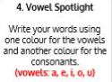  Use Vowel Spotlight to practise spelling this week’s words:  antique, dialogue, fatigue, cheque, colleague, catalogue, tongue, league, unique, grotesque.
9.45-10.00  Active break | LO: To boost my concentration through movement. | Join in with the Go Noodle clip below to get you moving!  https://family.gonoodle.com/activities/dynamite
10.00-11.00  English | SPaG LO: To identify expanded noun phrases.  LO: To generate vocabulary for the climax. | For today’s SPaG Daily Practice, watch this video to learn about expanded noun phrases:  What is an expanded noun phrase? - BBC Bitesize  Follow the link below to have a go at today’s English lesson:  To generate vocabulary for the climax (thenational.academy)
11.00- 11.15
Break
11.15-12.15  Maths | LO: To practise my recall of the 11 times table.  LO: To represent fractions on a number line. | Follow the link below to practise the 11 times table and get moving!  https://www.bbc.co.uk/teach/supermovers/ks2-maths-the-11-times-table/z464nrd  Follow the link below to have a go at today’s maths lesson:  More fractions on a numberline (thenational.academy)
12.15-1.00
Dinner
1.00-1.15  Storytime | LO: To listen to a story for pleasure. | Listen to Chapter 12 of House of Teeth.  Audible Stories: Free Audiobooks for Kids | Audible.com
1.15-2.30  Topic-  History | LO: To explore how the Roman Empire became so powerful. | Follow the link to have a go at today’s lesson:  How did the Roman Empire become so powerful? (thenational.academy)
Beat That!
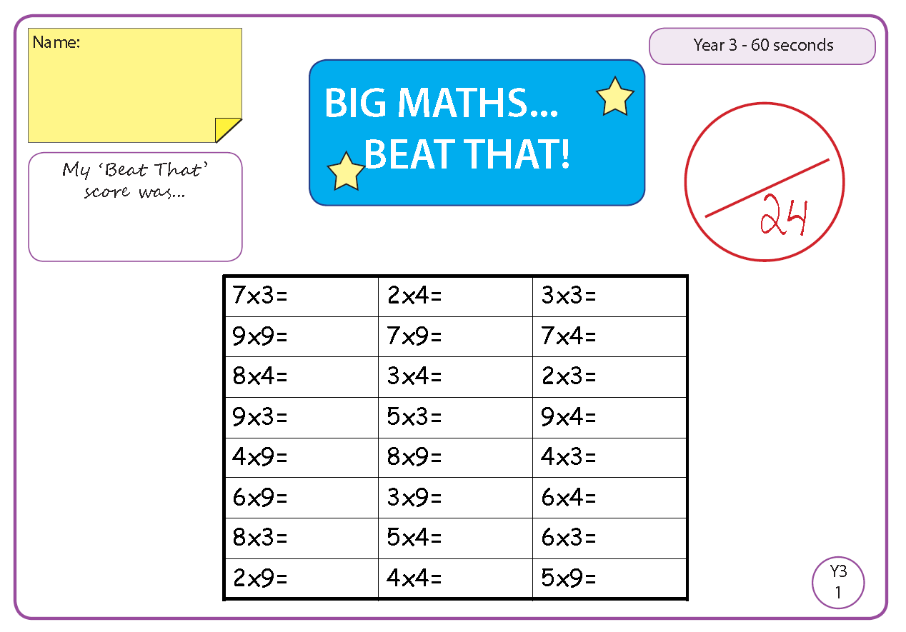
Time and Subject  Tuesday | Learning Objective | Task/Link/Resources
8.45-9.00  Reading | L.O: To practise and consolidate existing reading skills. | Read your individual reading book, either in your head or out loud.
9.00-9.15  Morning Maths | LO: To consolidate recall of number facts.  Revision LO: To choose the most efficient method for subtraction. | Complete today’s Beat That- scroll down below today’s timetable to find the questions. Remember, it is the same one every day for a week. Can you beat your own score?  Morning Maths: In Morning Maths today, you are going to revise your knowledge of subtraction. Click the link below and select the video Efficient subtraction.  Week 7 - Number: Addition & Subtraction | White Rose Maths
9.15-9.45  Spelling | LO: To practise Unit Eleven RWI spelling words. | This week, we are going to practise spelling the c sound spelt -que and the g sound spelt -gue.  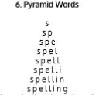  Use Pyramid Words to practise spelling this week’s words:  antique, dialogue, fatigue, cheque, colleague, catalogue, tongue, league, unique, grotesque.
9.45-10.00  Active break | L.O: To boost my concentration through movement. | Join in with the Go Noodle clip below to get you moving!  https://family.gonoodle.com/activities/madison-keys-jump-squat-turn-around
10.00-11.00  English | SPaG LO: To identify expanded noun phrases.  LO: To investigate double consonants. | For today’s SPaG Daily Practice, revise your knowledge of noun phrases by answering the question below:  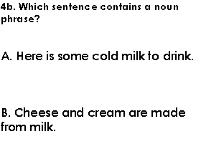  Follow the link below to have a go at today’s English lesson:  To investigate double consonants (thenational.academy)
11.00- 11.15
Break
11.15-12.15  Maths | LO: To practise my recall of the 11 times table.  LO: To develop fluency in counting fractions. | Follow the link below to practise the 11 times table:  https://www.timestables.co.uk/11-times-table.html  Follow the link below to have a go at today’s maths lesson:  Counting fractions (thenational.academy)
12.15-1.00
Dinner
1.00-1.15  Storytime | LO: To listen to a story for pleasure. | Listen to Chapter 13 of House of Teeth.  Audible Stories: Free Audiobooks for Kids | Audible.com
1.15-2.30  Topic-History | LO: To explore who Julius Caesar was. | Follow the link below to have a go at today’s lesson:  Who was Julius Caesar? (thenational.academy)
2.30-3.00  French | LO: To learn how to talk about the weather and seasons in French. | Follow the link below to have a go at today’s lesson:  Weather and Seasons - KS2 French - BBC Bitesize - BBC Bitesize

Beat That!

Time and Subject  Wednesday | Learning Objective | Task/Link/Resources
8.45-9.00  Reading | L.O: To practise and consolidate existing reading skills. | Read your individual reading book, either in your head or out loud.
9.00-9.15  Morning Maths | LO: To consolidate recall of number facts.  Revision LO: To practise estimation. | Complete today’s Beat That- scroll down below today’s timetable to find the questions. Remember, it is the same one every day for a week. Can you beat your own score?  Morning Maths: In Morning Maths today, you are going to revise your knowledge of addition and subtraction. Click the link below and select the video Estimate answers.  Week 7 - Number: Addition & Subtraction | White Rose Maths
9.15-9.45  Spelling | LO: To practise Unit Eleven RWI spelling words. | This week, we are going to practise spelling the c sound spelt -que and the g sound spelt -gue.  Use Rainbow Words to practise spelling this week’s words:  antique, dialogue, fatigue, cheque, colleague, catalogue, tongue, league, unique, grotesque.
9.45-10.00  Active break | LO: To boost my concentration through movement. | Join in with the Go Noodle clip below to get you moving!  https://family.gonoodle.com/activities/get-energized
10.00-11.00  English | SPaG LO: To identify expanded noun phrases.  LO: To explore punctuating speech first. | For today’s SPaG Daily Practice, revise your knowledge of noun phrases by answering the question below:  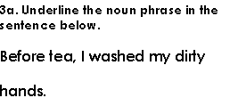  Follow the link below to have a go at today’s English lesson:  To explore punctuating speech first (thenational.academy)
11.00- 11.15
Break
11.15-12.15  Maths | LO: To practise my recall of the 11 times table.  LO: To write repeated addition equations to represent non-unit fractions. | Follow the link below to practise the 11 times table and get moving!  https://www.youtube.com/watch?v=muv9-tRzFmk  Follow the link below to have a go at today’s maths lesson:  Repeated addition of unit fractions (thenational.academy)
12.15-1.00
Dinner
1.00-1.15  Storytime | LO: To listen to a story for pleasure. | Listen to Chapter 14 of House of Teeth.  Audible Stories: Free Audiobooks for Kids | Audible.com
1.15-2.30  Topic- History | LO: To understand what Britain was like before the Romans. | Follow the link to have a go at today’s lesson:  What was Britain like before the Romans? (thenational.academy)
2.30-3.00  RHE | LO: To understand what deforestation is and the impact it has on animals. | Follow the link to have a go at today’s lesson:  Deforestation (thenational.academy)

Beat That!

Time and Subject  Thursday | Learning Objective | Task/Link/Resources
8.45-9.00  Reading | L.O: To practise and consolidate existing reading skills. | Read your individual reading book, either in your head or out loud.
9.00-9.15  Morning Maths | LO: To consolidate recall of number facts.  Revision LO: To use the inverse the operation to check answers. | Complete today’s Beat That- scroll down below today’s timetable to find the questions. Remember, it is the same one every day for a week. Can you beat your own score?  Morning Maths: In Morning Maths today, you are going to revise your knowledge of addition and subtraction. Click the link below and select the video Estimate answers.  Week 7 - Number: Addition & Subtraction | White Rose Maths
9.15-9.45  Spelling | LO: To practise Unit Eleven RWI spelling words. | This week, we are going to practise spelling the c sound spelt -que and the g sound spelt -gue.  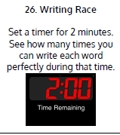  Use Writing Race to practise spelling this week’s words:  antique, dialogue, fatigue, cheque, colleague, catalogue, tongue, league, unique, grotesque.
9.45-10.00  Active break | LO: To boost my concentration through movement. | Join in with the brain break below to get you moving!  https://www.bbc.co.uk/teach/supermovers/pshe-super-mood-movers-fit-and-well/zqr67yc
10.00-11.00  English | SPaG LO: To identify expanded noun phrases.  LO: To plan the climax. | For today’s SPaG Daily Practice, revise your knowledge of noun phrases by answering the question below:  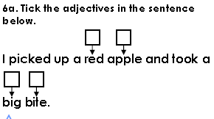  Follow the link below to have a go at today’s English lesson:  To plan the climax (thenational.academy)
11.00- 11.15
Break
11.15-12.15  Maths | LO: To practise my recall of the 11 times table.  LO: To write repeated addition equations to represent non-unit fractions. | Follow the link below to practise the 11 times table:  http://www.snappymaths.com/multdiv/11xtable/interactive/newlook/11xtablebtcd.htm  Follow the link below to have a go at today’s lesson:  More repeated addition of unit fractions (thenational.academy)
12.15-1.00
Dinner
1.00-1.15  Storytime | LO: To listen to a story for pleasure. | Listen to Chapter 15 of House of Teeth.  Audible Stories: Free Audiobooks for Kids | Audible.com
1.15-3.00  PE | LO: To build strength and stamina. | Follow the link to have a go at today’s PE activity:  GUARDIANS OF THE GALAXY 'Starlord' Workout for Kids - YouTube

Beat That!

Time and Subject  Friday | Learning Objective | Task/Link/Resources
8.45-9.00  Reading | L.O: To practise and consolidate existing reading skills. | Read your individual reading book, either in your head or out loud.
9.00-9.15  Morning Maths | LO: To consolidate recall of number facts.  Revision LO:  To find equivalent lengths. | Complete today’s Beat That- scroll down below today’s timetable to find the questions. Remember, it is the same one every day for a week. Can you beat your own score?  Morning Maths: In Morning Maths today, you are going to revise your knowledge of measure. Click the link below and select the video Equivalent lengths m and cm.  Week 8 - Measurement: Length & Perimeter | White Rose Maths
9.15-9.45  Spelling | LO: To practise Unit Eleven RWI spelling words. | This week, we are going to practise spelling the c sound spelt -que and the g sound spelt -gue.  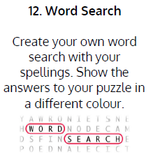  Use Word Search to practise spelling this week’s words:  antique, dialogue, fatigue, cheque, colleague, catalogue, tongue, league, unique, grotesque.  Spelling Test:  Scroll down below today’s timetable to use the look, cover, write, check sheet to help you to test yourself on this week’s words.
9.45-10.00  Active break | L.O: To boost my concentration through movement. | Join in with this brain break to get you moving!  https://www.bbc.co.uk/teach/supermovers/pshe-super-mood-movers-taking-care-of-the-world/zyxc3j6
10.00-11.00  English | SPaG LO: To identify expanded noun phrases.  LO: To develop a rich understanding of words associate with fighting or being in battle. | For today’s SPaG Daily Practice, revise your knowledge of noun phrases by answering the question below:  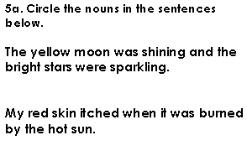  Follow the link below to have a go at today’s lesson:  To develop a rich understanding of words associated with fighting or being in battle (thenational.academy)
11.00- 11.15
Break
11.15-12.15  Maths | LO: To practise my recall of the 11 times table.  LO: To explore which non-unit fractions have the same unit value as 1 whole. | Follow the link below to practise the 11 times table:  http://www.snappymaths.com/multdiv/11xtable/interactive/newlook/11xmissintd.htm  Follow the link below to have a go at today’s lesson:  Fractions equal to one whole (thenational.academy)
12.15-1.00
Dinner
1.00-1.15  Storytime | LO: To listen to a story for pleasure. | Listen to Chapter 16 of House of Teeth.  Audible Stories: Free Audiobooks for Kids | Audible.com
1.15-3:00  Art | LO: To create art in the style of Pablo Picasso. | Pablo Picasso- a famous Spanish artist  Pablo Picasso for Elementary Students - YouTube  In the style of Pablo Picasso, draw a face using dark outlines. Will you create a brightly coloured drawing or a monotone piece?  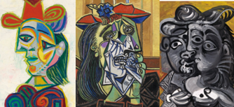

Beat That!
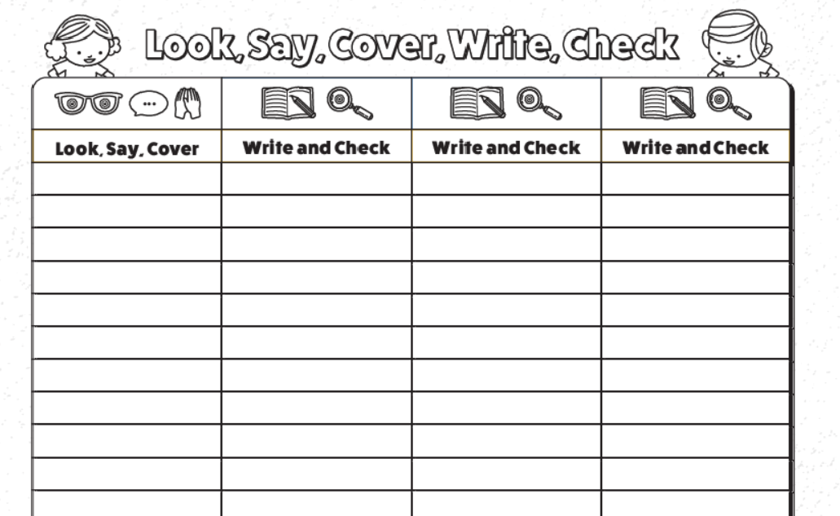
Spelling Test

