Time and Subject  Monday | Learning Objective | Task/Link/Resources
8.45-9.00  Reading | LO: To practise and consolidate existing reading skills. | Read your individual reading book, either in your head or out loud.
9.00-9.15  Morning Maths | LO: To consolidate recall of number facts.  Revision LO: To subtract a 1-digit number from a 3-digit number. | Complete today’s Beat That- scroll down below today’s timetable to find the questions. Remember, it is the same one every day for a week. Can you beat your own score?  Morning Maths: In Morning Maths today, you are going to revise your knowledge of subtraction. Click the link below and select the video Subtract a 1-digit number from a 3-digit number- crossing 10.  https://whiterosemaths.com/homelearning/year-3/week-5/
9.15-9.45  Spelling | LO: To practise Unit Eleven RWI Spelling words. | This week, we are going to practise adding the prefix re- to root words. Watch this prefix to help you learn this spelling rule:  Using prefixes - Year 4 - P5 - English - Catch Up Lessons - Home Learning with BBC Bitesize - BBC Bitesize  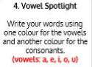  Use Vowel Spotlight to practise spelling this week’s words:  reconnect, reappear, rearrange, rebuilding, recycle, redecorate, refresh, reheat, renew
9.45-10.00  Active break | LO: To boost my concentration through movement. | Join in with the Go Noodle clip below to get you moving!  https://family.gonoodle.com/activities/dynamite
10.00-11.00  English | SPaG LO: To identify expanded noun phrases.  LO: To practise writing speech. | For today’s SPaG Daily Practice, watch this video to learn about expanded noun phrases:  What is an expanded noun phrase? - BBC Bitesize  Follow the link below to have a go at today’s English lesson:  To practise writing speech (thenational.academy)
11.00- 11.15
Break
11.15-12.15  Maths | LO: To practise my recall of the 8 times table.  LO: To recognise equivalent fractions. | Follow the link below to practise the 8 times table and get moving!  https://www.youtube.com/watch?v=z_BJjR9rdwA  Follow the link below to have a go at today’s maths lesson:  Fractions: Recognising equivalent fractions (Part 1) (thenational.academy)
12.15-1.00
Dinner
1.00-1.15  Storytime | LO: To listen to a story for pleasure. | Listen to Chapter 25 of The Golden Orchid:  Audible Stories: Free Audiobooks for Kids | Audible.com
1.15-2.30  Topic-  Science | LO: To explore the 3 types of variables. | Follow the link to have a go at today’s lesson:  What is a variable? (thenational.academy)

Beat That!
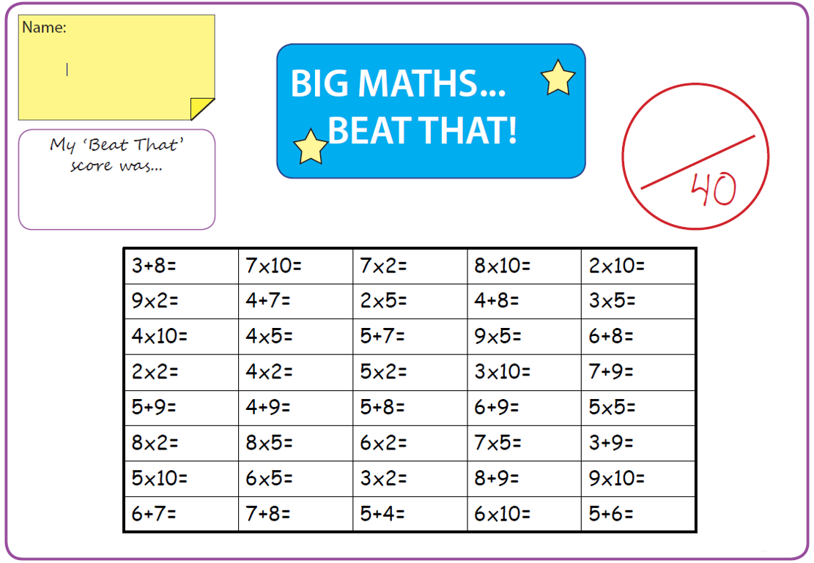
Time and Subject  Tuesday | Learning Objective | Task/Link/Resources
8.45-9.00  Reading | L.O: To practise and consolidate existing reading skills. | Read your individual reading book, either in your head or out loud.
9.00-9.15  Morning Maths | LO: To consolidate recall of number facts.  Revision LO: To add and subtract 3-digit and 2-digit numbers. | Complete today’s Beat That- scroll down below today’s timetable to find the questions. Remember, it is the same one every day for a week. Can you beat your own score?  Morning Maths: In Morning Maths today, you are going to revise your knowledge of addition and subtraction. Click the link below and select the video Add and subtract 3-digit and 2-digit numbers- not crossing 100.  https://whiterosemaths.com/homelearning/year-3/week-5/
9.15-9.45  Spelling | LO: To practise Unit Eleven RWI spelling words. | This week, we are going to practise adding the prefix re- to root words.  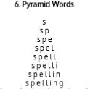  Use Pyramid Words to practise spelling this week’s words:  reconnect, reappear, rearrange, rebuilding, recycle, redecorate, refresh, reheat, renew
9.45-10.00  Active break | L.O: To boost my concentration through movement. | Join in with the Go Noodle clip below to get you moving!  https://family.gonoodle.com/activities/madison-keys-jump-squat-turn-around
10.00-11.00  English | SPaG LO: To identify expanded noun phrases.  LO: To practise and apply knowledge of suffixes:-ful and -less suffixes. | For today’s SPaG Daily Practice, revise your knowledge of noun phrases by answering the question below:  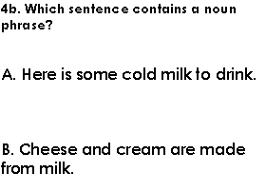  Follow the link below to have a go at today’s English lesson:  To practise and apply knowledge of suffixes: - ful and -less suffixes, including test (thenational.academy)
11.00- 11.15
Break
11.15-12.15  Maths | LO: To practise my recall of the 8 times table.  LO: To recognise equivalent fractions. | Follow the link below to practise the 8 times table:  http://www.snappymaths.com/multdiv/8xtable/interactive/8ximinute/8ximmm.htm  Follow the link below to have a go at today’s maths lesson:  Fractions: Recognising equivalent fractions (Part 2) (thenational.academy)
12.15-1.00
Dinner
1.00-1.15  Storytime | LO: To listen to a story for pleasure. | Listen to Chapter 26 of The Golden Orchid:  Audible Stories: Free Audiobooks for Kids | Audible.com
1.15-2.30  Topic-Science | LO: To understand how to draw a scientific diagram. | Follow the link below to have a go at today’s lesson:  How do you draw a scientific diagram? (thenational.academy)
2.30-3.00  French | LO: To learn how to talk about the weather and seasons in French. | Follow the link below to have a go at today’s lesson:  Weather and Seasons - KS2 French - BBC Bitesize - BBC Bitesize

Beat That!

Time and Subject  Wednesday | Learning Objective | Task/Link/Resources
8.45-9.00  Reading | L.O: To practise and consolidate existing reading skills. | Read your individual reading book, either in your head or out loud.
9.00-9.15  Morning Maths | LO: To consolidate recall of number facts.  Revision LO: To practise estimation. | Complete today’s Beat That- scroll down below today’s timetable to find the questions. Remember, it is the same one every day for a week. Can you beat your own score?  Morning Maths: In Morning Maths today, you are going to revise your knowledge of subtraction. Click the link below and select the video Subtract a 1-digit number from 2-digits- crossing 10.  https://whiterosemaths.com/homelearning/year-3/week-5/
9.15-9.45  Spelling | LO: To practise Unit Eleven RWI spelling words. | This week, we are going to practise adding the prefix re- to root words.  Use Rainbow Words to practise spelling this week’s words:  reconnect, reappear, rearrange, rebuilding, recycle, redecorate, refresh, reheat, renew
9.45-10.00  Active break | LO: To boost my concentration through movement. | Join in with the Go Noodle clip below to get you moving!  https://family.gonoodle.com/activities/get-energized
10.00-11.00  English | SPaG LO: To identify expanded noun phrases.  LO: To write the climax of a story. | For today’s SPaG Daily Practice, revise your knowledge of noun phrases by answering the question below:  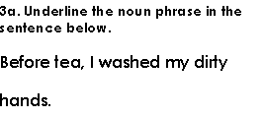  Follow the link below to have a go at today’s English lesson:  To write the climax of a story (thenational.academy)
11.00- 11.15
Break
11.15-12.15  Maths | LO: To practise my recall of the 8 times table.  LO: To add fractions with the same denominator. | Follow the link below to practise the 8 times table:  http://www.snappymaths.com/multdiv/8xtable/interactive/newlook/8xtableintd.htm  Follow the link below to have a go at today’s maths lesson:  Fractions: Adding fractions with the same denominator (thenational.academy)
12.15-1.00
Dinner
1.00-1.15  Storytime | LO: To listen to a story for pleasure. | Listen to Chapter 27 of The Golden Orchid:  Audible Stories: Free Audiobooks for Kids | Audible.com
1.15-2.30  Topic- Science | LO: To explore why a method is important. | Follow the link to have a go at today’s lesson:  Why is a method important? (thenational.academy)
2.30-3.00  RHE | LO: To understand what deforestation is and the impact it has on animals. | Follow the link to have a go at today’s lesson:  Deforestation (thenational.academy)

Beat That!

Time and Subject  Thursday | Learning Objective | Task/Link/Resources
8.45-9.00  Reading | L.O: To practise and consolidate existing reading skills. | Read your individual reading book, either in your head or out loud.
9.00-9.15  Morning Maths | LO: To consolidate recall of number facts.  Revision LO: To add and subtract 3-digit and 2-digit numbers. | Complete today’s Beat That- scroll down below today’s timetable to find the questions. Remember, it is the same one every day for a week. Can you beat your own score?  Morning Maths: In Morning Maths today, you are going to revise your knowledge of addition and subtraction. Click the link below and select the video Add and subtract 3-digit and 2-digit numbers- not crossing 100.  https://whiterosemaths.com/homelearning/year-3/week-5/
9.15-9.45  Spelling | LO: To practise Unit Eleven RWI spelling words. | This week, we are going to practise adding the prefix re- to root words.  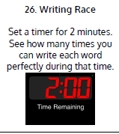  Use Writing Race to practise spelling this week’s words:  reconnect, reappear, rearrange, rebuilding, recycle, redecorate, refresh, reheat, renew
9.45-10.00  Active break | LO: To boost my concentration through movement. | Join in with the brain break below to get you moving!  https://www.bbc.co.uk/teach/supermovers/pshe-super-mood-movers-fit-and-well/zqr67yc
10.00-11.00  English | SPaG LO: To identify expanded noun phrases.  LO: To write and edit the climax of a story. | For today’s SPaG Daily Practice, revise your knowledge of noun phrases by answering the question below:  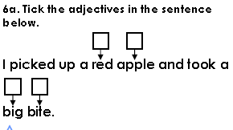  Follow the link below to have a go at today’s English lesson:  To write and edit the climax of a story (thenational.academy)
11.00- 11.15
Break
11.15-12.15  Maths | LO: To practise my recall of the 8 times table.  LO: To subtract fractions with the same denominator. | Follow the link below to practise the 8 times table:  http://www.snappymaths.com/multdiv/8xtable/interactive/countin8shfcyg/countin8shfcyg.htm  Follow the link below to have a go at today’s lesson:  Fractions: Subtracting fractions with the same denominator (thenational.academy)
12.15-1.00
Dinner
1.00-1.15  Storytime | LO: To listen to a story for pleasure. | Listen to Chapter 28 of The Golden Orchid:  Audible Stories: Free Audiobooks for Kids | Audible.com
1.15-3.00  PE | LO: To build strength and stamina. | Follow the link to have a go at today’s PE activity:  GUARDIANS OF THE GALAXY 'Starlord' Workout for Kids - YouTube

Beat That!

Time and Subject  Friday | Learning Objective | Task/Link/Resources
8.45-9.00  Reading | L.O: To practise and consolidate existing reading skills. | Read your individual reading book, either in your head or out loud.
9.00-9.15  Morning Maths | LO: To consolidate recall of number facts.  Revision LO:  To subtract a 2-digit number from a 3-digit number. | Complete today’s Beat That- scroll down below today’s timetable to find the questions. Remember, it is the same one every day for a week. Can you beat your own score?  Morning Maths: In Morning Maths today, you are going to revise your knowledge of subtraction. Click the link below and select the video Subtract a 2-digit number from a 3-digit number- crossing 100.  https://whiterosemaths.com/homelearning/year-3/week-5/
9.15-9.45  Spelling | LO: To practise Unit Eleven RWI spelling words. | This week, we are going to practise adding the prefix re- to root words.  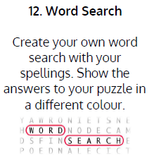  Use Word Search to practise spelling this week’s words:  reconnect, reappear, rearrange, rebuilding, recycle, redecorate, refresh, reheat, renew  Spelling Test:  Scroll down below today’s timetable to use the look, cover, write, check sheet to help you to test yourself on this week’s words.
9.45-10.00  Active break | L.O: To boost my concentration through movement. | Join in with this brain break to get you moving!  https://www.bbc.co.uk/teach/supermovers/pshe-super-mood-movers-taking-care-of-the-world/zyxc3j6
10.00-11.00  English | SPaG LO: To identify expanded noun phrases.  LO: To write the resolution of a story. | For today’s SPaG Daily Practice, revise your knowledge of noun phrases by answering the question below:  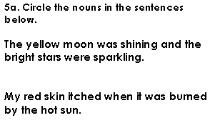  Follow the link below to have a go at today’s lesson:  To write the resolution of a story (thenational.academy)
11.00- 11.15
Break
11.15-12.15  Maths | LO: To practise my recall of the 8 times table.  LO: To revise learning on fractions. | Follow the link below to practise the 8 times table:  http://www.snappymaths.com/multdiv/8xtable/interactive/newlook/8xmissintd.htm  Follow the link below to have a go at today’s lesson:  Fractions: To revise learning on fractions (thenational.academy)
12.15-1.00
Dinner
1.00-1.15  Storytime | LO: To listen to a story for pleasure. | Listen to Chapter 29 of The Golden Orchid:  Audible Stories: Free Audiobooks for Kids | Audible.com
1.15-3:00  Art | LO: To create art in the style of Pablo Picasso. | Pablo Picasso- a famous Spanish artist  Pablo Picasso for Elementary Students - YouTube  In the style of Pablo Picasso, draw a face using dark outlines. Will you create a brightly coloured drawing or a monotone piece?

Beat That!
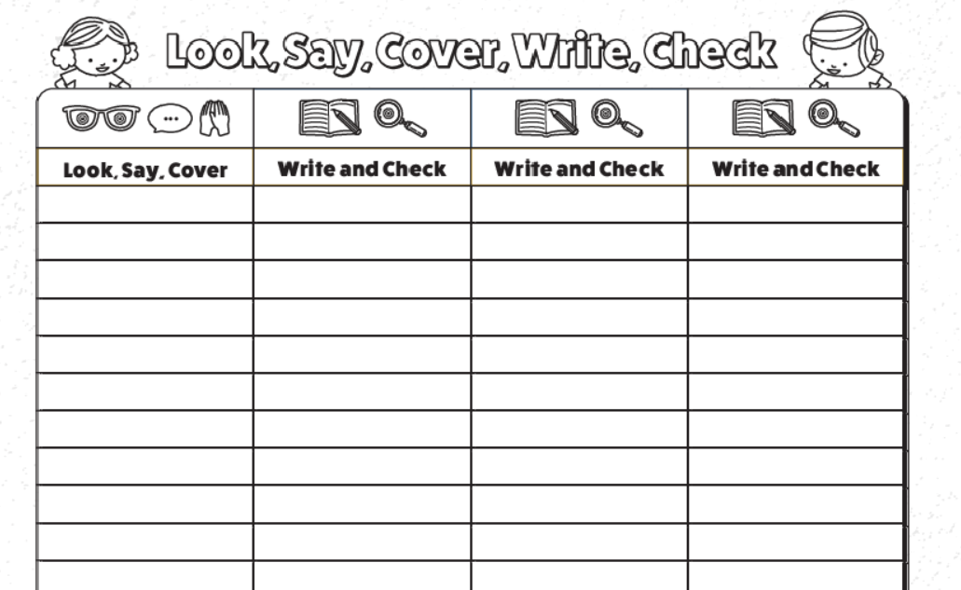
Spelling Test

