Time and Subject  Monday | Learning Objective | Task/Link/Resources
8.45-9.00  Reading | LO: To practise and consolidate existing reading skills. | Read your individual reading book, either in your head or out loud.
9.00-9.15  Morning Maths | LO: To consolidate recall of number facts.  Revision LO: To add and subtract 1s, 10s, 100s and 1000s. | Complete today’s Beat That- scroll down below today’s timetable to find the questions. Remember, it is the same one every day for a week. Can you beat your own score?  Morning Maths: In Morning Maths today, you are going to revise your knowledge of addition and subtraction. Click the link below and select the video Add and subtract 1s 10s 100s and 1000s.  https://whiterosemaths.com/homelearning/year-4/week-5/
9.15-9.45  Spelling | LO: To practise Unit Ten RWI spelling words. | This week, we are going to practise adding the prefix il- and revise adding un-, in-, mis- and dis-. Watch this video to help you to learn this spelling rule:  Using prefixes - Year 5-P6 - English - Catch Up Lesson - Home Learning with BBC Bitesize - BBC Bitesize  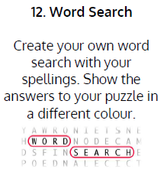  Use Word Search to practise spelling this week’s words:  disagree, disappear, dislike, disobey, disqualify, illegal, illogical, illiterate, illegible, impatient, impolite, impractical, incomplete, incorrect.
9.45-10.00  Active break | LO: To boost my concentration through movement. | Join in with the Go Noodle clip below to get you moving!  https://family.gonoodle.com/activities/jump
10.00-11.00  English | SPaG Revision LO: To identify and use adjectives to describe nouns.  LO: To engage with the poem. | For today’s SPaG Daily Practice, revise your knowledge of adjectives:  KS1 English: Adjectives & Adverbs with Johnny & Inel - BBC Teach  Follow the link below to have a go at today’s English lesson:  To engage with the poem (thenational.academy)
11.00- 11.15
Break
11.15-12.15  Maths | LO: To practise my recall of the 6 times table.  LO: To build wholes. | Follow the link below to practise the 6 times table and get moving!  https://www.bbc.co.uk/teach/supermovers/ks2-maths-the-6-times-table-with-fred-the-red/zrq3xyc  Follow the link below to have a go at today’s maths lesson:  Building wholes (thenational.academy)
12.15-1.00
Dinner
1.00-1.15  Storytime | LO: To listen to a story for pleasure. | Listen to Chapter 2 of House of Teeth.  Audible Stories: Free Audiobooks for Kids | Audible.com
1.15-3.00  Topic- RE | LO: To understand what Sikhism is. | Watch the videos and read the information to learn about Sikhism:  What is Sikhism? - BBC Bitesize  Create a mind map to show the key beliefs of Sikhs. Make sure that you include:  - When Sikhism was founded and who by.  - The actions Sikhs take to live a good life.  - Where and how Sikhs worship.  - What the Sikh holy book is called and what it includes.

Beat That!
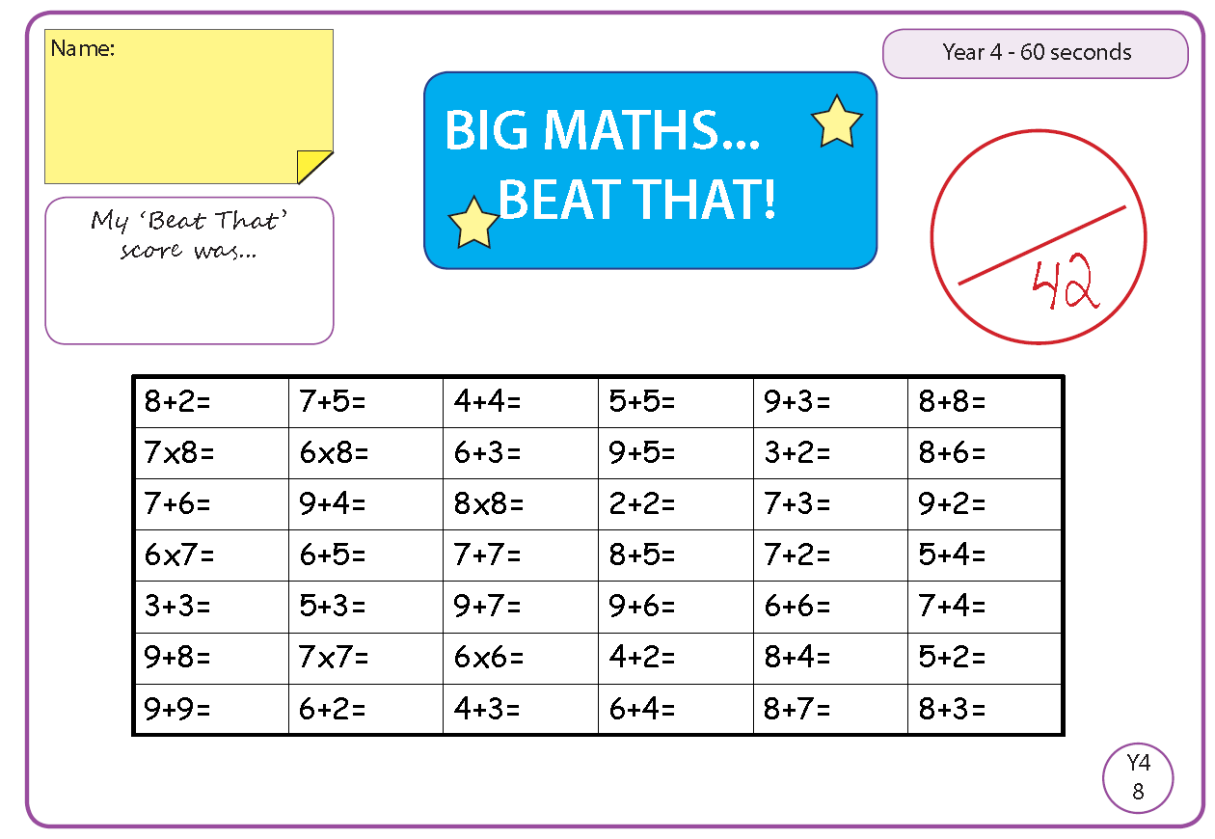

Time and Subject  Tuesday | Learning Objective | Task/Link/Resources
8.45-9.00  Reading | L.O: To practise and consolidate existing reading skills. | Read your individual reading book, either in your head or out loud.
9.00-9.15  Morning Maths | LO: To consolidate recall of number facts.  Revision LO: To add two 3-digit numbers. | Complete today’s Beat That- scroll down below today’s timetable to find the questions. Remember, it is the same one every day for a week. Can you beat your own score?  Morning Maths: In Morning Maths today, you are going to revise your knowledge of addition and subtraction. Click the link below and select the video Add two 3-digit numbers- not crossing 10 or 100.  https://whiterosemaths.com/homelearning/year-4/week-5/
9.15-9.45  Spelling | LO: To practise Unit Ten RWI spelling words. | This week, we are going to practise adding the prefix il- and revise adding un-, in-, mis- and dis-.  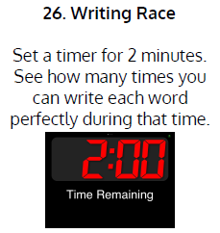  Use Writing Race to practise spelling this week’s words:  disagree, disappear, dislike, disobey, disqualify, illegal, illogical, illiterate, illegible, impatient, impolite, impractical, incomplete, incorrect.
9.45-10.00  Active break | L.O: To boost my concentration through movement. | Join in with the Go Noodle clip below to get you moving!  https://family.gonoodle.com/activities/believer
10.00-11.00  English | SPaG Revision LO: To identify and use adjectives.  LO: To investigate French derived sounds . | For today’s SPaG Daily Practice, revise your knowledge of adjectives by answering the question below:  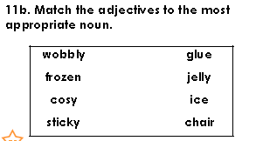  Follow the link below to have a go at today’s English lesson:  To investigate French derived sounds (thenational.academy)
11.00- 11.15
Break
11.15-12.15  Maths | LO: To practise my recall of the 6 times table.  LO: To build and compare wholes. | Follow the link below to practise the 6 times table:  https://www.timestables.co.uk/6-times-table.html  Follow the link below to have a go at today’s maths lesson:  Building and comparing wholes (thenational.academy)
12.15-1.00
Dinner
1.00-1.15  Storytime | LO: To listen to a story for pleasure. | Listen to Chapter 3 of House of Teeth.  Audible Stories: Free Audiobooks for Kids | Audible.com
1.15-2.30  Topic-R.E | LO: To understand the story of Guru Nanak. | Watch this video to learn about Guru Nanak:  The story of Guru Nanak | Religious Studies - Stories for Collective Worship - YouTube  Create a story board (with drawings and sentences) to retell the story of Guru Nanak.
2.30-3.00  French | LO: To practise talking about hobbies in French. | Follow the link below to have a go at today’s lesson:  Hobbies - KS2 French - BBC Bitesize - BBC Bitesize

Beat That!

Time and Subject  Wednesday | Learning Objective | Task/Link/Resources
8.45-9.00  Reading | L.O: To practise and consolidate existing reading skills. | Read your individual reading book, either in your head or out loud.
9.00-9.15  Morning Maths | LO: To consolidate recall of number facts.  Revision LO: To add two 4-digit numbers. | Complete today’s Beat That- scroll down below today’s timetable to find the questions. Remember, it is the same one every day for a week. Can you beat your own score?  Morning Maths: In Morning Maths today, you are going to revise your knowledge of addition. Click the link below and select the video Add two 4-digit numbers- no exchange.  https://whiterosemaths.com/homelearning/year-4/week-5/
9.15-9.45  Spelling | LO: To practise Unit Ten RWI spelling words. | This week, we are going to practise adding the prefix il- and revise adding un-, in-, mis- and dis-.  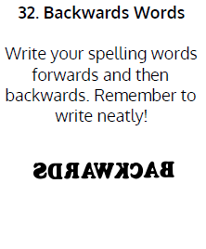  Use Backwards Words to practise spelling this week’s words:  disagree, disappear, dislike, disobey, disqualify, illegal, illogical, illiterate, illegible, impatient, impolite, impractical, incomplete, incorrect.
9.45-10.00  Active break | LO: To boost my concentration through movement. | Join in with the Go Noodle clip below to get you moving!  https://family.gonoodle.com/activities/roar
10.00-11.00  English | SPaG Revision LO: To identify and use adjectives.  LO: To explore the function of apostrophes. | For today’s SPaG Daily Practice, revise your knowledge of adjectives by answering the question below:  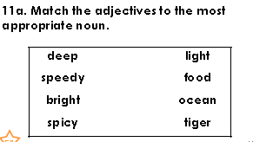  Follow the link below to have a go at today’s English lesson:  To explore the function of apostrophes (thenational.academy)
11.00- 11.15
Break
11.15-12.15  Maths | LO: To practise my recall of the 6 times table.  LO: To build and compare wholes from different unit fractions. | Follow the link below to practise the 6 times table and get moving!  https://www.youtube.com/watch?v=f3cEpwUSN7g  Follow the link below to have a go at today’s maths lesson:  Building and comparing wholes from different unit fractions (thenational.academy)
12.15-1.00
Dinner
1.00-1.15  Storytime | LO: To listen to a story for pleasure. | Listen to Chapter 4 of House of Teeth.  Audible Stories: Free Audiobooks for Kids | Audible.com
1.15-2.30  Topic-R.E | LO: To explore the 5 Ks. | Follow these links to learn about the 5 Ks:  What is Sikhism? - BBC Bitesize  The Five Ks in Sikhism | Religious Studies – My Life, My Religion: Sikhism - YouTube
2.30-3.00  RHE | LO: To learn about the causes and effects of climate change. | Follow the link to have a go at today’s lesson:  Be better and do more (thenational.academy)

Beat That!

Time and Subject  Thursday | Learning Objective | Task/Link/Resources
8.45-9.00  Reading | L.O: To practise and consolidate existing reading skills. | Read your individual reading book, either in your head or out loud.
9.00-9.15  Morning Maths | LO: To consolidate recall of number facts.  Revision LO: To add two 3-digit numbers (with exchange). | Complete today’s Beat That- scroll down below today’s timetable to find the questions. Remember, it is the same one every day for a week. Can you beat your own score?  Morning Maths: In Morning Maths today, you are going to revise your knowledge of addition. Click the link below and select the video Add two 3-digit numbers- crossing 10 or 100.  https://whiterosemaths.com/homelearning/year-4/week-5/
9.15-9.45  Spelling | LO: To practise Unit Ten RWI spelling words. | This week, we are going to practise adding the prefix il- and revise adding un-, in-, mis- and dis-.  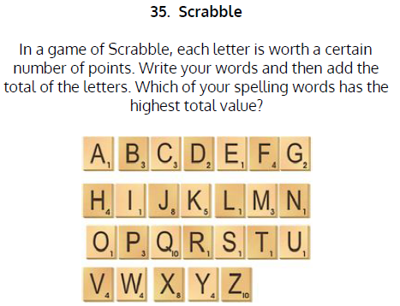  Use Scrabble to practise spelling this week’s words:  disagree, disappear, dislike, disobey, disqualify, illegal, illogical, illiterate, illegible, impatient, impolite, impractical, incomplete, incorrect.
9.45-10.00  Active break | LO: To boost my concentration through movement. | Join in with the Go Noodle clip below to get you moving!  https://family.gonoodle.com/activities/im-still-standing
10.00-11.00  English | SPaG Revision LO: To identify and use adjectives.  LO: To generate vocabulary to write the opening. | For today’s SPaG Daily Practice, revise your knowledge of adjectives by answering the question below:  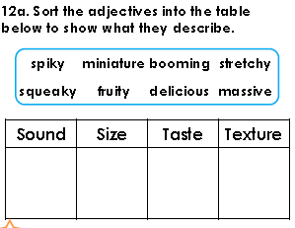  Follow the link below to have a go at today’s English lesson:  To generate vocabulary to write the opening (thenational.academy)
11.00- 11.15
Break
11.15-12.15  Maths | LO: To practise my recall of the 6 times table.  LO: To build and compare wholes from different unit fractions. | Follow the link below to practise the 6 times table:  http://www.snappymaths.com/multdiv/6xtable/interactive/newlook/6xtablebtcd.htm  Follow the link below to have a go at today’s lesson:  More building and comparing wholes from different unit fractions (thenational.academy)
12.15-1.00
Dinner
1.00-1.15  Storytime | LO: To listen to a story for pleasure. | Listen to Chapter 5 of House of Teeth.  Audible Stories: Free Audiobooks for Kids | Audible.com
1.15-3.00  PE | LO: To build strength and stamina. | Follow the link to have a go at today’s PE activity:  SPIDER-VERSE KIDS WORKOUT (MILES MORALES) - YouTube

Beat That!

Time and Subject  Friday | Learning Objective | Task/Link/Resources
8.45-9.00  Reading | L.O: To practise and consolidate existing reading skills. | Read your individual reading book, either in your head or out loud.
9.00-9.15  Morning Maths | LO: To consolidate recall of number facts.  Revision LO:  To add two 4-digit numbers (with exchange). | Complete today’s Beat That- scroll down below today’s timetable to find the questions. Remember, it is the same one every day for a week. Can you beat your own score?  Morning Maths: In Morning Maths today, you are going to revise your knowledge of addition. Click the link below and select the video Add two 4-digit numbers- one exchange.  https://whiterosemaths.com/homelearning/year-4/week-5/
9.15-9.45  Spelling | LO: To practise Unit Ten RWI spelling words. | This week, we are going to practise adding the prefix il- and revise adding un-, in-, mis- and dis-.  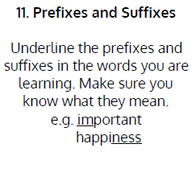  Use Scrabble to practise spelling this week’s words:  disagree, disappear, dislike, disobey, disqualify, illegal, illogical, illiterate, illegible, impatient, impolite, impractical, incomplete, incorrect.  Spelling Test:  Scroll down below today’s timetable to use the look, cover, write, check sheet to help you to test yourself on this week’s words.
9.45-10.00  Active break | L.O: To boost my concentration through movement. | Join in with the Go Noodle clip to get you moving!  https://family.gonoodle.com/activities/best-time-ever
10.00-11.00  English | SPaG Revision LO: To identify and use adjectives.  LO: To develop a rich understanding of words associated with being confident. | For today’s SPaG Daily Practice, revise your knowledge of adjectives by answering the question below:  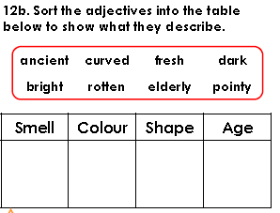  Follow the link below to have a go at today’s lesson:  To develop a rich understanding of words associated with being confident (thenational.academy)
11.00- 11.15
Break
11.15-12.15  Maths | LO: To practise my recall of the 6 times table.  LO: To represent non-unit fractions. | Follow the link below to practise the 6 times table:  http://www.snappymaths.com/multdiv/6xtable/interactive/newlook/6xmissintd.htm  Follow the link below to have a go at today’s lesson:  Representing non-unit fractions (thenational.academy)
12.15-1.00
Dinner
1.00-1.15  Storytime | LO: To listen to a story for pleasure. | Listen to Chapter 6 of House of Teeth.  Audible Stories: Free Audiobooks for Kids | Audible.com
1.15-3:00  Mindfulness | LO: To practise mindfulness. | Have a go at this meditation:  https://family.gonoodle.com/activities/rainbow-breath  Have a go at creating some mindfulness art:  https://www.youtube.com/watch?v=VXs0czMhsZw  Have a go at this relaxing Yoga session:  https://www.youtube.com/watch?v=on_9AhPQigE

Beat That!
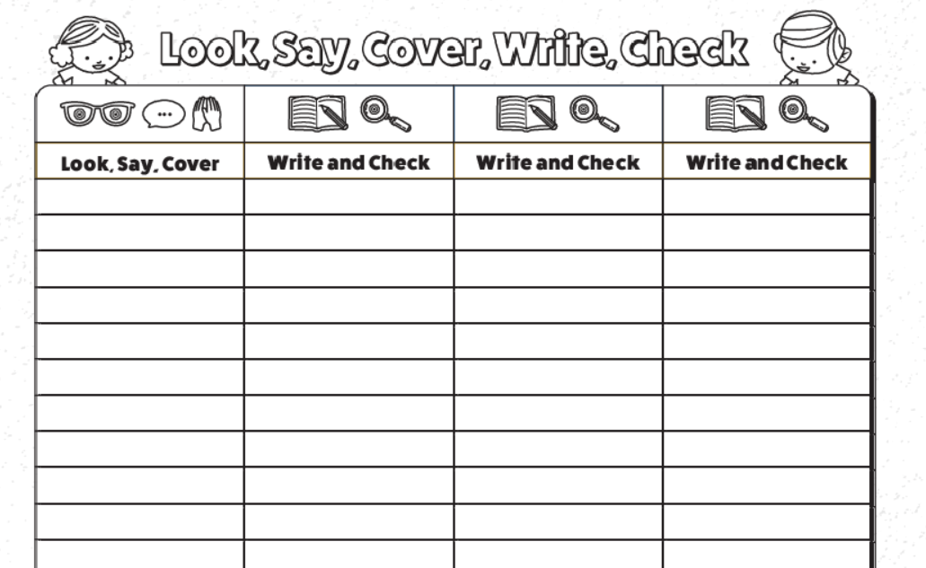
Spelling Test

