Time and Subject  Monday | Learning Objective | Task/Link/Resources
8.45-9.00  Reading | LO: To practise and consolidate existing reading skills. | Read your individual reading book, either in your head or out loud.
9.00-9.15  Morning Maths | LO: To consolidate recall of number facts.  Revision LO: To compare objects. | Complete today’s Beat That- scroll down below today’s timetable to find the questions. Remember, it is the same one every day for a week. Can you beat your own score?  Morning Maths: In Morning Maths today, you are going to revise your knowledge of place value. Click the link below and select the video Compare objects.  https://whiterosemaths.com/homelearning/year-3/week-3/
9.15-9.45  Spelling | LO: To practise Unit Ten RWI spelling words. | This week, we are going to practise adding the suffix -ian.  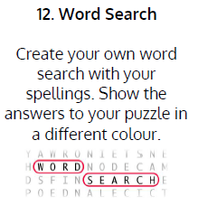  Use Word Search to practise spelling this week’s words:  attraction, location, construction, education, injection, electrician, mathematician, politician, magician, optician, musician
9.45-10.00  Active break | LO: To boost my concentration through movement. | Join in with the Go Noodle clip below to get you moving!  https://family.gonoodle.com/activities/jump
10.00-11.00  English | SPaG Revision LO: To identify and use adjectives to describe nouns.  LO: To understand and order the story of a picture book. | For today’s SPaG Daily Practice, revise your knowledge of adjectives:  KS1 English: Adjectives & Adverbs with Johnny & Inel - BBC Teach  Follow the link below to have a go at today’s English lesson:  To understand and order the story of a picture book (thenational.academy)
11.00- 11.15
Break
11.15-12.15  Maths | LO: To practise my recall of the 4 times table.  LO: To describe the part whole relationship. | Follow the link below to practise the 4 times table and get moving!  https://www.bbc.co.uk/teach/supermovers/ks1-maths-the-4-times-table-with-cyril-the-swan/zmsw382  Follow the link below to have a go at today’s maths lesson:  To describe the part whole relationship (thenational.academy)
12.15-1.00
Dinner
1.00-1.15  Storytime | LO: To listen to a story for pleasure. | Listen to Chapter 15 of The Golden Orchid:  Audible Stories: Free Audiobooks for Kids | Audible.com
1.15-3.00  Topic- RE | LO: To understand what Hinduism is. | Watch the videos and read the information to learn about Hinduism:  What is Hinduism? - BBC Bitesize  Create a mind map to show the key beliefs of Hindus. Make sure that you include:  - Their beliefs about the supreme God.  - Information about the holy books of Hinduism.  - Where and how Hindus worship.

Beat That!
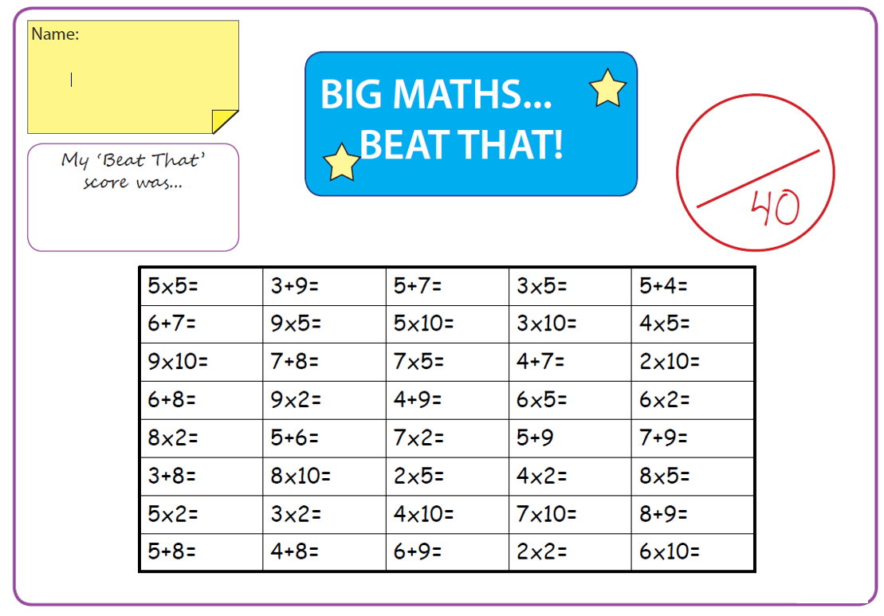

Time and Subject  Tuesday | Learning Objective | Task/Link/Resources
8.45-9.00  Reading | L.O: To practise and consolidate existing reading skills. | Read your individual reading book, either in your head or out loud.
9.00-9.15  Morning Maths | LO: To consolidate recall of number facts.  Revision LO: To compare numbers. | Complete today’s Beat That- scroll down below today’s timetable to find the questions. Remember, it is the same one every day for a week. Can you beat your own score?  Morning Maths: In Morning Maths today, you are going to revise your knowledge of place value. Click the link below and select the video Compare numbers.  https://whiterosemaths.com/homelearning/year-3/week-3/
9.15-9.45  Spelling | LO: To practise Unit Ten RWI spelling words. | This week, we are going to practise adding the prefix il- and revise adding un-, in-, mis- and dis-.  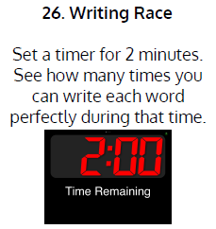  Use Writing Race to practise spelling this week’s words:  attraction, location, construction, education, injection, electrician, mathematician, politician, magician, optician, musician
9.45-10.00  Active break | L.O: To boost my concentration through movement. | Join in with the Go Noodle clip below to get you moving!  https://family.gonoodle.com/activities/believer
10.00-11.00  English | SPaG Revision LO: To identify and use adjectives.  LO: To investigate suffixes: -ly suffix | For today’s SPaG Daily Practice, revise your knowledge of adjectives by answering the question below:  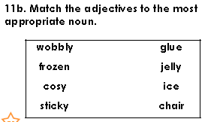  Follow the link below to have a go at today’s English lesson:  To investigate suffixes: -ly suffix (thenational.academy)
11.00- 11.15
Break
11.15-12.15  Maths | LO: To practise my recall of the 4 times table.  LO: To recognise parts that are equal and parts that are unequal. | Follow the link below to practise the 4 times table:  https://www.timestables.co.uk/4-times-table.html  Follow the link below to have a go at today’s maths lesson:  To recognise parts that are equal and parts that are unequal (thenational.academy)
12.15-1.00
Dinner
1.00-1.15  Storytime | LO: To listen to a story for pleasure. | Listen to Chapter 16 of The Golden Orchid:  Audible Stories: Free Audiobooks for Kids | Audible.com
1.15-2.30  Topic-R.E | LO: To understand the story of Holi. | Watch this video to learn about Holi:  What is Holi? - BBC Bitesize  Create a story board (with drawings and sentences) to retell the story of Holi.
2.30-3.00  French | LO: To practise talking about hobbies in French. | Follow the link below to have a go at today’s lesson:  Hobbies - KS2 French - BBC Bitesize - BBC Bitesize

Beat That!

Time and Subject  Wednesday | Learning Objective | Task/Link/Resources
8.45-9.00  Reading | L.O: To practise and consolidate existing reading skills. | Read your individual reading book, either in your head or out loud.
9.00-9.15  Morning Maths | LO: To consolidate recall of number facts.  Revision LO: To order numbers. | Complete today’s Beat That- scroll down below today’s timetable to find the questions. Remember, it is the same one every day for a week. Can you beat your own score?  Morning Maths: In Morning Maths today, you are going to revise your knowledge of place value. Click the link below and select the video Ordering numbers.  https://whiterosemaths.com/homelearning/year-3/week-3/
9.15-9.45  Spelling | LO: To practise Unit Ten RWI spelling words. | This week, we are going to practise adding the suffix -ian.  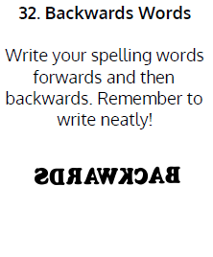  Use Backwards Words to practise spelling this week’s words:  attraction, location, construction, education, injection, electrician, mathematician, politician, magician, optician, musician
9.45-10.00  Active break | LO: To boost my concentration through movement. | Join in with the Go Noodle clip below to get you moving!  https://family.gonoodle.com/activities/roar
10.00-11.00  English | SPaG Revision LO: To identify and use adjectives.  LO: To explore word classes. | For today’s SPaG Daily Practice, revise your knowledge of adjectives by answering the question below:  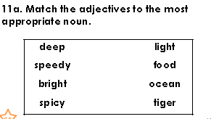  Follow the link below to have a go at today’s English lesson:  To explore word classes (thenational.academy)
11.00- 11.15
Break
11.15-12.15  Maths | LO: To practise my recall of the 4 times table.  LO: To recognise, identify and describe unit fractions. | Follow the link below to practise the 4 times table and get moving!  https://www.youtube.com/watch?v=LT3t-uLB9qs  Follow the link below to have a go at today’s maths lesson:  To recognise, identify and describe unit fractions (thenational.academy)
12.15-1.00
Dinner
1.00-1.15  Storytime | LO: To listen to a story for pleasure. | Listen to Chapter 17 of The Golden Orchid:  Audible Stories: Free Audiobooks for Kids | Audible.com
1.15-2.30  Topic-R.E | LO: To explore the festival of Diwali. | Follow this link to learn about Diwali:  What is Diwali? - BBC Bitesize  Create a fact file of information about Diwali.  Create your own Rangoli pattern to celebrate Diwali. You could create this in any way that you like- using coloured pencils, materials or chalk!
2.30-3.00  RHE | LO: To learn about the causes and effects of climate change. | Follow the link to have a go at today’s lesson:  Be better and do more (thenational.academy)

Beat That!

Time and Subject  Thursday | Learning Objective | Task/Link/Resources
8.45-9.00  Reading | L.O: To practise and consolidate existing reading skills. | Read your individual reading book, either in your head or out loud.
9.00-9.15  Morning Maths | LO: To consolidate recall of number facts.  Revision LO: To count in 50s. | Complete today’s Beat That- scroll down below today’s timetable to find the questions. Remember, it is the same one every day for a week. Can you beat your own score?  Morning Maths: In Morning Maths today, you are going to revise your knowledge of place value. Click the link below and select the video Count in 50s.  https://whiterosemaths.com/homelearning/year-3/week-3/
9.15-9.45  Spelling | LO: To practise Unit Ten RWI spelling words. | This week, we are going to practise adding the suffix -ian.  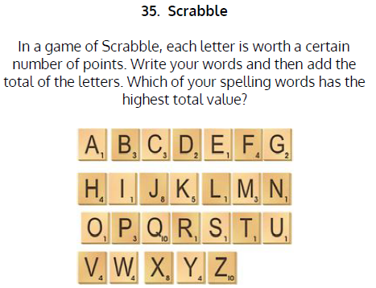  Use Scrabble to practise spelling this week’s words:  attraction, location, construction, education, injection, electrician, mathematician, politician, magician, optician, musician
9.45-10.00  Active break | LO: To boost my concentration through movement. | Join in with the Go Noodle clip below to get you moving!  https://family.gonoodle.com/activities/im-still-standing
10.00-11.00  English | SPaG Revision LO: To identify and use adjectives.  LO: To practise the four types of simple sentence. | For today’s SPaG Daily Practice, revise your knowledge of adjectives by answering the question below:  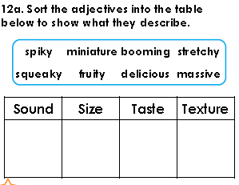  Follow the link below to have a go at today’s English lesson:  To practise the four types of simple sentence (thenational.academy)
11.00- 11.15
Break
11.15-12.15  Maths | LO: To practise my recall of the 4 times table.  LO: To find unit fractions of a given quantity. | Follow the link below to practise the 4 times table:  http://www.snappymaths.com/multdiv/4xtable/interactive/newlook/4xtablebtcd.htm  Follow the link below to have a go at today’s lesson:  To find unit fractions of a given quantity (thenational.academy)
12.15-1.00
Dinner
1.00-1.15  Storytime | LO: To listen to a story for pleasure. | Listen to Chapter 18 of The Golden Orchid:  Audible Stories: Free Audiobooks for Kids | Audible.com
1.15-3.00  PE | LO: To build strength and stamina. | Follow the link to have a go at today’s PE activity:  SPIDER-VERSE KIDS WORKOUT (MILES MORALES) - YouTube

Beat That!

Time and Subject  Friday | Learning Objective | Task/Link/Resources
8.45-9.00  Reading | L.O: To practise and consolidate existing reading skills. | Read your individual reading book, either in your head or out loud.
9.00-9.15  Morning Maths | LO: To consolidate recall of number facts.  Revision LO:  To add and subtract multiples of 100. | Complete today’s Beat That- scroll down below today’s timetable to find the questions. Remember, it is the same one every day for a week. Can you beat your own score?  Morning Maths: In Morning Maths today, you are going to revise your knowledge of place value. Click the link below and select the video Add and subtract multiples of 100.  https://whiterosemaths.com/homelearning/year-3/week-4/
9.15-9.45  Spelling | LO: To practise Unit Ten RWI spelling words. | This week, we are going to practise adding the suffix -ian.  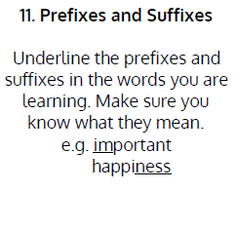  Use Scrabble to practise spelling this week’s words:  attraction, location, construction, education, injection, electrician, mathematician, politician, magician, optician, musician  Spelling Test:  Scroll down below today’s timetable to use the look, cover, write, check sheet to help you to test yourself on this week’s words.
9.45-10.00  Active break | L.O: To boost my concentration through movement. | Join in with the Go Noodle clip to get you moving!  https://family.gonoodle.com/activities/best-time-ever
10.00-11.00  English | SPaG Revision LO: To identify and use adjectives.  LO: To develop a rich understanding of words associated with confidence. | For today’s SPaG Daily Practice, revise your knowledge of adjectives by answering the question below:  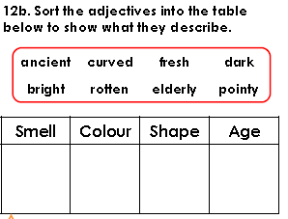  Follow the link below to have a go at today’s lesson:  To develop a rich understanding of words associated with confidence (thenational.academy)
11.00- 11.15
Break
11.15-12.15  Maths | LO: To practise my recall of the 4 times table.  LO: To describe unit and non-unit fractions. | Follow the link below to practise the 4 times table:  http://www.snappymaths.com/multdiv/4xtable/interactive/newlook/4xmissintd.htm  Follow the link below to have a go at today’s lesson:  To describe unit and non-unit fractions (thenational.academy)
12.15-1.00
Dinner
1.00-1.15  Storytime | LO: To listen to a story for pleasure. | Listen to Chapter 19 of The Golden Orchid:  Audible Stories: Free Audiobooks for Kids | Audible.com
1.15-3:00  Mindfulness | LO: To practise mindfulness. | Have a go at this meditation:  https://family.gonoodle.com/activities/rainbow-breath  Have a go at creating some mindfulness art:  https://www.youtube.com/watch?v=VXs0czMhsZw  Have a go at this relaxing Yoga session:  https://www.youtube.com/watch?v=on_9AhPQigE

Beat That!
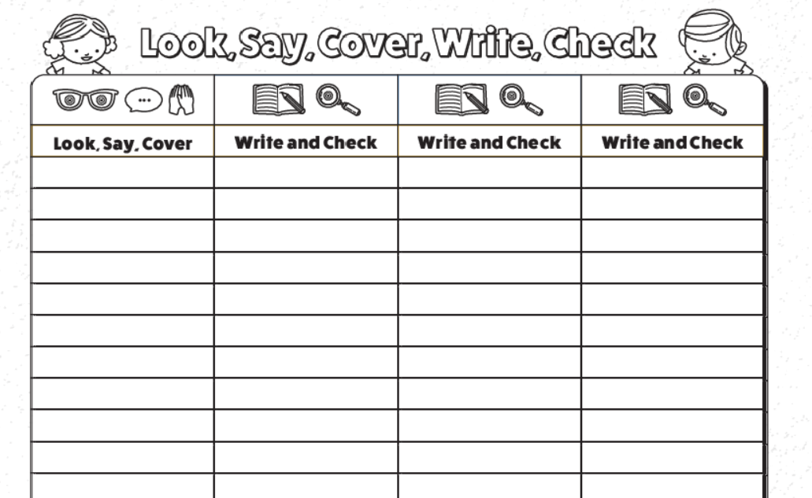
Spelling Test

