Time and Subject  Monday | Learning Objective | Task/Link/Resources
8.45-9.00  Reading | LO: To practise and consolidate existing reading skills. | Read your individual reading book, either in your head or out loud.
9.00-9.15  Morning Maths | LO: To consolidate recall of number facts.  Revision LO: To round to the nearest 1000. | Complete today’s Beat That- scroll down below today’s timetable to find the questions. Remember, it is the same one every day for a week. Can you beat your own score?  Morning Maths: In Morning Maths today, you are going to revise your knowledge of place value. Click the link below and select the video Round to the nearest 1000.  Week 3 - Number: Place Value | White Rose Maths
9.15-9.45  Spelling | LO: To practise Year 3/4 Common Exception words. | This week, we are going to practise spelling some of our tricky orange words!  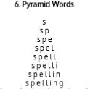  Use Pyramid Words to practise spelling this week’s orange words:  medicine, mention, minute, natural, naughty, notice, occasion, occasionally, often, opposite, ordinary
9.45-10.00  Active break | LO: To boost my concentration through movement. | Join in with the Go Noodle clip below to get you moving!  https://family.gonoodle.com/activities/life-of-the-party
10.00-11.00  English | SPaG Revision LO: To identify adverbs.  LO: To analyse ‘Carnival Jumbie’ | For today’s SPaG Daily Practice, revise your knowledge of adverbs:  What is an adverb? - BBC Bitesize  Follow the link below to have a go at today’s English lesson:  To analyse 'Carnival Jumbie' (thenational.academy)
11.00- 11.15
Break
11.15-12.15  Maths | LO: To practise my recall of the 10 times table.  LO: To build and compare different wholes from the same unit fractions that represent the same length. | Follow the link below to practise the 10 times table and get moving!  https://www.bbc.co.uk/teach/supermovers/ks1-maths-the-10-times-table-with-webster-the-spider/zm32cqt  Follow the link below to have a go at today’s maths lesson:  Build and compare different wholes from the same unit fractions that represent the same length (thenational.academy)
12.15-1.00
Dinner
1.00-1.15  Storytime | LO: To listen to a story for pleasure. | Listen to Chapter 26 of The Mystwick School of Musicraft:  Audible Stories: Free Audiobooks for Kids | Audible.com
1.15-2.30  RHE | LO: To understand the water cycle. | Follow the link to have a go at today’s lesson:  H20 (thenational.academy)
2.30-3.00  Music | LO: To recognise time signatures. | Follow the link below to have a go at today’s lesson:  https://classroom.thenational.academy/lessons/recognising-time-signatures-6rv36d

Beat That!
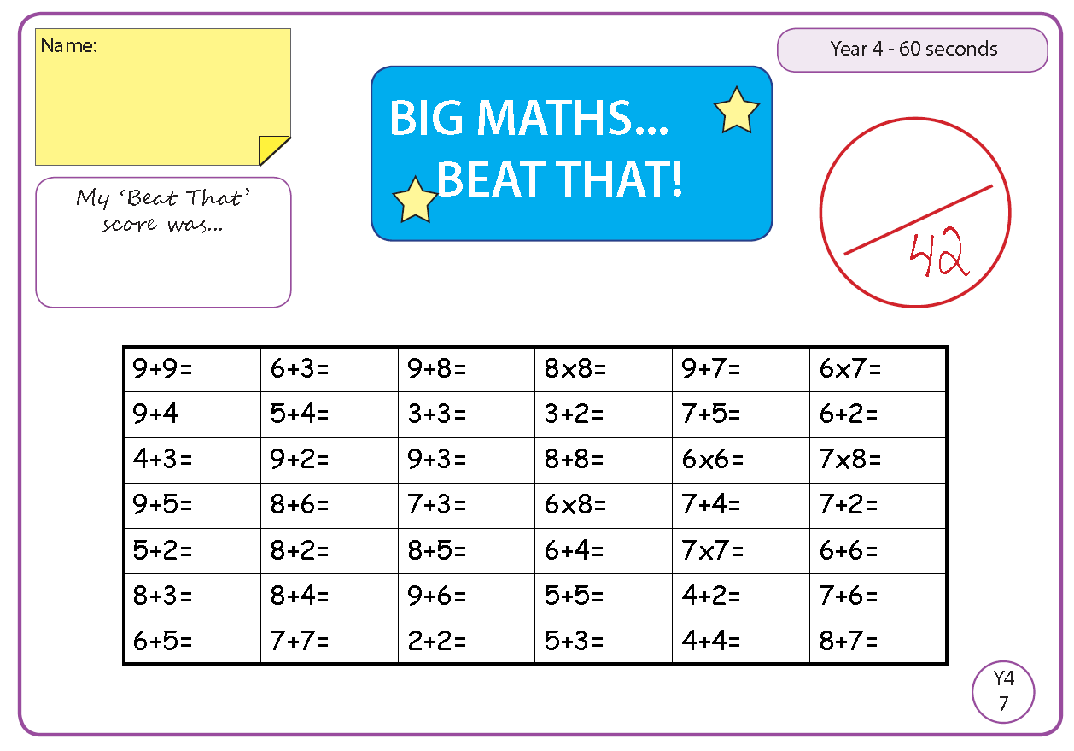

Time and Subject  Tuesday | Learning Objective | Task/Link/Resources
8.45-9.00  Reading | L.O: To practise and consolidate existing reading skills. | Read your individual reading book, either in your head or out loud.
9.00-9.15  Morning Maths | LO: To consolidate recall of number facts.  Revision LO: To count in 25s. | Complete today’s Beat That- scroll down below today’s timetable to find the questions. Remember, it is the same one every day for a week. Can you beat your own score?  Morning Maths: In Morning Maths today, you are going to revise your knowledge of place value. Click the link below and select the video Count in 25s.  Week 4 - Number: Place Value | White Rose Maths
9.15-9.45  Spelling | LO: To practise Year 3/4 Common Exception words. | This week, we are going to practise spelling some of our tricky orange words!  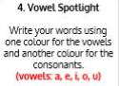  Use Vowel Spotlight to practise spelling this week’s words:  medicine, mention, minute, natural, naughty, notice, occasion, occasionally, often, opposite, ordinary
9.45-10.00  Active break | L.O: To boost my concentration through movement. | Join in with the Go Noodle clip below to get you moving!  https://family.gonoodle.com/activities/cheerleader
10.00-11.00  English | SPaG Revision LO: To identify adverbs.  LO: To practise and apply our knowledge of suffixes: -ial. | For today’s SPaG Daily Practice, revise your knowledge of adverbs by answering the question below:  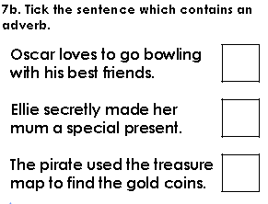  Follow the link below to have a go at today’s English lesson:  To practise and apply knowledge of suffixes: -ial, including test (thenational.academy)
11.00- 11.15
Break
11.15-12.15  Maths | LO: To practise my recall of the 10 times table.  LO: To build and compare different wholes from the same unit fractions that represent different lengths. | Follow the link below to practise the 10 times table:  https://www.timestables.co.uk/10-times-table.html  Follow the link below to have a go at today’s maths lesson:  Build and compare different wholes from the same unit fractions that represent different lengths (thenational.academy)
12.15-1.00
Dinner
1.00-1.15  Storytime | LO: To listen to a story for pleasure. | Listen to Chapter 27 of The Mystwick School of Musicraft:  Audible Stories: Free Audiobooks for Kids | Audible.com
1.15-2.30  Topic-RHE | LO: To understand the importance of recycling. | Follow the link below to have a go at today’s lesson:  Reduce, reuse, recycle (thenational.academy)
2.30-3.00  French | LO: To practise the language needed to order food in French. | Follow the link below to have a go at today’s lesson:  Eating Out - KS2 French - BBC Bitesize - BBC Bitesize

Beat That!

Time and Subject  Wednesday | Learning Objective | Task/Link/Resources
8.45-9.00  Reading | L.O: To practise and consolidate existing reading skills. | Read your individual reading book, either in your head or out loud.
9.00-9.15  Morning Maths | LO: To consolidate recall of number facts.  Revision LO: To count forwards and backwards through 0. | Complete today’s Beat That- scroll down below today’s timetable to find the questions. Remember, it is the same one every day for a week. Can you beat your own score?  Morning Maths: In Morning Maths today, you are going to revise your knowledge of place value. Click the link below and select the video Introducing negative numbers.  Week 4 - Number: Place Value | White Rose Maths
9.15-9.45  Spelling | LO: To practise Year 3/4 Common Exception words. | This week, we are going to practise spelling some of our tricky orange words.  Use Rainbow Words to practise spelling this week’s words:  medicine, mention, minute, natural, naughty, notice, occasion, occasionally, often, opposite, ordinary
9.45-10.00  Active break | LO: To boost my concentration through movement. | Join in with the Go Noodle clip below to get you moving!  https://family.gonoodle.com/activities/kidz-bop-shuffle
10.00-11.00  English | SPaG Revision LO: To identify adverbs.  LO: To analyse ‘Carnival Dance Lesson’ | For today’s SPaG Daily Practice, revise your knowledge of adverbs by answering the question below:  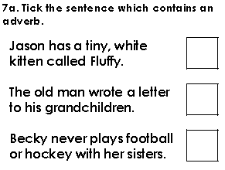  Follow the link below to have a go at today’s English lesson:  To analyse 'Carnival Dance Lesson' (thenational.academy)
11.00- 11.15
Break
11.15-12.15  Maths | LO: To practise my recall of the 10 times table.  LO: To build and compare wholes when different unit fractions represent different amounts. | Follow the link below to practise the 10 times table and get moving!  https://www.youtube.com/watch?v=8yxMJUHBslY  Follow the link below to have a go at today’s maths lesson:  Build and compare wholes when different unit fractions represent different amounts (thenational.academy)
12.15-1.00
Dinner
1.00-1.15  Storytime | LO: To listen to a story for pleasure. | Listen to Chapter 28 of The Mystwick School of Musicraft:  Audible Stories: Free Audiobooks for Kids | Audible.com
1.15-2.30  Topic- P.E | LO: To develop strength and stamina. | Follow the link to have a go at today’s PE activity:  FROZEN - ELSA'S WORKOUT - YouTube
2.30-3.00  RHE | LO: To understand the water cycle. | Follow the link to have a go at today’s lesson:  H20 (thenational.academy)

Beat That!

Time and Subject  Thursday | Learning Objective | Task/Link/Resources
8.45-9.00  Reading | L.O: To practise and consolidate existing reading skills. | Read your individual reading book, either in your head or out loud.
9.00-9.15  Morning Maths | LO: To consolidate recall of number facts.  Revision LO: To count forwards and backwards through 0. | Complete today’s Beat That- scroll down below today’s timetable to find the questions. Remember, it is the same one every day for a week. Can you beat your own score?  Morning Maths: In Morning Maths today, you are going to revise your knowledge of place value. Click the link below and select the video Negative numbers.  Week 4 - Number: Place Value | White Rose Maths
9.15-9.45  Spelling | LO: To practise Year 3/4 Common Exception words. | This week, we are going to practise spelling some of our tricky orange words.  Use Bubble Letters to practise spelling this week’s words:  medicine, mention, minute, natural, naughty, notice, occasion, occasionally, often, opposite, ordinary
9.45-10.00  Active break | LO: To boost my concentration through movement. | Join in with the Go Noodle clip below to get you moving!  https://family.gonoodle.com/activities/dance-monkey
10.00-11.00  English | SPaG Revision LO: To identify adverbs.  LO: To generate and develop vocabulary. | For today’s SPaG Daily Practice, revise your knowledge of adverbs by answering the question below:  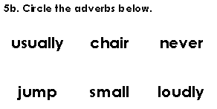  Follow the link below to have a go at today’s English lesson:  To generate and develop vocabulary (Part 2) (thenational.academy)
11.00- 11.15
Break
11.15-12.15  Maths | LO: To practise my recall of the 10 times table.  LO: To build and compare different wholes from different unit fractions that represent different quantities. | Follow the link below to practise the 10 times table:  http://www.snappymaths.com/multdiv/10xtable/interactive/newlook/10xtablebtcd.htm  Follow the link below to have a go at today’s lesson:  Build and compare different wholes from different unit fractions that represent different quantities (thenational.academy)
12.15-1.00
Dinner
1.00-1.15  Storytime | LO: To listen to a story for pleasure. | Listen to Chapter 29 of The Mystwick School of Musicraft:  Audible Stories: Free Audiobooks for Kids | Audible.com
1.15-3.00  PE | LO: To build strength and stamina. | Follow the link to have a go at today’s PE activity:  Harry Potter 'Enchanted Spells' Kids Workout - YouTube

Beat That!

Time and Subject  Friday | Learning Objective | Task/Link/Resources
8.45-9.00  Reading | L.O: To practise and consolidate existing reading skills. | Read your individual reading book, either in your head or out loud.
9.00-9.15  Morning Maths | LO: To consolidate recall of number facts.  Revision LO:  To use Roman Numerals. | Complete today’s Beat That- scroll down below today’s timetable to find the questions. Remember, it is the same one every day for a week. Can you beat your own score?  Morning Maths: In Morning Maths today, you are going to revise your knowledge of place value. Click the link below and select the video Roman Numerals.  Week 4 - Number: Place Value | White Rose Maths
9.15-9.45  Spelling | LO: To practise Year 3/4 Common Exception words. | This week, we are going to practise spelling some of our tricky orange words.  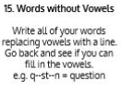  Use Words without Vowels to practise spelling this week’s words:  medicine, mention, minute, natural, naughty, notice, occasion, occasionally, often, opposite, ordinary  Spelling Test:  Scroll down below today’s timetable to use the look, cover, write, check sheet to help you to test yourself on this week’s words.
9.45-10.00  Active break | L.O: To boost my concentration through movement. | Join in with the Go Noodle clip to get you moving!  https://family.gonoodle.com/activities/wake-up
10.00-11.00  English | SPaG Revision LO: To identify adverbs.  LO: To write a poem. | For today’s SPaG Daily Practice, revise your knowledge of adverbs by answering the question below:  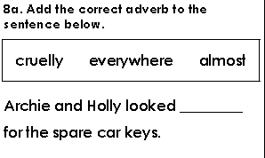  Follow the link below to have a go at today’s lesson:  To write a poem (thenational.academy)
11.00- 11.15
Break
11.15-12.15  Maths | LO: To practise my recall of the 10 times table.  LO: To build and compare wholes when different unit fractions represent different amounts. | Follow the link below to practise the 10 times table:  http://www.snappymaths.com/multdiv/10xtable/interactive/newlook/10xmissintd.htm  Follow the link below to have a go at today’s lesson:  Build and compare wholes when different unit fractions represent different amounts (thenational.academy)
12.15-1.00
Dinner
1.00-1.15  Storytime | LO: To listen to a story for pleasure. | Listen to Chapter 1 of House of Teeth.  Audible Stories: Free Audiobooks for Kids | Audible.com
1.15-3:00  Yoga | Golden Time  LO: To develop core strength and flexibility. | Join in with this relaxing yoga session:  https://www.youtube.com/watch?v=nRkojdFPjjI
Beat That!
Spelling Test
